|  |
| --- |
| bitter panicum |
| *Panicum amarum* Ell. |
| Plant Symbol = PAAM2 |

Contributed by: USDA NRCS Plant Materials Program

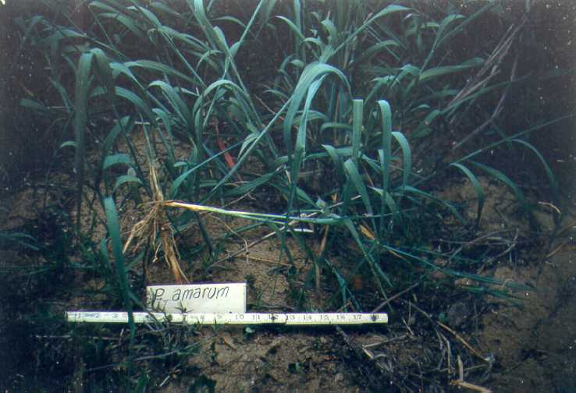

USDA NRCS National Plant Materials Center

Beltsville, MD

Alternate Names

bitter panicgrass

Uses

*Erosion control*: The principal use for bitter panicum is in coastal dune erosion control and it may have a role in stabilizing other dry, sterile areas such as roadsides and minespoils.

*Livestock*: Bitter panicum is consumed by cattle, sheep, and goats.

Status

Please consult the PLANTS Web site and your State Department of Natural Resources for this plant’s current status (e.g. threatened or endangered species, state noxious status, and wetland indicator values).

Description

*Panicum amarum* Ell., bitter panicum, is a perennial, U.S. native, warm season grass growing to a height of 7 feet with a growth habit ranging from erect to prostrate. The leaves are 1/4 to 1/2 inch wide, 7 to 20 inches long, smooth without hair, and bluish in color. A robust grass, it spreads slowly from short, strong rhizomes to form open clumps. Small quantities of poor quality seed are produced on compact clusters 6 to 12 inches long and 2 to 4 inches wide.

Adaptation and Distribution

Bitter panicum is adapted to very dry sterile sites. It can withstand periods of extended drought and is somewhat winter hardy.

Bitter panicum is distributed throughout the East and lower Midwest. For a current distribution map, please consult the Plant Profile page for this species on the PLANTS Website.

Establishment

Generally, no site preparation is required when planting bitter panicum. Freshly dug bareroot shoots (tillers) and rooted or unrooted stem cuttings can be used to establish plantings. Plant potted plants and bare root plants in staggered rows 2 to 3 feet apart with plants 2 feet apart in each row. Place plants 8 to 10 inches deep or deeper in moist soil. Bury unrooted stems end to end in trenches 4 to 6 inches deep and 2 to 3 feet apart leaving the top 6 to 10 inches of the stem exposed. Plant unrooted cuttings 3 to a hole in staggered rows 2 to 3 feet apart with holes 2 feet apart in each row.

Bitter panicum can be established in the fall with cuttings, in late winter or early spring with potted plants, or in late spring (beginning of rainy season) with young tillers.

Management

During establishment, restrict traffic and livestock grazing. All sites should be allowed to establish the first year, prior to any grazing. Once grazing is started do not graze lower than 4 to 6 inches. Apply fertilizer according to soil test recommendations. Application of fertilizer may be split.

Pests and Potential Problems

There are no known serious pests of bitter panicum.

Cultivars, Improved, and Selected Materials (and area of origin)

‘Northpa’ (NC) and ‘Southpa’ (FL). Planting materials are available from commercial sources.

Prepared By & Species Coordinator:

*USDA NRCS Plant Materials Program*

Edited: 05Feb2002 JLK; 25may06jsp

For more information about this and other plants, please contact your local NRCS field office or Conservation District, and visit the PLANTS Web site<<http://plants.usda.gov>> or the Plant Materials Program Web site <<http://Plant-Materials.nrcs.usda.gov>>

*The U.S. Department of Agriculture (USDA) prohibits discrimination in all its programs and activities on the basis of race, color, national origin, sex, religion, age, disability, political beliefs, sexual orientation, and marital or family status. (Not all prohibited bases apply to all programs.) Persons with disabilities who require alternative means for communication of program information (Braille, large print, audiotape, etc.) should contact USDA's* [*TARGET Center*](http://www.usda.gov/oo/target.htm) *at 202-720-2600 (voice and TDD).*

*To file a complaint of discrimination write USDA, Director, Office of Civil Rights, Room 326-W, Whitten Building, 14th and Independence Avenue, SW, Washington, DC 20250-9410 or call 202-720-5964 (voice or TDD). USDA is an equal opportunity provider and employer.*

*Read about* [*Civil Rights at the Natural Resources Convervation Service*](http://www.nrcs.usda.gov/about/civilrights/)*.*