|  |
| --- |
| coastal panicgrass |
| *Panicum amarum* Ell. var. *amarulum* (A.S. Hitchc. & Chase) P.G. Palmer |
| Plant Symbol = PAAMA2 |

Contributed by: USDA NRCS Plant Materials Program

Alternate Names

*Panicum amarulum* A. S. Hitchc. & Chase, *Panicum amarum* Ell. ssp. *amarulum* (A.S. Hitchc. & Chase) Freckmann & Lelong, bitter panicgrass

Uses

Coastal panicgrass has a deep fibrous root system which has made it a top choice for secondary sand dune stabilization in the mid-Atlantic states. Due to its upright form, this warm-season grass has been recommended for use in developing vegetative wind barriers. Due to its hedges form and winter persistence, coastal panicgrass is popular for wildlife cover on sandy coastal soils and reclaimed minelands. It is also useful as a primary stabilizer of very well or excessively drained sites, such as gravel pits, dikes, and road bank cuts and fills.

Status

Please consult the PLANTS Web site and your State Department of Natural Resources for this plant’s current status (e.g. threatened or endangered species, state noxious status, and wetland indicator values).

Description

This grass is deep rooted (+6 feet), robust, long lived where hardy, and grows to heights of 3 to 6 feet. This is a U.S. native grass. The stems may be as thick as 1/2 inch, with bluish green leaves from 8 to 20 inches long and 1/4 to 1/2 inch wide. Although coastal panicgrass grows faster than most warm season grasses, it is slower than cool season grasses. Producing short outwardly spreading rhizomes, it forms clumps or bunches. Like most other species in the genus *Panicum*, coastal panicgrass has a large terminal inflorescence. It is a tightly arranged, densely flowered cluster. Seed dispersal is the primary means of reproduction of this species. There are an average of 350,000 seeds per pound.

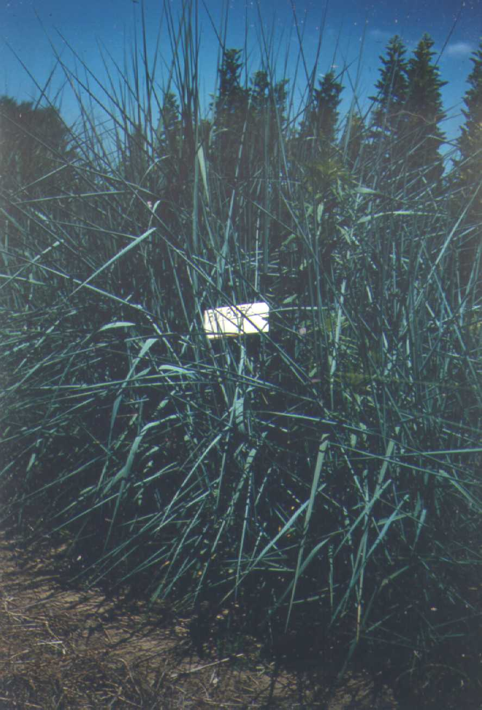

USDA NRCS National Plant Materials Center

Beltsville, MD

Adaptation and Distribution

Coastal panicgrass naturally occurs from Massachusetts to Florida, west to Texas. Like most plants, coastal panicgrass flourishes on fertile, well drained soils, but will perform well on droughty, very sandy sites. When established on sand dunes it will only survive where other species have initially stabilized the location. It will tolerate moderate saline overspray, and pH as low as 5.0. It does not tolerate large deposits of sand. Coastal panicgrass is useful in warm season grass mixtures on sand and gravel pits. There the good seedling vigor helps with initial stand establishment. Inland and north of Massachusetts it will winterkill, but not before helping during the seeding years.

For a current distribution map, please consult the Plant Profile page for this species on the PLANTS Website.

Establishment

Coastal panicgrass can be propagated by seed or vegetative divisions. It is the only species known to be successfully established on mid-Atlantic sand dunes by direct seeding. It is best to sow from early spring, until May. If sands shift after planting, covering seed more than 2” deep, emergence will be obstructed. Depending on soil texture and available moisture, seed should be placed 1 (with increased % fines) to 1 1/2 (coarse soils) inches deep. Drilling in rows 10 to 20 inches apart, using 6 to 8 pounds of seed per acre results in the best establishment. In mixtures with other warm season grasses, 3 lb/ac of coastal panicgrass is sufficient. Inland critical areas should be established using standard broad cast seeding, mulching, and fertilization procedures on sand and gravel pits, tracking with a dozer is recommended.

Planting trials on field sites have been established utilizing bare-rooted stem divisions and containerized divisions, with mixed results. Successful sites were on protected locations, while failures were located on exposed, unstable sites. Under nursery conditions, most vegetative techniques work well.

Management

Annual controlled burning often stimulates seed production, recycles nutrients, and suppresses weed growth. At the time of planting 250 pounds per acre of 10-10-10, or the equivalent, should be band applied below the seed. Top or side dressed spring applications of 500 pounds of 10-10-10 fertilizer or the equivalent per acre, in post establishment years, will promote good plant and seed growth.

Cultivars, Improved, and Selected Materials (and area of origin)

Only one cultivar is grown for commercial distribution; that is ‘Atlantic’ (Virginia). ‘Atlantic’ was evaluated and selected for release by the Cape May Plant Materials Center in 1981. Foundation seed of this grass is available from the Cape May Plant Materials Center in New Jersey; certified seed is available from commercial nurseries. Seed distribution is the primary means of propagation.

Prepared By & Species Coordinator:

USDA NRCS Plant Materials Program

Edited: 05Feb2002 JLK; 25may06jsp

For more information about this and other plants, please contact your local NRCS field office or Conservation District, and visit the PLANTS Web site<<http://plants.usda.gov>> or the Plant Materials Program Web site <<http://Plant-Materials.nrcs.usda.gov>>

*The U.S. Department of Agriculture (USDA) prohibits discrimination in all its programs and activities on the basis of race, color, national origin, sex, religion, age, disability, political beliefs, sexual orientation, and marital or family status. (Not all prohibited bases apply to all programs.) Persons with disabilities who require alternative means for communication of program information (Braille, large print, audiotape, etc.) should contact USDA's* [*TARGET Center*](http://www.usda.gov/oo/target.htm) *at 202-720-2600 (voice and TDD).*

*To file a complaint of discrimination write USDA, Director, Office of Civil Rights, Room 326-W, Whitten Building, 14th and Independence Avenue, SW, Washington, DC 20250-9410 or call 202-720-5964 (voice or TDD). USDA is an equal opportunity provider and employer.*

*Read about* [*Civil Rights at the Natural Resources Convervation Service*](http://www.nrcs.usda.gov/about/civilrights/)*.*