|  |
| --- |
| Golden Ragwort |
| *Packera aurea* (L.) A. Love & D. Love |
| Plant Symbol = PAAU3 |

Contributed by: USDA NRCS National Plant Materials Center, Beltsville, MD

Wayne Hughes, used with permission

Alternate Names

Golden groundsel, Senecio aureus L.

Uses

*Landscaping and Wildlife*: Golden Ragwort is a beautiful plant in flower and makes an effective groundcover even in dry shade conditions. For these reasons it is often used in native landscape gardens and meadow plantings. It also has potential as a component of conservation mixes. It will grow well in moist to wet soils in sunny to shady locations where it naturalizes rapidly. The nectar and pollen of the flowers are attractive to small bees and flies such as little carpenter bees, cuckoo bees, and various Halictid bees. The caterpillars of the gem moth (*Orthonama obstipata*) feed on the foliage.

*Ethnobotanical:* The root and leaf are used in teas by the Cherokee Indians for heart trouble, and to prevent pregnancy. Other Native Americans used it to regulate menses, to aid childbirth, treat urinary problems and to treat lung diseases such as tuberculosis. It is also used for external ointments and infusions for ulcers and wounds. The leaves contain a low toxicity alkaloid (Pyrrolizidine). The foliage is shunned by most mammalian herbivores due to its toxicity, although sheep are more tolerant and will eat it.

Status

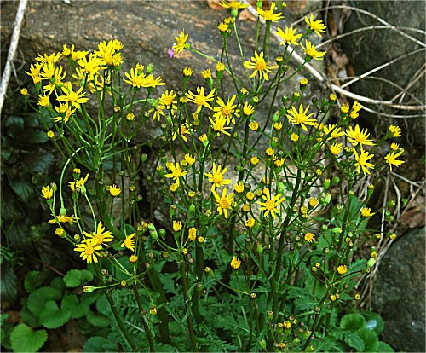Please consult the PLANTS Web site and your State Department of Natural Resources for this plant’s current status (e.g. threatened or endangered species, state noxious status, and wetland indicator values).

Description and Adaptation

Golden Ragwort is a member of the Aster family (Asteraceae). It is a somewhat weedy, short lived, perennial forb growing from 6 inches to 2 feet tall. The two very different kinds of leaves are highly distinctive. The blades of the basal leaves are 2 inches long and 2 inches across; they are cordate-orbicular in shape. The slender petioles of the basal leaves are 2 inches long. A flower stalk develops from the center of each rosette. Along this stalk, there are usually 2 – 3 alternate leaves. These leaves are smaller in size than the basal leaves and pinnatifid in shape. Both the alternate leaves and the stalk are hairless. The stalk ends in a flat-headed panicle of yellow flowers. The blooming period occurs early spring (March – April) and lasts about 3 weeks. Each daisy-like flower is 1 inch across; in the center there are numerous golden yellow disk florets, which are surrounded by 6-16 yellow ray florets. Both the disk and ray florets are fertile. Each floret is replaced by a purple bullet shaped achene which is distributed by the wind. The short rootstock has spreading fibrous roots and it produces rhizomes (and sometimes stolons).

Golden Ragwort is a carefree plant which prefers full sun to light shade in wet to moist soils with ample organic matter to retain moisture. Plants grown in full sun require more moisture than plants growing in shade. It often forms colonies of plants in favorable habitats.

*Distribution*: This species is very widely distributed in the eastern North America in USDA hardiness zones 3 - 9. Habitats include wet deciduous woods, meadows, banks of rivers, streams and lakes, slopes of rocky ravines, and roadsides.

Establishment

This species is easily grown; and can be planted as containers in the spring or early fall. Divisions of the plant in the spring are another option for establishment. Golden Ragwort will form dense colonies even within the root system of mature trees.

The seed does not require a pre-treatment for germination to occur and the plant freely self-seeds.

Management

Golden Ragwort is a hardy plant with relatively few problems. This species is easy to grow and maintain with moderate levels of N, P and K. It will naturalize under optimal conditions. It can become weedy in moist conditions.

Pests and Potential Problems

Golden Ragwort is a plant with no serious insect or disease problems.

Cultivars, Improved, and Selected Materials (and area of origin)

There are no recommended cultivars or selected materials at this time. Golden Ragwort is somewhat available from commercial nurseries specializing in native plants.

Prepared By and Species Coordinator:

*Shawn Belt,* USDA NRCS National Plant Materials Center, Beltsville, Maryland

Edited: 080915jsp

For more information about this and other plants, please contact your local NRCS field office or Conservation District, and visit the PLANTS Web site<<http://plants.usda.gov>> or the Plant Materials Program Web site <<http://Plant-Materials.nrcs.usda.gov>>

*The U.S. Department of Agriculture (USDA) prohibits discrimination in all its programs and activities on the basis of race, color, national origin, sex, religion, age, disability, political beliefs, sexual orientation, and marital or family status. (Not all prohibited bases apply to all programs.) Persons with disabilities who require alternative means for communication of program information (Braille, large print, audiotape, etc.) should contact USDA's* [*TARGET Center*](http://www.usda.gov/oo/target.htm) *at 202-720-2600 (voice and TDD).*

*To file a complaint of discrimination write USDA, Director, Office of Civil Rights, Room 326-W, Whitten Building, 14th and Independence Avenue, SW, Washington, DC 20250-9410 or call 202-720-5964 (voice or TDD). USDA is an equal opportunity provider and employer.*

*Read about* [*Civil Rights at the Natural Resources Conservation Service*](http://www.nrcs.usda.gov/about/civilrights/)*.*