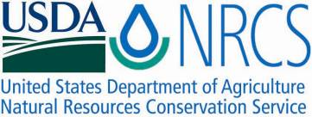

Plant Fact Sheet

# Knotgrass

## Paspalum distichum L.

### Plant Symbol = PADI6

#### Contributed by: USDA NRCS James E. “Bud” Smith Plant Materials Center, Knox City, Texas

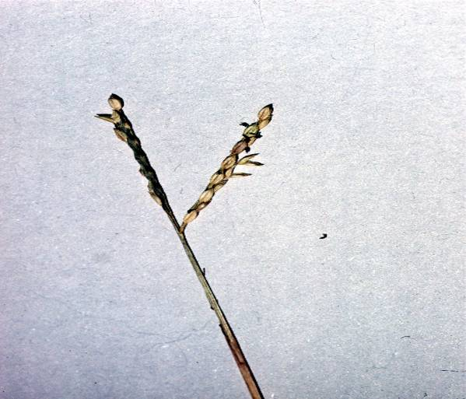 Robert H. Mohlenbrock @ USDA-NRCS PLANTS Database/ USDA SCS 1991. Southern wetland flora: Field office guide to plant species. South National Technical Center, Fort Worth.

#### **Alternate Names**

Eternity grass, Fort Thompson grass, ginger grass, joint grass, joint paspalum, saltene, salt jointgrass, salt-water couch grass, salt-water paspalum, seashore paspalum, and turfgrass

#### **Uses**

*Wildlife:* Knotgrass is grazed by deer and other mammals. It provides a substantial source of food for ducks as well. Knotgrass also serves as a larval host to the sunrise skipper, *Adopaeoides prittwitzi.*

*Livestock:* Knotgrass can provide valuable forage for livestock, especially in areas of high salinity. It can be used for hay, but is not suitable for use in silage.

*Erosion:* Knotgrass can tolerate a waterlogged environment which allows it to be used in the restoration of wetlands, marshes, beaches, and stream banks.

#### **Status**

Please consult the PLANTS website ([www.plants.usda.gov](http://www.plants.usda.gov)) and your State Department of Natural Resources for this plant’s current status (e.g., threatened or endangered species, state noxious status, and wetland indicator values).

#### **Weediness**

This plant may become weedy or invasive in some regions or habitats and may displace desirable vegetation if not properly managed. Please consult with your local NRCS Field Office, Cooperative Extension Service office, state natural resource, or state agriculture department regarding its status and use. Weed information is also available from the PLANTS website at [http://plants.usda.gov](http://plants.usda.gov/). Please consult the Related Web Sites on the Plant Profile for this species for further information.

#### **Description**

Knotgrass is a warm season, perennial grass that grows in clumps or creeping along the soil surface. New growth begins in March and will remain green until the first frost. Stems grow along the soil and range from 6-72 inches in length. At each node, roots are sent downward, and flowering stems emerge up to 18 inches tall. Nodes on the creeping stems are often pubescent whereas the nodes on the mat-forming stems are glabrous. Blades are flat and taper to an enrolled apex. They are 2-6 inches long and about one inch wide. Flowers from knotgrass range in color from usually pink to red, green, or dull white. They are about 1/8 inch long and grow in clusters of two to three per stem. Seed have an oval shape with one end tapered to a point. They have a yellowish light color and averages about 1/10 inch long.

#### **Adaptation**

Knotgrass is found in both wet and well-drained areas. Common locations to find knotgrass are meadows, marshes, and ditches, but it can also be found growing in cultivated and disturbed areas. Knotgrass is also adapted to areas with high salinity.

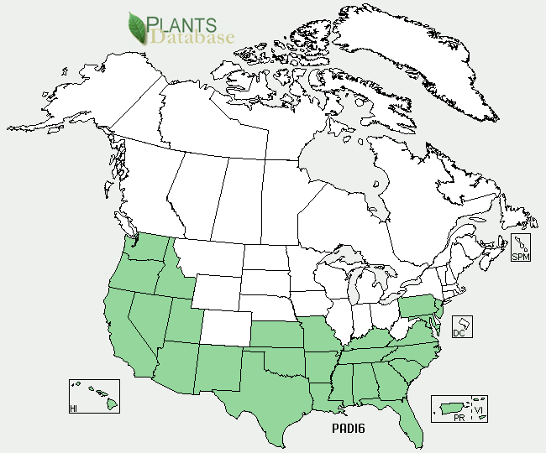 Knotgrass distribution from USDA-NRCS PLANTS Database

For updated distribution, please consult the Plant Profile page for this species on the PLANTS Web site.

#### **Establishment**

Knotgrass reproduces from rhizomes, stolons, and seeds. It can be easily established by sowing stolons in damp holes. It can also be planted directly into water saturated sites, which would allow it to remain green throughout the year. Knotgrass may flower throughout the year. The seed may be gathered; however, seed dormancy must break before they germinate. The seed yields the highest germination when temperatures are between 82 to 95° F. Scarifying seed with acid will also increase germination. It is not recommended to mix knotgrass with cool season grasses in seed mixtures. The cool season grasses will dominate the warm season grasses that begin growth later in the year.

#### **Management**

Knotgrass can be grazed, but it is recommended to lightly graze and give 2 ½ to 3 months rest because the stolons are easily uprooted. Consult your local NRCS Field Office for assistance with planning and applying prescribed grazing. Tilling knotgrass on dry surfaces will increase the number of stolons rooting into the soil and encourage a denser sod. Proper management is needed to prevent knotgrass from blocking irrigation ditches and other waterways. Knotgrass will survive burnings as long as water is above the soil surface to protect the rhizomes. Consult your local NRCS Field Office for assistance with planning and applying prescribed burning.

#### **Pests and Potential Problems**

None Known

#### **Environmental Concerns**

None Known

#### **Control**

Knotgrass can become a serious weed in direct-seeded rice fields under favorable conditions. Please contact your local agricultural extension specialist or county weed specialist to learn what works best in your area and how to use it safely. Always read label and safety instructions for each control method. Trade names and control measures appear in this document only to provide specific information. USDA NRCS does not guarantee or warranty the products and control methods named, and other products may be equally effective.

#### **Cultivars, Improved, and Selected Materials (and area of origin)**

None

#### **Prepared By:** Brandon Carr, USDA NRCS James E. “Bud” Smith Plant Materials Center, Knox City, Texas

Citation

Carr, C. 2010. Plant Fact Sheet for Knotgrass(*Paspalum distichum*). USDA-Natural Resources Conservation Service, James E. “Bud” Smith Plant Materials Center. Knox City, TX 79529

Published: August 2010

Edited: 30Jul2010 bc,

For more information about this and other plants, please contact your local NRCS field office or Conservation District <<http://www.nrcs.usda.gov/>>, and visit the PLANTS Web site <[http://plants.usda.gov](http://plants.usda.gov/)> or the Plant Materials Program Web site <<http://plant-materials.nrcs.usda.gov>>

**USDA IS AN EQUAL OPPORTUNITY PROVIDER AND EMPLOYER**