|  |
| --- |
| Maidencane |
| *Panicum hemitomon* Schult. |
| Plant Symbol = PAHE2 |

Contributed by: USDA NRCS East Texas Plant Material Center

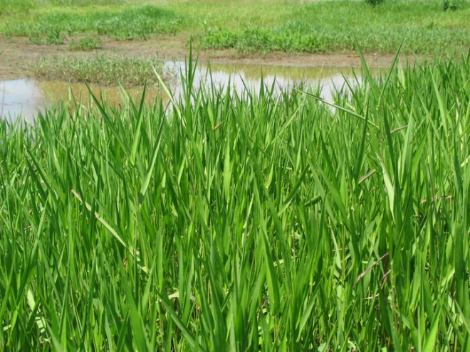

R. Alan Shadow

USDA NRCS East Texas Plant Materials Center

**Alternate Names**

Paille fine, canouche

Uses

*Forage:*

Maidencane can be an important forage grass in the coastal zone of the southeastern Untied States, and is very palatable to livestock. It is highly digestible, with a TDN of 50% and crude protein levels of 10.5% from June to September. This decreases to 34% TDN and 7.4% crude protein during winter months. Maidencane is very prolific; often forming monotypic stands, and can produce 4-5 tons of high quality forage per acre.

*Wildlife:*

Palatability among browse animals is rated as fair. Maidencane provides excellent habitat and cover for a wide array of mammals, reptiles, amphibians, birds, and fish. Maidencane marshes in Florida are reported to be extensively used by whitetail deer and the endangered Florida Panther.

*Conservation:*

Maidencane is an excellent plant for use in shoreline stabilization in fresh water locations. It has a rapid growth rate, and forms dense stand that extend from shallow water, up the bank as far as moisture permits. It is capable of decreasing wave energies and trapping suspended sediment. Its network of roots and rhizomes anchor the soil and trapped sediments in place.

Status

Please consult the PLANTS Web site and your State Department of Natural Resources for this plant’s current status (e.g. threatened or endangered species, state noxious status, and wetland indicator values).

**Weediness**

This plant may become weedy or invasive in some regions or habitats and may displace desirable vegetation if not properly managed. Please consult with your local NRCS Field Office, Cooperative Extension Service office, state natural resource, or state agriculture department regarding its status and use. Weed information is also available from the PLANTS Web site. Please consult the Related Web Sites on the Plant Profile for this species for further information.

Description and Adaptation

*Description:*

Maidencane is a warm season, rhizomatous, perennial, grass that grows from 2 to 5 feet in height. Its leaves are alternate with over lapping sheaths that grasp the stem and extend at approximately 35 degree angles. Maidencane is smooth and hairless with a membranous ligule. It typically spreads via rhizomes and produces few seed heads. Seed heads are very delicate in appearance, and are often sterile. Vegetative stems will greatly outnumber reproductive stems.

*Adaptation:*

Maidencane will tolerate a wide array of soil textures and prefers a near neutral pH. It will tolerate anaerobic conditions, and is one of the dominate species found in the floating marshes of Louisiana. It will not tolerate salt, and is absent in brackish areas. Maidencane is fire tolerant, as long as the rhizomes and roots are moist, and can withstand temperatures down to -3 degrees Fahrenheit.

*Distribution:*

Maidencane is widespread throughout the Southeastern seaboard from Texas to New Jersey, and as far inland as Tennessee. It is commonly associated with freshwater wetlands, marshes, river margins, and drainages.

Establishment

Maidencane is not a prolific or dependable seed producer, and is typically established from vegetative propagules. Rhizomes may be harvested and planted directly, or potted and grown out in a controlled environment for future use. Rhizomes are perishable, but will tolerate brief storage if kept moist and cool. Storage should be limited to a week or less to ensure viability and planting success. Maidencane should be planted in moist areas during the spring or fall to avoid weather extremes during establishment. Rhizomes should be spaced on one foot intervals and planted approximately 1-2 inches deep, but no deeper than 2 inches. Avoid planting dry areas or areas that remain inundated for long periods, brief inundation is acceptable. Moist, transitional areas make excellent planting sites and offer the best chance of planting success.

Management

Maidencane will respond favorably to fertilization, though it is typically not needed for conservation purposes. Fertilization may aid in establishment of new plantings or when used as a forage. Proper grazing management is necessary due to its high palatability and intolerance of heavy grazing. No more than 50% of its biomass should be removed each year from grazing or cutting to maintain healthy, vigorous stands.

Pests and Potential Problems

There are no known pests of problems associated with this species.

Environmental Concerns

Maidencane is very prolific and is capable of creating a monotypic stand. Under favorable conditions, it can out compete other plants, decreasing the diversity within the ecosystem. It can become invasive in moist soil units and constructed wetlands where a monotypic stand may not be desired.

Control

Maidencane can be controlled mechanically by mowing or environmentally with fire and hydro-period management, if possible. Herbicides may also be used to create openings in wetlands.Please contact your local agricultural extension specialist or county weed specialist to learn what works best in your area and how to use it safely. Always read label and safety instructions for each control method. Trade names and control measures appear in this document only to provide specific information. USDA NRCS does not guarantee or warranty the products and control methods named, and other products may be equally effective.

Cultivars, Improved, and Selected Materials (and area of origin)

‘Halifax’ was released in 1974 by the USDA NRCS Jamie L. Whitten Plant Materials Center in Coffeeville, MS, and Citrus Germplasm was released in 1998 by the USDA NRCS Brooksville Plant Materials Center in Brooksville, FL.

Prepared By:

*R. Alan Shadow*, Soil Conservationists, East Texas Plant Materials Center, Nacogdoches, Texas

Species Coordinator:

*R. Alan Shadow*, Soil Conservationists, East Texas Plant Materials Center, Nacogdoches, Texas

Edited: 080724 jsp

For more information about this and other plants, please contact your local NRCS field office or Conservation District, and visit the PLANTS Web site<<http://plants.usda.gov>> or the Plant Materials Program Web site <<http://Plant-Materials.nrcs.usda.gov>>

*The U.S. Department of Agriculture (USDA) prohibits discrimination in all its programs and activities on the basis of race, color, national origin, sex, religion, age, disability, political beliefs, sexual orientation, and marital or family status. (Not all prohibited bases apply to all programs.) Persons with disabilities who require alternative means for communication of program information (Braille, large print, audiotape, etc.) should contact USDA's* [*TARGET Center*](http://www.usda.gov/oo/target.htm) *at 202-720-2600 (voice and TDD).*

*To file a complaint of discrimination write USDA, Director, Office of Civil Rights, Room 326-W, Whitten Building, 14th and Independence Avenue, SW, Washington, DC 20250-9410 or call 202-720-5964 (voice or TDD). USDA is an equal opportunity provider and employer.*

*Read about* [*Civil Rights at the Natural Resources Conservation Service*](http://www.nrcs.usda.gov/about/civilrights/)*.*