|  |
| --- |
| Purple passionflower |
| *Passiflora incarnata* L*.* |
| Plant Symbol = PAIN6 |

Contributed by: USDA NRCS Booneville Plant Materials Center, Booneville, Arkansas

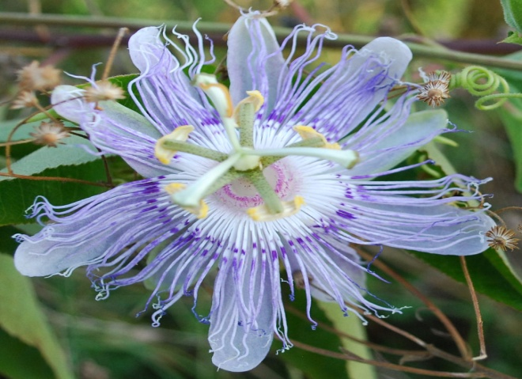

Alternate Names

Wild passion flower, maypop, apricot vine, old field apricot, Holy-Trinity flower, molly-pop, passion vine, pop-apple, granadilla, maycock, maracoc, maracock, white sarsaparilla.

Uses

*Horticultural*: One of the uses of the purple passionflower is ornamental in nature. This is because of their showy blooms and their climbing ability over fences, arbors, or up walls.

*Ethnobotany*: Native Americans used the poultice root for boils, cuts, earaches and inflammation. Dried leaves boiled with water were also used to treat insomnia.

*Wildlife*: Purple passionflower attracts butterflies and young tendrils are eaten by wild turkey. Deer resistance is moderate.

Status

Please consult the PLANTS Web site and your State Department of Natural Resources for this plant’s current status (e.g. threatened or endangered species, state noxious status, and wetland indicator values).

Description and Adaptation

The purple passion-flower is a native, herbaceous vine, 25 foot long, which climbs with axillary tendrils or sprawls along the ground. In rare cases, they can be white. Intricate, three-inch lavender flowers are short-stalked from leaf axils. The petals and sepals subtend a fringe of wavy or crimped, hair-like segments. The pistil and stamens are also showy. Three-lobed, deciduous leaves are dark-green above and whitish below. The plants bloom from June to September. The pulpy fruit or “maypop” develops in two to three months after flowering and may be harvested from July to October. It will be yellowish in color and it is about the size of a large oval hen’s egg.

Establishment

The purple passionflower requires direct sunlight for at least half of the day and prefers fertile, well-drained soil although it will grow in heavier clay soils. Plants may be propagated from seed or by cuttings. Seeds should be collected in the fall after the fruit has begun to shrivel. Mature seeds are brown in color with no traces of white. Wash the gelatinous covering from the seeds if they are to be stored for any length of time. It is best to plant the seed directly into an outdoor seedbed. Cuttings should be taken in the early spring. Remove the lower leaves from a 15 to 20 cm cutting before placing it in the rooting medium. Removing the suckers that develop around the established plants provides materials for propagating by division. With a shovel, separate and remove the suckers and roots. Transplant the divisions and water them immediately.

Control/Management

Purple passionflowers may become invasive in some regions or habitats. To control the spread of purple passionflower, remove the suckers regularly.

Prepared By and Species Coordinator:

*Debbie Orick*, USDA NRCS Booneville Plant Materials Center, Booneville, Arkansas

Edited: August 15, 2008 DLO; 080821 jsp

For more information about this and other plants, please contact your local NRCS field office or Conservation District, and visit the PLANTS Web site<<http://plants.usda.gov>> or the Plant Materials Program Web site <<http://Plant-Materials.nrcs.usda.gov>>

*The U.S. Department of Agriculture (USDA) prohibits discrimination in all its programs and activities on the basis of race, color, national origin, sex, religion, age, disability, political beliefs, sexual orientation, and marital or family status. (Not all prohibited bases apply to all programs.) Persons with disabilities who require alternative means for communication of program information (Braille, large print, audiotape, etc.) should contact USDA's* [*TARGET Center*](http://www.usda.gov/oo/target.htm) *at 202-720-2600 (voice and TDD).*

*To file a complaint of discrimination write USDA, Director, Office of Civil Rights, Room 326-W, Whitten Building, 14th and Independence venue, SW, Washington, DC 20250-9410 or call 202-720-5964 (voice or TDD). USDA is an equal opportunity provider and employer.*

*Read about* [*Civil Rights at the Natural Resources Conservation Service*](http://www.nrcs.usda.gov/about/civilrights/)