

Plant Fact Sheet

**LEWIS MOCKORANGE**

***Philadelphus lewisii* Pursh**

Plant symbol = PHLE4

Contributed by: USDA NRCS Plant Materials Center, Corvallis, Oregon

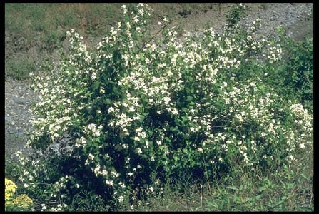© 1995 Saint Mary's College of California. Used with permission.

**Alternate names**

Gordon’s mockorange or *Philadelphus* *gordonianus* is now classified as the same species. There are at least 8 subspecies and varieties. Other common names include syringa, Indian arrowwood, and wild mockorange. Lewis’ mock orange and mock-orange are alternative spellings.

**Uses**

Lewis mockorange is useful for streambank stabilization, including soil bioengineering practices such as live staking and live fascines, restoration of riparian areas and moist ravines, and erosion control on hillsides and drier rocky slopes. The species provides good food and cover for wildlife. It is moderately important winter browse and thermal cover for elk and deer. Quail and squirrels consume the seeds. The flowers are a source of nectar for hummingbirds as well as food for certain butterflies, bees, and other pollinators. Livestock generally make light use of this plant and palatability is considered low, with exceptions. Sprouts and new shoots are very palatable. Native Americans used the wood for arrow shafts, combs, bows, cradles, and other products. Bruised leaves and flowers formed a soapy lather. Lewis mockorange is cultivated for ornamentalpurposes and hedgerows in part because of its large, showy, fragrant blooms.

**Description**

Lewis mockorange is an erect to spreading deciduous shrub in the Hydrangea family that grows 4 to 12 ft (1.2-3.6 m) tall and 3 to 9 ft (1.0-2.7 m) wide. The leaves are oblong to broadly lance shaped, opposite, simple, and 1 to 3 in. (2.5-8 cm) long with smooth to sparsely toothed margins. This species blooms from May to July depending on location. The scented flowers are white with four petals, solitary or born terminally in clusters of 3 to 15, and 1 to 1.5 in. (2-4 cm) wide. The fruit is a small, light brown, 4-celled capsule and the bark is light brown-grey and shredded or scaly.

**Status**

Please consult the Plants Web site and your State Department of Natural Resources for this plant’s current status, such as state noxious and wetland indicator values.

**Adaptation**

Lewis mockorange does best in full sun to moderate shade on moist, well drained soils that are coarse to medium (rich, loamy) textured. While preferring open woods and stream sides, it can also be found on moderately dry rocky slopes and bluffs. Its soil pH range is 5.4 to 8.0 and its annual precipitation range is 14 to 69 in. (36-175 cm). Eastern and northern exposures are favored by this species. Classified as fire resistant, it will resprout from root crowns after burning and regenerate from the seed bank that builds up in the soil.

*Distribution*-Lewis mockorange occurs naturally from southern British Columbia south to northern California and east to Alberta and western Montana. The elevation range is sea-level to 8000 ft (2400 m) in the mountains. Habitat includes riparian zones, wooded ravines, forest edges, dry hillsides, chaparral, and fir and pine communities. For current distribution, please consult the Plant profile page for this species on the PLANTS Web site.

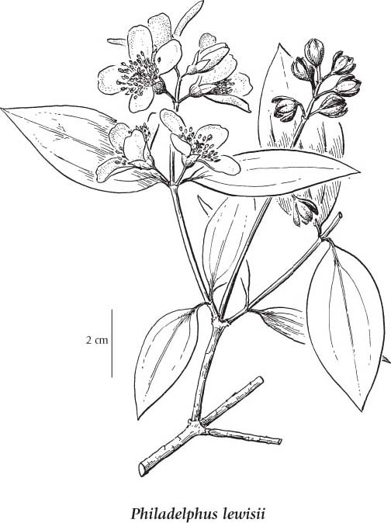.

Reprinted with permission, University of WA Press.

**Limitations or environmental concerns**

Few insect or disease pest problems have been described, but seedlings can be susceptible to damping off. The foliage and twigs are edible to ungulates, suggesting a degree of safety. However, the species is listed as poisonous to animals and humans by the FDA’s Center for Food Safety and Applied Nutrition. Its seeds are poisonous according to some sources, but other plant parts may be implicated. The species is generally not considered weedy.

**Establishment**

Lewis mockorange is readily propagated by seed, stem cuttings, layering, root suckers, or division. Dried capsules are collected in late summer and crushed to release the seed. The seed should be stored cool and dry but germination greatly improves with 2 to 5 months of moist cold stratification (prechilling at 1 to 5°C or 33 to 41°F) to overcome dormancy. Containers, beds for bareroot plant production, and weed free, well drained revegetation sites may be sown in the fall (untreated seed) or spring (treated seed) and the seed lightly covered. The species may be propagated from softwood cuttings taken in spring and treated with 1000 ppm of IBA (Indole-butyric acid). Hardwood cuttings can be similarly treated but often root readily without enhancement, allowing for direct sticking or live staking on revegetation sites. Mulch or irrigation the first summer can greatly improve establishment of unrooted cuttings and rooted stock, as can weed suppression. Fall planting is usually best. Protection from animal browse may be critical.

**Improved cultivars and selected materials (and area of origin)**

For restoration and revegetation, the NRCS Plant Materials Center in Pullman, WA, released two selected class pre-varieties: St. Maries Germplasm (from near Sts. Maries, ID) and Colfax Germplasm (from near Colfax, WA). For projects in other regions, material originating from the nearest natural population should be favored. Ornamental varieties in the landscape nursery trade include ‘Cheyenne’, ‘Blizzard’ (winter hardy), ‘Marjorie Schmidt’(double flowered), ‘Snow Velvet’, ‘Fallbrook’, ‘Goose Creek’, 'Mount Tahoma' (variegated), and ‘Waterton’ among others.

**Prepared by**

Dale Darris and Pete Gonzalves, USDA NRCS Plant Materials Center, Corvallis, Oregon.

**Species coordinator**

Dale Darris, USDA NRCS Plant Materials Center, Corvallis, Oregon.

Published: October, 2009

Edited:

For more information about this and other plants, please contact your local NRCS field office or Conservation District <<http://www.nrcs.usda.gov/>>, and visit the PLANTS Web site <[http://plants.usda.gov](http://plants.usda.gov/)> or the Plant Materials Program Web site <<http://plant-materials.nrcs.usda.gov>>

**USDA IS AN EQUAL OPPORTUNITY PROVIDER AND EMPLOYER**