|  |
| --- |
| narrowleaf Silkgrass |
| *Pityopsis graminifolia*  (Michx.) Nutt |
| Plant Symbol = PIGR4 |

Contributed by: USDA NRCS National Plant Materials Center (NPMC), Beltsville, Maryland

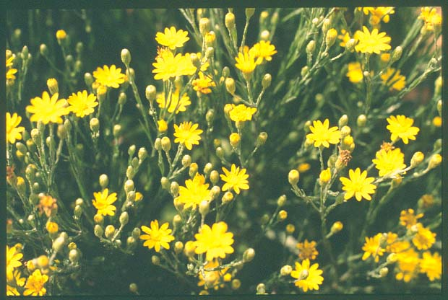 John Englert, USDA, NRCS National Plant Materials Center

Alternate Names

*Chrysopsis* *graminifolia* (Michx.) Ell.; *Heterotheca* *graminifolia* (Michx.) Shinners; grassleaf golden aster; silk-grass

Uses

Narrowleaf silkgrass has its greatest potential as a component of conservation mixes. It thrives in roadside or ornamental plantings in dry, sunny locations. It will quickly spread by underground stems (rhizomes) to form thick colonies. The plant will also perform well in ornamental perennial gardens, where it should be placed in front of taller wildflowers. It is a useful component for xeriscaping. It is grazed by livestock and wildlife, its rhizomatous growth habit is useful for controlling upland erosion

Status

Please consult the PLANTS Web site and your state department of natural resources for this plant’s current status (e.g. threatened or endangered species, state noxious status, and wetland indicator values).

Potential Weediness

Narrowleaf silkgrass spreads by seed and rhizomes. It can form large colonies on poor soils but does not displace other plants. Seed is carried by the wind up to several hundred yards. Seed establishment through stands of other vegetation is minimal. In a landscape or garden setting plants expand in size similar to other garden perennials.

Description and Adaptation

Narrowleaf silkgrass, *Pityopsis graminifolia*, is a native, warm-season, rhizomatous, perennial wildflower. It will grow to a height of 1 to 3 feet with equal or slightly greater spread. It has linear, grass-like leaves with parallel venation; lower leaves are up to 10 inches long by ¾ inch wide, becoming progressively smaller up the stems. Both the leaves and stems are covered with a whitish, silky hair that gives the plant a silvery appearance from a distance. Bright yellow composite flower heads occur in clusters at the end of branches from September through October in the Mid-Atlantic U.S. Seeds are 1/16 of an inch long and linear-shaped. Seeds turn from tan to dark brown at maturity and are easily pulled off the seed heads.

Narrowleaf silkgrass is found on sandy or shaley, dry soils from Delaware to Ohio and south to Texas and Florida (USDA hardiness zones 5 – 9). For a current distribution map, please consult the Plant Profile page for this species on the PLANTS Web site**,** [http://plants.usda.gov/](http://plants.usda.gov/%20%20)**.**

Establishment

Field Establishment from Seed

Narrowleaf silkgrass can be direct sowed by drilling seed at the rate of 2.5 lbs. (pure live de-bearded seed) per acre at a depth of a 1/4 inch or less. Seeding should occur in April/May for the Mid-Atlantic U.S. This planting date would need to be shifted to earlier dates in more southern sites (i.e. March/April in North Carolina, February/early March in Florida). It is very important to control broadleaf weeds before planting. Treat the field with glyphosate at least 10 days prior to control aggressive species such as tall fescue, clover or crown vetch which will out-compete narrowleaf silkgrass seedlings.

There are approximately 642,900 narrowleaf silkgrass seeds per pound.

Field Establishment from Plugs

In order to produce plugs, sow seed on germination mix. A pre-germination cold treatment is not necessary. Germination generally occurs 9 to 12 days after sowing. After four weeks, seedlings may be transplanted into larger plugs. Maintain seedlings under long-days (>14 hrs.) to prevent premature flowering in the spring. The best planting date for plugs is May for the Mid-Atlantic U.S., as narrowleaf silkgrass is a warm-season perennial. As with seed, planting dates this should be shifted to earlier dates for planting in more southern sites

**Management**

Weed Control

In conservation plantings due to the strong spreading nature of narrowleaf silkgrass, weed control typically is not a major concern. However in some situations weeds may be problematic, mowing and spot herbicide applications are the two best weed control options. Mowing at a height of 4’ – 6’ is an effective way to control taller growing weeds. Stop mowing when flower buds of silkgrass emerge in late summer (MD). Established stands are also tolerant of late winter/early spring burning. Be aware though that burning the foliage creates a thick smoke due to the resins in the leaves.

Pre-emergent herbicides Treflan™ (trifluralin) and Surflan™ (oryzalin) have been used successfully to prevent weed seed germination in established stands. Yellow nutsedge has also been controlled effectively by the selective post-emergent herbicide Manage™.

For seed production fields, a multivator type cultivator (spaced on 4’ rows) will reduce weed competition. Cultivate areas around the plants only during early stages of growth as you might damage rhizomes of older plants. Alternately, planting a cover crop of hard fescue or red fescue between rows when plugs are transplanted will limit weed competition.

Irrigation

Supplemental watering may be needed if droughty conditions arise after planting during the first season. An established stand can tolerate dry conditions and will not require irrigation.

Fertilization

Fertilization during the establishment is not recommended. Established stands can be fertilized according to soil test results. In nitrogen deficient soils 30 – 50 lbs. nitrogen/acre applied will help maintain stands.

Pests and Potential Problems

Seedlings are susceptible to damping-off (*Pythium*, *Fusarium*, and *Rhizoctonia*) due to fine hairs on the leaves. Alternaria leaf spot and *Phyllosticta* will affect silkgrass during cool wet spring weather. Treatment of Alternaria and Phyllosticta is usually not necessary as the plants will out-grow the damage. No other serious pests or diseases have been observed under cultivation.

Cultivars, Improved, and Selected Materials (and area of origin)

There are no recommended cultivars or selected materials at this time. Narrowleaf silkgrass is somewhat available from commercial sources.

Prepared By:

*Shawn Belt* , USDA NRCS National Plant Materials Center, Beltsville, Maryland

*Mary Anne Gonter*, USDA NRCS Brooksville Plant Materials Center, Brooksville, Florida

Species Coordinator:

*Shawn Belt* , USDA NRCS National Plant Materials Center, Beltsville, Maryland

Edited: 27Jan07; 070209 jsp

For more information about this and other plants, please contact your local NRCS field office or Conservation District, and visit the PLANTS Web site<<http://plants.usda.gov>> or the Plant Materials Program Web site <<http://Plant-Materials.nrcs.usda.gov>>

*The U.S. Department of Agriculture (USDA) prohibits discrimination in all its programs and activities on the basis of race, color, national origin, sex, religion, age, disability, political beliefs, sexual orientation, and marital or family status. (Not all prohibited bases apply to all programs.) Persons with disabilities who require alternative means for communication of program information (Braille, large print, audiotape, etc.) should contact USDA's* [*TARGET Center*](http://www.usda.gov/oo/target.htm) *at 202-720-2600 (voice and TDD).*

*To file a complaint of discrimination write USDA, Director, Office of Civil Rights, Room 326-W, Whitten Building, 14th and Independence Avenue, SW, Washington, DC 20250-9410 or call 202-720-5964 (voice or TDD). USDA is an equal opportunity provider and employer.*

*Read about* [*Civil Rights at the Natural Resources Conservation Service*](http://www.nrcs.usda.gov/about/civilrights/)*.*