# LONGLEAF PINE

## Pinus palustris Mill.

Plant Symbol = PIPA2

Contributed by: USDA NRCS Jimmy Carter Plant Materials Center

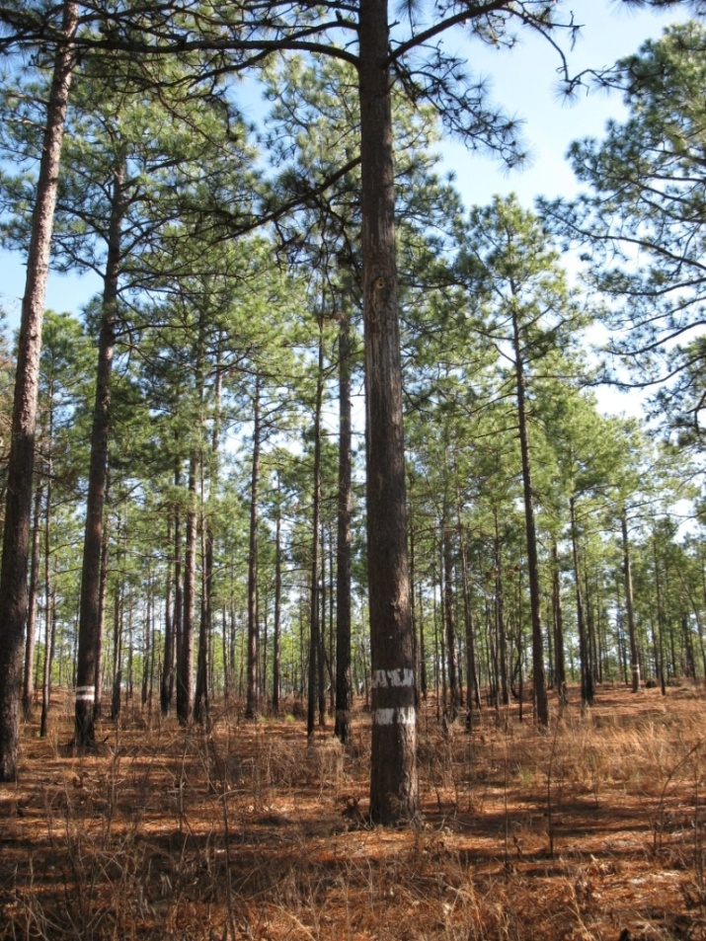

Tom Ward

USDA NRCS

East Technology Support Center

**Alternate Names**

Longstraw pine, southern yellow pine, Longleaf yellow pine, Georgia pine.

### Uses

*Erosion Control*: Longleaf pine is a highly recommended species for reforestation on many soil types in the southeastern U.S.

*Wildlife*: Birds and small mammals eat the large seeds, ants feed on germinating seeds, and feral hogs eat the roots of seedlings. When managed with the proper fire regime, the longleaf pine plant community provides excellent habitat for gopher tortoise, eastern diamond-backed rattlesnake, indigo snake, fox squirrel, southern flying squirrel, cotton-tailed rabbit, eastern woodrat, white-footed mouse ,cotton rat, cotton mouse, deer mouse, white-tailed deer, wild turkey, northern bobwhite quail, red-cockaded woodpecker, red-headed woodpecker, brown-headed nuthatch, eastern wood pewee, coopers hawk, prairie warbler, northern cardinal, indigo bunting, Bachman’s sparrow, chipping sparrow, pine warbler, and mourning dove.

*Wood and Tree Products*: Longleaf pine was a major source of naval stores, including resin, tar, pitch and turpentine. The yellow resinous wood is often clear, straight, and with few defects. It has been used for lumber, poles, wood pulp, and ship building. Longleaf pine straw is used for garden mulch and coiled basket making. Old stumps are used as kindling for fireplaces.

*Restoration and Recreation*: Restoration of longleaf pine ecosystems has received much public interest. This restoration effort includes re-establishing native understory grasses, legumes and composite plants. Restored longleaf pine sites provide recreational opportunities and habitat for many native plants and animals.

**Status**

Please consult the PLANTS Web site and your State Department of Natural Resources for this plant’s current status (e.g., threatened or endangered species, state noxious status, and wetland indicator values).

### Description and Adaptation

*Pinus palustris* Mill., longleaf pine, is found in the Atlantic and Gulf coastal plains from southeastern Virginia to central Florida and west to eastern Texas, and in the Piedmont region and Valley and Ridge province of Georgia and Alabama. Longleaf pine is a long-lived, native, evergreen conifer with orange-brown to gray scaly bark. Needles are in bundles of 3(occasionally 2); they are shiny, dark green, and 6 to 18inches long. Seed bearing cones are 6 to 10 inches long. Mature trees attain a height of 100 to 120 feet and 2½ feet in diameter. The seed are the largest of all southern pines with approximately 4,700 seed per pound. It has extensive lateral roots and an 8 to 12 foot taproot. Longleaf pine grows best in a warm, wet, temperate climate with an annual precipitation range of 43 to 69 inches. This species occurs in a wide variety of upland and flatwood sites. It is common on sandy, infertile, well-drained soils. It typically occurs below 660 feet elevation.

Longleaf pine is distributed throughout the Southeast. For a current distribution map, please consult the Plant Profile page for this species on the PLANTS Website.

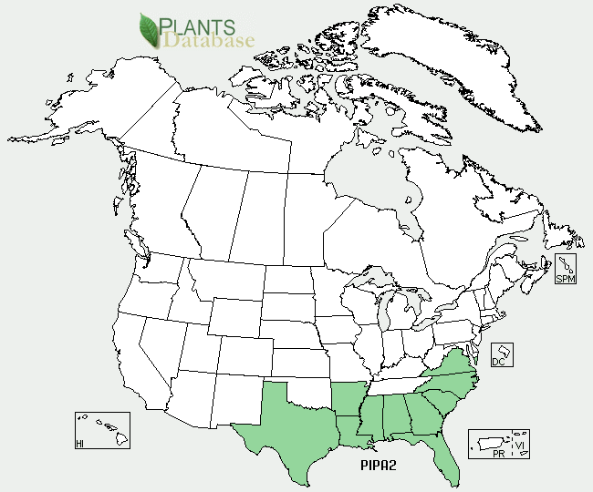

Longleaf pine distribution from USDA-NRCS PLANTS Database.

### Establishment

Longleaf pine stands may be successfully established by either seeding or planting containerized seedlings. Seed (including prechilled dormant seed) can be sown in the fall or spring. They should be pressed into the soil at densities from 15 to 75 seedlings per square foot. Seed require mineral soil to germinate. The seed’s large size and persistent wing prevent it from penetrating through the litter. Seedlings are stem less after one growing season and this lasts from two to many years, the stem less stage is called the grass stage. During the grass-stage, the seedling develops an extensive root system, and the root collar increases in diameter. When the root collar approaches 1 inch in diameter, height growth begins. Seedlings can be transplanted by hand or using tree planting equipment. A field-grown seedling grows 10 feet in 3 years when height growth is initiated. Branch production is delayed until the seedling reaches 10 to 16 feet in height. If grass-stage seedlings are top-killed, they can sprout from the root collar. Once height growth is initiated, sprouting ability decreases rapidly.

Vegetative propagation is typically done by grafting.

### Management

Longleaf pine is intolerant to both shade and competition. With frequent fire, trees of various ages form pure park-like savannahs. Because longleaf pine naturally regenerates in openings created by dead trees, small clusters of trees of the same age are dispersed throughout the stand. In the absence of frequent fire, the species is replaced by hardwoods and other southern pines. This hastens the decline of mature longleaf pine. Lightning ignited fires are pivotal to perpetuation of longleaf pine sites. When establishing longleaf pine seedlings reduction of competition by mechanical or chemical application is required. Heavy grazing can reduce tree density, significantly causing crop failure. The cattle lean on longleaf pine trunks or push them down to the ground.

### Pests and Potential Problems

The main disease of longleaf pine is brown-spot needle blight (*Scirrhia* *acicola*). Other diseases include pitch canker; annosus root rot, and cone rust. Insects that attack longleaf pine include black turpentine beetle, bark beetles, and seed bugs.

### Environmental Concerns

There are no known environmental concerns with longleaf pine.

### Cultivars, Improved, and Selected Materials (and area of origin)

No cultivars are currently recommended. Seeds and seedlings are commercially available from woody plant seed companies.

### Prepared By: Jimmy Carter Plant Materials Center

### Citation

Owsley, Mike, 2011. Plant fact sheet for longleaf pine. (*Pinus palustris* Mill.). USDA-Natural Resources Conservation Service, Jimmy Carter PMC Americus, Georgia 31719.

Published: January, 2011

Edited: 05Feb2002 jlk; 060802 jsp, 27Jan2011 cmo

For more information about this and other plants, please contact your local NRCS field office or Conservation District <<http://www.nrcs.usda.gov/>>, and visit the PLANTS Web site <[http://plants.usda.gov](http://plants.usda.gov/)> or the Plant Materials Program Web site <<http://plant-materials.nrcs.usda.gov>>