

Plant Fact Sheet

# shortspur seablush

## Plectritis congesta (Lindl.) DC.

Plant Symbol = PLCO4

*Contributed by: USDA NRCS Corvallis Plant Materials Center, Oregon*

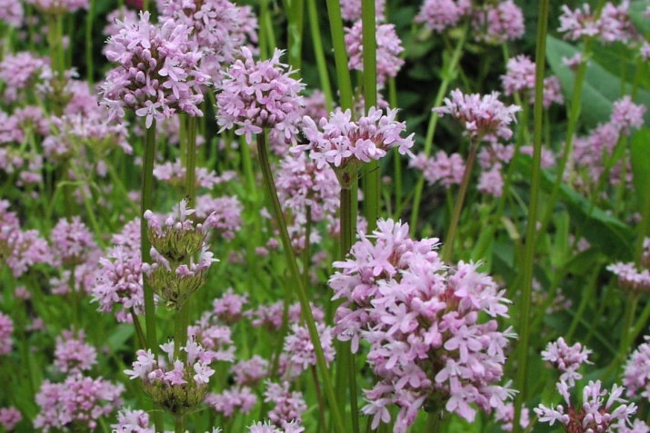

Photo by Amy Bartow, NRCS Plant Materials Center, 1999

### Alternative Names

*Alternate Common Names:* sea blush, rosy plectritis, pink plectritis, short-spurred plectritis, showy plectritis

*Alternate Scientific Names:* There are two subspecies of *P. congesta*, ssp. *congesta* and ssp. *brachystemon*. A synonym for *P. congesta* ssp*. congesta* is *Valerianella congesta* Lindl. Synonyms for *P. congesta* (Lindl.) A. DC. ssp. *brachystemon* (Fisch. & C. A. Mey.) Morey include *Plectritis congesta* (Lindl.) A. DC. ssp. *nitida* (A. Heller) Morey, *Plectritis brachystemon* Fisch. & C. A. Mey.*, Plectritis anomala* (A. Gray) Suksd., *Plectritis aphanoptera* (A. Gray) Suksd., *Plectritis anomala* var*. gibbosa* (Suksd.) Dyal*, Plectritis congesta* var*. major* (Fisch. & C. A. Mey.) Dyal, *Plectritis magna* (Greene) Suksd. var. *magna*, *Plectritis magna* var*. nitida* (A. Heller) Dyal., and *Plectritis samolifolia* (DC.) Hoeck.

### Uses

*Ornamental:* This annual wildflower makes a pretty addition to a wildflower meadow, stony bank, parking area or rock garden. Established populations will generally reseed themselves and plants are hardy in USDA Zones 6a to 9b.

*Pollinator Habitat*: Flowers provide a spring nectar source for bumble bees and other native bees, as well as butterflies including the endangered Fender’s blue (*Plebejus icarioides fenderi*) and the rare Taylor’s checkerspot (*Euphydryas editha taylori*).

*Restoration:* This plant may be used as part of a seed mix for meadow revegetation projects or wildlife enhancement and pollinator plantings throughout its native range.

### Status

This plant usually occurs in non-wetlands, but is occasionally found in wetlands. Please consult the PLANTS Web site and your State Department of Natural Resources for this plant’s current status (e.g., threatened or endangered species, state noxious status, and wetland indicator values).

### Description and Adaptation

Shortspur seablush is a native, annual wildflower that can paint entire hillsides pink in the spring. It is a member of the valerian family (Valerianaceae). The stems are usually unbranched, slender, upright, angled, and hairless, reaching 4 to 24 inches tall. The basal leaves are early deciduous, while the more persistent stem leaves are opposite, smooth-margined or slightly toothed, hairless, and 3/8 to 2½ inches long by 1/8 to 7/8 inch wide. Lower leaves have short stalks and are spatula to egg-shaped with the wider end near the tip, while upper leaves have no stalk, are oblong to elliptic in shape, and often clasping. The small, bright pink to white flowers grow in densely crowded, more or less headlike clusters at the stem tips. Individual flowers have five petals that are fused into a 2-lipped tube less than 3/8 inch long with a spur that often has a wider, rounded tip. Flowering period is from March to June. The fruits are achenes and are one-seeded, keeled, and sometimes winged.

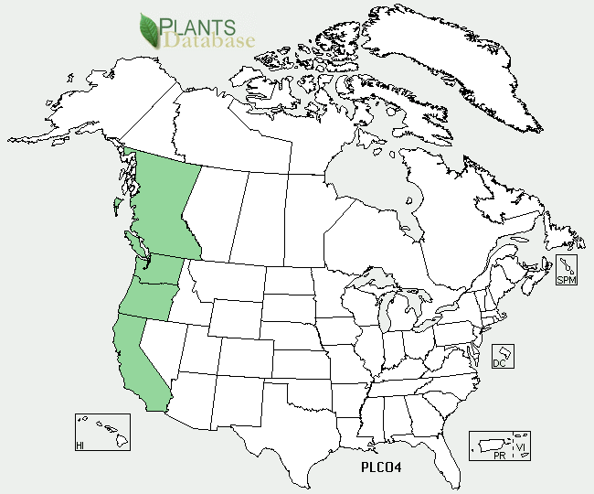

Shortspur seablush distribution from USDA-NRCS PLANTS Database.

This plant prefers open to partly shaded meadows and slopes that are moist in the spring, but also grows along coastal bluffs, rocky balds, and roadsides in spring-moist areas or seeps. This species is found mostly west of the Cascades from southwestern British Columbia through California at elevations below 6300 ft, and along the Columbia River Gorge at elevations of 100 to 2400 ft. For updated distribution, please consult the Plant Profile page for this species on the PLANTS Web site.

### Establishment

Establishment is easiest by directly seeding into the site in the fall or early spring. Seed lacks dormancy so does not require pre-treatment, and can be broadcast on the soil surface at a rate of 2 pounds per acre and pressed in with a roller or harrow. Best germination occurs at cool temperatures after fall rains begin, usually within one to two weeks. There are approximately 1.3 million seeds per pound, resulting in about 30 live seeds per square foot for each pound of pure live seed that is planted. Plants can also be started as plugs in a greenhouse set at moderate temperatures (70°F days/50°F nights). The plugs should be planted out in the early spring at a spacing of 3 to 9 inches.

### Management and Seed Production

This plant requires little management once established as long as it has sufficient sunlight and moist soil in the spring. Established populations will generally reseed themselves when open ground is available. For seed

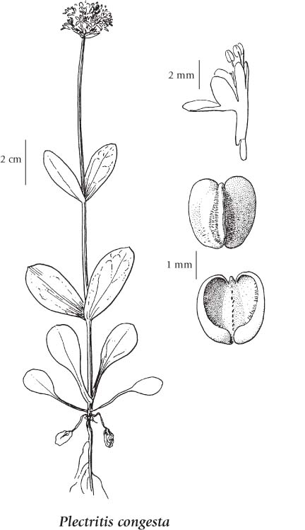

Reprinted with permission of University of Washington Press.

production, fields are generally direct sown in the fall. Larger fields can be swathed and the material collected to dry on tarps, while small fields are sown into weed fabric so the seed can be vacuumed off the fabric when it shatters.

### Pests and Potential Problems

There are no serious pests or disease problems associated with this plant under garden or wild conditions, but aphids can be problematic in greenhouse settings.

### Environmental Concerns

There are no known environmental concerns associated with shortspur seablush.

### Cultivars, Improved, and Selected Materials (and area of origin)

There are no improved materials, but seed of local ecotypes is sometimes available from commercial sources.

### Color photo close-up of shortspur seablush flowers.

Photo by Kathy Pendergrass, Oregon NRCS, 2007

### Prepared By

### *Annie Young-Mathews,* Conservation Agronomist

### USDA-NRCS Corvallis Plant Materials Center, Oregon

### Citation

Young-Mathews, A. 2012. Plant fact sheet for shortspur seablush (*Plectritis congesta)*. USDA-Natural Resources Conservation Service, Plant Materials Center, Corvallis, OR.

Published October 2012

Edited: 09Jan2012 klp; 12Jan2012 dcd; 17Apr2012 jab; 27Apr2012 dhg

For more information about this and other plants, please contact your local NRCS field office or Conservation District <<http://www.nrcs.usda.gov/>>, and visit the PLANTS Web site <[http://plants.usda.gov](http://plants.usda.gov/)> or the Plant Materials Program Web site <<http://plant-materials.nrcs.usda.gov>>

**USDA IS AN EQUAL OPPORTUNITY PROVIDER AND EMPLOYER**