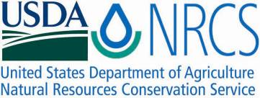

Plant Fact Sheet

# HOOKERS PLANTAIN

Plantago hookeriana

**Fisch. & C.A. Mey.**

Plant Symbol = PLHO

Contributed by: E. “Kika” de la Garza Plant Materials Center, Kingsville, Texas & South Texas Natives, Kingsville, Texas

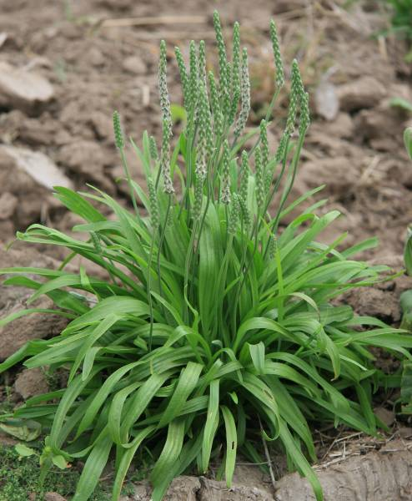

Forrest Smith, South Texas Natives

Alternate Names

Tallow weed, California plantain

Uses

*Wildlife*: Hookers plantain is a cool season forage recommended for cool season upland wildlife plantings and in range seeding mixes. Hookers plantain seed is consumed by game birds such as bobwhite quail and mourning doves, and the foliage is eaten by bobwhite quail, Rio Grande wild turkeys, white-tailed deer, and cattle.

*Erosion:* Hookers plantain also can be used in many types of conservation plantings, such as stream-side buffers and filter strips.

Status

Please consult the PLANTS Web site and your State Department of Natural Resources for this plant’s current status (e.g. threatened or endangered species, state noxious status, and wetland indicator values).

Description and Adaptation

Hookers plantain is a short-stemmed, cool season annual with a slender taproot. The leaves are linear to narrowly oblanceolate, with margins that are entire or with small scattered denticulations. The leaves are up to 3 dm. long and 2 cm. wide, but usually much smaller and are glabrous to lanate.

The scapes (inflorescences) are erect or ascending, and may be shorter than or exceed the leaves in height. The scapes are glabrate to pubescent with spikes to 12 cm. long and 8 mm. thick, rarely reduced to only 2 flowers. The bracts are broad at the base. The corolla lobes are up to 4 mm. long and whitish with a brown spot at base of each or brown stripes the entire length of each. Each flower produces two seeds, dull-brown, finely pitted, and about 3 mm. long and 1.3 mm wide. STN-561 Germplasm contains 197,816 seeds per pound.

*Distribution*: Please consult the Plant Profile page for this species on the PLANTS Web site.

Establishment

Plantains are established from seed. Seeds should be sown directly into the seedbed. Germination tests conducted by the South Texas Natives Project (2006) found germination rates ranging from a low of 28% to a high of 94% and rapid initiation of germination following the onset of favorable conditions (germination < 36 hours). Seed dormancy can be as high as 90% but appears to be easily broken by field conditions. Plantains typically take 180 days from planting to seed maturity.

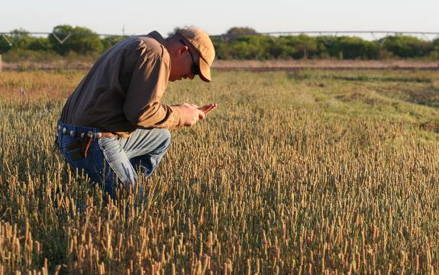Forrest Smith, South Texas Natives

For direct seeding, broadcast or drill seed during September through December into a clean, weed free seedbed. Seeds should be covered from ¼ to ½” depth to ensure good soil to seed contact. The full seeding rate for Hookers plantain is 10 PLS pounds per acre for a pure stand. When planting this as a component of a seed mixture, the seeding rate should be adjusted to the desired percent of the mix.

Forrest Smith, South Texas Natives

Management

Hookers plantain requires little management. Seed production plots will require occasional weeding. It can survive in both droughty and moist conditions. For seed production purposes, occasional irrigation during extremely droughty periods may help seed fertility.

Hookers plantain can be harvested with a combine. When harvesting Hookers plantain, run the combine’s cylinder speed at 1100 RPM, the concave at 6 mm, the sieve open 3/8", and the fan at 600 rpm. To clean the seed, it should first be run through a Westrup brush machine and can then be cleaned further using a clipper style seed cleaner. It is recommended that after cleaning, the seed should be stored at 45oF and less than 50% humidity.

Seed increase plots in 2007 at TAES Beeville yielded seed with 93 % viability, 90 % seed dormancy, and 79 % pure live seed. Seed yield was estimated at 288 pounds of bulk seed per acre. Seed harvested from seed increase plots of STN-561 Germplasm at Kingsville in June 2008 had 92% viability, 0% dormancy, 94% active germination, and 93.49% pure live seed. Seed yield from Kingsville plantings was 322 lbs. pure live seed per acre.

Pests and Potential Problems

Thrips have been observed in the seed heads, however they are fairly easy to control with organophosphate (e.g..Malathion) and carbamate (e.g. Sevin) insecticides. Please contact your local agricultural extension specialist or county pest specialist to learn what works best in your area and how to use it safely. Always read label and safety instructions for each control method. Trade names and control measures appear in this document only to provide specific information. USDA NRCS does not guarantee or warranty the products and control methods named, and other products may be equally effective.

Cultivars, Improved, and Selected Materials

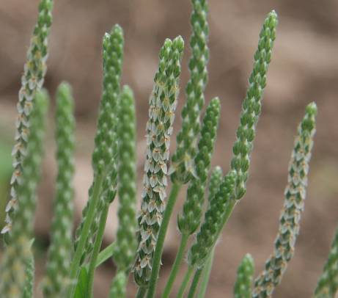STN-561 Germplasm Hookers plantain is a selected class release developed from seed originating from Median County, Texas. It was released cooperatively between the South Texas Natives Project, Texas AgriLife Research-Beeville, and the E. Kika de la Garza Plant Materials Center in 2009. STN-561 Germplasm will be marketed as part of a blend of 2 accessions of *Plantago* called Divot Tallow Weed Blend. STN-561 Germplasm superior vigor, seed production, and characteristics making mechanical harvest possible. STN-561 Germplasm was selected because of excellent seed establishment characteristics, suitability for mechanical harvest and agronomic production, and high seed yields in comparison to other South Texas collected accessions. It is intended to provide food for wildlife. Certified seed is available and Breeder Seed will be maintained by South Texas Natives, Kingsville, Texas.

Prepared By and Species Coordinator:

John Lloyd-Reilley & Shelly D. Maher, USDA NRCS, E. “Kika” de la Garza Plant Materials Center, Kingsville, Texas

Forrest S. Smith, South Texas Natives, Caesar Kleberg Wildlife Research Institute,

Texas A&M University-Kingsville, Kingsville, Texas

Published: October, 2009

Edited: [e.g., 08Sep2009 rg, 08Sep2009 jfh; 17Sep2009 jfe]

For more information about this and other plants, please contact your local NRCS field office or Conservation District <<http://www.nrcs.usda.gov/>>, and visit the PLANTS Web site <[http://plants.usda.gov](http://plants.usda.gov/)> or the Plant Materials Program Web site <<http://plant-materials.nrcs.usda.gov>>

**USDA IS AN EQUAL OPPORTUNITY PROVIDER AND EMPLOYER**