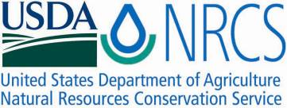

Plant Fact Sheet

# REDSEED PLANTAIN

Plantago rhodosperma

## Decne.

Plant Symbol =PLRH

Contributed by: E. “Kika” de la Garza Plant Materials Center, Kingsville, Texas & South Texas Natives, Kingsville, Texas

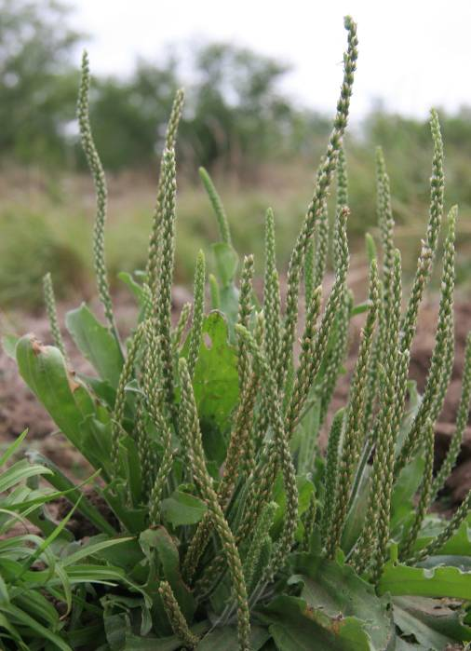

Forrest Smith, South Texas Natives

Alternate Names

Tallow weed, Redseed Indianwheat

Uses

*Wildlife*: Redseed plantain is a cool season forage recommended for upland wildlife plantings and in range seeding mixes. The seed is known to be consumed by game birds such as bobwhite quail and mourning doves, and the foliage is eaten by bobwhite quail, Rio Grande wild turkeys, white-tailed deer, and cattle. Redseed plantain has been shown to be an important component in the diets of both scaled and bobwhite quail in southwest Texas.

*Erosion:* Redseed plantain also can be used in many types of conservation plantings, such as stream-side buffers and filter strips.

Status

Please consult the PLANTS Web site and your State Department of Natural Resources for this plant’s current status (e.g. threatened or endangered species, state noxious status, and wetland indicator values).

Description and Adaptation

Redseed plantain is a cool season, annual with a slender taproot. Leaves are oblanceolate to 35 cm. long and 5 cm. wide, but usually much smaller. The leaves are grayish-green in color, pubescent, with margins that are entire to coarsely pectinate or salient-dentate.

The scapes (inflorescences) are one to several, hirsute, and shorter than to exceeding the leaves in height. The spikes are up to 2 dm. long and 1 cm. thick. Each flower produces two seeds that are bright red to reddish black in color. The seeds are 2-3 mm. long, more than half as wide, nearly flat on both sides, and have a thin pale margin. STN-496 Germplasm contains 322,000 seeds per pound.

Distribution:

### Please consult the Plant Profile page for this species on the PLANTS Web site.

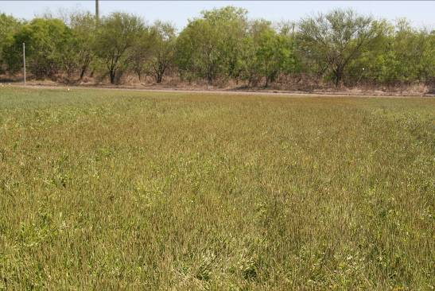

Forrest Smith, South Texas Natives

Establishment

Plantains are established from seed. Germination tests conducted by the South Texas Natives Project (2006) found germination rates ranging from a low of 40% to a high of 80% and rapid initiation of germination following the onset of favorable conditions (germination < 36 hours). Plantains typically take 180 days from planting to seed maturity.

### For direct seeding, broadcast or drill seed during September through December into a clean, weed free seedbed. Seeds should be covered from ¼ to ½” depth to ensure good soil to seed contact. The full seeding rate for redseed plantain is 10 PLS pounds per acre for a pure stand. When planting this as a component of a seed mixture, the seeding rate should be adjusted to the desired percent of the mix.

### Close up view of redseed plantain flowers.

Forrest Smith, South Texas Natives

Management

Redseed plantain requires little management. Seed production plots will require occasional weeding. It can survive in both droughty and moist conditions. For seed production purposes, occasional irrigation during extremely droughty periods may help seed fertility.

Redseed plantain can be harvested with a combine. When harvesting redseed plantain, run the combine’s cylinder speed at 1100 RPM, the concave at 6 mm, the sieve open 3/8", and the fan at 600 rpm. To clean the seed, it should first be run through a Westrup brush machine and can then be cleaned further using a clipper style seed cleaner. It is recommended that after cleaning, the seed should be stored at 45oF and less than 50% humidity.

Seed harvested from seed increase plots of STN-496 Germplasm at Kingsville in June 2008 had 88% viability, 12% dormancy, 79% active germination, and 87.43% pure live seed. Seed yield from Kingsville plantings was 400 lbs. pure live seed per acre. Seed harvested from Beeville plots in May 2007 had 98% viability, 45% dormancy, 53% active germination, and 89% pure live seed. Seed yield in Beeville was 387 lbs. pure live seed per acre.

Pests and Potential Problems

Thrips have been observed in the seed heads, however they are fairly easy to control with organophosphate (e.g.Malathion) and carbamate (e.g. Sevin) insecticides. Please contact your local agricultural extension specialist or county pest specialist to learn what works best in your area and how to use it safely. Always read label and safety instructions for each control method. Trade names and control measures appear in this document only to provide specific information. USDA NRCS does not guarantee or warranty the products and control methods named, and other products may be equally effective.

Cultivars, Improved, and Selected Materials

STN-496 Germplasm is a selected class release developed from seed originating from Bexar County, Texas. It was released cooperatively between the South Texas Natives Project, Texas AgriLife Research-Beeville, and the E. Kika de la Garza Plant Materials Center in 2009. STN-496 Germplasm will be marketed as part of a blend of 2 accessions of *Plantago* called Divot Tallow Weed Blend. STN-496 Germplasm was selected for excellent observed forage characteristics, ease of mechanical harvest and agronomic production, good active seed germination to dormancy ratio, and extremely high seed yields in comparison to other South Texas collected accessions. It is intended to provide food for wildlife. Certified seed is available and Breeder Seed will be maintained by South Texas Natives, Kingsville, Texas.

Prepared By and Species Coordinator:

John Lloyd-Reilley & Shelly D. Maher, USDA NRCS, E. “Kika” de la Garza Plant Materials Center, Kingsville, Texas

Forrest S. Smith, South Texas Natives, Caesar Kleberg Wildlife Research Institute,

Texas A&M University-Kingsville, Kingsville, Texas

Published: November, 2009

Edited:

For more information about this and other plants, please contact your local NRCS field office or Conservation District <<http://www.nrcs.usda.gov/>>, and visit the PLANTS Web site <[http://plants.usda.gov](http://plants.usda.gov/)> or the Plant Materials Program Web site <<http://plant-materials.nrcs.usda.gov>>

**USDA IS AN EQUAL OPPORTUNITY PROVIDER AND EMPLOYER**