|  |
| --- |
| PANAX |
| *Polyscias guilfoylei* (Bull ex Cogn. & E. March.) Bailey |
| Plant Symbol = POGU |

*Contributed by: USDA NRCS Hawaii Plant Materials Center*

[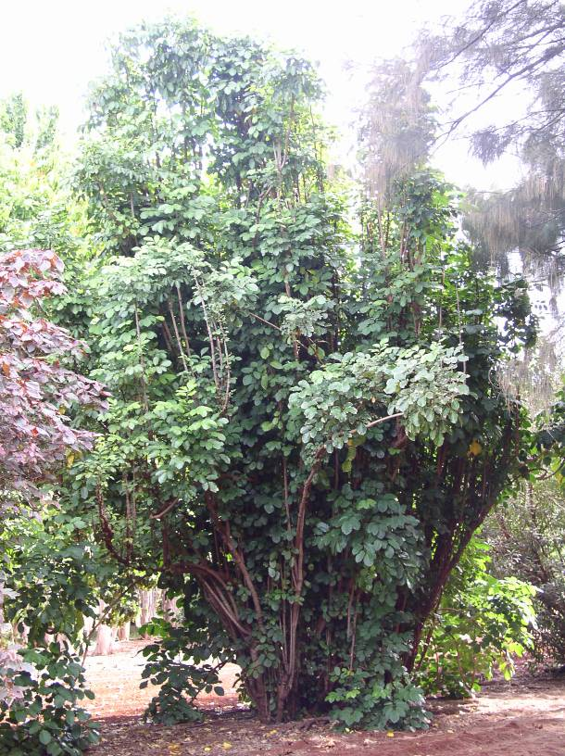](http://www.hear.org/starr/hiplants/images/hires/html/starr_061128_1600_sporobolus_virginicus.htm)Panax: height - 28 feet

David Duvauchelle, USDA NRCS Hawaii PMC

Alternate Names

Afia, bebero, berobero, coffeetree, geranium aralia, geranium-leaf aralia, Guilfoylei panax, hedge panax, kaope pa, kapaie, ndanindani, tagitagi, tanetane, tanitani, te kaimamara, te toara, ut, wild coffee, wild coffee panax.

Uses

Primarily, panax can be used for in-field windbreaks systems and as main windbreak systems. Alternatively, it can also be usde as a screen for noise, odor, or privacy. Panax is widely planted for ornamental purposes.

Status

Please consult the PLANTS Web site and your State Department of Natural Resources for this plant’s current status (e.g. threatened or endangered species, state noxious status, and wetland indicator values).

Weediness

This plant may become weedy or invasive in some regions or habitats and may displace desirable vegetation if not properly managed. Please consult with your local NRCS Field Office, Cooperative Extension Service office, or state natural resource or agriculture department regarding its status and use. Weed information is also available from the PLANTS Web site at plants.usda.gov.

Description

Aralia Family (Araliaceae). *Polyscias guilfoylei* is a columnar shrub with erect branches up to 24ft tall; leaves mostly 5.9-19.7” long, 1-pinnate, leaflets opposite, blades variable, but commonly broadly ovate or elliptic and coarsely dentate or lacerate, commonly variegated with white or pale yellow margins, or sometimes all dark green; leaflets mostly 1.9-3.9” long; inflorescence a compound panicle.

Adaptation and Distribution

The origin of panax is unknown, but it is widely cultivated in the paleotropics and in some parts of the neotropics.

Establishment

Panax can be easily propagated by cuttings. Cuttings should be 1 inch in diameter and at least 18” long ensure a successful planting. Panax can be started in the shade-house, but it also does very well by direct planting. If planting for a windbreak, plant at least 2 feet spacing for single rows.

Management

Panax is not drought tolerant and requires a moderate amount of moisture. A windbreak row that is irrigated by drip-line for 8 hours a day, once a week should be sufficient, with more frequent irrigations when first planted to aid in root development. Panax will grow in nutrient deficient soils, but any nutrient amendments made, according to soil tests, will improve establishment and subsequent growth. Preliminary studies at the Hoolehua Plant Materials Center indicate that nitrogen supplements will increase the growth-rate of panax significantly.

Infrequent trimming of side branches that have a slight tendency to lean over is all that is needed to control the upright form of a panax windbreak.

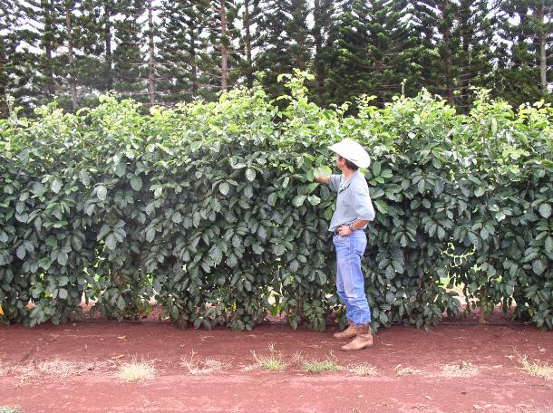

Panax, 1 year after planting

David Duvauchelle, USDA NRCS Hawaii PMC

Pests and Potential Problems

Locusts like to eat the new shoots; ants favor panax to farm aphids, but not to the point of harming plant growth. Other observations indicate that panax is prone to root rot if over-watered

Environmental Concerns

PIER (Pacific Island Ecosystems at Risk) rates panax as a low risk introduced species.

Cultivars, Improved, and Selected Materials (and area of origin)

Many ornamental varieties available commercially.

Control

Please contact your local agricultural extension specialist or county weed specialist to learn what works best in your area and how to use it safely. Always read label and safety instructions for each control method. Trade names and control measures appear in this document only to provide specific information. USDA, NRCS does not guarantee or warranty the products and control methods named, and other products may be equally effective.

Prepared By:

David Duvauchelle, USDA NRCS Hawaii Plant Materials Center, Hoolehua, Hawaii

Edited: 070810 jsp

For more information about this and other plants, please contact your local NRCS field office or Conservation District, and visit the PLANTS Web site<<http://plants.usda.gov>> or the Plant Materials Program Web site <<http://Plant-Materials.nrcs.usda.gov>>

*The U.S. Department of Agriculture (USDA) prohibits discrimination in all its programs and activities on the basis of race, color, national origin, sex, religion, age, disability, political beliefs, sexual orientation, and marital or family status. (Not all prohibited bases apply to all programs.) Persons with disabilities who require alternative means for communication of program information (Braille, large print, audiotape, etc.) should contact USDA's* [*TARGET Center*](http://www.usda.gov/oo/target.htm) *at 202-720-2600 (voice and TDD).*

*To file a complaint of discrimination write USDA, Director, Office of Civil Rights, Room 326-W, Whitten Building, 14th and Independence Avenue, SW, Washington, DC 20250-9410 or call 202-720-5964 (voice or TDD). USDA is an equal opportunity provider and employer.*

Read about [*Civil Rights at the Natural Resources Conservation Service*](http://www.nrcs.usda.gov/about/civilrights/).