

Plant Fact Sheet

# beach plum

*Prunus maritima* Marsh.

Plant Symbol = PRMA2

Contributed by: USDA NRCS Cape May Plant Materials Program

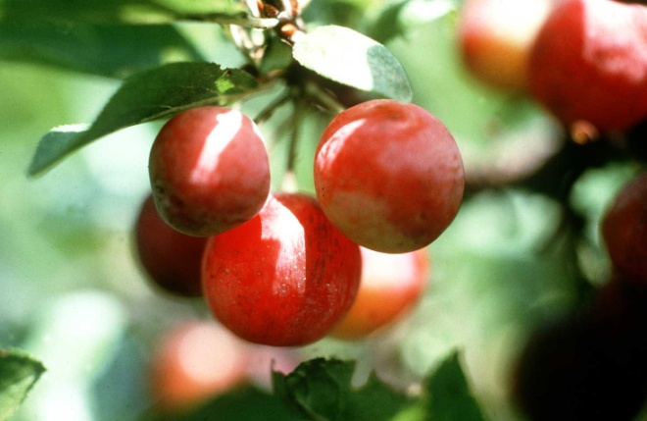

C. MIller

USDA NRCS

Uses

Beach plum is most useful in the secondary stabilization and restoration of coastal sand dunes. On Cape Cod, MA, efforts are being made to develop and promote the commercial fruit production of this native plum. This native shrub is utilized by coastal wildlife.

Status

Please consult the PLANTS Web site and your State Department of Natural Resources for this plant’s current status (e.g. threatened or endangered species, state noxious status, and wetland indicator values).

Description

On sand dunes beach plum will reach heights of 4 to 7 feet; but if this species is moved inland, and it can attain heights of 16 to 18 feet. When maximum heights have been reached, stem diameter will range from 4 to 8 inches at the root collar. The root system penetrates deep into the soil, and as lower branches are covered by shifting sands, adventitious roots develop. Colonies formed from this layering effect can expand up to 20 feet.

The egg shaped leaves of beach plum are firm, alternate, and dull green; they are rough and ridged above, paler and finely hairy beneath. The leaves are half as wide as they are long, measuring 1½ to 2½ inches long; each leaf is attached to the branches with a stout, hairy, often granular stalk. The leaf edges are finely serrated, with broadly triangular to semi-circular shaped, abruptly pointed teeth.

In April to early May, flowers emerge before the leaves. Each snowy white flower measures ¼ to ½ inch across, with very hairy stalks and sepals. Flowers develop in axillary clusters of two or three. After pollination occurs by bees or wind the flowers become pinkish in color. The edible fruit that develops is round and ½ to ¾ inches in diameter. The color may vary from a purplish-black to red; there are some plants that produce yellow fruit. The fleshy fruit’s surface is covered with a tough skin which has a heavy, white waxy residue. Each fruit contains a single stone type seed which is egg shaped, swollen, and squared-off at the base.

Adaptation and Distribution

Although indigenous to the mid-Atlantic coastal region, beach plum has been planted successfully on more inland sites. It is well adapted to droughty sites with moderately fertile, slightly acidic, loamy and sandy soils. Beach plum does not perform well on heavy clay soils, but will tolerate moderately well drained conditions.

Beach plum is distributed throughout the Northeast. For a current distribution map, please consult the Plant Profile page for this species on the PLANTS Web site.

Establishment

Quality seedlings are easily produced in nurseries on raised beds. Fall sowing works best to utilize natural stratification forces to break seed dormancy. If spring sowing is selected, the seed must be exposed to a cool moist stratification for at least 30 days, prior to planting. Due to the expansive root system which rapidly develops, seedlings are distributed as 1 year old bare-root or containerized stock. Controlling competing weeds through the establishment period is critical to good survival and performance of the seedlings. Mulching, hand cultivating, and no fertilization for the first year or two are the most effective means of avoiding weedy growth. Application of fertilizer can initiate excessive growth of competing grasses. Once this shrub is established it requires little or no maintenance.

Management

Chemical control of mildew and aphids is sometimes necessary with beach plum, if an infestation becomes excessive.

Cultivars, Improved, and Selected Materials (and area of origin)

There is one variety available on the commercial nursery market for conservation uses named ‘Ocean View’ (composite from plants in DE, NJ, MA). This cultivar was developed and released in 1992 by the Cape May Plant Materials Center, in Cape May Court House, NJ. Foundation seed and orchard stock can be acquired from the PMC by commercial producers. Common stock material of locally collected sources can be purchased from nurseries.

Prepared By:

USDA NRCS Northeast Plant Materials Program

Species Coordinator:

*Christopher Miller*, PMS-Southern NE/Mid-Atlantic

USDA NRCS, Somerset, New Jersey

Published March, 2002

Edited: 05Feb2002 JLK; 060809 jsp

For more information about this and other plants, please contact your local NRCS field office or Conservation District <<http://www.nrcs.usda.gov/>>, and visit the PLANTS Web site <[http://plants.usda.gov](http://plants.usda.gov/)> or the Plant Materials Program Web site <<http://plant-materials.nrcs.usda.gov>>

**USDA IS AN EQUAL OPPORTUNITY PROVIDER AND EMPLOYER**