|  |
| --- |
| western chokecherry |
| *Prunus virginiana* L. var. *demissa* (Nutt.) Torr. |
| Plant Symbol = PRVID |

Contributed by: USDA NRCS Plant Materials Program

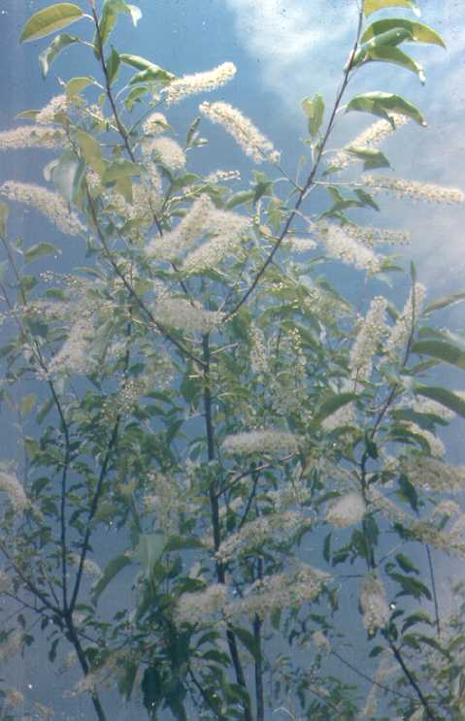

USDA NRCS National Plant Materials Center

Beltsville, MD

Alternate Names

*Prunus demissa* (Nutt.) Walp, *Prunus virginiana* L. ssp. *demissa* (Nutt.) Taylor & MacBryde

Uses

*Ornamental*: This plant is well adapted for use around homes, office buildings, and recreational areas. The form and dark green shiny foliage during spring and summer; the large number of showy flowers in the spring and the dark purple, grape-like clusters of fruit in the fall makes this a desirable species for beautification.

*Crops*: While not currently planted for this purpose, the fruit has a sweetish, astringent taste and is fit for human consumption. The fruit makes excellent jellies and jams and is occasionally used for wine.

*Erosion control*: It is a good erosion control plant because it can form thickets and spread by rhizomes.

*Livestock*: It is poor to fair forage for cattle, sheep, and goats and useless for horses; however, the foliage is consumed when the range is over utilized or in livestock concentration areas such as near water, along driveways, and near bedding grounds. One fourth of a pound of foliage is fatal to sheep and 1½ pounds will kill a 500 pound cow. This must be eaten at a single feeding and is usually lethal if very little other forage is consumed. The poisoning agent is hydrocyanic (prussic) acid. Cattle will usually not eat much chokecherry when a good supply of other forage species are available.

*Recreation*: This plant makes good screening in campgrounds and picnic areas.

*Wildlife*: Western chokecherry is excellent to good forage for deer and elk. The fruit is relished by bear, many species of songbirds, pheasants, and grouse.

Status

Please consult the PLANTS Web site and your State Department of Natural Resources for this plant’s current status (e.g. threatened or endangered species, state noxious status, and wetland indicator values).

Description

*Prunus virginiana* var*. demissa* (Nutt.) Torr., western chokecherry, is also called bitter cherry and black chokecherry. It is a shrub or small tree from 3 to 20 feet tall and occasionally as tall as 30 feet in favorable sites. The bark is smooth to scaly and dull red to gray. Leaves are ovate to broadly elliptical, rounded at the base or slightly heart shaped, 1½ to 3½ inches long, 1 to 2 inches wide, smooth or only slightly hairy, with finely toothed margins. Flowers are white, showy, and clustered in 2 to 5 inch long racemes at the ends of leafy shoots. Western chokecherry blooms from April to May. The fruit is round, ¼ to ½ inch in diameter, dark purple when ripe, and matures from September to October.

Adaptation and Distribution

It is found mostly at elevations of 6,000 to 10,000 feet in snow drift areas and near springs or seeps or in stream bottoms where the average annual precipitation varies from 14 to 40 inches and the winters are cold. Soil texture varies from clays to sandy loams but this species prefers deep, fertile loam soils. It is frequently found on shallow soils or deep to moderately deep soils with more than 35 percent coarse fragments throughout the soil profile. It can be found as a small shrub on rocky talus slopes, shallow shale, and on very shallow rocky sites.

Western choke cherry is distributed throughout the western and southwestern United States. For a current distribution map, please consult the Plant Profile page for this species on the PLANTS Web site.

Establishment

Sow seeds during the fall (or the spring with stratified seed) in drill rows 8 to 12 inches apart. Cover or drill ½ inch deep. Sow 25 seeds per foot of drill row. Field plant with 1 year old bareroot stock on deep, well-drained soils in sunny locations. Moist exposed mineral soil makes the best seedbed. Dormancy may be overcome by stratification of seed in moist sand or peat at low temperature for 90 to 160 days.

Management

This species is better if not pruned or thinned. Irrigation will be needed on areas that receive less than 14 inches of precipitation annually. This species will withstand grazing and remains vigorous when 50 percentof the total annual growth is grazed. Care must be taken to prevent cattle from feeding on this plant once it has undergone stress due to drought or frost because of the toxic accumulation of hydrocyanic acid in the plant.

Pests and Potential Problems

There are no serious insect pests, however western chokecherry is susceptible to black knot fungus, fireblight, and several other diseases.

Cultivars, Improved, and Selected Materials (and area of origin)

No cultivars are currently recommended. Planting materials can be obtained from most commercial hardwood nurseries and seed sources in the west.

Prepared By & Species Coordinator:

USDA NRCS Plant Materials Program

Edited: 05Feb2002 JLK; 060809 jsp

For more information about this and other plants, please contact your local NRCS field office or Conservation District, and visit the PLANTS Web site<<http://plants.usda.gov>> or the Plant Materials Program Web site <<http://Plant-Materials.nrcs.usda.gov>>

*The U.S. Department of Agriculture (USDA) prohibits discrimination in all its programs and activities on the basis of race, color, national origin, sex, religion, age, disability, political beliefs, sexual orientation, and marital or family status. (Not all prohibited bases apply to all programs.) Persons with disabilities who require alternative means for communication of program information (Braille, large print, audiotape, etc.) should contact USDA's* [*TARGET Center*](http://www.usda.gov/oo/target.htm) *at 202-720-2600 (voice and TDD).*

*To file a complaint of discrimination write USDA, Director, Office of Civil Rights, Room 326-W, Whitten Building, 14th and Independence Avenue, SW, Washington, DC 20250-9410 or call 202-720-5964 (voice or TDD). USDA is an equal opportunity provider and employer.*

*Read about* [*Civil Rights at the Natural Resources Convervation Service*](http://www.nrcs.usda.gov/about/civilrights/)*.*