|  |
| --- |
| ANTELOPE BITTERBRUSH |
| *Purshia tridentate (Pursh)* DC*.* |
| Plant Symbol = PUTR2 |

Contributed by: Upper Colorado Environmental Plant Center

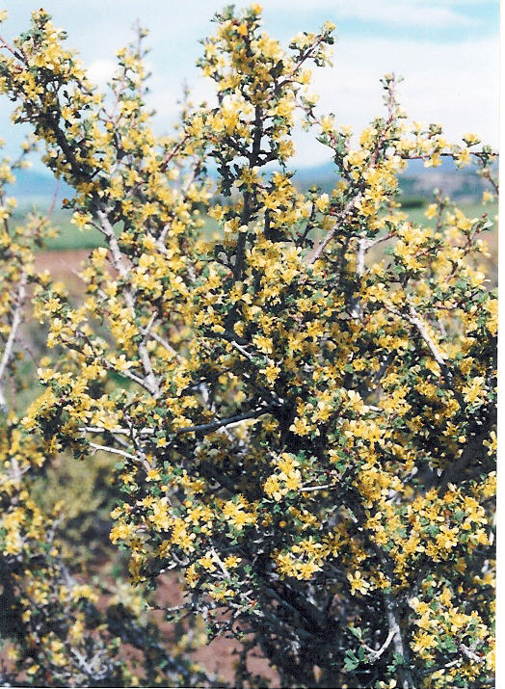

Steve Parr, UCEPC, Meeker, Colorado

Alternate Names

Antelopebrush, buckbrush, quininebrush

Uses

Antelopebitterbrush is a very palatable, high quality shrub for big game and livestock. It also provides cover for small animals and birds. It is considered a medium quality cover for sage-grouse. Bitterbrush seed is an important source of food for small animals. The shrub is also used for reclamation of mined areas where adapted. It has the potential for use as a living snow fence, roadside beautification, and xeriscape plantings.

**Status**

Please consult the PLANTS Web site and your state Department of Natural Resources for this plant’s current status (e.g. threatened or endangered species, state noxious status, and wetland indicator values).

**Description and Adaptation**

Antelope bitterbrush is an important native browse shrub in the intermountain Western United States. It is adapted to a wide range of soils with 8 to 34 inches of annual precipitation and occurs at elevations of 4000 to 8500 feet, but has been noted at 11,000 feet in California. The shrub is slow growing with a moderate to very deep root system and wide ecotypic variations. It is normally 2 to 6 feet in height and up to 8 feet in width with wedge shaped, three lobed leaves (some are persistent in winter). Branches near the soil may layer (branches that touch the soil develop roots) providing additional rooting for the plant. Flowering occurs in late spring to early summer with yellow to white blossoms.

Establishment

Natural establishment of antelope bitterbrush occurs in years with good seed production when rodents cache seed and do not use all of the caches. Moisture is necessary the first few years of seedling growth for establishment. Late fall or winter seeding is recommended and competition can be a problem for establishment. Plants should not be used for the first four years and seedlings should be protected until they are 8 to 10 inches tall. Rodents normally cache seeds within 50 to 75 feet of an existing seed source. Suitable environmental conditions may allow natural revegetation in only one out of 20 years. Antelope bitterbrush can also be established with tubling plants. These should be planted in the spring or early summer.

Management

Since antelope bitterbrush is a very palatable shrub for big game and livestock, its use should be controlled or it can be easily eliminated by over use. The shrub is most often used by big game in the fall, winter, or early spring when other plants are still covered by snow. Stands of bitterbrush can become decadent with no use and mature plants should be browsed for good forage production and vigor. However, no more than 50 to 60 percent of current annual growth should be removed. The literature indicates that bitterbrush is not a fire resistant shrub, but is fire dependent and light to moderate fires may enhance stands.

Pests and Potential Problems

Many species of insects and mites inhabit antelope bitterbrush, several of these are beneficial. It should be noted that bitterbrush is insect pollinated. Insects that cause problems include defoliators such as mountain mahogany loper and Western tussock moth. Some of the noted seed insects are bitterbrush seed midge, Say’s stinkbug, dark bitterbrush leaf tier, white collared leaf tier, and flower thrips. Large numbers of seedlings and small plants have been destroyed by cutworms and false wireworms. Diseases associated with bitterbrush include root rot, root and stem wilt, and root-stem canker. Seedlings have been damaged by damping off (a disease caused by fungi).

Environmental Concerns

There are no known environmental concerns associated with antelope bitterbrush.

Cultivars, Improved, and Selected Materials (and area of origin)

‘Lassen’ is a cultivar of antelope bitterbrush released in 1984 by USDA Forest Service, Shrub Sciences Laboratory, Provo, Utah, Soil Conservation Service and Utah Division of Wildlife Resources, Ephraim, Utah. Seven other agencies in California, Idaho, Nevada, and Oregon cooperated. Its origin is near Janesville in Lassen County, California.

Fountain Green germplasm is a source identified release of antelope bitterbrush. It was released in 1990 by the USDA Forest Service, Shrub Sciences Laboratory, Provo, Utah, and the Utah Division of Wildlife Resources, Ephraim, Utah. Its origin is North of Fountain Green, Utah.

Maybell germplasm was released in 1997 as a selected class release by Upper Colorado Environmental Plant Center. Five other agencies participated in the release. Maybell’s origin is Moffat County in Northwest Colorado, near the town of Maybell.

Prepared By and Species Coordinator

*Gary L. Noller, Ph.D.*, Plant Materials Consultant

Upper Colorado Environmental Plant Center

Meeker, Colorado

Edited: 070814 jsp

For more information about this and other plants, please contact your local NRCS field office or Conservation District, and visit the PLANTS Web site<<http://plants.usda.gov>> or the Plant Materials Program Web site <<http://Plant-Materials.nrcs.usda.gov>>

*The U.S. Department of Agriculture (USDA) prohibits discrimination in all its programs and activities on the basis of race, color, national origin, age, disability, and where applicable, sex, marital status, familial status, parental status, religion, sexual orientation, genetic information, political beliefs, reprisal, or because all or a part of an individual's income is derived from any public assistance program. (Not all prohibited bases apply to all programs.) Persons with disabilities who require alternative means for communication of program information (Braille, large print, audiotape, etc.) should contact USDA's TARGET Center at (202) 720-2600 (voice and TDD). To file a complaint of discrimination write to USDA, Director, Office of Civil Rights, 1400 Independence Avenue, S.W., Washington, D.C. 20250-9410 or call (800) 795-3272 (voice) or (202) 720-6382 (TDD). USDA is an equal opportunity provider and employer."*

*Read about* [*Civil Rights at the Natural Resources Conservation Service*](http://www.nrcs.usda.gov/about/civilrights/)*.*