

Plant Fact Sheet

# BUR OAK

*Quercus macrocarpa* Michx.

Plant Symbol = QUMA2

Contributed by: USDA NRCS Plant Materials Program

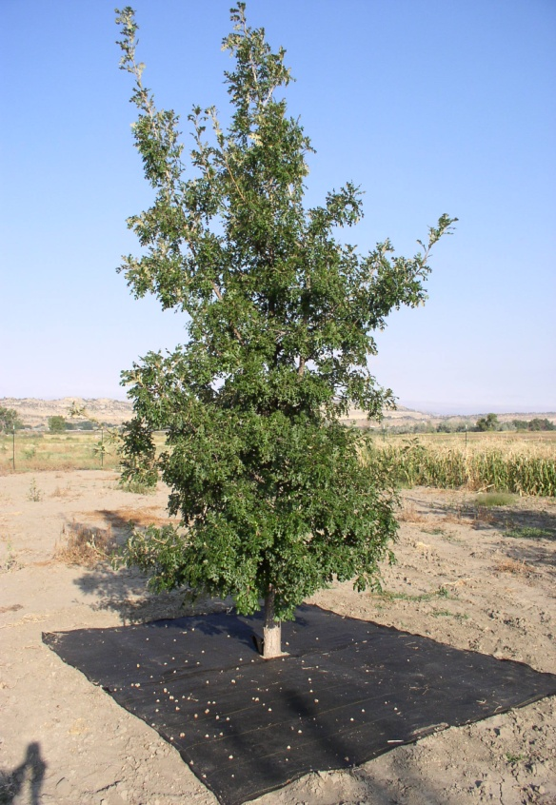

Photo by Joe Scianna, USDA-NRCS, Bridger, Montana

##### Uses

*Windbreaks and Shelterbelts*: Bur oak is recommended as a medium to tall component in windbreak and shelterbelt systems. Although modest in growth rate, especially in the western U.S., it is a strong-wooded and long lived species.

*Riparian Forest Buffers*: Bur oak can be used in riparian forest buffer plantings and may be a suitable substitute, depending on site conditions, for green ash (*Fraxinus pennsylvanica*) and Russian olive (*Elaeagnus angustifolia*).

*Woody Draw Restoration*: Bur oak is a natural component of woody draws in the central and western Great Plains. Seedlings grown in containers are preferred over bareroot stock and direct sowing.

*Timber*: The wood of bur oak is quite valuable and is often marketed as “white oak.” It is used in the manufacture of cabinets, barrels, hardwood flooring, and fence posts.

*Ornamental*: Bur oak makes an excellent landscape specimen, and is well suited to drought tolerant landscapes. Its strong branches make it a good choice for street trees provided it has ample space to accommodate its wide spreading basal branches.

*Wildlife*: Bur oak is an excellent source of food for many wildlife species including deer, turkeys, squirrels, rabbits, raccoons, and rodents. As it reaches maturity it provides roosting, loafing, and nesting for numerous species of birds.

##### Status

Please consult the PLANTS Web site and your State Department of Natural Resources for this plant’s current status (e.g., threatened or endangered species, state noxious status, and wetland indicator values).

##### Description

Bur oak or mossycup oak is a medium- to tall-stature deciduous tree widely distributed across the United States. Bur oak has several desirable attributes including strong branches, drought tolerance, winter hardiness, and freedom from serious insects or diseases.

On good sites, bur oak has a spreading habit with a broad crown; massive bole; and low, large branches. It is capable of reaching heights over 80 feet and individual trees up to 100 feet are found on good sites. At the far western edge of its range, heights of 50 feet can be considered about the upper limits of growth.

##### Adaptation and Distribution

Bur oak has a large native range extending from Nova Scotia, west to Manitoba, south through Kansas to Texas, east to Alabama, and northeast to Virginia and New England. Landscape specimens can be found in many western states outside of its native range. Most references list bur oak as hardy in

USDA Winter Hardiness Zones 4 to 8, although Zone 2 is given in at least one source. Bur oak is considered only moderately shade tolerant.

Although favoring rich alluvial bottomland, bur oak grows well on rocky hillsides, limestone soils, droughty soils, clayey sites, and other marginal sites -- given full sun conditions. This species performed better than most others tested on coal-mine spoils of pH 5.6 in eastern Kansas. In the western United States, bur oak is considered a pioneer species and is capable of invading prairie grasslands. In the eastern Great Plains it occurs primarily along stream bottoms and stream terraces in association with green ash, boxelder (*Acer negundo*), and cottonwood (*Populus sp.*). Bur oak is, however, intolerant of flooding.

For a current distribution map, please consult the Plant Profile page for this species on the PLANTS web site.

##### Establishment

Cross pollination between individual trees appears to be favored. Acorns ripen in one year, falling as early as August or as late as November depending on the tree and location. Acorns usually germinate immediately without pretreatment, but may require cold:moist stratification when collected from northern sources. Average minimum seed-bearing age of forest trees is approximately 35 years with best production typically between 75 to 150 years. Good crops usually occur every two to three years. It may be necessary to check seed-bearing trees regularly in order to assure harvesting the acorns before the wildlife do. Under fallow, dryland conditions in Bridger, Montana, bur oak trees began producing substantial amounts of seed by 10 years of age.

Bur oak is considered moderately tolerant to intolerant to shade. Initial height growth is normally slow for the first three to five years, then moderate as the plant becomes established. Seedlings produce a vigorous and aggressive taproot that allows this species to utilize sub-surface moisture and tolerate drought. Container produced seedlings, cultivated in tall, narrow pots and at least two years of age are the preferred stock type.

##### Management

Protection from wildlife is highly recommended for all bur oak plantings as this species is preferred browse for deer and rabbits. Its slow initial growth warrants the use of weed barrier or other forms of vegetation control for reducing plant competition. Supplemental water may result in modest increases in seedling survival and biomass production on droughty sites. Supplemental fertility is not considered necessary for most conservation plantings in the northern Great Plains and Intermountain West.

##### Pests and Potential Problems

Reported insect problems include oak webworm, oak skeletonizer, leaf miner, variable oakleaf caterpillar, oak lacebug, and June beetles. Oak lacebug can be a serious problem in shelterbelt plantings, especially during drought conditions. Serious insect and disease problems are relatively limited for bur oak in the western United States.

##### Cultivars, Improved, and Selected Materials (and area of origin)

‘Lippert’ bur oak, released in 1994 by the Manhattan, Kansas Plant Materials Center, is a seed propagated cultivar recommended for conservation use in multi-row windbreaks, reforestation for watershed protection, and wildlife habitat plantings.

‘Boomer’ bur oak was released by the James E “Bud” Smith Plant Materials Center in Knox City, Texas. It is recommended for conservation use in windbreaks, as a landscape plant for urban and recreational areas, and for wildlife food and shelter.

Ekalaka Germplasm bur oak is a Selected Class pre-varietal selection of bur oak released by the Bridger, Montana Plant Materials Center in 2009 for improved rate of height growth, percentage seedling survival, and vigor rating. It is recommended for various conservation applications such as windbreaks, shelterbelts, riparian forest buffers, Xeriscapes®, woody draw restoration projects, and wildlife plantings.

Bur oak seed is readily available through commercial seed sources in the central and western United States. Seedlings can be purchased from both state and commercial nurseries. Foundation seed of Plant Materials Program selections is available by contacting the releasing Plant Materials Center or respective Plant Materials Specialist.

##### Prepared By & Species Coordinator:

*Joseph D. Scianna*

*Research Horticulturist*

*USDA-NRCS*

*Bridger, Montana*

Published November, 2009

Edited: 28Aug09JSJ

For more information about this and other plants, please contact your local NRCS field office or Conservation District <<http://www.nrcs.usda.gov/>>, and visit the PLANTS Web site <[http://plants.usda.gov](http://plants.usda.gov/)> or the Plant Materials Program Web site <<http://plant-materials.nrcs.usda.gov>>

**USDA IS AN EQUAL OPPORTUNITY PROVIDER AND EMPLOYER**