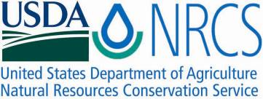

Plant Fact Sheet

# oilseed radish

## Raphanus sativus L.

Plant Symbol = RASA2

Contributed by: USDA NRCS Booneville Plant Materials Center, Arkansas

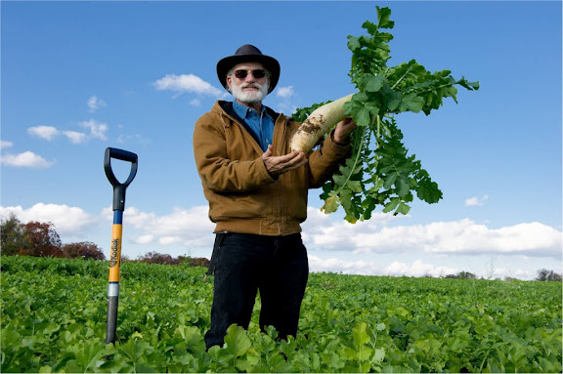

*Dr. Ray Weil harvesting oilseed radish. Photo provided by Dr. Ray Weil, University of Maryland.*

Alternative Names

*Common Names*: forage radish, fodder radish, tillage radish®, radish ripper, daikon, Japanese radish

*Scientific Names: Raphanus sativus* var.*oleifer* Stokes, *Raphanus sativus* L. *ssp.* Oleiferus, *Raphanus sativus* L. var. *oleiformis* Pers.

### Uses

*Cover Crop*: Oilseed radish is a cover crop planted in early fall or after harvest of the primary crop. Planting occurs after the harvest of cash crops such as wheat, rye, early potatoes, pickling cucumbers, snap beans, or celery. It can also be aerial seeded into standing corn, soybean, or cotton prior to harvest. Oilseed radish has a uniquely deep taproot, which can reach a depth of six feet. It develops an enlarged upper portion of the taproot, which can reach 12 to 20 inches in length and 2 inches in diameter. This deep-rooting growth habit is capable of treating multiple resource concerns on cropland such as:

*Soil Compaction*: The thick taproot penetrates compacted soil layers. The root decomposes in the spring and leaves large, deep holes in the soil. These holes enable water, air, and cash crop roots to penetrate the soil in the summer when the soil is dry and hard. Planting oilseed radish is an alternative to using machinery to deeply rip or plow the soil, and can be used by farmers with no-till systems.

*Nitrate leaching:* The deep taproot can scavenge nitrogen in the soil left by the previous crop. The roots of oilseed radish absorb nitrogen at greater depths than other crops and keep it from leaching into the groundwater. When the plant decomposes in the spring, nitrogen is released back to the cash crop.

*Weed Management:* Oilseed radish seedlings can emerge as soon as 3 days after planting (if conditions are favorable), and can quickly grow and suppress weeds. Biomass decomposes quickly and may leave the seedbed ready for planting, without the need to till leftover residue.

### *Pest Management:* Like other plants in the Brassicaceae (mustard) family, the roots of oilseed radish exude chemicals that help suppress soil pests like nematodes.

### Status

Please consult the PLANTS Web site and your State Department of Natural Resources for this plant’s current status (e.g., threatened or endangered species, state noxious status, and wetland indicator values).

### Weediness

To prevent oilseed radish from becoming a weed pest, kill the crop before plants produce seed. Seeds may remain viable in the soil for multiple growing seasons, and can germinate when the cash crop is growing. This plant may become weedy or invasive in some regions or habitats and may displace desirable vegetation if not properly managed. Please consult with your local NRCS Field Office, Cooperative Extension Service office, state natural resource, or state agriculture department regarding its status and use. Weed information is also available from the PLANTS Web site at <http://plants.usda.gov/>. Please consult the Related Web Sites on the Plant Profile for this species for further information.

### Description and Adaptation

Oilseed radish is a coarse winter annual in the Brassicaceae (or Cruciferae) family. Leaves grow in a basal rosette to 2-3 feet tall. Seed stalks elongate from the rosette. Pink, white, or lavender flowers bloom in spring. The Brassicaceae family also produces edible crops such as broccoli and cabbage. Oilseed radish differs from typical radish because it develops a thick, white taproot that can grow 1-2 inches in diameter and up to 1 foot in length. Plants give off a foul “rotten egg-like” odor when they decompose in the spring.

Oilseed radish grows best in cool, moist growing conditions (most often during the fall). Plants are not tolerant of shade, standing water, or severely nitrogen-deficient soils. Plants cannot survive freezing temperatures of 20⁰F or below.

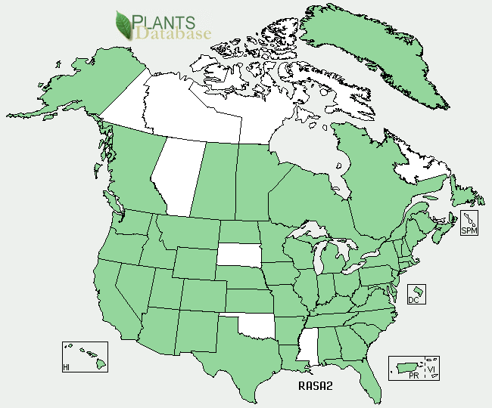

Oilseed radish distribution from USDA-NRCS PLANTS Database.

For updated distribution, please consult the Plant Profile page for this species on the PLANTS Web site.

### Establishment

Prepare a clean, firm, weed-free seedbed prior to planting oilseed radish. Adjust planting times according to the first expected frosts. Oilseed radish will die or sustain damage if temperatures drop below 20⁰F. In the Mid-Atlantic, planting times are generally late August or early September. Use the small grain box (seed is similar in size to alfalfa) on a conventional or no-till drill. It is suggested that you plant a minimum of 6-10 lb/acre of pure live seed (PLS). Planting depth should be ¼ to ½ inch. Drilling yields more successful stands, but seed can also be broadcast at a higher rate of 12-14 PLS lb/acre. Follow broadcast seeding with a light disking, cultipacking, or rolling with water-filled roller. Aerial seeding can be done on standing crops. Increase seeding rates to 14-16 PLS lb/acre and broadcast into standing corn or soybean canopies when lower leaves begin to turn yellow. Cotton crops can be aerially seeded prior to defoliation and harvest.

### Management

Oilseed radish establishes quickly if soil moisture is adequate (soil moisture varies by soil texture). Plants will scavenge leftover nitrogen in the soil profile and do not need additional fertilization. The most important management consideration when planting oilseed radish is ensuring that plants do not go to seed. When the taproots decompose, a foul rotten-egg or natural gas-like odor is emitted.

### Pests and Potential Problems

Avoid planting oilseed radish as a cover crop when the cash crop includes broccoli, cabbage, radish, or other members of the mustard family because it can encourage the establishment of some pathogens and pests. Rotate other cover crop species with oilseed radish to avoid pest and pathogen problems.

### Control/Cover Crop Termination

Oilseed radish must be killed prior to planting of the cash crop to allow cash crop germination. Oilseed radish will naturally die in winter conditions/frost when temperatures fall below 20°F and decompose naturally in the soil.

If plants do not winterkill, mowing, grazing, lightly disking, or spraying with appropriate herbicide treatment is recommended at flowering before seed set. Please contact your local agricultural extension specialist or county weed specialist to learn what works best in your area and how to use it safely. Always read label and safety instructions for each control method. Trade names and control measures appear in this document only to provide specific information. USDA NRCS does not guarantee or warranty the products and control methods named, and other products may be equally effective.

### Cultivars, Improved, and Selected Materials (and area of origin)

Seeds are available from select commercial sources, but can be more expensive than many other cover crop species. There are several trademark varieties in the United States, including Tillage Radish® and Groundhog™. Many cultivars including ‘Adagio’, ‘Arena’, ‘Colonel’, ‘Remonta’ ‘Revena’, ‘Rimbo’, and ‘Ultimo’ have European origins. Commercially available “common” varieties are also sold under ‘VNS’ for variety not stated.

### Prepared By Alayna Jacobs, USDA-NRCS Booneville Plant Materials Center, Arkansas

### Citation

Jacobs, A. 2012. Plant fact sheet for oilseed radish (*Raphanus sativus* var. *oleiformis)*. USDA-Natural Resources Conservation Service, Booneville Plant Materials Center, Booneville, AR.

Published May 2012

Edited: May2012 aym, May2012cs, May2012

For more information about this and other plants, please contact your local NRCS field office or Conservation District <<http://www.nrcs.usda.gov/>>, and visit the PLANTS Web site <[http://plants.usda.gov](http://plants.usda.gov/)> or the Plant Materials Program Web site <<http://plant-materials.nrcs.usda.gov>>

**USDA IS AN EQUAL OPPORTUNITY PROVIDER AND EMPLOYER**