|  |
| --- |
| RED-FLOWERING CURRANT |
| *Ribes sanguineum* Pursh |
| Plant Symbol = RISA |

Contributed by: USDA NRCS Plant Materials Center, Corvallis, Oregon

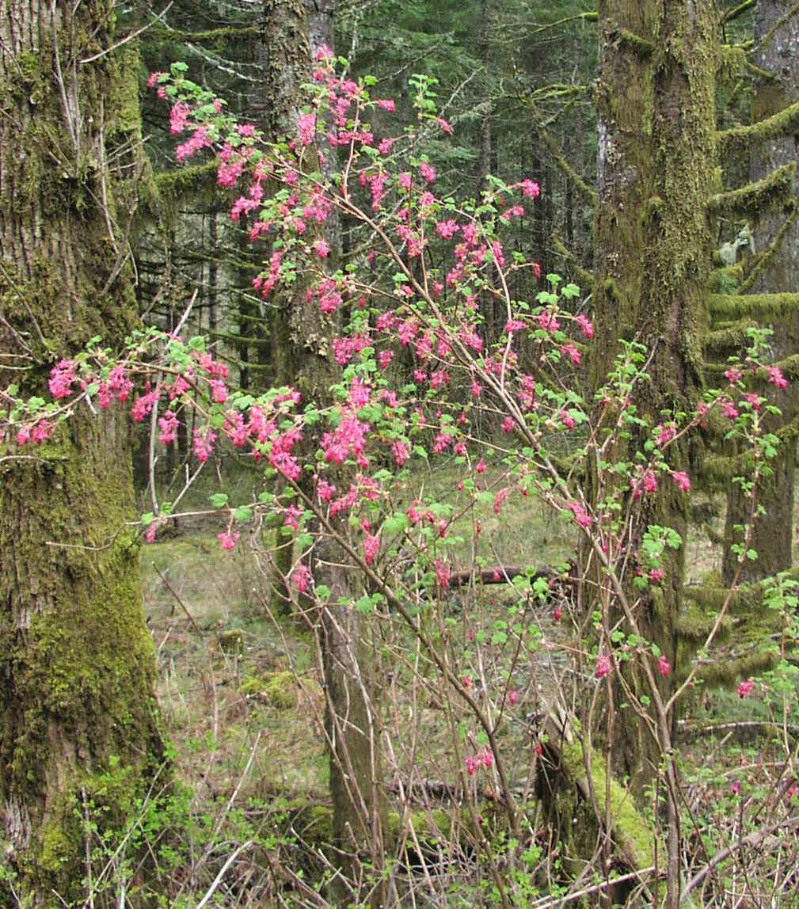

Pete Gonzalves

Alternate Names: Also known as *Ribes* *sanguineum* Pursh forma *atrorubens* (Loudon) Rehder, *R. glutinosum* Benth, *Coreosma sanguinea* (Pursh) Spach and *Calobotrya sanguinea* (Pursh) Spach. Common names include redflower currant, blood currant, winter currant, and pink-flowering currant.

Uses: Red-flowering currant is a drought tolerant deciduous shrub that may be useful in restoration plantings. It provides early spring nectar for hummingbirds and butterflies, forage for the larvae of more than two dozen species of moths and butterflies, and nesting sites or cover for songbirds and small mammals. Numerous birds including grouse, quail, robins, finches, towhees, and woodpeckers, and small mammals consume the berries. Red-flowering currant provides occasional browse for game animals and modest forage value for sheep and cattle. Abundant showy flowers make this plant attractive as a landscape specimen or informal hedge and more than a dozen selections and hybrids are featured in the ornamental trade. Berries, although very tart, are considered suitable by some for jam, jelly, pie, juice or syrup. Native Americans ate the berries fresh or dried. This species has been investigated for medicinal anti bacterial and anti viral properties and is used in currant fruit breeding programs to confer resistance to anthracnose, powdery mildew and currant stem borer.

Status: This plant is critically imperiled within Idaho and planting of currants is restricted in Michigan. Please consult the PLANTS Web site and your State Department of Natural Resources for this plant’s current status (e.g. threatened or endangered species, state noxious status, and wetland indicator values).

Description: Red-flowering currant (family: Grossulariaceae) produces numerous small flowering spurs on multiple thornless stems. It grows at a moderate rate up to 10 ft. and develops an upright to spreading form. Deciduous, alternate leaves are 1-3 in. and rounded with 3-5 shallow lobes and deep veins lending a wrinkled appearance. They are green above and dull green beneath due to fine hairs and turn yellow to reddish in mid to late summer. Leaves of some plants are pungent when crushed. Numerous 2-6 in. long, nodding clusters of 5-25 flowers appear in March to June. The flowers are composed of pink to deep red (rarely white) tubular fused sepals and small protruding red or white flower petals. Blue-black berries smaller than 0.5 in. have a thin white waxy coating, hold about 20 seeds each, and mature in early to mid summer. Thin orange or red tinted bark turns gray-brown and peels from older stems.

**Adaptation:** Red flowering currant is a moderately long-lived woody perennial hardy to -4°F. It prefers sun or partial shade and well-drained, moderately fertile soil of near neutral or slightly acidic pH. Plants are commonly found from southwest British Columbia through western Washington and Oregon (mostly west of the Cascade Mountains crest) and the California Coast Ranges to Santa Barbara County. There are also small relict populations in northern Idaho.Red-flowering currant habitat includes open woods, forest gaps, dry rocky slopes and disturbed sites from sea level up to 6,000 ft. For a current distribution map, please consult the Plant Profile page for this species on the PLANTS Web site.

Establishment: Red-flowering currant is a pioneer species sprouting from seed or root crowns following fire. It is propagated by seed, cuttings or layering. Heavy seed crops occur every second or third year and 100 lbs. of berries will yield about 4 lbs. of seed. There are approximately 284,000 seeds per pound. Seed is naturally distributed by birds and small mammals and may remain viable in soil for several years. Fall sowing or cold moist storage (stratification) near 32°F for 30-140 days may aid germination. Propagation with cuttings has been successful with soft wood in spring, semi-hard wood in summer and hard wood collected during the dormant season. Rooting may improve by including a ‘heel’ of older wood and using bottom heat, mist, or rooting hormone. Red-flowering currant generally does not establish well using soil bioengineering practices such as live stakes or fascines but may be successful on particularly favorable sites with supplemental irrigation or with mulch.

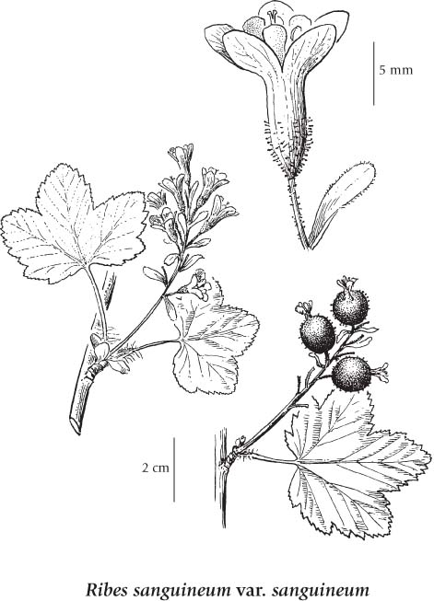

© University of Washington Press

Management: Provide supplemental water during the first and perhaps second season but allow soil to dry 3-4 in. down between irrigations and do not provide water after mid to late summer when leaves naturally begin to fall. Prune immediately after flowering to encourage vigorous growth suitable for future flower bearing.

Pests and Potential Problems: Red-flowering currant is fairly resistant to most insect and disease pests of this genus including aphids and currant fruit fly (*Euphranta canadensis*). It is susceptible to currant borer (*Synanthedon tipuliformis*), oak root fungus (*Armillaria mellea*) and seedlings may be susceptible to damping off disease.

Environmental Concerns: Red-flowering currant spreads slowly by seed, root sprouting and layering. As an alternate host of white pine blisterrust (*Cronartium ribicola*), red-flowering currant has been considered a weed in several timber states and, along with other *Ribes* sp., was the subject of extensive eradication efforts in the past. It is non-toxic to humans and wildlife.

Cultivars, Improved, and Selected Materials (and area of origin): There are four geographical botanical varieties of *Ribes sanguineum*. More than a dozen named cultivars and hybrids are routinely available as container stock from retail nurseries. Popular choices include ‘White Icicle’ (early white flowers) ‘Pinky Pig’ (pink flowers) and ‘King Edward VII’ (compact with deep red flowers).

**Prepared By and Species Coordinators:** *Pete Gonzalves* and *Dale Darris*, USDA NRCS Plant Materials Center, Corvallis, Oregon.

**Line Drawing Source Document:** Douglas, GW, GB Straley, D Meidinger, and J. Pojar. 1999. Illustrated Flora of British Columbia vol.3. Ministry of Environment, Lands and Parks, Victoria, BC.

**Edited:** 10Apr2008 pjg; 080917 jsp

For more information about this and other plants, please contact your local NRCS field office or Conservation District, and visit the PLANTS Web site<<http://plants.usda.gov>> or the Plant Materials Program Web site <<http://Plant-Materials.nrcs.usda.gov>>

*The U.S. Department of Agriculture (USDA) prohibits discrimination in all its programs and activities on the basis of race, color, national origin, sex, religion, age, disability, political beliefs, sexual orientation, and marital or family status. (Not all prohibited bases apply to all programs.) Persons with disabilities who require alternative means for communication of program information (Braille, large print, audiotape, etc.) should contact USDA's* [*TARGET Center*](http://www.usda.gov/oo/target.htm) *at 202-720-2600 (voice and TDD).*

*To file a complaint of discrimination write USDA, Director, Office of Civil Rights, Room 326-W, Whitten Building, 14th and Independence Avenue, SW, Washington, DC 20250-9410 or call 202-720-5964 (voice or TDD). USDA is an equal opportunity provider and employer.*

*Read about* [*Civil Rights at the Natural Resources Conservation Service*](http://www.nrcs.usda.gov/about/civilrights/)*.*