|  |
| --- |
| black-eyed susan |
| *Rudbeckia hirta* L. |
| Plant Symbol = RUHI2 |

Contributed by: USDA NRCS Plant Materials Program

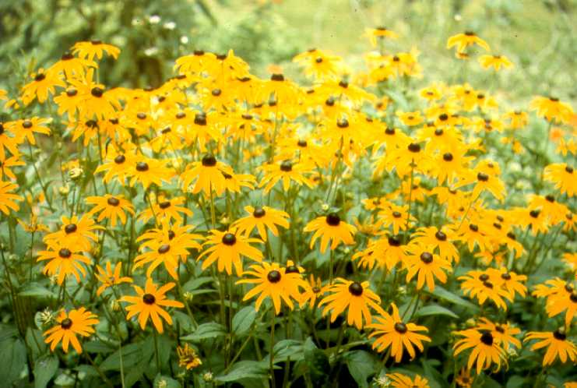

USDA NRCS National Plant Materials Center

Beltsville, MD

Uses

*Erosion control*: Black-eyed Susan is an important component in critical area treatment plantings along with grasses, legumes, and other forbs when used along road cuts, hillsides, and other areas subject to erosion.

*Wildlife*: This plant offers protection and food to several song and game birds.

*Recreation and beautification*: Black-eyed Susan can be used for landscaping and in wildflower gardens.

Status

Please consult the PLANTS Web site and your State Department of Natural Resources for this plant’s current status (e.g. threatened or endangered species, state noxious status, and wetland indicator values).

Description

*Rudbeckia hirta* L., black-eyed Susan, is a biennial forb about 1 m tall with yellow ray flowers and dark brown spherical centers. After germination, the seedling grows into a rosette with oblong leaves. Sometimes flower stalks will appear in the first summer, but typically black-eyed Susan blooms from June to September of the second year. After flowering and seed maturation, the plants die. The seed is very small (1,746,000 per pound) and black, about 2 mm long and 0.5 mm in diameter.

Adaptation and Distribution

Black-eyed Susan is naturalized in most of the states east of Kansas and the bordering areasof Canada. It is adapted throughout the Northeast on soils with a drainage classification range from well-drained to somewhat poorly drained. It will perform acceptably on droughty soils during years with average or above rainfall, but best growth is achieved on sandy, well drained sites. It is winter hardy inareas where low temperatures are between -30 ° and -20 °F.

For a current distribution map, please consult the Plant Profile page for this species on the PLANTS Website.

Establishment

Black-eyed Susan is easily established with most critical area seeding techniques. Generally ½ lb. of seed per acre is sufficient in mixes with conservation grasses, legumes, and other forbs. Where the intent is to maximize the impact of the forb component, utilize bunchgrasses rather than aggressively spreading grasses such as reed canarygrass or bromegrass. Once established, new seedlings will be produced from the preceding crop; the stand may perpetuate itself indefinitely.

Management

After establishment, competing perennial vegetation should be controlled through the use of mechanical or chemical practices. If competing vegetation is not controlled, one will observe a decrease in the number of black-eyed Susan plants.

Pests and Potential Problems

There are no major insect or disease pests of black-eyed Susan. Stands can be reduced by powdery mildew and damping-off organisms.

Cultivars, Improved, and Selected Materials (and area of origin)

'Golden Jubilee' black-eyed Susan was released by the Big Flats Plant Materials Center in 1985. It is typical of the species except slightly shorter in height with a longer bloom period. It was not selected for its flower size or color. 'Golden Jubilee' is the only cultivar of black-eyed Susan that has proven adaptation throughout the Northeast for conservation use. The original collection area of 'Golden Jubilee' was near Manchester, Vermont. Foundation seed is distributed to commercial producers by the Big Flats PMC in Corning, NY. Black-eyed Susan is readily available from commercial sources.

Prepared By & Species Coordinator:

USDA NRCS Plant Materials Program

Edited: 05Feb2002 JLK; 060809 jsp

For more information about this and other plants, please contact your local NRCS field office or Conservation District, and visit the PLANTS Web site<<http://plants.usda.gov>> or the Plant Materials Program Web site <<http://Plant-Materials.nrcs.usda.gov>>

*The U.S. Department of Agriculture (USDA) prohibits discrimination in all its programs and activities on the basis of race, color, national origin, sex, religion, age, disability, political beliefs, sexual orientation, and marital or family status. (Not all prohibited bases apply to all programs.) Persons with disabilities who require alternative means for communication of program information (Braille, large print, audiotape, etc.) should contact USDA's* [*TARGET Center*](http://www.usda.gov/oo/target.htm) *at 202-720-2600 (voice and TDD).*

*To file a complaint of discrimination write USDA, Director, Office of Civil Rights, Room 326-W, Whitten Building, 14th and Independence Avenue, SW, Washington, DC 20250-9410 or call 202-720-5964 (voice or TDD). USDA is an equal opportunity provider and employer.*

*Read about* [*Civil Rights at the Natural Resources Convervation Service*](http://www.nrcs.usda.gov/about/civilrights/)*.*