

Plant Fact Sheet

# BLACK WILLOW

## SALIX NIGRA Marsh.

Plant Symbol = SANI

Contributed by: USDA NRCS Plant Materials Center, Manhattan, Kansas & Kansas State University, Forestry Research

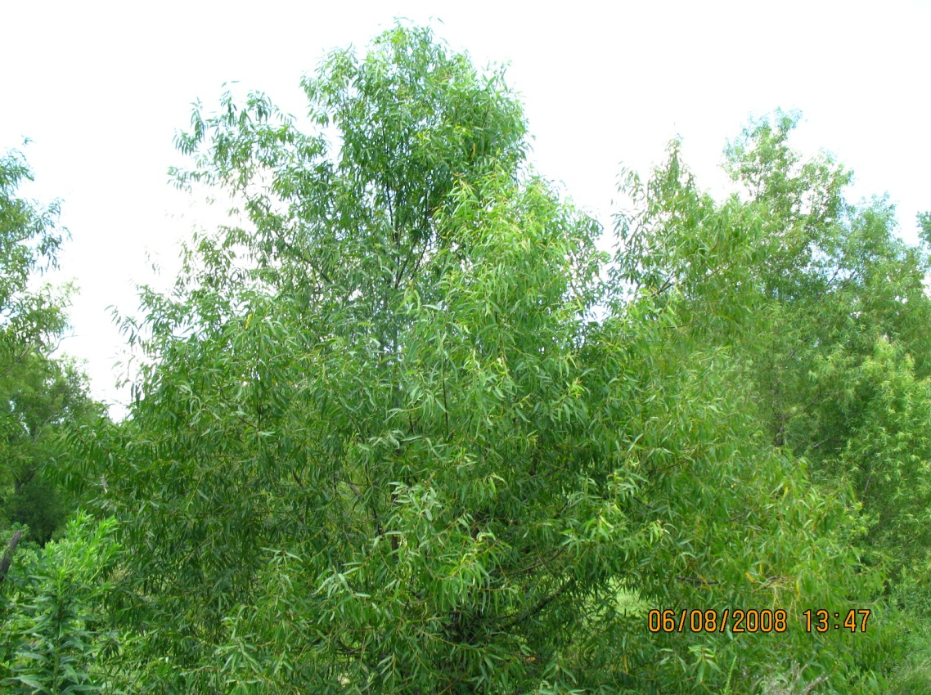

*Photo Courtesy of Philip Barbour, Wildlife Biologist, USDA NRCS, Madison, Mississippi*

Alternate Names

American, Brittle, Champlain, Dudley, Gooding, gulf black, puzzle, rough American, scythe-leaf, scythe-leaved, southwestern black, swamp, tall black, Texas black, and western black willow; sauce, saule, saule noir, sauz, swamp walnut**,** weide, wilg, willow, and willow catkins

The name willow derives from the Old English *wilwe.* The botanical name *Salix* was the name given by the ancient Romans.

**Uses**

*Ethnobotanic:* The ancient Greeks knew the therapeutic values of willow. Tea made from willow bark was used for stiff joints and rheumatic pains.

By the 1840’s, chemists had isolated salicylic acid from willow and found it produced marked antipyretic (fever-reducing) and analgesic (pain-killing) effects and “striking relief of acute articular rheumatism.” Modern aspirin (acetylsalicylic acid) is a synthetic product. Salicylic acid got its name from Salix.

*Industry:* Most black willow lumber is used for shipping boxes.

*Wildlife:* The willows are among the first plants to provide honey bees, after long winters, with nectar and pollen. Domestic grazing animals browse in willow thickets. Elk and beaver browse on willow leaves in the summer and willow twigs in the winter.

*Ornamental:* Black willow can be planted as an ornamental where a fine-textured shade tree is desired. It will tolerate dry soils with reduced vigor.

*Conservation:*  One of the greatest services of the willows is as a soil-binder. Growing along the banks of countless streams, their fibrous roots help to prevent the soil from being washed away.

Status

Please consult the PLANTS Web site and your State Department of Natural Resources for this plant’s current status (e.g. threatened or endangered species, state noxious status, and wetland indicator values.

Description and Adaptation

A member of the Willow Family (Salicaceae), black willow is a small to medium-sized tree 30 to 60 ft high and about 14 inches in diameter with a broad, irregular crown and a superficial root system.

Leaves are simple, alternate, deciduous, narrow, lance-shaped, with tapered bases, rounded base, finely toothed margin, blade yellow-green on both sides, with a few small hairs on the lower surface; petiole slender. Flowers of black willow: male and female catkins on separate trees. Catkins are 4-5 cm long, on ends of leafy shoots, many small, yellow-green flowers without petals. Twigs are light-red, slender, and flexible. Buds narrow, conical, orange-brown; leaf scars narrow, crescent shaped; broad, flat, often shaggy ridges; pith pale brown, small. The bark is dark gray-brown to nearly blackish, divided into deep fissures separating thick, interlacing, sometimes scaly ridges.

Black willow is adapted wherever ample soil moisture is found. Black willow grows best where the average annual rainfall is 51 inches, of which 20 inches falls during the growing season, April through August.

The estimated life span for black willow averages 65 years with a range of 40 to 100 years.

*Wood characteristics:* The wood is of moderately light to light density, moderately soft. It does not splinter easily, which makes excellent wood for toys, crates, and barn floors.

*Distribution*: Black willow ranges from New Brunswick to Manitoba, south to Florida and Texas.

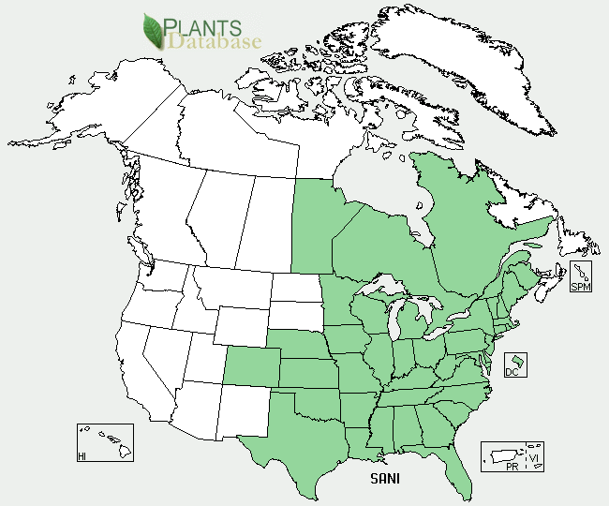

Black willow distribution from USDA-NRCS PLANTS Database.

*Habitat:* This species is usually found on moist or wet soils along banks of streams, lakes, swamps around farm ponds, and pasture sloughs.

**Establishment**

Black willow is easily established from cuttings. Stringent requirements of seed germination and seedling establishment limit black willow to wet soils.

Management

Stands of black willow can stagnate if not periodically thinned.

**Pests and Potential Problems**

A number of insect species attack black willow but few cause serious damage, such as, forest tent caterpillar, cotton wood leaf beetle, willow sawfly, stem borers, and twig borers.

**Seeds and Plant Production**

Good seed crops occur almost every year with only a few interspersed poor crop years. The seeds are widely disseminated by wind and water. Willow seed must be collected as soon as it ripens and sown immediately. Stem cuttings are highly desirable to propagate trees.

**Fire Effects**

Black willow is very susceptible to fire. Hot fires can kill entire stands of willows. Black willow will sprout at the base following fire.

**Cultivars, Improved, and Selected Materials** **(and area of origin)** ‘Webb’ compact willow is a “strikingly different vase-shaped form of black willow.” This unusual form was found by Mr. Charles Webb in Madison County, Florida.

**Control**

Please contact your local agricultural extension specialist or county weed specialist to learn what works best in your area and how to use it safely. Always read label and safety instructions for each control method. USDA, NRCS does not guarantee or warranty the products and control methods named, and other products may be equally effective.

Prepared By

*John M. Row*

USDA NRCS, Manhattan Plant Materials Center, Manhattan, Kansas 66502

*Wayne A. Geyer*

Forestry Division, Kansas State University, Manhattan, Kansas 66506

Published: May, 2010

Edited: For more information about this and other plants, please contact your local NRCS field office or Conservation District <<http://www.nrcs.usda.gov/>>, and visit the PLANTS Web site <[http://plants.usda.gov](http://plants.usda.gov/)> or the Plant Materials Program Web site <<http://plant-materials.nrcs.usda.gov>>

**USDA IS AN EQUAL OPPORTUNITY PROVIDER AND EMPLOYER**