|  |
| --- |
| california bulrush |
| *Schoenoplectus californicus* (C.A. Mey.) Palla |
| Plant Symbol = SCCA11 |

Contributed by: USDA NRCS Golden Meadow Plant Materials Center

*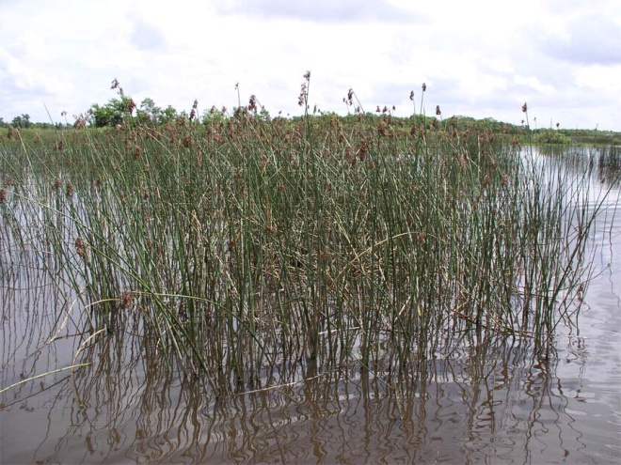USDA NRCS Golden Meadow Plant Materials Center*

**Alternate Names**

*Scirpus californicus* (C.A. Mey.) Steud; bullwhip, giant rush

**Uses**

California bulrush is used effectively to control shoreline erosion along streams, bayous, levee banks, canals and other places where land and water meet. Additionally, this species will form a vegetative barrier across open water reducing wave energy impacting shorelines. California bulrush is being used extensively in marsh restoration. Many forms of wildlife will utilize the plants for food and cover.

**Status**

Please consult the Plants website and your State Department of Natural Resources for this plant’s current statue (e.g. threatened or endangered species, state noxious status, and wetland indicator values)

**Description**

California bulrush is a native, herbaceous, rhizomatous perennial which forms dense colonies on mud flats, in open water and at shore water interface. The stems are remarkable in their length of five to ten feet. The stems are slightly angled with drooping branched terminal inflorescences.

**Adaptation**

California bulrush is an obligate wet site species found in coastal fresh water wetlands. Bulrush will tolerate only slight salinity (0-5 part per thousand), but will tolerate periodic short pulses of more saline water. This species can grow in water up to 36 inches or more. Plants tend to grow in a continuous colony parallel to the shore. Where competition with other species is not limiting, colonies grow in somewhat circular stands.

Establishment

California bulrush is best established with plugs or potted plants derived from divisions of the rhizomes. Production of viable seed has proven unreliable for commercial purposes.

Planting success is optimal in 12 inches of water but can be successful in one to 24 inches of water. Spacing depends on the size of the plant. Trade gallons can be planted on spacing of five to ten feet, while smaller plants should be closer. Planting in rows parallel to the shore is most effective. In zones of high wave energy, plantings should be anchored in the hole by stakes or pins until the plant establishes itself.

Management

California bulrush will thrive in a wide variety of marsh sites from mud flats to open water. Water management is critical during establishment and through the life of the wetland. Changes in water levels can influence species composition and plant communities.

Pests and Potential Problems

Nutria is the greatest cause of problems in California bulrush establishment. Nutria will excavate plants to feed on the roots. Where nutria are a problem, well anchored wire cages are required to allow plants to become established.

**Cultivars, Improved and Selected Materials (and area of origin**

The USDA NRCS Plant Materials Centers have one released variety:

‘Restorer’ is a cultivar of *S. californicus* released by the USDA, NRCS Jimmy Carter Plant Materials Center, Americus, Georgia

Bayou Lafourche Germplasm is a pre-varietal select release of *S. californicus* from the USDA, NRCS Golden Meadow Plant Materials Center, Galliano, Louisiana.

Commercial varieties of California bulrush are available from local nurseries. Contact your local Natural Resources Conservation Service office for more information.

**Prepared By and Species Coordinator:**

*Richard H. Neill*, USDA NRCS Louisiana Plant Materials Center, Galliano, Louisiana

Edited: 01feb2007 mjh; 080930 jsp

For more information about this and other plants, please contact your local NRCS field office or Conservation District, and visit the PLANTS Web site<<http://plants.usda.gov>> or the Plant Materials Program Web site <<http://Plant-Materials.nrcs.usda.gov>>

*The U.S. Department of Agriculture (USDA) prohibits discrimination in all its programs and activities on the basis of race, color, national origin, sex, religion, age, disability, political beliefs, sexual orientation, and marital or family status. (Not all prohibited bases apply to all programs.) Persons with disabilities who require alternative means for communication of program information (Braille, large print, audiotape, etc.) should contact USDA's* [*TARGET Center*](http://www.usda.gov/oo/target.htm) *at 202-720-2600 (voice and TDD).*

*To file a complaint of discrimination write USDA, Director, Office of Civil Rights, Room 326-W, Whitten Building, 14th and Independence Avenue, SW, Washington, DC 20250-9410 or call 202-720-5964 (voice or TDD). USDA is an equal opportunity provider and employer.*

*Read about* [*Civil Rights at the Natural Resources Convervation Service*](http://www.nrcs.usda.gov/about/civilrights/)*.*