|  |
| --- |
| silver buffaloberry |
| *Shepherdia argentea* (Pursh) Nutt. |
| Plant Symbol = SHAR |

Contributed by: USDA NRCS Plant Materials Program

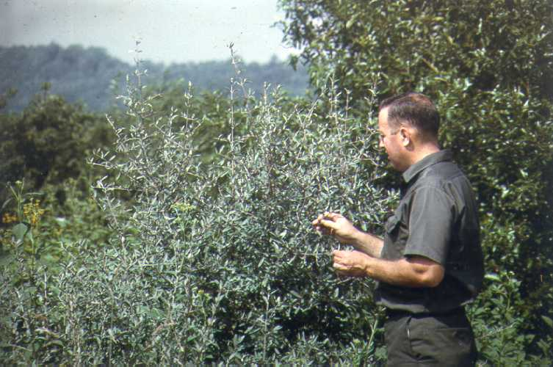

USDA NRCS National Plant Materials Center

Beltsville, MD

Alternate Names

Elaeagnus utilis A. Nels., Lepargyrea argentea (Pursh) Greene

Uses

*Windbreaks*: Plant silver buffaloberry in the outer rows of multi-row plantings when supplemental moisture is available. This species has potential for single-row plantings where a low, dense barrier is desired.

*Wildlife*: The thorny thickets formed by the shrub create ideal cover for numerous bird and animal species. It is preferred nesting site for many songbirds. Some birds eat the fruit although it is not relished by a wide variety of species.

*Recreation**and Beautification*: The thorns and suckering habit of this species must be taken into consideration when planning its use in recreation areas. The fruit is highly prized for making jelly.

Status

Please consult the PLANTS Web site and your State Department of Natural Resources for this plant’s current status (e.g. threatened or endangered species, state noxious status, and wetland indicator values).

Description

*Shepherdia argentea* (Pursh) Nutt., silver buffaloberry, is a deciduous, thorny shrub or small tree of 6 to 20 feet in height native to North America. It occurs as scattered to frequent plants along streams, in bottomlands, and on moist hillsides throughout western Wyoming and Colorado at elevations to 7,500 feet. The shrub is winter hardy and alkaline tolerant, but has only limited drought and shade tolerance. Under favorable conditions, it readily forms thorny thickets.

Fruits are reddish, globe-shaped “berries” (drupes) about 1/8 to 1/4 inch across; flowers are brownish-yellow, small, with male and female flowers borne on separate plants in clusters of 1 to 3 at the leaf axils; leaves are opposite, silvery-scurfy, oblong and entire, up to 2 inches long; stems are thorny, silvery-scurfy when young, brownish in age; roots are shallow and much branched, readily sprouting.

Adaptation and Distribution

This species is adapted to elevations below 7,500 feet and 15 to 20 inches of precipitation equivalent; it requires supplemental moisture in low precipitation zones.

For a current distribution map, please consult the Plant Profile page for this species on the PLANTS Website.

Establishment

Prepare a weed free site for planting.

Management

Planted areas should be kept free of weeds during the first 2 years of establishment. Care should be taken to prevent suckers from taking root in unwanted areas around homes and agricultural systems. Over-sprouting can be controlled mechanically or through the use of approved herbicides.

Pests and Potential Problems

This species may be subject to a heart rot disease which can cause serious problems. There are no known serious insect problems.

Cultivars, Improved, and Selected Materials (and area of origin)

Seedlings of silver buffaloberry are available from most hardwood commercial nurseries. ‘Sakakawea’ (Canada) was developed by the Bismarck, ND Plant Materials Center and released in 1984.

Prepared By & Species Coordinator:

USDA NRCS Plant Materials Program

Edited: 05Feb2002 JLK; 060817 jsp

For more information about this and other plants, please contact your local NRCS field office or Conservation District, and visit the PLANTS Web site<<http://plants.usda.gov>> or the Plant Materials Program Web site <<http://Plant-Materials.nrcs.usda.gov>>

*The U.S. Department of Agriculture (USDA) prohibits discrimination in all its programs and activities on the basis of race, color, national origin, sex, religion, age, disability, political beliefs, sexual orientation, and marital or family status. (Not all prohibited bases apply to all programs.) Persons with disabilities who require alternative means for communication of program information (Braille, large print, audiotape, etc.) should contact USDA's* [*TARGET Center*](http://www.usda.gov/oo/target.htm) *at 202-720-2600 (voice and TDD).*

*To file a complaint of discrimination write USDA, Director, Office of Civil Rights, Room 326-W, Whitten Building, 14th and Independence Avenue, SW, Washington, DC 20250-9410 or call 202-720-5964 (voice or TDD). USDA is an equal opportunity provider and employer.*

*Read about* [*Civil Rights at the Natural Resources Convervation Service*](http://www.nrcs.usda.gov/about/civilrights/)*.*