

Plant Fact Sheet

# meadow checkerbloom

## Sidalcea campestris Greene

Plant Symbol = SICA2

Contributed by: USDA NRCS Corvallis Plant Materials Center, Oregon

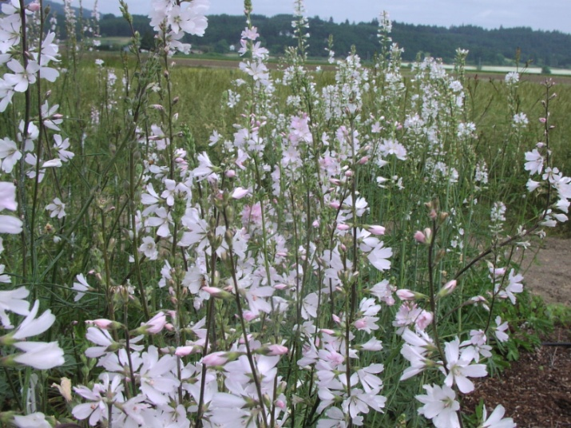

Photo by Amy Bartow, NRCS Corvallis Plant Materials Center, 2009

### Alternative Names

*Alternate Common Names:* meadow checker-mallow, tall wild hollyhock, tall wild checkermallow

*Alternate Scientific Names: Sidalcea sylvestris* A. Nelson

### Uses

*Pollinator habitat:* Meadow checkerbloom attracts a wide array of native bees, wasps, flies, beetles, and butterflies. The flowers are a high-quality nectar source for the Oregon endangered Fender’s blue butterfly (*Plebejus icarioides fenderi*), and a possible butterfly host plant for the West Coast lady (*Vanessa annabella*), common checkered skipper (*Pyrgus communis*), painted lady (*Vanessa cardui*), gray hairstreak (*Strymon melinus*), and American lady (*Vanessa virginiensis*). There is also a species of native bee (*Diadasia nigrifrons*) that is a specialist on the three *Sidalcea* species in the Willamette Valley, so this bee’s survival is closely linked to the presence of its rare host/forage species.

*Ornamental*: This plant makes a tall, showy addition to a butterfly meadow or wildflower garden. It can be used along bed borders, fences, driveways, roadsides, and hedgerow edges.

### Status

*Sidalcea campestris* is listed as a Candidate species by the State of Oregon and is on the Oregon Natural Heritage Program List 4 (of conservation concern but not currently threatened or endangered). Please consult the PLANTS Web site and your State Department of Natural Resources for this plant’s current status (e.g., threatened or endangered species, state noxious status, and wetland indicator values).

### Description and Adaptation

Meadow checkerbloom is an uncommon, native, herbaceous perennial wildflower in the mallow family (Malvaceae). A clump of stout, upright, hairy, hollow, branched stems originates from a thick taproot or short rhizome and grows 1½ to 6 ft tall. The gray-green, alternate leaves have hairy stems 4 to 8 inches long and are 2 to 6 inches broad and deeply palmately divided into 7 to 9 thin, hairy, toothed lobes with sharply pointed tips. The white to pale-pink, cup-shaped flowers have five petals that are about ¾ inch long. The flowers are borne on short stalks, arranged in a simple or somewhat branched, elongated, open inflorescence, and mature from the bottom upward. There are both bisexual and female plants; the female flowers are smaller and lack anthers (see photo below).

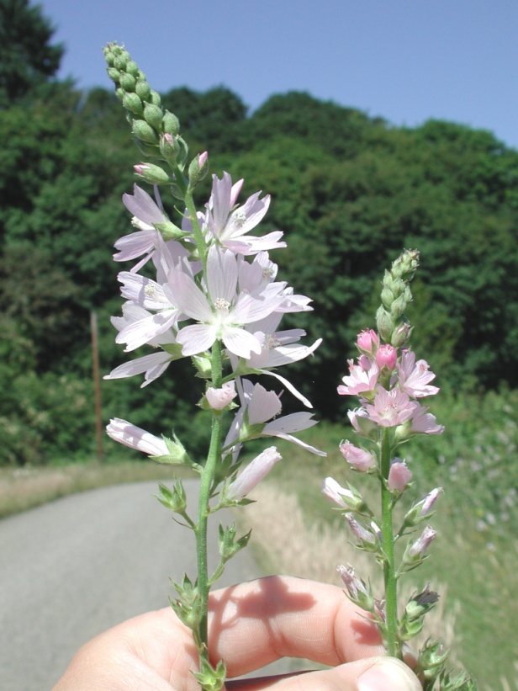

Meadow checkerbloom flowering stalks: bisexual flowers on the left and female flowers on the right. Photo by Steven Gisler, June 2001.

Flowering period is from June to August. The fruit is a schizocarp which contains 7 to 9 single-seeded, beaked carpels about 1/8 inch long that form a ring, like the segments of an orange, and separate at maturity to fall from the parent plant.

Meadow checkerbloom grows in meadows and prairies, as well as along roadsides and the edges of woodlands, wetlands and riparian areas. Its native distribution extends throughout the Willamette Valley of Oregon at elevations below 700 ft. It was introduced, probably as a garden plant, to the Seattle, Washington area, but it rarely persists there. For updated distribution, please consult the Plant Profile page for this species on the PLANTS Web site.

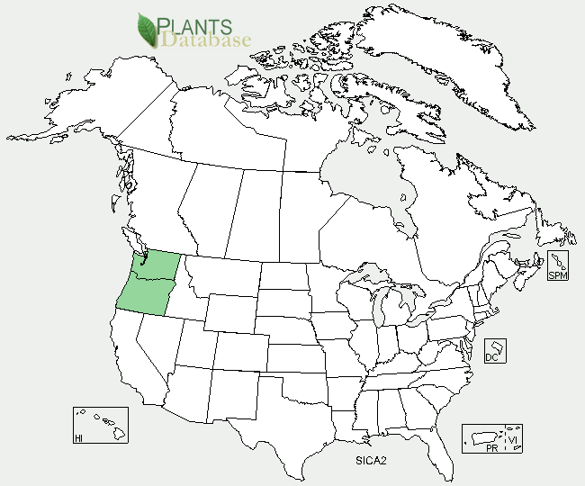

Meadow checkerbloom distribution from USDA-NRCS PLANTS Database.

### Establishment and Seed Production

Meadow checkerbloom can be established with moderate ease by direct seeding, transplanting plugs, or from divisions. The seeds exhibit some physical dormancy so germination rates are improved by lightly scarifying the seed coat with sandpaper prior to sowing; seedlings generally emerge within two weeks. Seed can be broadcast at a rate of 4 pounds per acre or drilled no deeper than ¼ inch at a rate of 2 pounds per acre for single species plantings. There are approximately 100,000 seeds per pound, so a seeding rate of one pound pure live seed per acre results in about 2 live seeds per square foot. For prairie restoration or pollinator plantings, plugs should be planted on 3-foot centers in clumps resulting in a total of about 4,840 plants per acre.

For seed production, fields are generally established from transplanted plugs, and seed can be harvested the first year. Large fields can be direct combined, while small fields are generally swathed and the material is collected to dry on tarps before cleaning.

### Management

Most remaining populations of meadow checkerbloom exist along roadsides or fences, so spray programs are a threat to the survival of this species in the wild. Other threats to remnant populations include habitat loss to agricultural and urban development, displacement by invasive weeds, and encroachment by trees and shrubs.

### Color photo of meadow checkerbloom in flower along a fencerow in Linn County, Oregon in June 2001. Photo by Steven Gisler.

Remnant population of meadow checkerbloom along a fencerow in Linn County, OR. Photo by Steven Gisler, June 2001.

### Pests and Potential Problems

Seed weevils can cause significant pre-dispersal damage to seeds, reducing seed yields or preventing natural reseeding, but predators can be significantly reduced through the use of a synthetic pyrethroid insecticide applied early in the flowering season. Please contact your local agricultural extension specialist or county weed specialist to learn what works best in your area and how to use it safely. Always read label and safety instructions for each control method. Trade names and control measures appear in this document only to provide specific information. USDA NRCS does not guarantee or warranty the products and control methods named, and other products may be equally effective.

### Environmental Concerns

No environmental concerns are known at this time.

### Cultivars, Improved, and Selected Materials (and area of origin)

None, but seed is sometimes available from commercial sources in the Pacific Northwest.

### Prepared By

*Annie Young-Mathews,* Conservation Agronomist

USDA-NRCS Corvallis Plant Materials Center, Oregon

### Citation

Young-Mathews, A. 2012. Plant fact sheet for meadow checkerbloom (*Sidalcea campestris)*. USDA-Natural Resources Conservation Service, Plant Materials Center, Corvallis, OR.

Published June 2012

Edited: 12Jan2012 dcd; 12Jan2012 klp; 13Jan2012 ab; 17Apr2012 jab

For more information about this and other plants, please contact your local NRCS field office or Conservation District <<http://www.nrcs.usda.gov/>>, and visit the PLANTS Web site <[http://plants.usda.gov](http://plants.usda.gov/)> or the Plant Materials Program Web site <<http://plant-materials.nrcs.usda.gov>>

**USDA IS AN EQUAL OPPORTUNITY PROVIDER AND EMPLOYER**