

Plant Fact Sheet

# AWNLESS BUSHSUNFLOWER

## Simsia calva (Engelm. & A. Gray) A. Gray

Plant Symbol = SICA7

Contributed by: USDA NRCS James E. “Bud” Smith Plant Materials Center, Knox City, Texas

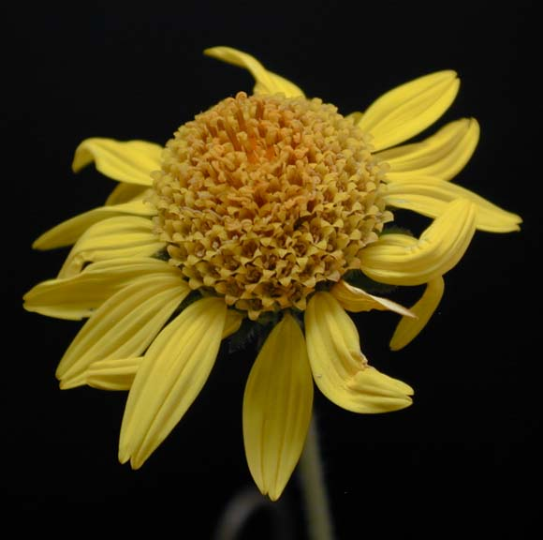Texas A&M University System

Uses

*Wildlife:* Awnless bushsunflower provides a high protein browse for deer, as well as seed which is eaten by songbirds.

*Livestock:* Awnless bushsunfloweris a good source of protein that is easily digested by both sheep and goats.

*Erosion Control:* Awnless Bushsunflower is used as a component of seed mixtures to prevent soil erosion. It is commonly used in revegetation of surface mined lands.

**Status**

Please consult the PLANTS Web site ([http://plants.usda.gov](http://plants.usda.gov/)) and your State Department of Natural Resources for this plant’s current status (e.g. threatened or endangered species, state noxious status, and wetland indicator values).

**Weediness**

This plant may become weedy or invasive in some regions or habitats and may displace desirable vegetation if not properly managed. Please consult your local NRCS Field Office, Cooperative Extension Service office, state natural resource, or state agriculture department regarding its status and use. Weed information is also available from the PLANTS Web site at http://www.plants.usda.gov. Please consult this and Related Web Sites and view the plant profile for this species for further information.

**Description**

Awnless bushsunflower is a native, perennial warm-season forb that grows 1½ to 3 feet tall. The plant stands upright with multi-branches and a large woody or fleshy taproot. The leaves of the awnless bushsunflower have an arrowhead appearance with jagged edges. Older leaves at the bottom of the plant measure about two inches long while the newer leaves at the top are much shorter. The stem splits into three separate stalks, each with its own flower. Each flower is 1 to 1½ inches wide with yellow petals and a yellowish center.

**Adaptation**

Awnless bushsunflower is primarily adapted to the Edwards Plateau, but it also performs well in the western Gulf Coast Prairies, Rio Grande Plain, and Central Rolling Red and Grand Prairies. It desires full sun, well-drained soils like sandy or clay loams. Awnless bushsunflower does not tolerate salinity, deep sands, heavy clays or wet bottomlands.

*Distribution*: Please consult the Plant Profile page for this species on the PLANTS Web site.

**Establishment**

Awnless bushsunflower should be planted in the spring on a clean, firm seedbed. Seed should be placed ¼ to ½ inch deep, but never covered more than ½ inch. Fertilizer applications will vary depending on individual soil samples. Nitrogen, potassium, and phosphorus should be added to attain a medium fertility level. A soil sample should always be taken before applying fertilizer. Awnless bushsunflower should be planted at a rate of 2.6 lbs pure live seed (pls) per acre. When planting this as a component of a seed mixture, the seeding rate should be adjusted to the desired percent of the mix.

**Management**

Awnless bushsunflower is rarely planted as a monoculture planting but as a component of a range seeding mixture. At a minimum, one full growing season of grazing deferment should be planned and applied to allow plant establishment. Awnless bushsunflower does not tolerate continuous grazing or heavy overuse.

Proper management of awnless bushsunflower is required to ensure the plant is not overgrazed or over utilized by livestock or wildlife. Consult your local NRCS Field Office for assistance with planning and applying prescribed grazing.

**Control**

Please contact your local agricultural extension specialist or county weed specialist to learn what works best in your area and how to use it safely. Always read label and safety instructions for each control method. Trade names and control measures appear in this document only to provide specific information. USDA NRCS does not guarantee or warranty the products and control methods named, and other products may be equally effective.

**Pests and Potential Problems**

None known

**Cultivars, Improved, and Selected Materials (and area of origin)**

‘Plateau’ awnless bushsunflower was released from the James E. “Bud’ Smith Plant Materials Center, Knox City, TX in 1987 to provide an adapted forb for inclusion in range mixes for wildlife and livestock browse.

Always read label and safety instructions for each control method. Trade names and control measures appear in this document only to provide specific information. USDA NRCS does not guarantee or warranty the products and control methods named, and other products may be equally effective.

### Awnless bushsunflower in bloom

*USDA NRCS 2009*

### Prepared By

Brandon Carr, USDA NRCS James E. “Bud” Smith Plant Materials Center, Knox City, Texas

Published: November, 2009

Edited:

For more information about this and other plants, please contact your local NRCS field office or Conservation District <<http://www.nrcs.usda.gov/>>, and visit the PLANTS Web site <[http://plants.usda.gov](http://plants.usda.gov/)> or the Plant Materials Program Web site <<http://plant-materials.nrcs.usda.gov>>

.

**USDA IS AN EQUAL OPPORTUNITY PROVIDER AND EMPLOYER**