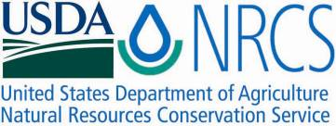

Plant Fact Sheet

# COMpassplant

*Silphium laciniatum* L.

Plant Symbol = SILA3

Contributed by: USDA NRCS Plant Materials Center Manhattan, Kansas

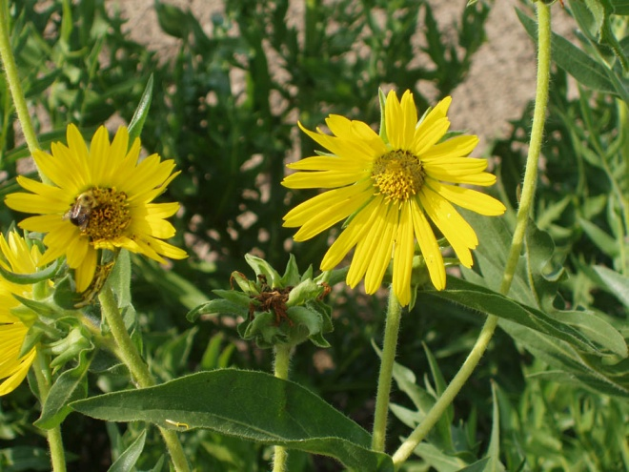

Alan Shadow, NRCS, East Texas PMC, Nacogdoches, TX

Alternate Names

Rosinweed, gum weed, cut-leaf silphium, or turpentine plant

Uses

*Livestock*: It is reported that compass plant is palatable and nutritious and grazed by livestock especially in its juvenile state. It will decrease in heavily grazed pastures and eventually be removed from the site in continuously grazed situations.

*Native Americans*: The powdered root of compass plant was used by the Pawnees to make a tea for individuals with general debility. The Indian children of several tribes used the resinous sap as a chewing gum to cleanse their teeth and sweeten their breath.

*Wildlife*: Small mammals and birds eat the seed of compass plant. In grasslands the compass plant provides a sturdy perch for prairie song birds. The eastern kingbirds use the compass plant as a perch to locate and capture grassland insects.

Status

Please consult the PLANTS Web site and your State Department of Natural Resources for this plant’s current status (e.g. threatened or endangered species, state noxious status, and wetland indicator values).

Description and Adaptation

*General*: Compass plant is a long lived, perennial member of the sunflower family. Its basal leaves and stems all arise from an underground crown. A large reddish brown tap root 1 to 2 inches in diameter is located just below the crown. The tap root rapidly looses diameter as it descends up to 16 feet into the prairie soil. The large basal leaves can be 15 to 24 inches long and are deeply cut like a giant pin oak leaf. The rigid, sand paper like leaves orient themselves in a north to south direction to avoid the direct rays of the midday sun, thus leading to the plants common name, compass plant. Stems are erect and number from one to several with an overall height of from 3 to 10 feet. The simple leaves are alternately arranged on the stem and are less divided, smaller and have direct attachment higher up on the stem. Leaves are leathery and stiff with rough surfaces and hairs occurring on the leaf main veins. Large yellow flower heads from 2 to 4 inches across are conspicuous on the upper half to two thirds of the stem in small clusters. Flowering begins in late June and proceeds through August. Flower heads begin opening at the top of the stem first. There are 15 to 34 narrow yellow petal flowers (ray florets) that are 1 to 2 inches long. The center of the flower contains the numerous disk florets with yellow corollas. The fruit is a flattened achene about ½ inch long with a notched tip. Achenes develop on the outside of the head since the ray florets are the only fertile seed producing units on the flower.

*Distribution*: Please consult the Plant Profile page for this species on the PLANTS Web site. Compass plant grows in the eastern half of Kansas. It is found in the eastern section of the Great Plains from North Dakota to Texas and east to Ohio and Alabama.

Establishment

The easiest way to propagate compass plant is by planting stratified seed in the spring or unstratified seed in the fall. Moist stratification (60 days at 40 degrees F) and scarification will promote germination of this species. To scarify the seed, nick the seed coat with a sharp knife prior to planting. The initial year the seedling will exist as a single leaf, and it will normally take two to three years for the plant to mature and reproduce sexually. Much of the plants energy and carbon are invested in extensive root production the first few years.

Management

Seed heads can be harvested from production fields in late August or September. The seed heads can be run through a hammer mill to break out the seed units and release the achenes. Then the achenes can be run through a two screen cleaner to increase purity of the product. The seed can be cleaned to a purity of 48 percent with approximately 18,400 seeds per pound. Seed lots cleaned at the Manhattan PMC have had purities as great as 96 % and a germination of 88 %.

Compass plant seedlings have only a single leaf their first year of growth. Speculation has it that compass plant will not produce flowers until the second or third year of growth. Other plant enthusiasts indicate that perhaps compass plant needs four or five years to produce flowers and seed. Should compass plant be grown as a specimen plant it may need to be staked up to prevent its stems from being blown over by the wind.

Pests and Potential Problems

A disease was noted and studied on compass plant grown in Poland as a horticultural crop. The disease symptoms were noticed on approximately 15 percent of the population of plants. The plants exhibited stunting, yellowing and reduced inflorescence production. Oblong brown-purplish lesions were noticed on the plants stems in July. The causal agent isolated from the lesions was *Alternaria alternata* which was subsequently grown on artificial media and used to re-infect compass plant seedlings.

Compass plant, grown in a cultivated situation, has also been known to have stems blown down when subjected to strong winds at full maturity.

Environmental Concerns

Compass plant does not spread vegetatively except as the clump of the original plant grows in diameter. This plant volunteers easily from seed, but does not spread actively.

Cultivars, Improved, and Selected Materials (and area of origin)

Two compass plant germplasm lines, NF-1 and NF-1 Profuse Ligule, were developed by the Samuel Roberts Noble Foundation Inc. in Ardmore, OK. These germplasm lines should be useful in developing improved cultivars, novel germplasm, as well as studying the biology, ecology, and genetics of the compass plant. Seed stocks of the two lines will be maintained by the Biotechnology Group at the Noble Foundation.

Prepared By and Species Coordinator:

*Richard Wynia*, USDA NRCS Manhattan Plant Materials Center, Manhattan, KS

### Citation

Wynia, R. 2009. Plant fact sheet for compassplant (Silphium laciniatum L.). USDA-Natural Resources Conservation Service, Kansas Plant Materials Center, Manhattan, Kansas 66502

Published June, 2009

Edited: 090529 jsp

For more information about this and other plants, please contact your local NRCS field office or Conservation District <<http://www.nrcs.usda.gov/>>, and visit the PLANTS Web site <[http://plants.usda.gov](http://plants.usda.gov/)> or the Plant Materials Program Web site <<http://plant-materials.nrcs.usda.gov>>

**USDA IS AN EQUAL OPPORTUNITY PROVIDER AND EMPLOYER**