

Plant Fact Sheet

# Missouri Goldenrod

## Solidago missouriensis Nutt.

Plant Symbol = SOMI2

#### Contributed by: NRCS Plant Materials Center, Pullman, WA

### Photo of Missouri goldenrod by Rod Gilbert, University of Washington Burke Herbarium

*Solidago missouriensis*. Rod Gilbert, University of Washington Burke Herbarium

### Alternate Names

Prairie goldenrod, Tolmie’s goldenrod (*S. missouriensis* var. *tolmieana*)

### Uses

*Pollinator habitat: Solidago* species provide vital sources of pollen and nectar for bees and other insects in the late summer and fall throughout North America.

*Rangeland revegetation:* Missouri goldenrod can be used for revegetation of disturbed areas, for mine spoil reclamation, and soil stabilization.

*Forage:* This plant has poor forage value, however may be grazed by sheep, cattle, deer and antelope.

*Ethnobotanical:* Native Americans chewed leaves and flowers of this plant to relieve sore throats, and chewed roots to relieve toothache (Stubbendieck et al. 2003).

*Ornamental:* Missouri goldenrod is not typically planted in a landscaped setting due to its spreading rhizomatous growth. However, it is possible to manage plants by planting in a pot submersed in the ground, or by removing new growth each year. Seed dispersal can be controlled by removing flower heads prior to seed ripening.

### Status

Missouri goldenrod is the state flower of Nebraska, and is listed as threatened in Michigan. Consult the PLANTS Web site and your State Department of Natural Resources for this plant’s current status (e.g., threatened or endangered species, state noxious status, and wetland indicator values).

### Weediness

Goldenrods have a reputation of being weedy due to their aggressive rhizomatous growth. However, in stable rangeland environments they seldom achieve densities that are problematic. Please consult with your local NRCS Field Office, Cooperative Extension Service office, state natural resource, or state agriculture department regarding this plant’s status and management.

### Description and Adaptation

*General*: Sunflower family (Asteraceae). *Solidago missouriensis* is a native, warm-season, short-lived perennial. Stems grow singularly or in group from a woody base or creeping rhizome. Stems are reddish-green, smooth, slender, erect and are 8 to 36 inches tall. Leaves are alternate, triple-nerved and have entire or sparsely serrated edges. Basal leaves are up to 12 inches long and 1 inch wide, and have short petioles. Upper leaves are smaller and sessile. Numerous inflorescences form on curved panicle branches. Inflorescences have 7 to 13 yellow disc flowers and 8 to 13 yellow ray flowers, and bloom July through October. Seeds are brown, cylindrical, smooth or hairy, and have white bristly pappus.

Missouri goldenrod is adapted to areas receiving 12 to 35 inches of annual precipitation at elevations up to 10,600 feet. Plants grow well in sandy loam to clay loam soils, and poorly in gravel or dense clay. Plants are tolerant of weakly acidic to moderately basic and weakly saline soil.

Plants grow on dry, open slopes in upland prairies, plains, meadows, deciduous and evergreen forests, deserts, and along roadsides, railroads, ditches and fences.

Missouri goldenrod is found in most Midwestern and western states in the U.S., and in the south-central and southwest provinces of Canada. There are four varieties: var. *fasciculata,* var. *missouriensis*, var. *tenuissima*, and var. *tolmieana* (Tolmie’s goldenrod). For current distribution of this species and varieties, consult the Plant Profile page on the PLANTS Web site.

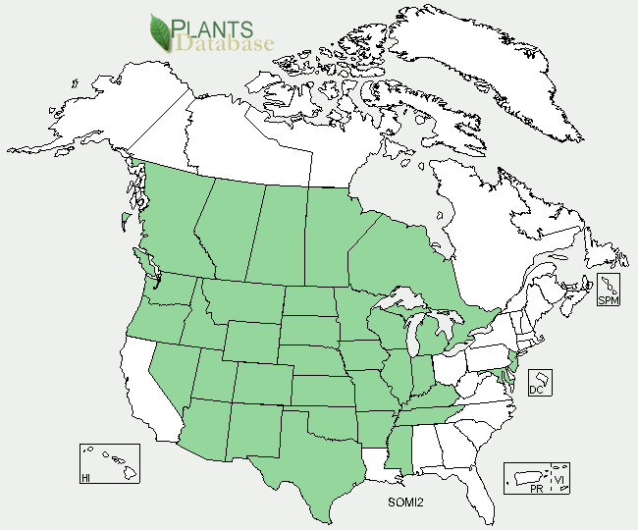

Missouri goldenrod distribution from the USDA PLANTS Database

### Establishment

Plants can be established by seed, seedlings, or rhizomes. Seed should be planted into a firm, weed-free seed bed at a rate of 1 lb PLS/ac and at a depth of 0.125 to 0.25 inches. If planted in a mix, the seeding rate should be adjusted according to the proportion of the mix. The seed does not require a cold moist period for optimal germination (Skinner 2004) therefore can be planted in the spring or fall.

Plants established by seedlings can be started by sowing seed in containers in January and placed in a greenhouse. Seed should be covered lightly with soil and kept moist until germination. A layer of pea gravel can be applied to the soil surface to prevent seeds from floating. Plants should be moved to a cold-frame in late March or early April and hardened off for 2 to 4 weeks prior to transplanting into a prepared field site in early May. Plants should be spaced 1 to 2 feet apart.

### **Plants can also be established by rhizomes. Sections of rhizomes should be collected from cultivated plants or approved areas, kept moist during transport, and replanted in a prepared field site.**

### Management

### This plant spreads by rhizomes and by seed. Where plant spread is not desired, seedlings should be planted in a large pot or barrel submersed in the soil, or new growth should be cut and removed each year. To prevent seed dispersal, flower heads should be removed prior to seed ripening. Plants will withstand vigorous cutting, and will regrow if cut during the growing season.

### Pests and Potential Problems

### Missouri goldenrod can be damaged by a native leaf feeding beetle, *Trirhabda canadensis* (Skinner 2004).

### Environmental Concerns

### This plant may form dense stands in some habitats, particularly where ground is open and disturbed. To prevent dense stands from forming, seed Missouri goldenrod at low densities or plant in small areas.

### Control

If control of this species is desired, contact your local agricultural extension specialist or county weed specialist to learn what works best in your area and how to use it safely. Always read label and safety instructions for any control method.

### Cultivars, Improved, and Selected Materials (and area of origin)

None, however seed and seedlings are available from multiple vendors.

### Prepared By

*Pamela L.S. Pavek*, USDA NRCS Plant Materials Center,

Pullman, Washington

**References**

Skinner, D. 2007. Unpublished data. USDA NRCS Plant Materials Center, Pullman, WA.

Stubbendieck, J., S.L. Hatch and L.M. Landholt. 2003. North American Wildland Plants: A Field Guide. University of Nebraska Press, Lincoln and London.

### Citation

Pavek, P.L.S. 2012. Plant fact sheet for Missouri goldenrod (*Solidago missouriensis*). USDA-Natural Resources Conservation Service. Pullman, WA.

Published June 2012

Edited: 18May2012jab; 25June2012plsp

For more information about this and other plants, please contact your local NRCS field office or Conservation District <<http://www.nrcs.usda.gov/>>, and visit the PLANTS Web site <[http://plants.usda.gov](http://plants.usda.gov/)> or the Plant Materials Program Web site <<http://plant-materials.nrcs.usda.gov>>

**USDA IS AN EQUAL OPPORTUNITY PROVIDER AND EMPLOYER**