# INDIANGRASS

## Sorghastrum nutans (L.) Nash

Plant Symbol = SONU2

Contributed by: USDA NRCS Jimmy Carter Plant Materials Center, Americus Georgia

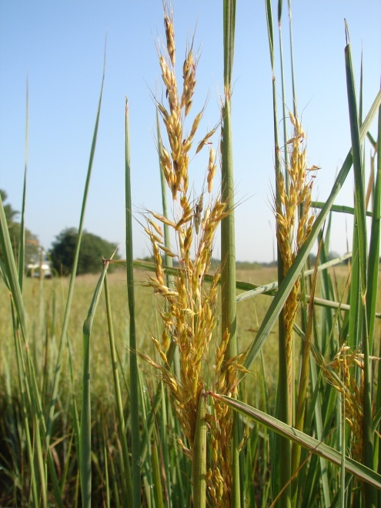

Mike Owsley

Jimmy Carter Plant Materials Center

Americus, Georgia

### Alternate Names

Indian grass and yellow indiangrass

### Uses

*Erosion control*: Critical areas, roadside cover and areas subject to wind erosion

*Livestock*: Indiangrass growing singly, or in mixtures with other native grasses, provide livestock forage on rangeland, pastureland, and hayland. Forage quality is high when green and fair when mature.

*Pollinators:* Indiangrass constitutes part of the native plant community in support of pollinators.

*Restoration:* Indiangrassis used in restoration of native prairie areas and longleaf pine understory sites.

*Wildlife*: White-tailed deer browse Indiangrass foliage. A mix of Indiangrass and other native warm-season grasses and forbs provide nest, brood and escape cover for bobwhite quail. Indiangrass seed is consumed by birds and small mammals.

### Status

Please consult the PLANTS Web site and your State Department of Natural Resources for this plant’s current status (e.g., threatened or endangered species, state noxious status, and wetland indicator values).

### Weediness

This plant may become weedy or invasive in some regions or habitats and may displace desirable vegetation if not properly managed. Please consult with your local NRCS Field Office, Cooperative Extension Service office, state natural resource, or state agriculture department regarding its status and use. Weed information is also available from the PLANTS Web site at [http://plants.usda.gov](http://plants.usda.gov/). Please consult the Related Web Sites on the Plant Profile for this species for further information.

### Description and Adaptation

Indiangrass (*Sorghastrum* *nutans* [ L.] Nash), is a native, rhizomatous, perennial, warm-season bunchgrass. It is a major component of the tall grass vegetation which dominated the prairies of the central and eastern United States. It is common in longleaf pine understory communities. Indiangrass grows 3 to 7 feet tall. Even when young, it can be distinguished by the “rifle-sight” ligule occurring where the leaf blade attaches to the leaf sheath. The leaf blades grow to 3 feet long, and narrow at the point of attachment. The seed head is a single, narrow, bronze-yellow plume-like panicle maturing to brown. The seed is light and fluffy with small awns attached. There are approximately 175,000 seeds per pound. Indiangrass is adapted from Florida, north to Canada, and west to North Dakota, Wyoming, and Utah. It grows well in deep, well-drained floodplain soils and in well-drained upland sandy loam soils. It is tolerant of poor and well-drained soils, acid to alkaline conditions, and textures from sand to clay.

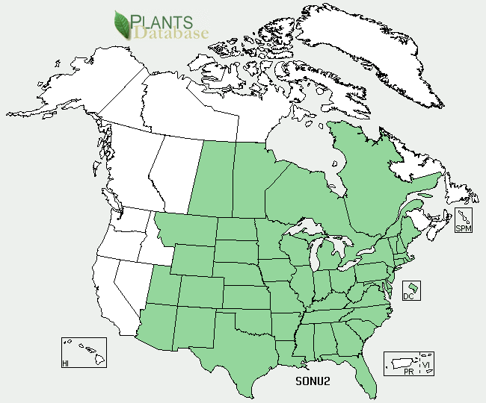

Indiangrass distribution from USDA-NRCS PLANTS Database.

For updated distribution, please consult the Plant Profile page for this species on the PLANTS Web site.

**Establishment**

Indiangrass requires a soil temperature above 50°F for germination. Dormant seedings have not been successful. The optimum time to plant is from early May to late June. In the southern states planting is recommended after last threat of frost but before hot dry conditions of summer.

The seed is light and has small awns attached. Debearding removes the awns producing a free-flowing product. The planting site should be free of weeds. A moist, firm seedbed is essential. Firming the soil with a roller packer before and after seeding helps to ensure that the seed is placed at the recommended seeding depth of 1/8 to 1/4 inch. Packing after planting is especially important if seeded with a broadcast spreader.

If drilled for pasture conditions, use 6 to 8 pounds PLS (pure live seed) per acre. For broadcast seedings, use 10 pounds per acre. The seeding rate for mixed pastures of Indiangrass, switchgrass, big bluestem and little bluestem are 2 pounds PLS each per acre. Seeding rates for other uses will normally be lower than the pasture rate. Indiangrass has strong seedling vigor, but stands develop slowly where there is competition from broadleaf weeds and cool-season grasses. To minimize the amount of exposed weed seed in seedings use no-till establishment methods. Cool season grasses must be controlled before seeding. Indiangrass is tolerant to most broadleaf herbicides. It is important to follow label instructions for application amounts and grazing requirements.

The most common cause of failure of native warm-season grasses is a loose seedbed and improper seed placement. The seedbed should be firm, showing only a light footprint.

### Management

Fertilizing with moderate amounts of phosphorus and potassium are recommended for establishment. Applications of nitrogen are not recommended until the grass is established. In the establishment year, 20 to 40 pounds per acre of phosphorus and potassium may be applied in late summer. In the second year, phosphorus and potassium may be applied in the early summer at a rate of 40 to 80 pounds per acre. In future years fertilizer may be applied to enhance vigor for forage production and erosion control. Indiangrass used for purposes other than pasture will require minimal if any fertilization.

Properly managed and maintained stands of Indiangrass should not require replanting. Poor stands can be rejuvenated using management practices, such as controlled grazing, the application of herbicides and fertilizer, and prescribed burning. Nitrogen, phosphorus, and potassium fertilizer should be applied according to soil tests.

In rotational grazing systems, remove no more than ½ the above ground growth (no shorter than 8 to 12 inches). With care, the stand will last indefinitely. Forage quality will remain high until the seed head emerges. Grazing should begin when grass is 18 to 20 inches in height. Overgrazing can damage the stand and should be stopped when the plants are grazed to within 8 inches of the soil level. Leaving this much stubble before frost allows the plants to store carbohydrates and ensures the production of vigorous plant growth in the spring.

Prescribed burns increase vigor in the plant and improve its ability to control erosion and increase forage production. They are essential in restoration and wildlife plantings.

### Pests and Potential Problems

During exceptionally wet summers Indiangrass can be attacked by rust. Armyworms can become a problem in dry years.

### Environmental Concerns

Cultivars developed for forage production may dominate native Indiangrass stands in natural plant communities and restoration sites.

### Control

Please contact your local agricultural extension specialist or county weed specialist to learn what works best in your area and how to use it safely. Always read label and safety instructions for each control method. Trade names and control measures appear in this document only to provide specific information. USDA NRCS does not guarantee or warranty the products and control methods named, and other products may be equally effective.

### Cultivars, Improved, and Selected Materials (and area of origin)

‘Holt’ (NE), ‘Llano’ (NM), ‘Lometa’ (TX), ‘Osage’ (KS and OK), ‘Oto’ (NE and KS), ‘Rumsey’ (IL), ‘Tomahawk’ (ND and SD); ‘Americus’(GA/AL); Cheyenne (informal release, OK); source identified releases from northern, central, and southern Iowa, and northern and western Missouri.

### Prepared By: Jimmy Carter Plant Materials Center

### Citation

Owsley, Mike, 2011. Plant fact sheet for Indiangrass (*Sorghastrum nutans[ L.]* Nash). USDA-Natural Resources Conservation Service, Jimmy Carter PMC Americus, Georgia 31719.

Published: February, 2011

Edited: e.g., 08Sep2009 rg, 08Sep2009 jfh; 17Sep2009 jfe, 10 Feb2011 cmo

For more information about this and other plants, please contact your local NRCS field office or Conservation District <<http://www.nrcs.usda.gov/>>, and visit the PLANTS Web site <[http://plants.usda.gov](http://plants.usda.gov/)> or the Plant Materials Program Web site <<http://plant-materials.nrcs.usda.gov>