|  |
| --- |
| composite dropseed |
| ***Sporobolus compositus* (Poir.) Merr. var. *compositus*** |
| Plant symbol = SPCOC2 |

Contributed By: USDA NRCS National Plant Data

# *Center*

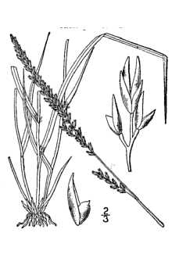

Britton & Brown 1913

@ plants.usda.gov

# *Alternate names*

rough dropseed, meadow dropseed, tall droopseed, and dropseeed

## Uses

Composite dropseed is tough and wiry and is not grazed as readily as tall or hairy dropseed. Cattle and horses graze it in winter when associated grasses are dormant.

## Status

Please consult the PLANTS Web site and your State Department of Natural Resources for this plant’s current status, such as, state noxious status and wetland indicator values.

## Description

Grass Family (Poaceae). Composite dropseed is a warm-season, perennial bunch grass. The height ranges from 2 to 4 feet. The leaf blade is flat and narrow; at least 20 inches long and rolls inward, and becomes threadlike at the tip. The leaf sheath is shorter than internodes. The upper sheath, often inflated, encloses seedhead. The ligule has a short and hairy membrane. The seedhead is narrow purplish panicle usually 3 to 8 inches long; spikelets 1‑flowered and wedge shaped.

# Management

This grass increases on ranges that are grazed only in summer because associated grasses are more palatable. If it is the key management species during the winter grazing season, no more than 50 percent of current year's growth by weight should be grazed off.

# Establishment

Growth starts in late winter or early spring. Seedheads form in August. Some leaves remain green in the dense bunches through winter. It is best adapted to deep clay soils that is intermittently wet and dry. It does not grow on soils with a high water table or on deep sandy soils.

## Cultivars, Improved and Selected Materials (and area of origin)

Please contact your local NRCS Field Office.

**Reference**

Leithead, H.L., L.L. Yarlett, & T.N. Shiflett. 1976. 100 native forage grasses in 11 southern states. USDA SCS *Agriculture Handbook No. 389*, Washington, DC.

## Prepared By & Species Coordinator:

*Percy Magee*

USDA NRCS National Plant Data Center, Baton Rouge, Louisiana

Edited: 13may02 ahv; jul03 ahv; 20sep05 jsp