

Plant Fact Sheet

# ROSE SPIREA

## Spiraea douglasii Hook

Plant Symbol = SPDO

Contributed by: USDA NRCS Plant Materials Center, Corvallis, Oregon

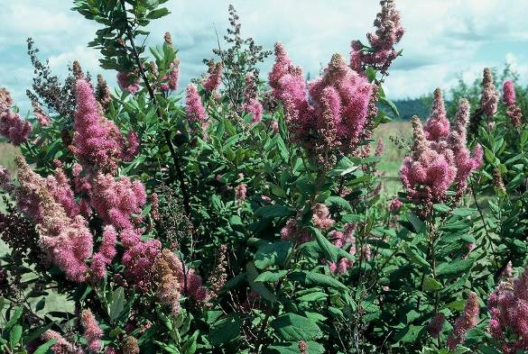

Photo by Dale Darris

**Alternate names**

There are two botanical varieties, var. *douglasii* and var. *menziesii*, with the latter referred to as Menzies’ spirea. Other common names include Douglas spirea, Western spirea, hardhack, steeplebush, meadowsweet, and pink spirea.

**Uses**

Rose spirea is useful for stabilization of stream-banks and shorelines as well as the restoration of wetlands including marshes, bogs, and open swamps. Limbs are suitable for branch packing, fascines, and other soil bioengineering practices. In some cases this species should be planted sparingly at best because of its ability to spread and dominate favorable sites. Rose spirea withstands competition from wetland grasses better than certain other woody species. If not severely shaded when young, it may also compete well with exotic reed canarygrass.

Rose spirea provides good cover for birds and small mammals. Grouse apparently eat the dried spikes and other wildlife consume the seed filled capsules. The flowers are a source of nectar for hummingbirds, butterflies, and other pollinator insects. Although occasionally browsed by deer and livestock, it is considered poor forage and little mention is made concerning its nutritional value and palatability. Native Americans made minor use of this plant. At least one tribe used the seeds to make a tea for the treatment of diarrhea. The branches were used to spread and cook salmon, hang salmon for drying and smoking, and make brooms. With its attractive and fragrant flower clusters, rose spirea is used for naturalistic landscaping, ponds, hedges, and screens. The canes and dry flower heads provide visual interest in winter.

**Description**

Rose spirea is a deciduous shrub in the Rose family that grows 2 to 7 ft tall, has upright slender limbs, and spreads by suckers (under-ground shoots) to form dense thickets. The leaves are oblong to elliptical in shape, 1 to 3 in. long, lighter and sometimes wooly beneath, and toothed along the upper half of the margins. Tiny, fragrant reddish pink flowers are borne in dense, elongate clusters at the end of shoots. The clusters appear ‘fuzzy’ from the abundance of long stamens. Flowering occurs from June to September. The fruit is a smooth, dry follicle that persists in winter. This species hybridizes in the wild with white spirea (*Spiraea betulifolia*).

**Status**

Please consult the Plants Web site and your State Department of Natural Resources for this plant’s current status, such as state noxious and wetland indicator values.

**Adaptation**

Rose spirea grows best in full sun to dappled shade and in a wide range of soils (gravelly sandy loams to heavy clays) that range from acidic to neutral (pH 4.5-7.5) and from moist well drained to wet and poorly drained (hydric). The species tolerates extended periods of flooding and perpetually water-logged soils. Only the most severe fires will eliminate regrowth from basal portions and suckers.

*Distribution*- Rose spirea occurs naturally from southern Alaska south to northern California and east to western Montana. The elevation range is sea-level to 6,500 ft in the mountains. Habitat includes damp meadows, riparian zones, bogs, marshes, open swamps, and the margins of ponds and lakes. It is a member of many willow, alder, freshwater marsh, moist coniferous forest, scrub shrub and semi-aquatic plant communities.

**Limitations or environmental concerns**

Rose spirea may be susceptible to fire blight disease which causes dieback of tips and scorched looking leaves. It is host to several insect pests including aphids, leaf rollers, and scales. This species can become invasive, as it spreads readily by suckers and seedlings, especially on flat, moist to wet sites in full sun. Dense thickets can become nearly impenetrable and too competitive for other desirable plant species. It may not be suitable for small areas without regular management. The species is a mild allergen. Some authorities list it as nonpoisonous. Others describe it as poisonous, possibly because spireas in general are known to contain aspirin like compounds which in concentrated form are toxic if taken internally.

[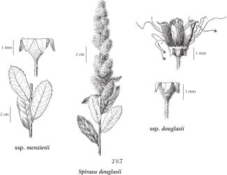](http://linnet.geog.ubc.ca/Images/Drawings/big/PDROS1Q050.jpg)

Reprinted with permission, Univ. of WA Press

**Establishment**

Rose spirea is readily propagated by softwood, semi-hardwood, and dormant hardwood cuttings, layering, rhizome and root segments (in spring), division, and seed. With spring cuttings, some suggest making a slice cut at the basal end, soaking in water for several weeks in a cooler, and dipping in a rooting hormone (1000 ppm IBA-talc or solution) before planting into a light rooting medium. Mist benches and bottom heat may also improve rooting. If installed properly in fall or winter, a fair percentage of untreated hardwood cuttings (18 in or longer) can root and establish directly on suitable, moist revegetation sites. As with rooted stock, mulch, first year irrigation, and weed suppression are beneficial for establishment in the nursery and field.

Seed is collected in fall when the fruits turn dry and brown and then extracted from the capsules by shaking or tumbling. Store the seed under cool dry conditions.Germination occurs quickly without seed treatment if little drying has occurred prior to sowing. Otherwise, the seed may require 1 to 3 months of prechilling (moist cold stratification at 33 to 38°F) or fall sowing to break dormancy over winter.

**Improved cultivars and selected materials (and area of origin)**

For streambank stabilization and rehabilitation of wetlands at low elevation in western Oregon and Washington, the NRCS Plant Materials Center, Corvallis, OR, and the Agricultural Experiment Stations of Oregon and Washington released ‘Bashaw’ Douglas spirea. Clonally propagated, it originated from a stand in Snohomish Co., WA. Until more is known about the genetic variation of this species in relation to the environment, material originating from the same region, same elevation band (low, mid, high), and similar habitat should be favored for revegetation.

**Prepared by**

Dale Darris and Pete Gonzalves, USDA NRCS Plant Materials Center, Corvallis, Oregon.

**Species coordinator**

Dale Darris, USDA NRCS Plant Materials Center, Corvallis, Oregon.

Published September, 2009

Edited:

For more information about this and other plants, please contact your local NRCS field office or Conservation District <<http://www.nrcs.usda.gov/>>, and visit the PLANTS Web site <[http://plants.usda.gov](http://plants.usda.gov/)> or the Plant Materials Program Web site <<http://plant-materials.nrcs.usda.gov>>

**USDA IS AN EQUAL OPPORTUNITY PROVIDER AND EMPLOYER**