|  |
| --- |
| intermediate wheatgrass |
| *Thinopyrum intermedium* (Host) Barkworth & D.R. Dewey |
| Plant Symbol = THIN6 |

Contributed by: USDA NRCS Plant Materials Program

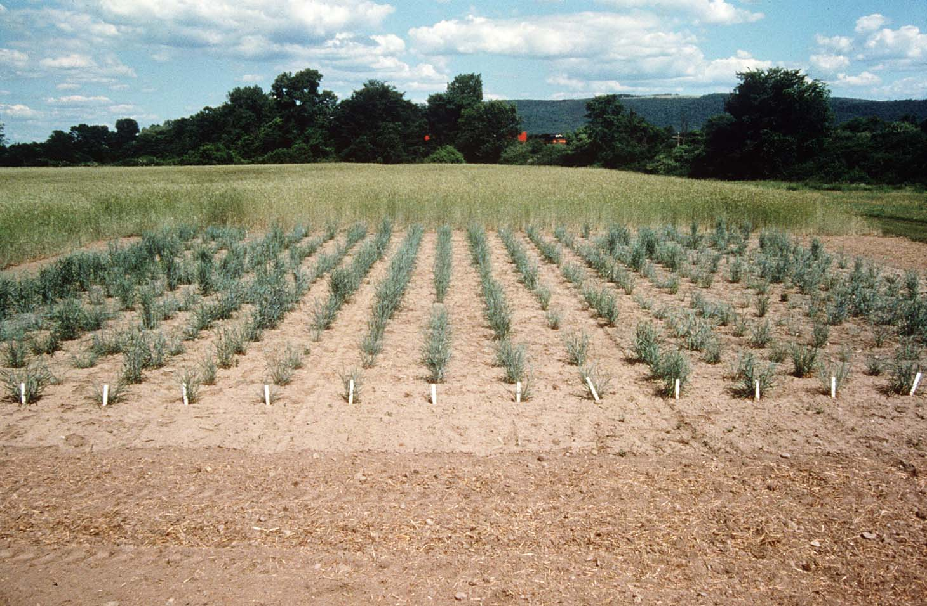

Big Flats Plant Materials Center

Big Flats, NY

Alternate Names

pubescent wheatgrass, Elytrigia intermedia (Host) Nevski, Agropyon intermedium (Host) Beauv.

Uses

*Grazing/pastureland/hayland*: Intermediate wheatgrass is used for hay and pasture from the northern Great Plains to eastern Washington, and south into Colorado and Kansas. It produces good hay yields both individually and with alfalfa where stiff stems tend to keep alfalfa from lodging. Intermediate wheatgrass is palatable to all classes of livestock and wildlife. It is a preferred feed for cattle, sheep, horses, deer, antelope and elk in spring, early summer and fall. It is considered a desirable feed for cattle, sheep, horses and elk in summer and winter.

*Erosion control/reclamation*: Intermediate wheatgrass is well adapted to stabilization of disturbed soils. It can be used in critical and urban areas where irrigation water is limited and to stabilize ditchbanks, dikes and roadsides. This grass can also be use to build soils because of its heavy root production. Levels as high as 7,000 pounds (dry weight) per acre of root production in the upper 8 inches of soil have been measured in 5 year old stands.

*Wildlife*: Strips of this grass ungrazed provide good nesting cover for game birds and migratory waterfowl.

Weediness

This plant may become weedy or invasive in some regions or habitats and may displace desirable vegetation if not properly managed. Please consult with your local NRCS Field Office, Cooperative Extension Service office, or state natural resource or agriculture department regarding its status and use. Weed information is also available from the PLANTS Web site at plants.usda.gov.

Status

Please consult the PLANTS Web site and your State Department of Natural Resources for this plant’s current status (e.g. threatened or endangered species, state noxious status, and wetland indicator values).

Description

Intermediate wheatgrass is an introduced perennial grass native to Europe and Asia. Included with this species is pubescent wheatgrass (formerly *Agropyron trichophorum*), an introduced perennial grass native to Europe and Asia considered slightly more drought tolerant and winter hardy than intermediate wheatgrass. As the common name implies, the flower spikes and leaves of the pubescent form are densely covered with hairs whereas intermediate wheatgrass’ vegetative structures are for the most part smooth, but may have a fringe of hairs on the leaf margins.

Intermediate wheatgrass grows to 3 to 4 feet tall. It is a long-lived cool season grasses with short rhizomes and a deep feeding root system. The seed spikes may be up to 4 to 8 inches long. Leaves are 4-8 mm wide and green to blue-green in color and sometimes drooping. The florets are usually fewer than seven. Intermediate and pubescent wheatgrass readily cross and commercial seed often contains both types.

Adaptation and Distribution

Intermediate wheatgrass is adapted to areas with 12 to 13 inches of annual rainfall or greater. The pubescent type can tolerate slightly more droughty conditions of about 11 to 12 inches of rainfall or greater. The species performs best above 3,500 and up to 9,000 feet elevation. It can be seeded at lower elevations, but its moisture requirement is greater. It is not as drought tolerant as some cultivars of crested wheatgrass, Siberian wheatgrass, and Russian wildrye.

Intermediate wheatgrass prefers well drained loamy to clayey textured soils; the pubescent form performs best on loamy to sandy to shallow soils. It will tolerate slightly acidic to mildly saline conditions, are cold tolerant, can withstand moderate periodic flooding in the spring, and are very tolerant of fire. The pubescent form can tolerate lower fertility, more alkaline soils, higher elevations and drier conditions than intermediate wheatgrass. The species performs poorly on wet, poorly drained, moderately saline to alkaline soils.

For a current distribution map, please consult the Plant Profile page for this species on the PLANTS Website.

Establishment

Intermediate wheatgrass should be seeded with a drill at a depth of ½ inch or less on medium to fine textured soils and no more than 1 inch deep on coarse textured soils. When seeded alone, a rate of 10 to 12 pounds Pure Live Seed (PLS) per acre or 21 to 25 PLS seeds per square foot is recommended. It is compatible with other species, particularly alfalfa. If used as a component of a mix, adjust to percent of mix desired. The best dryland results are obtained from seeding in very early spring on heavy to medium textured soils and in late fall (dormant) on medium to light textured soils. Irrigated lands should be seeded in spring through summer. Late summer (August - mid September) seedings are not recommended unless irrigation is available.

For mined lands, roadsides and other harsh critical areas, the seeding rate should be increased to 15 to 18 pounds PLS per acre or 31 to 38 PLS seeds per square foot. Light frequent irrigations are beneficial for stand establishment.

Protect new seedings until they are fully established and are able to withstand pulling by grazing animals without being uprooted. It is desirable to cut at least one hay crop prior to grazing. Stands may require weed control measures during establishment. Application of 2,4-D should not be made until plants have reached the 4 to 6 leaf stage. Mow weeds at or prior to their bloom stage.

Management

Ten to twelve inches of new growth should be attained in spring before grazing is allowed on established stands. A six-inch stubble height should be maintained following each mowing and going into winter. Care should be taken to allow proper rest of 21 to 28 days between grazing periods in irrigated and high moisture situations. When planted with a legume, harvest hay at optimum stage for the legume. This will allow the grass to be harvested prior to flowering and result in very high quality hay. Harvest pure stands for hay when plants start to flower. Apply nitrogen as needed to maintain vigorous growth. A balance of nitrogen and phosphate fertilizer needs to be considered in order to maintain a legume component. A soil test is recommended.

Intermediate wheatgrass is distributed primarily throughout the West. For a current distribution map, please consult the Plant Profile page for this species on the PLANTS Website.

Pests and Potential Problems

New stands may also be damaged by grasshoppers and other insects and pesticides may be needed.

Cultivars, Improved, and Selected Materials (and area of origin)

Russian seed origin: ‘Chief’, ‘Clarke’, ‘Luna’ (Russia, Turkey), ‘Mandan 759’, ‘Manska’, ‘Oahe.’ Turkish seed origin: ‘Tegmar’. Other seed sources: ‘Amur’ (China), ‘Greenleaf’, ‘Reliant’, ‘Rush’, ‘Slate.’

Prepared By & Species Coordinator:

Dan Ogle

USDA NRCS Idaho State Office, Boise, Idaho

Edited: 08Nov2001 JLK; 060818 jsp

For more information about this and other plants, please contact your local NRCS field office or Conservation District, and visit the PLANTS Web site<<http://plants.usda.gov>> or the Plant Materials Program Web site <<http://Plant-Materials.nrcs.usda.gov>>

*The U.S. Department of Agriculture (USDA) prohibits discrimination in all its programs and activities on the basis of race, color, national origin, sex, religion, age, disability, political beliefs, sexual orientation, and marital or family status. (Not all prohibited bases apply to all programs.) Persons with disabilities who require alternative means for communication of program information (Braille, large print, audiotape, etc.) should contact USDA's* [*TARGET Center*](http://www.usda.gov/oo/target.htm) *at 202-720-2600 (voice and TDD).*

*To file a complaint of discrimination write USDA, Director, Office of Civil Rights, Room 326-W, Whitten Building, 14th and Independence Avenue, SW, Washington, DC 20250-9410 or call 202-720-5964 (voice or TDD). USDA is an equal opportunity provider and employer.*

*Read about* [*Civil Rights at the Natural Resources Convervation Service*](http://www.nrcs.usda.gov/about/civilrights/)*.*