

Plant Fact Sheet

# sea oats

**Uniola paniculata L.**

Plant Symbol = UNPA

Contributed by: USDA NRCS East Texas Plant Materials Center

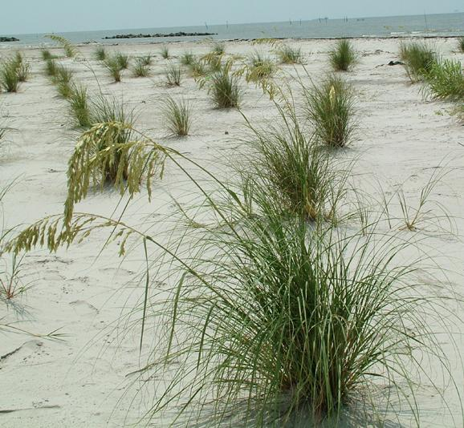 R. Alan Shadow

USDA NRCS East Texas Plant Material Center

Uses

*Landscaping*:

Sea Oats is an attractive and important plant of the coastal community. Seed heads from this plant are sometimes used in floral arrangements. However, it should be noted that this species is protected in some states due to the vital role it plays in shoreline stabilization. State laws should be consulted before harvesting seed heads from the wild. Sea Oats is very valuable as a dune builder and stabilizer.

*Forage*:

Sea Oats is reported to have high palatability to browsing animals and moderate palatability to grazing animals. However, due to the location of its habitat, protected status, and low protein content, it has no value as a forage plant.

Status

Please consult the PLANTS Web site and your State Department of Natural Resources for this plant’s current status (e.g. threatened or endangered species, state noxious status, and wetland indicator values).

Description and Adaptation

Sea oats is a long lived, slow growing, warm season, perennial grass commonly associated with the upper dunes along beach fronts. It grows erect to approximately 6 feet in height at maturity, and has leaves that can grow to 24 inches in length. The leaves are narrow, less than 1 inch in width, and taper towards their ends. The ends of the leaves are often brown and curled in appearance. It produces a large seed head, or panicle, during the summer. The panicles are made up of many flat spikelets containing seed. The panicle turns from green to straw colored in late summer as the plant matures. The stem of the plant has bulges, or nodes, near the soil surface. These will often root down and anchor to the soil surface as wind born sediment accumulates around the plant. Sea oats is also rhizomatous. These rhizomes have a scale-like appearance when young, and can be seen as pale yellow, sharp, stiff, protrusions near the base of the plant.

Sea oats is very drought tolerant. This species produces a massive root system, and will tolerate salt spray and brief inundation with salt water. It prefers full sun, and thrives in areas with blowing sand, such as dunes along the upper beach front. Burial of the plant’s base by blowing sand actually stimulates plant growth and helps the plant spread via rhizomes and tacking down at the stem nodes. It prefers coarse sediments, but will tolerate medium grained sediments. It will not tolerate fine grained sediments, and has a difficult time surviving in lower, wetter portions of the beach area. Though it is capable of surviving brief inundations of salt water, it will not tolerate water logging.

*Distribution*: Sea oats can be found on beach fronts and barrier islands along the eastern seaboard of the United States from Virginia to Florida. Their range extends along the coast line of the Gulf States, south into portions of Mexico. It can also be found in the Bahamas and portions of Cuba.

Establishment

Sea oats is not a prolific seed producer. It produces large panicles with numerous spikelets. However, very few seed are actually produced. Seed is viable and will grow readily in greenhouse conditions. However, there are no sources of commercial seed available.

Sea oats is predominantly established from containerized material and vegetative propagules. This species is rhizomatous and can be expanded by splitting larger plants into smaller propagules. Sea oats is relatively slow growing and will require time to recover from the shock of being split into smaller units and transplanting. It responds well to fertilization, but requires little to no nutrient input in field situations.

Plantings on 2-5 foot centers have proven to be very effective. Due to the harsh environment this species inhabits, there is little competition from other plants. Site prep work is usually not needed. Plantings in early spring or fall produce the least amount of stress by allowing establishment time before the harshest portions of the year arrive. Though this species is very drought tolerant, plantings should be timed when adequate moisture is present. This will help reduce the shock associated with transplanting.

Management

Once established, Sea oats require very little management. Traffic into newly planted areas should be limited until the plants have become successfully established. A slow release fertilizer pellet is beneficial during early establishment. However, routine fertilization is not required.

Pests and Potential Problems

There are no known pests or potential problems associated with this species.

Environmental Concerns

Sea oats is an extremely valuable plant for coast line and barrier island protect. Its massive root system is capable of holding soil and sand in place during extreme weather events such as hurricanes and tropical storms. This plant’s habitat puts it at the forefront of shoreline protection. It is also capable of catching blowing sand and building dunes. It is very important to natural and artificial dune stabilization throughout much of its range.

Cultivars, Improved, and Selected Materials (and area of origin)

Caminada Germplasm is a pre-varietal release from the Golden Meadow Plant Material Center, Galliano, Louisiana

Prepared By:

R. Alan Shadow, Soil Conservationist, East Texas Plant Material Center, Nacogdoches, TX

Species Coordinator: Citation

Shadow, R. A. 2007.. Plant fact sheet for Sea oats (Uniola paniculata L.. USDA-Natural Resources Conservation Service, East Texas Plant Material Center, Nacogdoches, TX 75964

Published October, 2007

Edited: 17Mar10jad

For more information about this and other plants, please contact your local NRCS field office or Conservation District <<http://www.nrcs.usda.gov/>>, and visit the PLANTS Web site <[http://plants.usda.gov](http://plants.usda.gov/)> or the Plant Materials Program Web site <<http://plant-materials.nrcs.usda.gov>>

**USDA IS AN EQUAL OPPORTUNITY PROVIDER AND EMPLOYER**