

Plant Fact Sheet

# AMERICAN VETCH

## Vicia americana Muhl. Ex Willd.

### Plant Symbol = VIAM

#### Contributed by: USDA, NRCS, Norman A. Berg National Plant Materials Center, Beltsville, MD

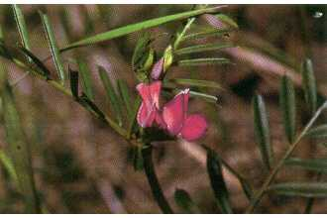 Robert H. Mohlenbrock. USDA NRCS. 1992.

#### **Alternate Names**

Purple vetch

American deer vetch

Stiff-leaf vetch

#### **Uses**

*Crop*: American vetch fixes nitrogen and can be grown as a cover preceding late spring-planted crops.

*Conservation*: American vetch is a drought-tolerant climbing vine excellent for sunny and partially shady locations. It is a native plant and can be part of a wildlife seed mixture where native grasses and wildflowers are seeded together. It will support itself using tall grasses such as rye .

*Ethnobotanical:*  Native Americans used the pods, seeds, and leaves of American vetch as food. A poultice of the leaves has been used to treat spider bites, an infusion of the plant has been used as eyewash and an infusion of the tops has been used as a wash in sweat houses. American vetch has also been used as a panacea, an aphrodisiac, and a good luck charm. Native Americans would get horses to smoke the plant to increase the horses’ endurance.

*Landscaping and wildlife:* American vetch is an excellent grazing and fodder plant for game birds, small mammals, black bear, grizzly bear, and mule deer. Horses, sheep, and cattle will browse on the aerial portions of American vetch. Growing in disturbed sites it can be planted to help restore roadsides, former coal mine sites and disturbed rangelands. Use this plant as a native alternative for crown vetch in landscaping.

#### **Status**

American vetch is listed as endangered/extirpated in Maryland.Please consult the PLANTS Web site and your State Department of Natural Resources for this plant’s current status (e.g., threatened or endangered species, state noxious status, and wetland indicatorvalues).

#### **Weediness**

This plant may become weedy or invasive in some regions or habitats and may displace desirable vegetation if not properly managed. Please consult with your local NRCS Field Office, Cooperative Extension Service office, state natural resource, or state agriculture department regarding its status and use. Weed information is also available from the PLANTS Web site at [http://plants.usda.gov](http://plants.usda.gov/). Please consult the Related Web Sites on the Plant Profile for this species for further information.

#### **Description and Adaptation**

American vetch is a native, perennial, climbing vine that grows approximately 1 to 2 feet tall. Each plant has a single stem. Tendrils emerge from the end of the multiple leaflets to help secure the plant to the climbing structure. The purple flowers, which are gathered together in racemes (flower stalks) of 3 to 10 flowers, appear in late spring (May through August) and give way to 1 to 1.5 inch pods about one month after flowering. Each pod contains two or more pea like brown seeds. American vetch spreads through rhizomes (roots that spread out from the parent plant and produce new plants).

*Distribution:* American vetch grows in medium- to finely-textured moist to dry soils in full sun. It is widely distributed west of the Mississippi River and in the northeastern United States (USDA cold hardiness zones 4 through 7).

*Habitat*: American vetch grows in open patches in swampy woods, road banks, fencerows, borders, mixed forests, meadows, foothill canyons, and clearings.

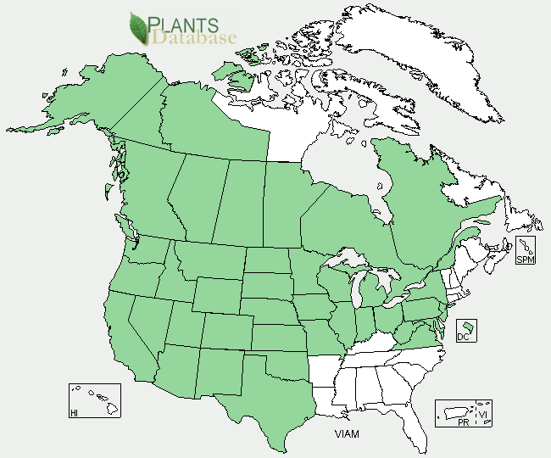

American vetch distribution from USDA-NRCS PLANTS Database.

For updated distribution, please consult the Plant Profile page for this species on the PLANTS Web site.

#### **Establishment**

Direct sow American vetch in the fall. Unscarified seed will germinate in approximately 14 days. Scarification (scratching or etching) the seeds will decrease their germination time to 3 to 7 days but will not improve their overall germination capacity. Due to the climbing habit of the plant, it is often sown in combination with rye with the rye providing support. In a mixture, 50 pounds of rye and 15 to 20 pounds of vetch per acre should be used. Most varieties of vetch are seeded at 20 to 40 pounds per acre. American vetch will self-reseed.

#### **Management**

American vetch grows in moist to dry soils and typically reaches its full height only if it attaches itself to a supporting structure. It prefers full sun and neutral to slightly acidic soil.

#### **Pests and Potential Problems**

*Vicia spp*. is susceptible to several species of *Botrytis* fungus. Vetch seeds are also susceptible to vetch bruchid (*Bruchus brachialis*) injury. This insect pest is largely responsible for poor natural reseeding of vetch in pastures.

#### **Environmental Concerns**

No concerns known environmental concerns.

#### **Cultivars, Improved, and Selected Materials (and area of origin)**

There are no recommended cultivars or selected materials at this time.

#### **Prepared By**

Samantha Kirk and Shawn Belt, NRCS, Norman A. Berg National Plant Materials Center, Beltsville, MD

#### **Citation**

#### Kirk, S. and Belt, S. 2010. Plant fact sheet for American Vetch (Vicia americana), USDA, Natural Resources Conservation Service, Norman A. Berg National Plant Materials Center, Beltsville, MD 20705

Published: [January, 2011]

Edited: [4-2009 SMK, 12-2010 SVB]

For more information about this and other plants, please contact your local NRCS field office or Conservation District <<http://www.nrcs.usda.gov/>>, and visit the PLANTS Web site <[http://plants.usda.gov](http://plants.usda.gov/)> or the Plant Materials Program Web site <<http://plant-materials.nrcs.usda.gov>>

**USDA IS AN EQUAL OPPORTUNITY PROVIDER AND EMPLOYER**