Plant Fact Sheet

# HAIRY VETCH

***Vicia villosa*****Roth**

Plant Symbol = VIVI

Contributed by: USDA NRCS Jimmy Carter Plant Materials Center

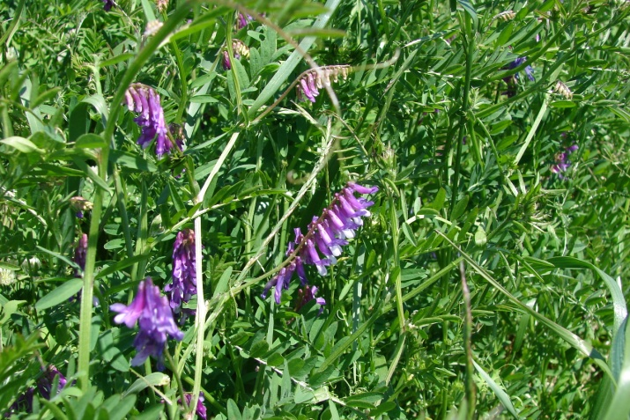

Mike Owsley

USDA NRCS

Jimmy Carter Plant Materials Center

### Alternate Names

winter vetch, wooly vetch

### Uses

*Erosion control/Cover Crop*: Hairy vetch provides good ground cover for erosion control during winter and spring. In the southeastern U.S. early cultivars like ‘AU EarlyCover’ can produce three times the dry matter in February as a late maturing hairy vetch. Hairy vetch is valuable for use in no-till systems. Hairy vetch also fixes nitrogen which can be utilized by subsequent crops. The following have been grown after hairy vetch: safflower, corn, tobacco, orchards, vineyards, tomatoes, and other vegetables.

*Pollinator:* Hairy vetch is utilized during pollination by bumble bees.

*Organic Farming*: Hairy vetch provides a natural source of nitrogen for organically grown crops. It also acts as a host plant for beneficial insects.

*Livestock*: Hairy vetch produces high crude protein content and is utilized as forage for livestock.

### Status

Please consult the PLANTS Web site and your State Department of Natural Resources for this plant’s current status (e.g., threatened or endangered species, state noxious status, and wetland indicator values).

### Weediness

This plant may become weedy or invasive in some regions or habitats and may displace desirable vegetation if not properly managed. Please consult with your local NRCS Field Office, Cooperative Extension Service office, state natural resource, or state agriculture department regarding its status and use. Weed information is also available from the PLANTS Web site at [http://plants.usda.gov](http://plants.usda.gov/). Please consult the Related Web Sites on the Plant Profile for this species for further information.

### Description and Adaptation

Hairy vetch (*Vicia villosa* Roth), is a trailing or climbing, cool season biennial or annual legume. It has a shallow root system. Stems may grow 2 to 5 feet long. Leaves are terminated by branched tendrils. Leaves are composed of 10 to 20 leaflets. Leaflets are narrowly oblong to linear-lanceolate. Stems and leaves of hairy vetch are usually pubescent (covered with soft woolly fuzz). Flowers are in clusters of 10 to 40. Each flower is violet and white to rose colored or white. Seed are round and black, developing inside elongated and flattened pods.

Hairy vetch is a hardy vetch suited to wetter soils and colder winters than other cool-season legumes. Hairy vetch develops best under cool temperatures, on fertile loam soils. It is also productive on sandy or clay soils. It grows well on light soils that are too sandy for crimson clover. It is only moderately sensitive to soil acidity.

Hairy vetch naturalized to the U.S. from Europe. Hairy vetch is distributed throughout each of the 50 states.

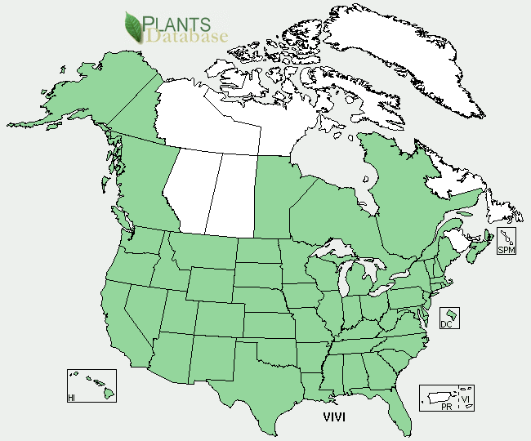Hairy vetch distribution from USDA-NRCS PLANTS Database.

For updated distribution, please consult the Plant Profile page for this species on the PLANTS Web site.

### Establishment

Hairy vetch is normally planted in the fall. It can be broadcast or drilled. For maximum cool season coverage, 30 pounds of scarified, inoculated seed per acre is recommended. Hairy vetch is often sown with rye, with the rye plants providing support to the vining, climbing habit of the plant. In a mixture, 50 pounds of rye and 15 to 20 pounds of hairy vetch per acre should be used.

### Management

Hairy vetch performs well in rotations with conventional and no-till planted row crops. In these systems, the fall planted legume is either mechanically or chemically terminated 2 to 3 weeks prior to planting or under proper conditions it is terminated at planting. Under most conditions a systemic herbicide produces better results than a contact herbicide. The row-crop is then planted conventionally or no-tilled into the cover crop. The legume decomposes, providing nitrogen for the subsequent crop. When grown for hay, vetch is generally cut when the first pods are set. When grown as a seed crop, hairy vetch is harvested when the lower pods are ripe to avoid shattering. If carefully managed, hairy vetch may be grown with bermudagrass. Hairy vetch volunteers profusely when allowed to disseminate seed.

### Pests and Potential Problems

There are no serious insect or disease pests of mature hairy vetch; however, the seed is highly susceptible to vetch bruchid (*Bruchus brachialis*) injury. This insect pest is largely responsible for poor natural reseeding of hairy vetch in pastures.

### Environmental Concerns

The primary environmental concern with hairy vetch is the ability of this naturalized plant to spread and maintain a stand after establishment. This is usually in crop areas, idle fields, and along roadways. If the stand is no longer desirable, a combination of mowing, and herbicides should eliminate the stand after several treatments. The number of treatments depends on the stand history.

### Control

Please contact your local agricultural extension specialist or county weed specialist to learn what works best in your area and how to use it safely. Always read label and safety instructions for each control method.

### Cultivars, Improved, and Selected Materials (and area of origin)

‘AU EarlyCover’ (Georgia/Alabama), ‘AU Merit’ (Alabama), ‘Lana’ (California), ‘Madison’ (Nebraska), ‘Purple Prosperity’ (Maryland).

### Prepared By: Jimmy Carter Plant Materials Center

### Citation

Owsley, M. 2011. Plant fact sheet for Hairy Vetch (*Vicia villosa)*. USDA-Natural Resources Conservation Service, USDA NRCS. Americus, GA 31709.

Published: January, 2011

Edited: 05Feb2002 jlk, 060818 jsp, 01Feb2011 cmo

For more information about this and other plants, please contact your local NRCS field office or Conservation District <<http://www.nrcs.usda.gov/>>, and visit the PLANTS Web site <[http://plants.usda.gov](http://plants.usda.gov/)> or the Plant Materials Program Web site <<http://plant-materials.nrcs.usda.gov>>

**USDA IS AN EQUAL OPPORTUNITY PROVIDER AND EMPLOYER**