|  |
| --- |
| western needlegrass |
| *Achnatherum occidentale* (Thurb. ex S.Wats.) Barkworth |
| Plant Symbol = ACOC3 |

Contributed by: USDA NRCS California State Office and Lockeford Plant Materials Center, California

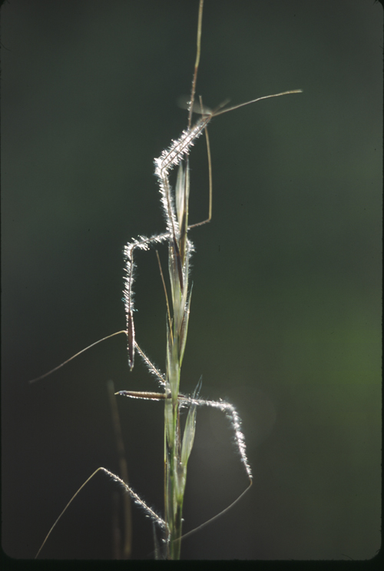© 2002 Steve Matson

@ CalPhotos

Uses

Prior to maturity, Western needlegrass is considered good forage for cattle, horses, sheep and deer. Western needlegrass also provides good protection from soil erosion.

Status

Please consult the PLANTS Web site and your State Department of Natural Resources for this plant’s current status (e.g. threatened or endangered species, state noxious status, and wetland indicator values).

Description

*General*: Western needlegrass is an erect, native, perennial grass with blue-green foliage. Densely tufted; culms 25-45 cm tall; sheath glabrous to pubescent, blade commonly narrow, 1-2 mm. wide; panicles 10-20 cm. long; glumes 10-15 mm long; lemma 6-8 mm. long, uniformly appressed-hairy; awn twice bent, densely hairy on all three segments.

**Distribution**

Western needlegrass usually is found in the Plains, rocky hills and open woods in Wyoming, Washington, Arizona and California. For more information on this species current distribution, please consult the PLANTS Web site.

**Adaptation**

Western Needlegrass has shown a preference for loam to clay loam soils. It can persist on moderately deep road cut slopes. It is best grown for seed on well to moderately well-drained, moist, medium textured soils. It does not tolerate poor drainage or prolonged flooding.

Establishment

Western Needlegrass seed germinates with autumn rains and early growth is satisfactory as long as soil moisture and temperature is suitable. Minimum rainfall requirements vary from 10-12 inches depending on soil type, elevation and aspect.

Management

Needlegrasses should be grazed only moderately until the flowers begin to head and should then be protected from grazing until their main growing season has ended. If thus managed, under normal weather conditions and in the absence of fire, they develop enough seed to regain their old-time abundance. Such management also enables the needlegrasses to store enough plant food in their crowns and roots for vigorous early growth the next fall.

Needlegrasses should always be regulated enough to leave a stubble averaging at least four inches in height. This allows the plants to continue to make healthy root and top growth during the current growing season, and to produce new foliage early in the next growing season.

Pests and Potential Problems

Needlegrass populations have been known to be damaged by rodents, but less so than most other perennial species.

**Seeds and Plant Production**

Flowering occurs in the late spring typically April to May. Adequate moisture will promote good seed set, but even under adverse conditions of low moisture, seed will be produced in most years. Seed is ripe 6 to 9 weeks after flowering. There are 311,000 seeds per pound. The planting rate for most vegetative practices is 5 pounds pure live seed per acre drilled and 7 pounds pure live seed per acre broadcast.

Cultivars, Improved, and Selected Materials (and area of origin)

‘LK621e’ Cultivar- LK621e was collected from a native stand five miles southwest of Canby, California at an elevation of 4600 feet above sea level. Employees of the NRCS originally obtained the seed in 1997. It was evaluated in a common garden at Lockeford Plant Materials Center against 16 other *Achnatherum* populations assembled from California.

References

Crampton, B. 1974. *Grasses in California*. California Natural History Guides. University of California Press, Berkeley, California

Green, L.R. & J.R. Bentley. September 1957. *Seeding and Trials of Stipa on foothill ranges*. USDA Forest Service, Forest Research Notes, California Forest and Range Experiment Station, Berkeley, California.

Young, Vernon A. unknown date. *Two important needlegrasses in San Diego County*. Department Range Management, Texas A & M College, College Station, Texas.

Prepared By:

Dyer, Dave, USDA NRCS Plant Materials Center, Lockeford and Reina O’Beck, California State Office, Davis, California.

Species Coordinator:

Dave Dyer, USDA NRCS Plant Materials Center, Lockeford, California.

Edited: 11Jul2005; 06dec05 jsp; 30may06jsp

For more information about this and other plants, please contact your local NRCS field office or Conservation District, and visit the PLANTS Web site<<http://plants.usda.gov>> or the Plant Materials Program Web site <<http://Plant-Materials.nrcs.usda.gov>>

*The U.S. Department of Agriculture (USDA) prohibits discrimination in all its programs and activities on the basis of race, color, national origin, sex, religion, age, disability, political beliefs, sexual orientation, and marital or family status. (Not all prohibited bases apply to all programs.) Persons with disabilities who require alternative means for communication of program information (Braille, large print, audiotape, etc.) should contact USDA's* [*TARGET Center*](http://www.usda.gov/oo/target.htm) *at 202-720-2600 (voice and TDD).*

*To file a complaint of discrimination write USDA, Director, Office of Civil Rights, Room 326-W, Whitten Building, 14th and Independence Avenue, SW, Washington, DC 20250-9410 or call 202-720-5964 (voice or TDD). USDA is an equal opportunity provider and employer.*

*Read about* [*Civil Rights at the Natural Resources Convervation Service*](http://www.nrcs.usda.gov/about/civilrights/)*.*