

Plant Guide

|  |
| --- |
| silver maple |
| *Acer saccharinum* L. |
| Plant Symbol = ACSA2 |

Contributed by: USDA NRCS Manhattan Plant Materials Center & Kansas State University, Forestry Research

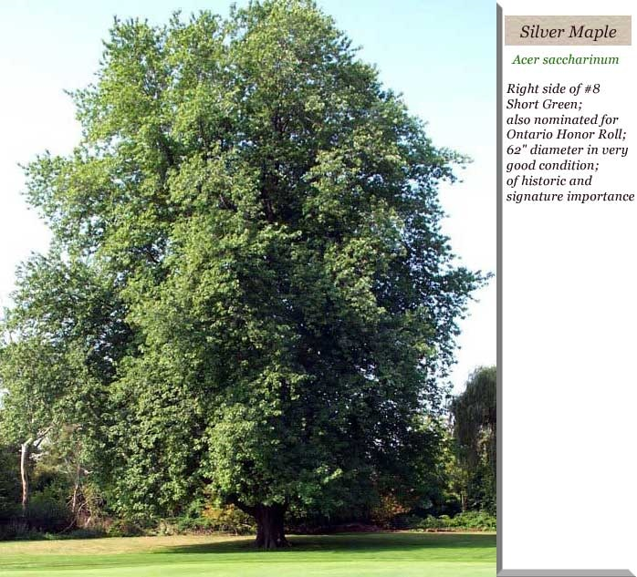

*Figure 1. Photo Courtesy of R. Brewster* (2010), *Mississaugua Country Golf and Country Club, Mississaugua, Ontario, CAN*

## Alternate Names

Soft maple, silverleaf maple, white maple, river maple, swamp maple, water maple

## Uses

*Biofuels*: The species is one of a few that has the growth rate for serious consideration for biofuel production. Though shrub willow and poplar hybrids are currently receiving greater attention, silver maple has been tested for this use in the Midwest (Geyer and Walawender, 1996; Geyer, 2004).

*Ethnobotanic:* Native Americans used the sap for many physical remedies - - coughs, cramps, dysentery, sore eyes, measles, running sores, diuretics, and venereal diseases.

As a food source sap was used for sugar, intoxicants, and bread (Moreman, 1998). Other uses include basketry, dyes, furniture.

C*onservation/Forest Buffers*: Silver maple is ideal for riparian forest buffer installations due to its common presence in such sites. It should be planted because of its rapid growth and early maturity. However, when silver maple is present in nearby stands, seed dispersal will provide copious volunteers, so planting is unnecessary. It is much preferred to box elder in a planting.

*Industry:* Silver maple on good sites can be managed for timber – it is often cut and sold with red maple as “soft maple” lumber. Silver maple sap can be used to make good, light syrup, although the sugar content of the sap is the lowest of the maple species used for syrup production (Koelling and Heiligmann, 1996)**.**

*Wood characteristics:* The wood of silver maple is fairly hard, even texture, rather brittle, and easily worked (Panshin and deZeeuw, 1980). It is used for furniture, cabinetry, paneling, flooring, woodturning, veneer, musical instruments, boxes and crates, tool handles, wagons, carts, and rails. The wood is moderately heavy (SpGr 0.44-0.49 green and 0.51-0.55 ovendry). Old heartwood develops a swirled pattern that is sold as “bird’s eye maple.”

*Ornamental:* Silver maple has been heavily planted as an ornamental in many urban areas because of its ease of transplanting and establishment, adaptability to a wide range of sites, rapid growth, and good form. The species also has been used for vegetative rehabilitation of surface mined lands as well as for bottomland reforestation (Gabriel, 2010).

*Wildlife*: The abundant seeds of silver maples are eaten by many birds, including evening grosbeaks, finches, wild turkeys, ducks, and other game birds, and small mammals, especially squirrels and chipmunks. The buds are an important food for squirrels when stored food is depleted, particularly in late winter and early spring (Reichard, 1976). The bark is a food source for beavers and deer, and rabbits browse the foliage. Silver maple tends to develop cavities that are used by cavity-nesting birds and mammals and provide shelter and breeding habitat for many other species, including raccoons, opossums, squirrels, owls, woodpeckers, and many other birds.

Because of its abundance and the wide distribution of silver maple, its early-produced pollen may be important to the biology of bees and other pollen-dependent insects. Most references describe silver maple as wind pollinated, but insect pollination may be important, as many insects, especially bees, visit the flowers.

## Status

Please consult the PLANTS Web site and your State Department of Natural Resources for this plant’s current status, such as, state noxious status and wetland indicator values.

**Weediness**

## Seeds production is prolific in some years; may be a problem in urban settings. Hand removal or herbicides may be used to remove plants.

## Description

*General:* Maple Family (Aceraceae): A native tree reaching to mature heights of 90-140 ft, usually with a short, thick trunk and spreading, open, irregular crown of long, curving branches with pendulous branchlets turning up at the ends; twigs produce a slightly unpleasant odor when crushed; bark gray and thin, becoming furrowed into long, shaggy, scaly ridges on older trunks and branches (Stephens, 1973). The National Registry of Big Trees reports a specimen in Michigan that is 115 feet tall with a circumference of 347 inches (American Forests, 2010). Silver maples can live to 130 years or longer.

The leaves are deciduous, opposite, 4-6 in long and nearly as wide, long-petioles, deeply 5-lobed and long-pointed (middle lobe often 3-lobed) with

V-shaped sinuses, doubly toothed, with three main veins from the base, dull green above, silvery-white beneath, usually turning pale yellow or soft gold in the autumn, occasionally scarlet and crimson (perhaps reflecting hybridization with red maple).

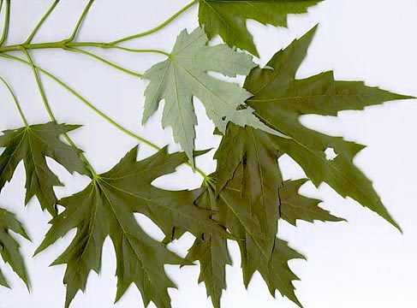

*Figure 2. Leaves dull green above, silvery-white beneath Photo Courtesy of Village of Waterford, Virginia* (2010).

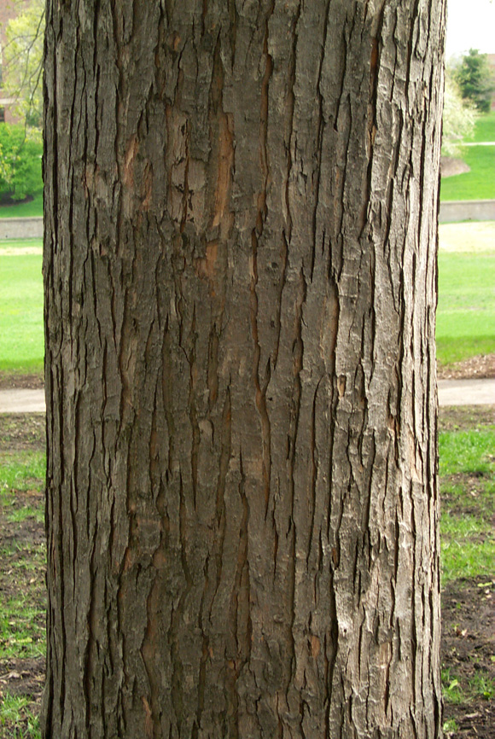

***Figure 3. Silver maple’s gray, thin bark. Photo Courtesy of Dave Hansen* (2010).**

*Flowering and Fruiting:* Silver maple flowers in March-April before the leaves, usually before red maple. All flowers on one tree are nearly synchronous. Fruiting occurs in April-June, maturing about 3 weeks after pollination and all released over a short period, usually less than 2 weeks (Burns and Honkala, 1990).

The flowers are usually greenish or yellow from reddish buds, about .2 inches long, the male (staminate) flowers fascicled, the female (pistillate) flowers in drooping racemes, the flowers functionally male or female. Individual trees commonly have all male or all female flowers (the species essentially dioecious) or some trees may have more of one type than the other, and scattered flowers may be functionally bisexual (the species technically polygamo-dioecious) (Burns and Honkala, 1990).

The fruits are winged nutlets (samaras) 1.6-2.4 inches long; light brown with pink veins, in a long-stalked, wide-spreading pair. The common name refers to the silvery appearance of the underside of the leaves (Harlow et al., 1979).

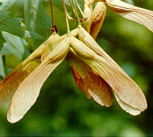 ***Figure 4.*  *Maturing samaras.* *Photo Courtesy of Ohio Public Library Information Network, Oplin.org* (2001).**

*Variation within the species:* Red maple forms natural hybrids with silver maple (*A. saccharinum*): *Acer* X *freemanii* E. Murray. The hybrids, however, are nearly sterile.

*Distribution:*Silver maple grows over most of the eastern half of the United States and immediately adjacent Canada, except along major portions of the Gulf and Atlantic coastal plains (Burns and Honkala, 1990). The natural range extends from Maine, New Brunswick, and southern Quebec, west to Minnesota and southeastern South Dakota, eastern Nebraska, Kansas, and Oklahoma, and south to Louisiana, Mississippi, Alabama, northwestern Florida, and central Georgia. It is relatively uncommon in the southern part of its range and absent at higher elevations in the Appalachians. Its abundance in natural habitats has decreased due to conversion of bottomland forests for agriculture but increased in urban areas due to planting. For current distribution, please consult the Plant Profile page for this species on the PLANTS Web site.

Silver maple has been introduced to the western United States as an ornamental and to areas of the Black Sea coast of the Soviet Union and various parts of Europe.

*Habitat:* The species is found on stream banks, flood plains, and lake edges where it grows best on better-drained, moist alluvial soils (Hosner, 1960) at elevations of 328 to 6,463 feet (Gabriel, 1990). Silver maple can grow on sites where soils are usually saturated most of the growing season. Seedlings have survived 60 days of continuously saturated soils. In the Upper Mississippi River Valley, silver maple trees survived 1 year of constant inundation (due to reservoir formation) but died after the second. It ranges from moderately shade-tolerant (good sites) to intolerant (poor sites). Silver maple dominance is usually in forest types that are pioneer to intermediate in succession and maintained only with management or disturbance, particularly flooding. It will quickly invade abandoned agricultural clearings and other cutover areas. Although it does not compete well with other species in upland sites, silver maple grows vigorously under a wide variety of conditions when planted as an ornamental.

**Adaptation**

Silver maple is adapted wherever adequate moisture is assured. It cannot generally compete with other species in an upland environment (Gabriel, 2010). As a pioneer species, silver maple is shade intolerant**.**

## Establishment

Silver maple may begin producing seed as early as 11 years old. Viable seed may be produced through self-pollination and large seed crops are produced annually. The seeds are primarily wind dispersed but are sometimes carried by water. Germination usually occurs in the spring shortly after dispersal – the seeds require no pretreatment or stratification (although seedlings require a considerable length of chilling to break dormancy). Natural regeneration by seed is most successful on moist mineral soil or moist litter with considerable organic matter (Weitzman and Hutnik, 1965).

Silver maple can be vegetatively propagated from cuttings and bud grafts and by layering. Seeds are abundant but seedlings are highly variable. Sprouts from the stump or root crown are prolific. The best sprouting occurs from younger trees with stumps less than 12 inches in diameter. Forest plantings should be on a 6 x 8-14 foot spacing depending on weed control equipment. Flood energy breaks off aboveground portions of silver maple – the remaining stems sprout vigorously and may vary in number after such damage.

## Management

Despite its usefulness in urban plantings, especially on poor sites, silver maple has significant limitations and is now not recommended. It has been over-planted. It often grows to a larger size than anticipated and the brittle branches are easily broken in winter storms and wind storms. Pruning is often required to develop good form and to remove broken branches and old, multi-trunk trees often require cabling. Relatively soft wood renders silver maple susceptible to a number of wood rotting fungi and it is susceptible to various leaf molds and wilts (e.g., anthracnose, verticillium wilt, leaf spot, and tar spot). Its large, vigorous, shallow-rooted root system can damage sidewalks and driveways, clog drain pipes, and penetrate septic systems and sewer pipes.

Silver maple is susceptible to fire damage because of its thin bark, soft wood, and shallow/surface roots; surface fires kill seedlings and saplings and wound larger trees, exacerbating the tendency to rot (Sullivan, 1994). Prescribed fire is not recommended where silver maple is a desirable species. Silver maple can be managed on good sites for saw timber and on poor or wet sites for pulp or cordwood.

Pests and Potential Problems

Like other maples, silver maple is susceptible to a wide range of insect and disease problems (Dirr, 1977). Gray mold spot is a foliage disease. A host of root and trunk rots attack silver maple. Because of its brittle wood properties, it is highly susceptible to ice damage (Gabriel, 2010).

## Environmental Concerns

The brittle nature of its wood limits the longevity of the species where high winds or heavy ice accumulations are common.

Control

Please contact your local agricultural extension specialist or county weed specialist to learn what works best in your area and how to use it safely. Always read label and safety instructions for each control method. Trade names and control measures appear in this document only to provide specific information. USDA, NRCS does not guarantee or warranty the products and control methods named, and other products may be equally effective.

## Seeds and Plant Production

## Seed ripening and dispersal over the range of the species begins in April and ends in June. Silver maples are the largest seed of any maple species in the United States (Schopmeyer, 1974).

## Cultivars, Improved and Selected Materials (and area of origin)

At least 58 cultivars have been named, encompassing variation in leaf form and color, branching pattern, and crown shape (Santamour and McArdle, 1982). At least one fruitless (male) strain has been selected. There is enough genetic variability to warrant selection (Wright, 1954).

**References**

American Forests. 2010. National Register of Big Trees: *Acer saccharinum* (http://americanforests .org/resources/bigtrees/register.php?detail). [online:cited January 2010].

Dirr, M.A. 1977***.***  *Manual of Woody Landscape Pants: Their Identification, Ornamental Characteristics, Culture, Propagation and Uses*. 50-52. Stipes Publishing L.L.C. Champaign. IL

Brewster, R. 2010. Silver maple. www.mississauguagolf/images/site [online: accessed January 2010].

Burns, R.M. and B.H. Honkala. 1990. *Silvics of Forest Trees of the United States.* Agriculture Handbook No. 271. USDA Forest Service, Washington D.C.875p.

Gabriel, W.J. 1990. *Acer saccharinum* L. Silver maple. Pp. 70-77, In R.M. Burns and B.H. Honkala (tech. coords.). *Silvics of North America*. *Volume 2.* *Hardwoods*. USDA, Forest Service Agric. Handbook 654, Washington, D.

Gabriel, W.J. 2010. Silver maple. http://www.na.fs.fed.us/pubs/silvics_manual/ volume_2/acer/sacchar... [online: cited October 2010].

Geyer, W. and W. Walawender 1996. Biomass properties and gasification behavior of young silver maple. Wood & Fiber Sci. 29(1) pp.85-90.

Geyer, W. 2004. Biomass production in the central Great Plains USA under various coppice regimes Energy and Biomass Jour.30:778-783.

Hansen, D. 2010. Tree Identification - Acer saccharinum - Silver Maple. Minnesota Tree Care Advisors http://www.mntca.org/resources/treeid/tree_dec_opp_map_silver.html [online: accessed 27 October 2010].

Harlow, W.H., E.S. Harrar, and F.M. White.1979. In *textbook of Dendrology*. Sixth Edition. McGraw-Hill Book Co. 510p.

Hosner, G.H. 1960. Relative tolerance to complete inundation of fourteen bottom land tree species. Forest Science 6:246-251.

Koelling, M.R. & R.B. Heiligmann (eds.) 1996. *North American maple syrup producers manual*. Ohio State Univ. Extension Bull. 856. AUG00. <http://www.ag.ohio-state.edu/~onioline/b856/index.html>

## Moreman, D.E. 1998. Native American Ethnobotany. Timber Press. Portland. London. 927pp.

OPLIN.org. 2001. Silver Maple. Ohio Public Library Information Network. http://www.oplin.org/tree/fact%20pages/maple_silver/maple_silver.html [online: assessed October 2010].

Panshin, A.J. and C. deZeeuw. 1980*. Textbook of wood   
 technology*, 4th Edition. McGraw-Hill Series in Forest   
 Resources. McGraw-Hill Book Co., New York. 722p.

Reichard, T.A. 1976. Spring food habits and feeding behavior of fox squirrels and red squirrels. American Midland Naturalist 96:443A50.

Schopmeyer, C.S., tech. coord. 1974. Seeds of woody plants in the Unites States. USDA Handbook 450. Washington D.C. 883p.

Santamour, F.S. and A.J. McArdle. 1982. Check list of cultivated maples. Iv. Acer saccharinum L. Jour. Arborculture 8(10):277-280.

Stephens, H.A. 1973. *Woody Plants of the North Central States.* Univ. Kansas, Lawrence. 250p.

Sullivan, J. 1994. *Acer saccharinum*. In W.C. Fischer (compiler). *The fire effects information system* [data base]. USDA, Forest Service, Intermountain Research Station, Intermountain Fire Sciences Laboratory, Missoula, Montana.

Village of Waterford, Virginia Web Site. 2010. Maple trees. http://www.waterfordvillage.org/nature-garden/trees-maples.htm [online: assessed January 2010].

Weitzman, S. and R.J. Hutnik. 1965. Silver maple (*Acer saccharinum* L.). In Silvics of forest trees in the United States. P.63-65. H. A. Fowells, comp. U.S. Department of Agriculture, Agriculture Handbook 271. Washington, DC.

Wright, J.W. 1954. Racial variation and individual tree selection in the Northeast. In Proceedings, First Northeastern Forest Tree Improvement Conference. P. 20-25. Northeastern Forest Experiment Station, Upper Darby, PA.

Prepared By

*Wayne A. Geyer*, Professor

Forestry Division, Kansas State University

Manhattan, KS 66056

*John Dickerson*, retired

USDA NRCS New York State Office

Syracuse, New York

*John M. Row,* Plant MaterialsSpecialist

NRCS Plant Materials Center

Manhattan, Kansas 66502

#### Citation

Geyer, W. A., J. Dickerson, and J. M. Row. 2010. Plant Guide for Silver Maple (*Acer saccharinum* L.). USDA-Natural Resources Conservation Service, Manhattan Plant Materials Center, Manhattan, KS 66502.

Published November 2010

Edited: [03 Nov10 jmr]

For more information about this and other plants, please contact your local NRCS field office or Conservation District at <http://www.nrcs.usda.gov/> and visit the PLANTS Web site at <http://plants.usda.gov/> or the Plant Materials Program Web site <http://plant-materials.nrcs.usda.gov>.

PLANTS is not responsible for the content or availability of other Web sites.

**USDA IS AN EQUAL OPPORTUNITY PROVIDER AND EMPLOYER**