

Plant Guide

**REDTOP**

***Agrostis gigantea* Roth**

Plant Symbol = AGGI2

Contributed by: USDA NRCS Idaho Plant Materials Program

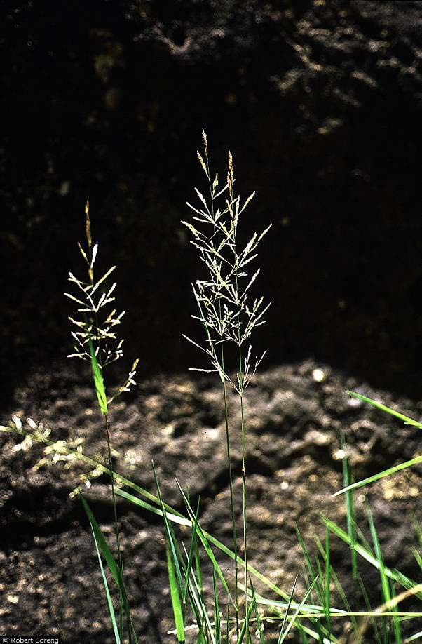

Figure 1. Redtop (Agrostis gigantea). Photo by Robert Soreng @ USDA-NRCS PLANTS database.

### Alternate Names

*Agrostis alba* auct. Non. L.

*Agrostis depressa* Vassey

*Agrostis palustris* Huds.

*Agrostis stolonifera* L. var. *major* (Gaudin) Farw.

Black bent

Carpet bentgrass

Redtop bent

Redtop bentgrass

Redtop has undergone numerous name changes over time, and the actual placement of the multiple species and varieties remains confused due to hybridization.

Linnaeus apparently based the original description of *Agrostis alba* on a specimen of *Poa nemoralis* (Hitchcock, 1971). Historically, several varieties have been described, yet other authors have combined *A. gigantea* under a broader *A. stolonifera* (creeping bentgrass) (Cronquist et al., 1977). Currently the PLANTS database recognizes *A. gigantea* as a separate species from *A.* stolonifera with *A. gigantea* being primarily rhizomatous while *A. stolonifera* typically produces stolons. This plant guide addresses *A. gigantea* in the broad sense which includes earlier treatments of *A. stolonifera* var. *major*.

**Uses**

*Livestock*:

Cattle prefer nearly all other cultivated grasses to redtop. It remains green summer long and is useful in western states in pasture plantings in mountain meadows. It is considered preferred feed for cattle and horses in spring and summer and a desirable feed in fall and winter. It is considered a preferred feed for sheep in spring and a desirable feed in summer (Ogle and Brazee, 2009).

*Hay:* One of the primary uses of redtop is for grass hay.

*Turf:*

Though creeping bentgrass (*A. stolonifera*) is much more prevalent in the turf industry than redtop, this species is used throughout North America and Europe in lawns and golf courses. It is also used for overseeding as a winter lawn grass in the South East.

*Erosion control*:

Redtop is commonly used for erosion control in plantings along riparian zones and wetlands. It germinates very rapidly and performs well on acidic low fertility soils. Its root system is well suited for holding soils on wetlands, waterways, ditchbanks and burned or cutover-timberland (Wasser, 1982).

*Revegetation*:

This species has been used to recapture sites which are very acid to land affected with heavy metals and poor soil quality such as mine spoils. It has been shown to have a higher tolerance of acidic soils than Kentucky bluegrass (Balasko et al., 1995).

*Wildlife*:

Redtop is a preferred feed for elk in spring, but is used sparingly by deer (Ogle and Brazee, 2009). It is commonly used as cover by numerous species of birds and small mammals. Ducks and geese use redtop for nesting cover, and it is grazed by geese.

**Status**

Consult the PLANTS Web site and your State Department of Natural Resources for this plant’s current status (e.g., threatened or endangered species, state noxious status, and wetland indicator values).

**Weediness**

Redtop has been described as weedy or invasive in some states and European countries. It may become weedy or invasive in some regions or habitats and may displace desirable vegetation if not properly managed. Consult your local NRCS Field Office, Cooperative Extension Service office, state natural resource, or state agriculture department regarding its status and use. Weed information is available from the PLANTS Web site at plants.usda.gov. Consult related web sites on the Plant Profile for this species for additional information.

### Description

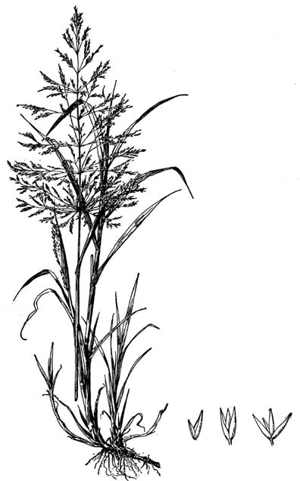

Figure 2. Line drawing of redtop. Hitchcock, A.S. (rev. A. Chase). 1950. Manual of the grasses of the United States. USDA Miscellaneous Publication No. 200. Washington, DC

*General*:

Grass family (Poaceae). Redtop is a cool season (C-3), sod-forming, perennial grass native to Europe (Wasser, 1982). The plant produces culms up to 4 feet in height which can be erect, decumbent or semi-prostrate in form. The leaf blades are flat, folded or curled, approximately 1/8 to 3/8 inches wide with a prominent ligule at the junction of the leaf blade and sheath. The inflorescence is an open panicle with ascending branches. The spikelets are small with the lemma reaching 0.08 inches long (Cronquist et al., 1977). The name redtop is derived from the reddish coloring of the panicle. The scaly, creeping rhizomes make a coarse, but fairly dense turf. The roots of redtop can reach 4 ft deep under favorable conditions (Troughton, 1957). There are approximately 4.85 million seeds/lb (USDA NRCS, 2010).

*Distribution*:

Redtop is native to Eurasia and North Africa and was introduced to North America in the 18th century as a lawn, meadow and pasture grass (Monsen et al., 2004). It has since become naturalized and widely distributed throughout the U.S. and Canada. It grows better in the moist mountain areas of the West and humid areas of the Northeast than in the warmer climates of the southern states. For current distribution, consult the Plant Profile page for this species on the PLANTS Web site.

*Habitat*:

Redtop has been cultivated and planted extensively throughout North America and has been widely naturalized in numerous habitats. It occurs in areas with shallow water, wet meadows and stream banks from sea level to 8,000 ft (Monsen et al., 2004). Redtop can be found growing in pure stands or with other wetland/wet meadow species such as sedges, rushes, and other grasses. It is also common in riparian areas growing in association with cottonwood, alder and willow species.

**Adaptation**

This species is broadly adapted to a wide range of soil and weather conditions. It thrives in cool moist habitats and is best adapted to the northern states but has been successfully established throughout North America, especially with management and irrigation.

Redtop is best adapted to mesic to semi-hydric soils, and is well suited to areas receiving 18 to 40+ inches mean annual precipitation. The plants are tolerant of poorly drained and sub irrigated sites and sites that are frequently flooded.

This species performs best on clay loam to loamy soils, but under irrigation will perform on nearly any soil type with the exception of limestone based soils. Redtop is adapted to soils with a pH of 4.5 to 8.0. It has a low tolerance to salinity.

Redtop displays good grazing resistance due to its rhizomes, its low palatability and semi-prostrate growth form. Stands of redtop often increases in pasture mixes and will decrease under light to non-grazed situations.

**Establishment**

Redtop can be established by seed, sprigs, or sod. For seeding, plant at a depth of 0-1/4 inch into a smooth, firm, well-drained, weed free seed bed. For turf plantings, seed at a rate of approximately 1 lb/1000 ft². For pasture and range plantings a rate of 0.5 lbs/ac is recommended (Ogle et al., 2009). Broadcast and lightly harrow to cover seed. Compaction of soil over seed may cause crusting which is impenetrable by seedlings. Use of an inert carrier or dilutent when drill seeding can improve seed flow and metering small seed such as redtop.

The soil surface should be kept moist during establishment. Early fall seeding is recommended which allows a minimum of 45 growing days prior to frost for good establishment if irrigation is available. If irrigation is not available, an early spring seeding is recommended. Do not apply nitrogen until the second growing season.

Seedlings have low vigor and seeding often results in poor stands; however, once established, stands of redtop will readily spread and persist for many years (Monsen et al., 2004).

Redtop is seldom seeded alone. Better forage and high quality hay is produced if redtop is mixed with species such as timothy, creeping foxtail and/or clover species. Redtop grows rapidly after seeding and excessive seeding rates are not recommended, particularly in mixtures.

**Management**

Stands of redtop should not be grazed until the plants are at least 8 inches tall. Pasture mixes will need to be grazed closely in a rotation to keep plants producing palatable regrowth on wet and sub-irrigated sites. Redtop should not be grazed closer than three inches (USDA NRCS, 1995).

Cut hay in early flowering stage for best quality. Forage contains 8 to 9 percent protein when cut at full bloom and 12 to 14 percent when cut before bloom. (USDA-NRCS, 1995).

Stands respond well to applications of fertilizer and lime. Low fertility critical areas should be fertilized prior to seeding.

**Pests and Potential Problems**

Redtop is known to develop ergot which can lead to livestock poisoning (Ontario, 2010). This species can also develop leaf rusts, spotting and snow mold, but these have generally not been a problem (Wasser, 1982).

**Environmental Concerns**

Redtop is an introduced species which can displace native vegetation under ideal conditions. It should not be planted in sites where revegetation of native species is desired. It hybridizes with other *Agrostis* species, so numerous non-typical plants can be found in most populations.

**Seeds and Plant Production**

Seed production fields should be soil tested before planting to determine soil nutrient levels and fertilizer needs.

Stands should be combined or swathed when plants are in the hard dough stage. Seed shatters readily, so delaying harvest can significantly reduce yields. Seed should be cleaned with air screens or clippers with a 28x28 upper screen and 50x50 lower screen (Wasser, 1982).

Seed production fields yield approximately 75 lbs/ac with 90 percent purity and 90 percent germination (Monsen et al., 2004).

There are approximately 4,850,000 seeds per pound.

**Cultivars, Improved, and Selected Materials (and area of origin)**

There are several released materials of the stoloniferous creeping bentgrass, which are used readily as lawn and golf course varieties. There is currently only one known released variety of redtop.

**‘Streaker’** redtop was released in 1982 by Jacklin Seed Company and Lofts Seed. It was chosen from among 21 lots of seed which were evaluated for uniformity, vigor, seed yield and mechanical purity and cleanliness. It’s intended use is for overseeding of dormant warm season grasses; low maintenance turf, reclamation and pasture (Alderson and Sharp, 1994).

### References

### Alderson, J. and W. C. Sharp 1994. Grass varieties in the United States. Agriculture Handbook No. 170. USDA, SCS, Washington, DC.

Balasko, J.A., G.W. Evers, and R.W. Duell. 1995. Bluegrasses, ryegrasses, and bentgrasses. In: Barnes, R.F., Miller, D.A. and C.J. Nelson. Forages. 5th ed. Iowa State University Press. Ames, IA.

Cronquist, A., A.H. Holmgren, N.H. Holmgren, J.L. Reveal, and P.K. Holmgren. 1977. Intermountain Flora. Vol. 6. The monocotyledons. Columbia Univ. Press, NY.

Hitchcock, A.S. 1971. Manual of the grasses of the United States, 2nd edition. Dover Publications, Inc. New York, NY.

Monsen, S.B., Stevens, R. and N. Shaw. 2004. Grasses. In: S.B. Monsen, R. Stevens, and N.L. Shaw [compilers]. Restoring western ranges and wildlands. Fort Collins, CO: USDA_FS-RMRS. General Technical Report RMRS-GTR-136-vol-2. p. 295-424.

Ogle, D., and B. Brazee. 2009. Estimating initial stocking rates. USDA-NRCS, ID-TN 3. Boise, ID.

Ogle, D., L. St. John, M. Stannard, and L. Holzworth. 2009. Grass, grass-like, forb, legume, and woody species for the Intermountain West. USDA-NRCS, ID-TN 24. Boise ID.

Ontario. 2010. Poisoning of livestock by Plants-Fact Sheet. Ontario Ministry of Agriculture, Food and Rural Affairs. Ontario, Canada.

Troughton, A. 1957. The Underground Organs of Herbage Grasses. Commonwealth Agricultural Bureaux. Farnham Royal, Bucks, England.

USDA Forest Service. 1937. Range Plant Handbook. Washington, D.C.

USDA NRCS. 1995. Hay and pasture management of redtop. USDA-NRCS. Columbia, MO.

USDA NRCS. 2010. The PLANTS Database [Online]. Available at http://plants.usda.gov (accessed 19 January 2010). USDA-NPDC, Baton Rouge, LA.

Wasser, C.H. 1982. Ecology and culture of selected species useful in revegetating disturbed lands in the west. USDI-FWS. Biological Services Program. FWS>OBS-82/56.

**Prepared By**

*Derek Tilley*; Range Scientist, USDA NRCS Plant Materials Center, Aberdeen, Idaho.

*Dan Ogle;* Plant Materials Specialist, USDA NRCS, Boise, Idaho.

*Loren St. John*; Team Leader, USDA NRCS Plant Materials Center, Aberdeen, Idaho.

**Citation**

Tilley, D., D. Ogle, and L. St. John. 2010. Plant guide for redtop (*Agrostis gigantea*). USDA-Natural Resources Conservation Service, Idaho Plant Materials Center. Aberdeen, ID. 83210.

Published July, 2010

Edited: 07Apr2010 djt; 07Apr10 dgo; 20Jan2010 lsj

For more information about this and other plants, please contact your local NRCS field office or Conservation District at <http://www.nrcs.usda.gov/> and visit the PLANTS Web site at <http://plants.usda.gov/> or the Plant Materials Program Web site <http://plant-materials.nrcs.usda.gov>.

**USDA IS AN EQUAL OPPORTUNITY PROVIDER AND EMPLOYER**