

Plant Guide

# Leadplant

## Amorpha canescens Pursh

Plant Symbol = AMCA6

*Contributed by*: USDA NRCS Kansas Plant Materials Center

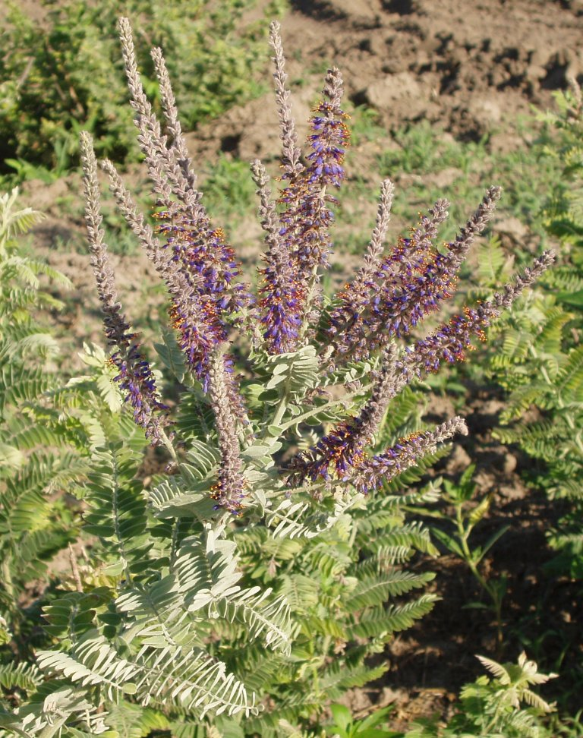

Figure 1. Leadplant showing lead gray color on leaves and purple flowers. Photo by Alan Shadow USDA NRCS (2006).

### Alternate Names

Lead-plant, leadplant amorpha, downy indigobush, prairie shoestrings, buffalo bellows, *Amorpha brachycarpa*

### Uses

*Erosion control:* Can be used for soil erosion control due to its deep, branching, woody root system.

*Ethnobotanic:* The Omaha Indians powdered the dried leaves and put them into cuts and open woulds where the astringent properties of the plant promoted scab formation (Kindscher, 1992). A moxa was also made from the twig ends of lead plant to treat rheumatism and neuralgia (Kindscher, 1992). A tea was made from the leaves of leadplant by many tribes. The Potawatomi Indians drank the tea to treat pinworms and other intestinal worms (Kindscher, 1992). Leaves were also steeped and the liquid used to treat eczema (Kindscher, 1992). The Lakota tribe mixed crushed leadplant leaves with buffalo fat for smoking material (Kindscher, 1992). The Assiniboins and Sioux tribes made a moistened powder from the roots of leadplant and beeplant (*Cleome* sp.) and then rubbed that on their clothes to gain “the power to attract buffalo and to kill as many of them as he wants” (Kindscher, 1992). The common name of “buffalo bellows” was given to leadplant by some tribes because the blooming period coincided with the time of the year that the buffalo were in rut and bellowing.

*Landscaping and restoration:* Can be used as an ornamental because it has very showy flowers and is drought and shade tolerant. Used in restoration projects because it is a native nitrogen fixing plant that is also good for soil erosion control.

*Wildlife and Livestock*: Leadplant is a floral food resource for pollinating insects, with pollen and nectar feeding solitary bees being some of the most important (Slagle and Hendrix, 2009). Leadplant is a palatable plant to cattle, sheep, and horses. It is also palatable to elk, mule deer, and white-tailed deer (Rosario, 1988).

### Status

Please consult the PLANTS Web site and your State Department of Natural Resources for this plant’s current status (e.g., threatened or endangered species, state noxious status, and wetland indicator values).

### Description

*General*: Fabaceae (Bean Family). Subshrub that can reach to 3.3 ft (1 m) tall. Plants that are mowed off or hayed have herbaceous stems. Leaves are 1.6-4 in (4-10 cm) long with 15-47 leaflets with lanceolate to elliptic or oblong with each leaflet being 0.1-0.5 in (8-14 mm) long and 0.1-0.2 in (3-6 mm) wide. The stems and bottoms of leaves are densely woolly. Florescence is 2.4-4 in (6-10 cm) long and the single petal (standard) is about 0.1-0.2 in (4-5 mm) long and purple in color. Fruit is densely wooly, curved, and about 0.18 in (4.5 mm) long. The seeds of leadplant are an orange-brown color, elliptical with a small beak on one end and about 0.07-0.1 in (2-2.5 mm) long (Bare, 1979). Leadplant begins growth around May 1 and flowers in late June to July, matures in August to September, and stays green until frost. The name leadplant comes from the lead-colored appearance caused by the silvery gray hairs on the foliage and stems (Haddock, 2005).

*Distribution*: Leadplant is distributed throughout the Great Plains. It is common from Manitoba and Ontario and south to Texas and New Mexico, and east to Wisconsin, Michigan, and Iowa. It also occurs in eastern Colorado, Utah, and Montana (Great Plains Flora Association, 1986).

For current distribution, please consult the Plant Profile page for this species on the PLANTS Web site.

*Habitat*: It can be found in prairies, hillsides, roadsides, and open woodlands (Haddock, 2005). Leadplant does very well in sandy to silt-textured soils and is tolerant to weakly acidic, moderately alkaline, and to weakly saline soils. Leadplant is found in areas with little bluestem, big bluestem, switchgrass, Indian grass, prairie dropseed, and also in sand bluestem, and prairie sandreed prairies.

**Adaptation**

Leadplant is winter hardy and has good drought and shade tolerance (Wasser, 1982). Leadplant is very palatable to livestock but decreases and is intolerant of close, repeated grazing and defoliation (Wasser, 1982). Leadplant is generally considered to be favored by fire and is usually present in increased numbers in the spring following a fire (Bock and Bock, 1984; Rosario, 1988). The top portion of the plant is most likely harmed by fire, but the underground parts of the plant survive (Rosario, 1988).

### Establishment

### Reduce competition by preparing a firm, weed-free seedbed and planting pods separately or in rows that alternate with grasses (Wasser, 1982). Seeds should be inoculated with nitrogen fixing bacteria before planting (Rock, 1981). Seed should be planted 1/4 in. to 3/16 in. deep (Vories, 1981). Planting can be in the spring (Wasser, 1982) or in the fall (Vories, 1981). For full stands of leadplant a seeding rate of 20 to 30 pure live seed (PLS) per square foot is needed. For seeding in grass or grass forb mixtures a seeding rate of 0.5 to 1 PLS per acre is recommended (Wasser, 1982)

### Seed will need to be stratified. Methods for stratification of seed are to sow seeds in the fall and let them stratify over winter (Brinkman, 1974), soak in water for 10 minutes (Brinkman, 1974), or soak in 180-200˚F (82-93˚C) water for 12 hours then moist chill seed at 41˚F (5˚C) for 30 days (Babb, 1959; Vories, 1981). Seed germination is epigeal and occurs at about 14 days in the laboratory according to Wasser (1982) and Vories (1981). In the field under favorable conditions germination is about 20 days (Wasser, 1982).

Leadplant can also be propagated by greenwood cuttings (Vories, 1981) in the summer, hardwood cuttings in the fall, or by suckers (Wasser, 1982). Transplanting success is generally poor in prairie restorations, probably because competition is not adequately reduced (Wasser, 1982).

### Management

Initially grazing should be withheld and weeds controlled by mowing above seedlings during establishment period. Graze or mow conservatively and periodically graze only after dormancy to sustain cover and high production improvement, leaving tall stubble (Wasser, 1982). The presence of leadplant on native rangeland is usually indicative of a well managed area (Kindscher, 1992).

### Pests and Potential Problems

Common pests of leadplant are grasshoppers, leafhoppers, and small mammals. Leaf spots, rusts, downy mildew, and *Cytospora amorphae* have been found on leadplant but they are not considered major diseases (Wasser, 1982).

### Environmental Concerns

Generally leadplant is a very slow growing plant and does not compete well with native warm-season grasses (Rosario, 1988). Therefore it has very little potential to become a weed problem in its native distribution area and there are no known environmental concerns associated with leadplant.

### Seeds and Plant Production

Slagle and Hendrix (2009) indicated that a diversity of bee species visiting leadplant is important for maintaining fruit set of leadplant. Seed becomes mature in late summer from August to September (Brinkman, 1974; Swingle, 1939; Vories, 1981). Harvest seed by hand-stripping from terminal branches (Wasser, 1982). Mowing and windrowing can be used on large patches (Wasser, 1982). Clean seed by using mechanical flail, then double clean in Clipper cleaner and seed blower (Wasser, 1982). Good seed crops are produced at least every two years, with some seed produced every year. Estimates of the number of seeds per pound of leadplant varies from 87,900- 105,754 (Swingle, 1939) to 296,000 (Brinkman, 1974). Storage of leadplant seeds should be in dry sealed containers at 41˚F (5˚C) (Brinkman, 1974; Swingle, 1939; Vories, 1981).

### Cultivars, Improved, and Selected Materials (and area of origin)

These plant materials are somewhat readily available from commercial sources. No known cultivars, improved, or selected materials of leadplant are known at this time.

### References

Bare, J.E. 1979. Wildflowers and weeds of Kansas. The Regents Press of Kansas. Lawrence, KS.

Bock, J.H. and C.E. Bock. 1984. Effect of fire on woody vegetation in the Pine-grassland ecotone of the Southern Black Hills. The American Midland Naturalist 112(1): 35-42.

Brinkman, K.A. 1974. *Amorpha* L*.*, Amorpha, false indigo. p. 216-219. *In* Schopmeyer C.S., tech. coord. Seeds of woody plants in the United States. Agriculture Handbook 450. USDA-Forest Service. Washington, DC.

Great Plains Flora Association. 1986. Flora of the Great Plains. University Press of Kansas. Lawrence, KS.

Haddock, M.J. 2005. Wildflowers and Grasses of Kansas: A field guide. University Press of Kansas. Lawrence, KS.

Kindscher, K. 1992. Medicinal wild plants of the prairie: An ethnobotanical guide. University Press of Kansas. Lawrence, KS.

Rock, H.W. 1981. Prairie propagation handbook. 6th ed. Wehr Nature Center. Hales Corner, WI.

Rosario, L.C. 1988. *Amorpha canescens*. *In*: Fire Effects Information System [online]. USDA-Forest Service. Rocky Mountain Research Station, Fire Sciences Laboratory. Available: http://www.fs.fed.us/database/feis/

Shadow, A. 2006. Photo of leadplant. USDA-NRCS East Texas Plant Materials Center, Nocogdoches, TX.

Slagle, M.W. and S.D. Hendrix. 2009. Reproduction of *Amorpha canescens* (Fabaceae) and diversity of its bee community in a fragmented landscape. Oecologia 161: 813-823.

Swingle, C.F. 1939. Seed propagation of trees, shrubs, and forbs for conservation planting. SCS-TP-27. USDA-Soil Conservation Service. Washington, DC.

Vories, K.C. 1981. Growing Colorado plants from seed: A state of the art. Vol. 1: Shrubs. USDA-Intermountain Forest and Range Experiment Station. USDA-Forest Service General Technical Report INT-103.

Wasser, C.H. 1982. Ecology and culture of selected species useful in revegetating disturbed lands in the West. USDI-Fish and Wildlife Service. FWS/OBS-82/56.

**Prepared By**: *P. Allen Casey,* USDA NRCS Kansas Plant Materials Center, Manhattan, Kansas

### Citation

Casey, P. A. 2011. Plant Guide for leadplant (*Amorpha canescens)*. USDA-Natural Resources Conservation Service, Manhattan Plant Materials Center. Manhattan, Kansas.

Published: March 2011

Edited: 26Jan2011 rlw; 27Jan2011 jmr; 2Feb2011 jd;

For more information about this and other plants, please contact your local NRCS field office or Conservation District at <http://www.nrcs.usda.gov/> and visit the PLANTS Web site at <http://plants.usda.gov/> or the Plant Materials Program Web site <http://plant-materials.nrcs.usda.gov>.

PLANTS is not responsible for the content or availability of other Web sites.

**USDA IS AN EQUAL OPPORTUNITY PROVIDER AND EMPLOYER**