|  |
| --- |
| red columbine |
| *Aquilegia canadensis* L. |
| Plant Symbol = AQCA |

Contributed by: USDA NRCS National Plant Data Center

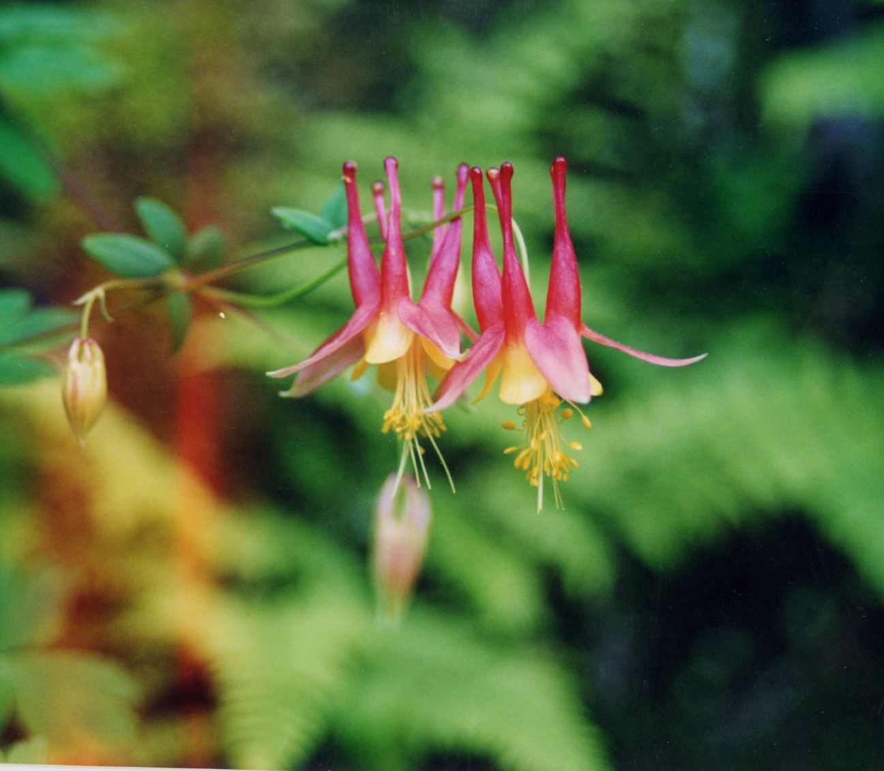

Jennifer Anderson 2002.

USDA-NRCS PLANTS Database

© Thomas G. Barnes

Alternate Names

Wild columbine, wild honeysuckle, meeting-houses, red-bell, Canada columbine, American columbine, rock-lily, jack-in-trousers, cluckies, *Aquilegia* *australis, Aquilegia* *canadensis* var. *australis, Aquilegia canadensis* var*. coccinea, Aquilegia* *canadensis* var. eminens, *Aquilegia canadensis* var. *flaviflora, Aquilegia* *canadensis* var. *hybrida, Aquilegia* *canadensis* var. *latiuscula, Aquilegia canadensis*  var. *phippenii, Aquilegia canadensis* forma *flaviflora*, *Aquilegia canadensis* forma *ecalcarata*, *Aquilegia canadensis* forma *albiflora*, *Aquilegia canadensis* forma *phippenii*, *Aquilegia* *coccinea, Aquilegia elegans, Aquilegia eminens, Aquilegia flaviflora, Aquilegia latiuscula, Aquilegia* *phoenicantha* and *Aquilegia variegata.*

**Uses**

*Ethnobotanic:* Seeds from this plant have been used to treat ailments such as headaches, sore throats, stomatitis, heart problems, skin rash or itch caused by poison ivy, kidney and urinary problems, and fever. They have also been used for ceremonial medicines, perfume, and as additives to tobacco. Roots of this plant can be used to treat gastrointestinal ailments.

*Landscaping:* Red columbine, in native or cultivated forms, is a popular garden perennial because it is hardy, lives approximately 3 to 5 years, and can readily regenerate by seed. It is also useful for woodland and meadow plantings.

*Wildlife:* Red columbine is pollinated by hummingbirds, which may depend on the plant as an important nectar source. In addition, at least four bee species have been found to be effective pollinators of red columbine in southeastern Wisconsin and northwards.

Status

Red columbine is endangered in Florida. Please consult the PLANTS Web site (<http://plants.usda>. gov) and your State Department of Natural Resources for this plant’s current status (e.g. threatened or endangered species, state noxious status, and wetland indicator values).

Description

*General*: Buttercup Family (Ranunculaceae). Red columbine is a perennial herb that has short-lived fibrous roots and a vertical underground stem (caudex). It is 30-80 cm (12-30 in) tall, growing from the caudex. Compound leaves are distinctly divided into obovate leaflets. The flower is downward facing, with all petals prolonged backward into a tubular spur. Sepals are petal-like and typically red. Petals are yellow and become redder at the tip of the spur. Plant growth begins in early spring. This plant blooms from March to July and sets fruit in mid to late summer (June to August). Aboveground portions of Red columbine die back to the caudex in mid to late autumn.

*Distribution*: Red Columbine is native to eastern and central North America and is found from Nova Scotia to Saskatchewan, south to northern Florida, western Oklahoma and eastern Texas. For current distribution, please consult the Plant Profile page for this species on the PLANTS Web site (http://plants.usda.gov).

*Habitat*: Red columbine is found in dry to mesic or even low woods, especially along borders or clearings of oak-hickory, oak-maple and maple-basswood forests, black-oak savannas, cedar glades, pine woods, and mixed conifer hardwood forests. It can also be found on wooded to open rocky hillsides, bluffs, calcareous cliffs, outcrops, ledges, banks, beach ridges, gravelly shorelines, roadsides, quarries, and peat bogs.

Adaptation

The USDA Hardiness Zones for red columbine is 3 to 8. It grows in thin soils over granitic bedrock, steep hillsides of thin loess over limestone or quartzite bedrock, and on gravelly glacial marine soils. Because of highly variable genetic plasticity, red columbine populations can occur in a wide range of habitats from rich woods to rocky cliffs.

Establishment

This hardy eastern perennial is propagated by seed. Seed is mature and ready for collection when it turns black in the follicles. Collected seed should be stored in seedbags at temperatures of 5o to 6oC (~41oF) and can be stored up to 4 months. A 3 to 4 week period of moist stratification at 5oC may speed up germina-tion time but does not increase germination rate.

*Aquilegia canadensis* seeds should be hand-sown into germination trays in greenhouse temperatures of 21o to 24oC (70o to 75oF). Germination will take place within 3 to 4 weeks, and supplemental lighting is not necessary. Soil in the germination trays must be kept evenly moist during germination. Fertilization may damage the foliage, so avoid application while in germination trays.

Seedlings can be transplanted into plug cells following a 3-4 week period of root development. Plugs will need to be cut back to allow for air circulation over the media surface. Approximately 2 weeks prior to outplanting, plants should be exposed to lower greenhouse, or frost-free outdoor, temperatures.

Although red columbine prefers soils that are well drained, loose, and slightly acidic, it will grow in medium that is loose and has a mixture of organic matter. It will not bloom during the first growing season.

Germination procedures can begin in August and as late as November. Outplanting should take place in the spring (April). Red columbine can also be direct-seeded at a planting site in the fall or early spring. The general recommendation for wildflower seeding is 11 pounds per acre.

**Management**

Columbine species are little bothered by powdery mildew or broad mites. The waxy nature of the leaves sheds water-based pesticides. Red columbine is unpalatable to livestock but is sometimes browsed by deer.

Red columbine can survive fire disturbance. Recolonization begins when the underground caudex resprouts following disturbance. Population growth continues by seed.

Cultivars, Improved, and Selected Materials (and area of origin)

Examples of cultivars include the ‘Canyon Vista,’ ‘Corbett,’ and ‘Nana’ columbines. These cultivars were developed for garden use to change the color intensity of the red and yellow flowers of the canadensis species.

Native plant material is readily available from a number of growers, wholesalers, and retailers of native seed. The National Plant Materials Center (NPMC) in Shenandoah National Park produces columbine plugs, quart-size plants, and seed.

**References**

Agricultural Research Service 2003. *Dr. Duke’s phytochemical and ethnobotanical databases.* USDA-ARS-NGRL, Beltsville Agricultural Research Center, Beltsville.

Anderson, J.. 2002. *USDA-NRCS PLANTS Database.* Version 3.5 (<http://plants.usda.gov>, 21 October 2004). National Plant Data Center, Baton Rouge.

Davis, K.M. & J.L. Knjawski 2001. *Propagation protocols for production of container Aquilegia canadensis plants (container plugs)*.Native Plant Network. (<http://www.nativeplantnetwork.org>, 16 December 2003). USDA NRCS National Plant Materials Center, Beltsville.

Gilmore, M.R. 1919. *Uses of plants by the Indians of the Missouri River.* SI-BAE Annual Report #33. Pp. 82-83.

Hartmann, H.T., D.E. Kester, F.T. Davies jr., & R.L. Geneve 1996. *Plant propagation principles and practices, 6th ed.* pp. 727, 770. Prentice Hall, Upper Saddle River.

Herrick, J.W. 1977. *Iroquois medical botany.* pp. 320. State University of New York, Albany.

Institute for Systematic Botany. 2002. *Aquilegia canadensis.* Atlas of Florida Vascular Plants. (<http://www.plantatlas.usf.edu/main.asp?plantID=3980>). University of South Florida, Tampa.

Kujawski, J., J. Englert, & H. Hayward 1997. *Wildflowers for the Mid-Atlantic: Columbine (Aquilegia canadensis).* Technical Note No. 97-08. USDA-NRCS National Plant Materials Center, Beltsville.

LaRoche, G. 1980. *The effects of restricting root growing space, decreasing nutrient supply and increasing water stress on the phenetics of Aquilegia canadensis L. (Ranunculaceae).* Bulletin of the Torrey Botanical Club 107(2): 220-231.

Macior, L.W. 1966. Foraging behavior of Bombus (Hymenoptera: Apidae) in relation to Aquilegia pollination. *American Journal of Botany* 53(3): 302-309.

Nichols, G.E. 1934. The influence of exposure to winter temperatures upon seed germination in various native American plants. *Ecology* 15(4): 364-373.

Rook, E.S. 2002. *Aquilegia canadensis.* (<http://www.rook.org/earl/bwca/nature/herbs/> index.html, 7 January 2004). Boundary Waters Canoe Area.

Smith, H.H. 1928. *Ethnobotany of the Meskwaki Indians.* Bulletin of the Public Museum of the City of Milwaukee 4: 175-326. Pp. 238-239.

Sullivan, J. 1992. *Aquilegia canadensis.* (<http://www.fs.fed.us/database/feis>, 17 December 2003). USDA Forest Service, Rocky Mountain Research Station, Fire Sciences Laboratory, Missoula.

USDA. 1990. *USDA Plant Hardiness Zone Map.* The U.S. National Arboretum. (<http://www.usna.usda.gov/Hardzone/ushzmap.html>, 7 January 2004). Washington D.C.

Prepared By:

*Sarah Wennerberg*

USDA NRCS National Plant Data Center

Baton Rouge, Louisiana

Species Coordinator:

*Mark Skinner*

USDA NRCS National Plant Data Center

Baton Rouge, Louisiana

Edited: 9Jan2004 sbw; 21Oct2004 rln; 31may06jsp

For more information about this and other plants, please contact your local NRCS field office or Conservation District, and visit the PLANTS Web site<<http://plants.usda.gov>> or the Plant Materials Program Web site <<http://Plant-Materials.nrcs.usda.gov>>

*The U.S. Department of Agriculture (USDA) prohibits discrimination in all its programs and activities on the basis of race, color, national origin, sex, religion, age, disability, political beliefs, sexual orientation, and marital or family status. (Not all prohibited bases apply to all programs.) Persons with disabilities who require alternative means for communication of program information (Braille, large print, audiotape, etc.) should contact USDA's* [*TARGET Center*](http://www.usda.gov/oo/target.htm) *at 202-720-2600 (voice and TDD).*

*To file a complaint of discrimination write USDA, Director, Office of Civil Rights, Room 326-W, Whitten Building, 14th and Independence Avenue, SW, Washington, DC 20250-9410 or call 202-720-5964 (voice or TDD). USDA is an equal opportunity provider and employer.*

*Read about* [*Civil Rights at the Natural Resources Convervation Service*](http://www.nrcs.usda.gov/about/civilrights/)*.*