|  |  |
| --- | --- |
| **Natural Resources Conservation Service** | Plant Guide |

# purple threeawn

## Aristida purpurea Nutt.

Plant Symbol = ARPU9

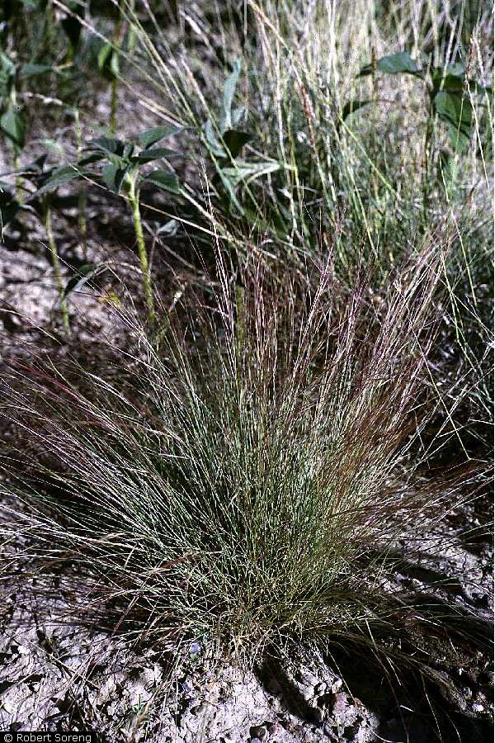

**Purple threeawn. Robert Soreng @ USDA-NRCS PLANTS Database.**

### Alternate Names

*Common Names:* wiregrass, red threeawn, dogtown grass, prairie threeawn

*Scientific Names: A. longiseta*

### Uses

### Forage value of purple threeawn depends largely on the other species growing in association in the region. In the Southwest, where forage is limited, purple threeawn is considered good spring forage while the plants remain green. In Arizona and New Mexico its abundance and fair palatability make purple threeawn a highly important source of forage. In northern areas where more palatable forage grasses are available, threeawn is considered weedy with little value (Stubendieck et al. 1994; USDA, 1937).

Purple threeawn is popular among horticulturalists for use in low water landscaping, especially in the Southwestern United States. Its reddish purple coloring and compact bunchgrass habit make it desirable. It spreads by seed readily however and can overwhelm landscape elements and become a nuisance. Seed also sticks to animal fur and human socks. Seed heads should be removed before maturity to prevent spread (Xeriscape Today 2010).

Purple threeawn provides some cover to small mammals and reptiles in sparsely vegetated desert areas. Native bees will make nests in the root structure.

### Status

Please consult the PLANTS Web site and your State Department of Natural Resources for this plant’s current status (e.g., threatened or endangered species, state noxious status, and wetland indicator values).

### Description

This species has been separated in the past into several distinct species. However, the characteristics used to separate these taxa such as culm height, beak length and awn length are highly variable within populations and even on the same plant (Cronquist et al. 1977). The PLANTS Database currently recognizes a single species with five varieties: purple threeawn (*A. purpurea* var*. purpurea*), Fendler’s threeawn (*A. p.* var*. fendleriana*), blue threeawn (*A. p.* var*. nealleyi*), Parish’s threeawn (*A. p.* var*. parishii*), and Wright’s threeawn (*A. p.* var*. wrightii*).

Purple threeawn is a short-lived native perennial warm season bunchgrass with densely tufted culms averaging 6 to 30 inches tall. The leaves are mostly basal with blades 1 to 10 inches long. The leaves are very narrow; less than 2 mm wide, and involute or rolled. The ligule is a membranous based ring of hairs 0.5 mm long. The inflorescence is a narrow panicle, 2 to 8 inches long with the lower branches ascending or spreading. The spikelets are reddish to purple colored. The floret bears a twisted awn column which divides into three awns 3/4 to 4 inches in length (Welsh et al. 2003).

Members of the genus have Kranz anatomy and C4 photosynthesis. (Voznesenskaya,et al. 2005).

*Distribution*: Purple threeawn occurs in western North America from the west coast eastward to Minnesota, Illinois and Louisiana. There are also disjunct documented occurrences in Vermont, North Carolina and South Carolina. For current distribution, please consult the Plant Profile page for this species on the PLANTS Web site.

*Habitat*: Purple threeawn inhabits dry coarse or sandy soils in desert valleys and foothills. It grows in a variety of plant communities including: creosote bush, blackbrush, shadscale, greasewood, pinyon-juniper and ponderosa pine (Welsh et al. 2003). It is often found growing in association with sand dropseed, needleandthread, and bluebunch wheatgrass (Monsen et al. 2004).

Purple threeawn quickly invades roadsides, animal burrows and other areas where the soil is disturbed.

**Adaptation**

Purple threeawn is very drought tolerant and is generally adapted to sites receiving 6 inches or more annual precipitation. Plants are hardy to -10° F and suggested for use in USDA zone 6 (Mountain States Wholesale Nursery 2001).

### Establishment

### Warm to hot temperatures improve germination of purple threeawn. Evans and Tisdale (1972) recorded little germination before seeds were subjected to air temperatures of 104° F. Other studies show optimum germination between 50 and 86° F (Eddleman 1978).

Purple threeawn can be seeded alone or in mixtures with other native species (Monsen et al. 2004). Drill seeding to a depth of 1/2 to 1 inch is recommended. The full stand seeding rate of 4 lbs/ac Pure Live Seed (PLS) provides an average of 25 seeds/sq ft (Ogle et al., 2014).

De-awned seed can be drill seeded; however USDA-NRCS (2004) suggest that de-awning may reduce seed quality.

### Management

### Grazing should be deferred for two or more seasons to allow plants to establish (Ogle et al. 2011).

Purple threeawn increases under grazing because other more palatable bunchgrasses are favored by livestock.

### Pests and Potential Problems

There are no pests or potential problems documented for this species.

### Environmental Concerns

### Purple threeawn is native to arid locations in western North America and poses no concern to native plant communities. However it spreads quickly into disturbed areas and can be considered invasive in certain situations. Its dominance may be indicative of poor grazing management, especially in the Northern Great Plains.

### Once matured, the long awns on the seed head can become problematic. The awns and sharp seed can become lodged in the soft tissues of the mouth and nose developing into abscesses which are extremely painful. Animals will typically avoid eating threeawn when other more palatable forage is available. The awns may also decrease value of sheep wool.

### C:\Users\derek.tilley\Desktop\threeawn.jpg

**Purple threeawn florets. Bruce Leander, Ladybird Johnson Wildflower Center**.

### Seeds and Plant Production

### The USDA-NRCS Tucson Plant Materials Center (2004) recommends planting purple threeawn with 24 to 38 inch row spacing for seed production to allow for between row cultivation. Narrower row spacing can be used but seed yields and stand longevity may be reduced.

### Seed is drilled in late summer to early fall into a firm, weed free seed bed. Fields are irrigated to prevent crusting and to aid stand establishment. After establishment fields are irrigated to field capacity in late fall. Established fields are irrigated if necessary in spring through the boot stage. Overhead irrigation should be avoided during flowering.

Seed is harvested in Tucson from May to July when seed is in the hard dough to mature stage. Some lodging may occur. Seed can be stripped for maximum yields. Direct combining or swathing and windrowing provide satisfactory results.

Awns are removed with a hammermill at moderate speed, and the seed is cleaned with air-screening. Weed seed can be removed using an indent or disc cleaner.

### Cultivars, Improved, and Selected Materials (and area of origin)

Common seed of purple threeawn is available commercially.

### References

Cronquist, A., Holmgren, A.H., Holmgren, N.H., Reveal, J.L. and P.K. Holmgren. 1977. Intermountain Flora. Volume 6: the Monocotyledons. Columbia University Press. New York, NY. 584p.

Eddleman, L.E. 1978. Survey of viability of indigenous grasses, forbs and shrubs. Annual Progress Report. RLO-2232-T2-3. Prepared for US Energy Research and Development Administration.

Evans, G.R and E.W. Tisdale. 1972. Ecological characteristics of *Aristida* *longiseta* and *Agropyron* *spicatum* in west-central Idaho. Ecology. 53: 137-142.

Monsen, S.B., Stevens, R. and N. Shaw. 2004. Grasses. In: S.B. Monsen, R. Stevens, and N.L. Shaw [compilers]. Restoring western ranges and wildlands. Fort Collins, CO: USDA Forest Service, Rocky Mountain Research Station. General Technical Report RMRS-GTR-136-vol-2. p. 295-424.

Mountain States Wholesale Nursery. http://www.mswn.com/ Visited January 20, 2014.

Ogle, D., St. John, l. Stannard, M., Cornwell, J, Holzworth, L. 2011. Technical Note 10: Pasture and Range Seedings – Planning, Installation, Evaluation, Management. USDA-NRCS Boise, ID-Salt Lake City, UT-Spokane, WA. 35p.

Ogle, D., St. John, l. Stannard, M., Holzworth, L., Tilley, D. 2014. Technical Note 24: Conservation Plant Species for the Intermountain West. USDA-NRCS Boise, ID-Salt Lake City, UT-Spokane, WA. 73 p.

Stubbendieck, J., G.Y. Friisoe, & M.R. Bolick. 1994. Weeds of Nebraska and the Great Plains. Nebraska Department of Agriculture, Bureau of Plant Industry. Lincoln, Nebraska.USDA, Forest Service. 1937. Range Plant Handbook. 532 p.

USDA, Natural Resources Conservation Service. 2004. Native Seed Production. USDA-NRCS in cooperation with Coronado Resource Conservation and Development Area, Inc.

Voznesenskaya, E.V., Koteyeva, N.K.; Chuong, S.D.X.; Edwards, G.E.; and Franceschi, V.R. 2005. Functional compartmentation of C4 photosynthesis in the triple-layered chlorenchyma of Aristida. Functional plant biology. 32 (1): 67-77.

Welsh, S.L., Atwood, N.D., Goodrich, S., and L.C. Higgins. 2003. A Utah Flora. Third Edition, revised. Brigham Young University, Provo, UT.

Xeriscape Today. www.xeriscape-today.com Visited January 21, 2014.

**Citation**

D. Tilley and L. St. John, L. 2013. Plant guide for purple needlegrass (*Aristida* *purpurea*). USDA-Natural Resources Conservation Service, Plant Materials Center, Aberdeen, Idaho 83210.

Published February 2014

Edited: 21Jan2014ls; 27Jan2014jab

For more information about this and other plants, please contact your local NRCS field office or Conservation District at http://www.nrcs.usda.gov/ and visit the PLANTS Web site at http://plants.usda.gov/ or the Plant Materials Program Web site http://plant-materials.nrcs.usda.gov.

PLANTS is not responsible for the content or availability of other Web sites

***Helping People Help the Land***

**USDA IS AN EQUAL OPPORTUNITY PROVIDER AND EMPLOYER**