

Plant Guide

# packard’s milkvetch

***Astragalus cusickii* A. Gray var*. packardiae* Barneby**

Plant Symbol = ASCUP

*Contributed by*: USDA NRCS Idaho and Utah Plant Materials Program

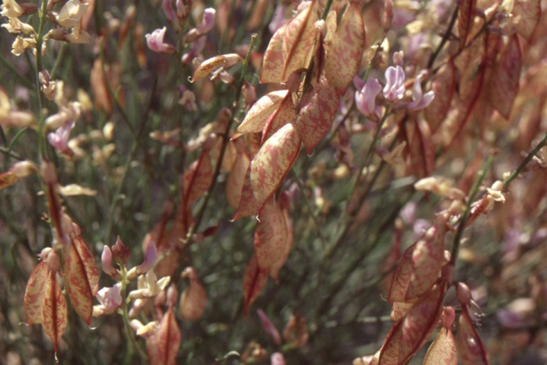**Seed pods and flowers of Packard’s milkvetch (*Astragalus cusickii* var*. packardiae*). Photo by Mark Lowry, USDI-BLM**

### Alternate Names

None

### Uses

There are no known human uses of Packard’s milkvetch. Grazing by livestock has been observed (Mancuso, 1999).

### Status

Packard’s milkvetch was designated a candidate for listing as endangered or threatened in 2010 with a Listing Priority Number (LPN) of 3, a subspecies facing high-magnitude, imminent threat (USDI-FWS, 2010).

Consult the PLANTS Web site and your State Department of Natural Resources for this plant’s current status (e.g., threatened or endangered species, state noxious status, and wetland indicator values).

### Description

*General*: Legume family (Fabaceae). Packard’s milkvetch is an erect, multi-stemmed, perennial forb. Mature plants are 25 to 50 cm (9.8 to 19.7 in) tall. The leaves are pinnately compound with 2 to 9 broadly spaced leaflets. The upper leaves are often

reduced to a naked rachis, a stem with no leaflets. The leaflets are approximately 7 mm (0.3 in) long and 1 mm (0.04 in) wide. The inflorescence is a loose raceme with up to 20 creamy white, purple tinged flowers reaching approximately 1 cm (0.4 in) in length. The fruit is an inflated, narrowly elliptic, yellow-green pod with reddish mottling, approximately 4 cm (1.6 in) long and 1 cm (0.4 in) wide (Cronquist et al., 1989).

*Distribution*:

Packard’s milkvetch is endemic to the northeastern corner of Payette County, Idaho. The known range of the species covers an area approximately 9.7 km (6 mi) long by 3.2 km (2 mi) wide.

For current distribution, consult the Plant Profile page for this species on the PLANTS Web site.

*Habitat*:

Packard’s milkvetch occurs in an area of rolling uplands in the sagebrush steppe in what was historically a Wyoming big sagebrush (*Artemisia* *tridentata* ssp. *wyomingensis*) and bluebunch wheatgrass (*Pseudoroegneria spicata*) plant community. Much of the surrounding habitat occupied by Packard’s milkvetch has been altered by wildfire and grazing and has subsequently been invaded by introduced annual grasses (Mancuso, 1999). Packard’s milkvetch is restricted to small islands of undisturbed habitat. Associated plant species include Blue Mountain buckwheat (*Eriogonum strictum*), bottlebrush squirreltail (*Elymus elymoides*), Sandberg bluegrass (*Poa secunda*), bluebunch wheatgrass (*Pseudoroegneria spicata*), basin wildrye (*Leymus cinereus*), and fernleaf biscuitroot (*Lomatium dissectum*).

**Adaptation**

Packard’s milkvetch appears to be limited to a series of visually distinct sedimentary outcrops exposed between Big Willow Creek, Little Willow Creek, Dry Creek and Stone Quarry Gulch (Mancuso, 1999). The exposed substrates are whitish in color, with relatively sparse vegetation and a high percentage of bare ground. Populations have been found from 823 to 975 m (2,700 to 3,200 ft) elevation in an area receiving approximately 40 cm (16 in) mean annual precipitation.

### Management

Packard’s milkvetch habitat is threatened by wildfire, non-native invasive plant species including cheatgrass (*Bromus* *tectorum*) and medusahead (*Taeniatherum caput-medusae*) and off road vehicle use (USDI-FWS, 2010). Heavy weed encroachment by cheatgrass and medusahead has been observed in the surrounding habitat, but appears to not be entering the specific edaphic substrates occupied by Packard’s milkvetch (Mancuso, 1999). However, higher densities of annual grasses are known to contribute to increased frequency of wildfires.

ORV use is a widespread activity in Packard’s milkvetch habitat resulting in crushed plants and accelerated erosion of the fine loose soils.

Although grazing by cattle and sheep has been observed, it is unknown if grazing is beneficial or deleterious to plant recruitment (Mancuso, 1999).

### Pests and Potential Problems

There are no known pests associated with Packard’s milkvetch.

### Environmental Concerns

There are no known environmental concerns regarding Packard’s milkvetch.

### Seed and Plant Production

Flowers bloom in late May with fruit ripening in June. Pollination vectors are unknown (Mancuso, 1999).

### References

Cronquist, A., A.H. Holmgren, N.H. Holmgren, J.L. Reveal, and P.K. Holmgren. 1989. Intermountain flora, Vol. 3. New York Botanical Garden, Bronx, New York.

Mancuso, M. 1999. The status of Astragalus cusickii var. packardiae (Packard’s milkvetch). Idaho Department of Fish and Game. Boise, Idaho. 26p.

U.S. Fish and Wildlife Service. 2010. Endangered and threatened wildlife and plants; review of native species that are candidates for listing as endangered or threatened; annual notice of findings on resubmitted petitions; annual description of progress on listing actions. In: Federal Register. 75(217): 69222-69294.

**Prepared By**:

*Derek Tilley*; USDA NRCS Plant Materials Center, Aberdeen, Idaho.

*Loren St. John*, USDA NRCS Plant Materials Center, Aberdeen, Idaho.

*Dan Ogle*, USDA NRCS, Boise, Idaho.

### Citation

Tilley, D., L. St. John and D. Ogle. 2011. Plant guide for Packard’s milkvetch (*Astragalus cusickii* var*. packardiae*). USDA-Natural Resources Conservation Service, Idaho Plant Materials Center. Aberdeen, ID.

Published Feb 2011

Edited: 03Feb2011djt; 03feb2011dgo; 03feb2011ls

For more information about this and other plants, please contact your local NRCS field office or Conservation District at http://www.nrcs.usda.gov/ and visit the PLANTS Web site at http://plants.usda.gov/ or the Plant Materials Program Web site http://plant-materials.nrcs.usda.gov.

PLANTS is not responsible for the content or availability of other Web sites.

**USDA IS AN EQUAL OPPORTUNITY PROVIDER AND EMPLOYER**