

Plant Guide

# Kremmling

# Milkvetch

## Astragalus osterhoutii M.E. Jones

Plant Symbol = ASOS

*Contributed by*: USDA NRCS Colorado Plant Materials Program

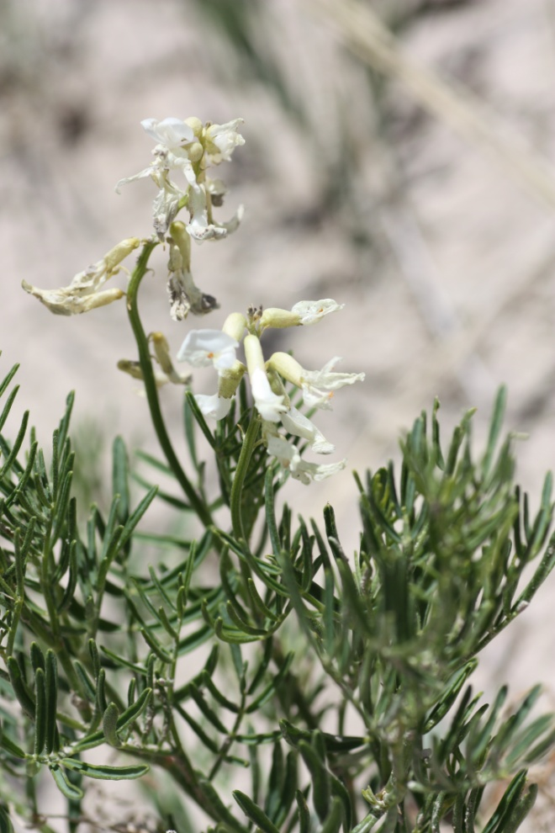

Figure1: Kremmling milkvetch, *Astragalus osterhoutii*. Photo USFWS, Alicia Langton July 2010.

### Alternate Names

### *Osterhout’s milkvetch*

### Warning: Kremmling milkvetch is a selenium accumulator and may cause selenium poisoning.

### Uses

Kremmling milkvetch (*Astragalus osterhoutii)* was discovered at Sulphur Springs in Grand County Colorado in 1905 by George Osterhout. The flowers are white and showy attracting a variety of pollinators. Primary pollinators include *Apis mellifera*, *Bombus* sp., and *Osmia* sp (Watrous and Cane, 2011). Kremmling milkvetch is of economic significance as an indicator of selenium and as a potentially toxic plant in rangelands (Brown and Shrift, 1982). The plants have no known agricultural, economic, or other human uses known at this time.

### Status

The US Fish and Wildlife Service in (1988) cited the Kremmling milkvetch population size at approximately 25,000 to 50,000 individuals across 6 documented occurrences within its 15-mile range, predominately in Grand County, Colorado. Kremmling milkvetch, because of its limited range, small population size, and numerous threats, became listed as “endangered” under the Endangered Species Act in 1989, with a recovery priority number of 5C, indicating a high degree of threat and low recovery potential, with conflict from development. A significant part of the known range and one population was lost when a new reservoir was filled on the Muddy Creek in 1995 (Center for Plant Conservation, 2011).Recently, a total estimated sum of 11,435 individuals were cited from 5 of the 6 documented occurrences, with one of the occurrences not observed in over 20 years (NatureServe, 2011). The NatureServe conservation status rank, an international effort which rank species on their “global” status, denotes Kremmling milkvetch as G1/S1- critically imperiled globally and statewide, because of its extreme rarity, makes it especially vulnerable to extinction.

**Description**

*General*:

Pea family (Fabaceae). Kremmling milkvetch, is a relatively tall plant with linear leaflets and several bright green stems reaching up to 40 inches (100 centimeters) in height. There are 12—25 white flowers, 1 in (2.4 cm) long, per inflorescence, each ultimately with stipitate pendulous pods, 1.8 in (4.5 cm) long. *Astragalus pattersonii* and *A. bisulcatus* are similar species also with a relatively tall growth form. The three species may be separated as follows (USFWS, 1992): Kremmling milkvetch is distinguished from *A. pattersonii* by its long, pendulous fruits that are laterally compressed, from *A. bisulcatus* by its large, white flowers, and from both by its lime-green,linear leaflets (USFWS, 1989).

*Distribution*:

Kremmling milkvetch is endemic to a localized area near the town of Kremmling in “Middle Park”, Colorado. The current known global distribution includes five small and scattered populations within an eight-mile radius, occupying an estimated 800 acres of habitat. Of the known populations of Kremmling milkvetch, approximately 33% occur on private land (USFWS, 2009). Please consult the USFWS website at www.fws.gov for a map of the species occurrence.

For current distribution, please consult the Plant Profile page for this species on the PLANTS Web site.

*Habitat*:

Kremmling milkvetch occurs on moderate slopes, on white shale outcrops of the Niobrara, Pierre, and Troublesome Formations in northern Grand County, Colorado. The chaparral/shrubland habitat includes the following common plant associates: big sagebrush *(Artemesia tridentata),* yellow rabbitbrush (*Chrysothamnus viscidiflorus),* broom snakeweed *(*Gutierrezia sarothrae), winterfat (Krascheninnikovia lanata)*,* spiny phlox (*Phlox hoodii),* shortstem buckwheat (*Eriogonum brevicaule),* andwestern wheatgrass (Pascopyrum smithii), (NatureServe, 2011). Kremmling milkvetch has been described as a likely ice-age relic of the southern Wyoming flora that is now limited to a small area of habitat (desert badlands) in Middle Park, isolated by high ranges of the Rocky Mountains (USFWS, 1989).

**Adaptation**

Kremmling milkvetch is adapted to grow on highly seleniferous, grayish-brown clay soils derived from shales of Niobrara, Pierre, and Troublesome formations. Kremmling milkvetch occurs on shaley slopes at middle elevations ranging from 7,400 – 7,900 feet (2,256 – 2,408 meters) (CPC, 2011), within the sagebrush parks eco-region (Chapman, 2006) with an average annual precipitation of 10-16 inches (US Department of Agriculture, 2006).

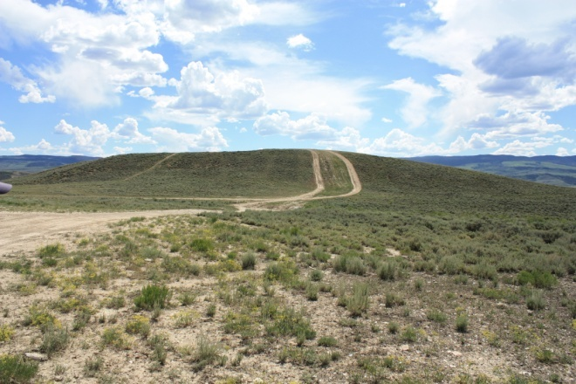

Figure 2: Photo USFWS, Alicia Langton, July 2010, ATV track through Kremmling milkvetch habitat.

**Management**

Kremmling milkvetch is threatened by commercial, residential, and agricultural property development, and the associated new utility installations and access roads, reservoir operations and expansion, off-highway vehicle recreation (Figure 2), oil and gas exploration, and livestock grazing. A loss of pollinators and their habitat due to development is also a threat to this species.

### Pests and Potential Problems

Blister beetles (*Epicauta pennsylvanica*) have been noted feeding en masse, on the flowers of Kremmling milkvetch, particularly affecting populations occuring along Muddy Creek (Dawson, 2011 personal communication). Also, larval bruchine beetles of the genus *Acanthoscelides* may feed uponKremmling milkvetch seeds as evidenced by pin-sized emergence holes on the seed pods (Cane, 2011 personal communication).

### Environmental Concerns

Kremmling milkvetch is known to accumulate selenium at toxic levels in its foliage and is known to be a selenium indicator plant (Brown and Shrift, 1982). Selenium causes the plant to emit an unpleasant pungent odor of garlic or sulfur (rotten egg) and at high levels is known to be toxic to grazing animals (Brown and Shrift, 1982).

### Seeds and Plant Production

Seeds of Kremmling milkvetch exhibit physical dormancy requiring scarification in order to germinate (Dawson, 2011 personal communication). Kremmling milkvetch may be mycorrhizal (Haskins and Murray, 2009) and is likely a symbiotic dinitrogen fixer with Rhizobium bacteria, as nearly all *Astragalus* species (Paschke, 2011 personal communication). Kremmling milkvetch plants produce viable seeds by both outcrossing and self-pollination, with higher fruit set from self-pollination (Karron, 1989). Low fecundity is commonly found in the *Astragalus* genus, many species persist in small, highly restricted populations which are endemic to particular geologic formations (Karron, 1989).

### References

Allphin, L, N. Brian and T. Matheson. 2005. Reproductive success and genetic divergence among varieties *of* the rare and endangered *Astragalus cremnophylax* (Fabaceae) from Arizona, USA. Conservation Genetics 6:803-821.

Barneby, R.C. 1964. Atlas of North American Astragalus. Bronx, New York: New York Botanical Garden. 1188p.

Brown, T. A., Shrift, A. Selenium: Toxicity and Tolerance in Higher Plants. Biological Reviews. 1982, Vol. 57, pp. 59-84.

Cane, J.H. 2011 Personal Communication. USDA-ARS Pollinating Insect Research Lab

Utah State University, Logan, UT 84322 USA.

Chapman, S.S., Griffith, G.E., Omernik, J.M., Price, A.B., Freeouf, J., and Schrupp, D.L., 2006, Ecoregions of Colorado (color poster with map, descriptive text, summary tables, and photographs): Reston, Virginia, U.S. Geological Survey (map scale 1:1,200,000).

Center for Plant Conservation (CPC).

http://www.centerforplantconservation.org/. Access September 2011 at: http://www.centerforplantconservation.org/Collection/CPC_ViewProfile.asp?CPCNum=461.

Dawson, Carol. Personal Communication. September 2011.

Karron, J.D. 1989. Breeding systems and levels of inbreeding depression geographically restricted and widespread species of *Astragalus* (Fabaceae). American Journal of Botany 76:331-340.

NatureServe. (2011). NatureServe. (2011). NatureServe Explorer: An online encyclopedia of life [web application]. Version 7.1. NatureServe, Arlington, Virginia. Available http://www.natureserve.org/explorer. (Accessed: September 25, 2011 ).

O'Kane, S. L. 1988. Colorado's Rare Flora. Great Basin Naturalist. 48(4):434-484.

Paschke, Mark. 2011. Personal Communications. Warner College of Natural Resources, Colorado State Univeristy, Fort Collins, Co.

USDI Fish and Wildlife Service. 1989 [Final rule to determine Astragalus osterhoutii](http://ecos.fws.gov/docs/federal_register/fr973.pdf), and Penstemon penlandii to be endangered species. Federal Register.

U.S. Fish and Wildlife Service. 1992. Osterhout’s Milkvetch, *Astragalus osterhoutii* and Penland Beardtounge, *Penstemon penlandii*, Recovery Plan.http://ecos.fws.gov/docs/federal_register/fr1561.pdf.

US Department of Agriculture, Natural Resources Conservation Service. 2006. Land Resource Regions and Major Land Resource Areas of the United States, the Carribean, and the Pacific Basin. U.S. Department of Agriculture Handbook 296.

Watrous, K.M. and Cane, J.H. 2011. Breeding Biology of Threadstalk Milkvetch, Astragalus filipes (Fabaceae), with a Review of the Genus. The American Midland Naturalist, 165(2):225-240.

**Acknowledgements:**

Thank you for editorial and photo contributions from:

Anderson, David, S.S. Panjabi, P. Lyons and the Botany Team. Colorado Natural Heritage Program, (CNHP) Colorado State University, Fort Collins, CO.

Cane, Jim. USDA-ARS Pollinating Insect Research Lab Utah State University, Logan, UT

Dawson, Carol. BLM State Botanist, Denver State Office, Colorado.

US Fish and Wildlife Service. Grand Junction, CO.

O’Kane, Steve. Univeristy of Northern Iowa, Cedar Falls, IA.

Paschke, Mark . Warner College of Natural Resources, Colorado State University, Fort Collins, CO.

**Prepared By**:

Christine Taliga, USDA NRCS Colorado State Office, Denver, CO.

### Citation

Taliga, Christine E., 2011. Plant Guide for Kremmling milkvetch (*Astragalus osterhoutii)*. USDA-Natural Resources Conservation Service, Colorado State Office. Denver, CO 80225-0426.

Published September 2011

Edited: 18Sep2011 cet, 19Sep2011 slo, 19Sep2011 jsj, 22Sep2011cnhp, 23Sep2011cga, 23Sep2011jab

For more information about this and other plants, please contact your local NRCS field office or Conservation District at <http://www.nrcs.usda.gov/> and visit the PLANTS Web site at <http://plants.usda.gov/> or the Plant Materials Program Web site <http://plant-materials.nrcs.usda.gov>.

PLANTS is not responsible for the content or availability of other Web sites.

**USDA IS AN EQUAL OPPORTUNITY PROVIDER AND EMPLOYER**