

Plant Guide

# Welsh’s milkweed

## Asclepias welshii N.H. Holmgren & P.K. Holmgren

Plant Symbol = ASWE3

*Contributed by*: USDA NRCS Idaho and Utah Plant Materials Program

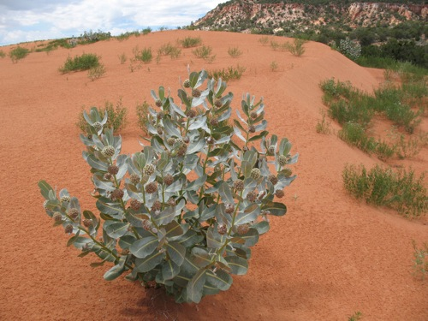

**Welsh’s milkweed (Asclepias welshii). Photo by J.P. Riser, Washington State University**

### Uses

There are no known human uses of Welsh’s milkweed. This species, unlike other members of the genus, is not toxic to livestock. However larger animals tend to avoid the unconsolidated sands that make up Welsh’s milkweed habitat, leaving it largely unutilized by grazers.

### Status

Welsh’s milkweed was listed as a threatened species in 1987 with designated critical habitat (USDI-FWS, 1987).

Consult the PLANTS Web site and your State Department of Natural Resources for this plant’s current status (e.g., threatened or endangered species, state noxious status, and wetland indicator values).

### Description

*General*: Milkweed family (Asclepiadaceae). Welsh’s milkweed is a perennial forb which grows from an extensive underground root system comprised of a taproot and horizontal runners connecting stem clusters. The plants grow with one to several erect stems to a height of 25 to 100 cm (10 to

39 in). The leaves are opposite, and broadly ovate; 6 to 9 cm (2.3 to 3.5 in) long, and 3 to 6 cm (1.2 to 2.3 in) wide (Welsh et al., 2003). The leaves and stems are covered with a white wooly tomentum, or pubescence, early in the season. Windblown sands abrade the hairs leaving the vegetation nearly glabrous later in the year. The inflorescence is a globose cluster of around 30 cream colored flowers with a rose-tinged middle. The fruit is a 4 to 8 cm (1.6 to 3.2 in) long pod or follicle. The seeds are large, 2 cm (1 in) long with a rudimentary coma, or tuft of hairs (USDI-FWS, 1992).

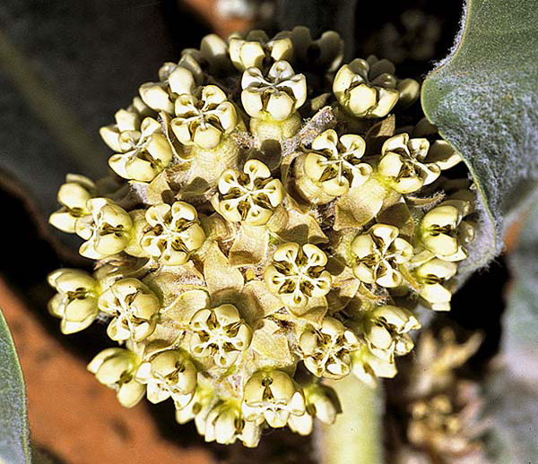

**Welsh’s milkweed inflorescence. Photo by S. O’Kane**

*Distribution*:

Welsh’s milkweed is currently known to occur in three populations in southern Utah and northern Arizona. The largest population of an estimated 10,000 plants lies on the Coral Pink Sand Dunes in Kane County, Utah. A second Utah population of approximately 500 individuals is found in the Sand Hills, also in Kane County. A third population of approximately 500 plants is known at Sand Cove on the Kane County, Utah and Coconino County, Arizona border.

For current distribution, consult the Plant Profile page for this species on the PLANTS Web site.

*Habitat*:

Welsh’s milkweed is found on shifting sands and dunes adjacent to sagebrush, juniper and ponderosa pine communities from 1,700 to 1,900 m (5,600 to 6,200 ft) in elevation. Other dune-loving plant species found in association with Welsh’s milkweed include blowout grass (*Redfieldia flexuosa*), sand dropseed (*Sporobolus cryptandrus*), Indian ricegrass (*Achnatherum hymenoides*) and giant dunegrass (*Calamovilfa gigantea*).

**Adaptation**

Welsh’s milkweed is adapted to aeolian sands on active dunes in the arid deserts of southern Utah and northern Arizona. Mean annual precipitation in nearby Kanab, Utah is reported at 38 cm (15 in).

### Management

### The primary threats to Welsh’s milkweed involve potential habitat loss and habitat damage due to off highway vehicle (OHV) use (USDI-FWS, 1992). However; Welsh (2003) observed the species thriving despite the utilization of dunes for recreation, because OHV users tend to avoid vegetated areas. Management strategies in place include regulating OHV use, monitoring known populations, and inventorying suitable habitat.

### Pests and Potential Problems

There are no known pests or potential problems regarding Welsh’s milkweed*.*

### Environmental Concerns

There are no known environmental concerns regarding Welsh’s milkweed*.*

### Seeds and Plant Production

Flowering occurs from May to June with seed set and dispersal occurring from July to September (USDI-FWS, 1992). Several potential pollinators that have been observed visiting Welsh’s milkweed include bees, wasps, and butterflies. One species of carpenter bee (*Xylocopa californica* ssp*. arizonensis*) and one species of bumble bee (*Bombus bifarius*) have been observed carrying milkweed pollen (USDI-FWS, 1992).

### References

USDI-FWS. 1987. Endangered and threatened wildlife and plants; final rule determining *Asclepias welshii* (Welsh’s milkweed) to be a threatened species with critical habitat. In: Federal Register. 52(208): 41435-41441.

USDI-FWS. 1992. Welsh’s milkweed (*Asclepias welshii*) recovery plan. U.S. Fish and Wildlife Service, Denver, Colorado. 19pp.

Welsh, S.L., N.D. Atwood, S. Goodrich, and L.C. Higgins. 2003. A Utah Flora. Third Edition, revised. Brigham Young University, Provo, UT.

**Prepared By**:

*Derek Tilley*; USDA NRCS Plant Materials Center, Aberdeen, Idaho.

*Loren St. John*, USDA NRCS Plant Materials Center, Aberdeen, Idaho.

*Dan Ogle*, USDA NRCS, Boise, Idaho.

### Citation

Tilley, D., L. St. John and D. Ogle. 2010. Plant guide for Welsh’s milkweed (*Asclepias welshii*). USDA-Natural Resources Conservation Service, Idaho Plant Materials Center. Aberdeen, ID.

Published Jan 2010

Edited: 03Jan2011djt, 03Jan2011ls, 03jan2011dgo

For more information about this and other plants, please contact your local NRCS field office or Conservation District at http://www.nrcs.usda.gov/ and visit the PLANTS Web site at http://plants.usda.gov/ or the Plant Materials Program Web site http://plant-materials.nrcs.usda.gov.

PLANTS is not responsible for the content or availability of other Web sites.

**USDA IS AN EQUAL OPPORTUNITY PROVIDER AND EMPLOYER**