|  |
| --- |
| black mangrove |
| *Avicennia germinans* (L.) L. |
| Plant Symbol = AVGE |

*Contributed by: USDA NRCS Plant Materials Center*

*Golden Meadow, Louisiana*

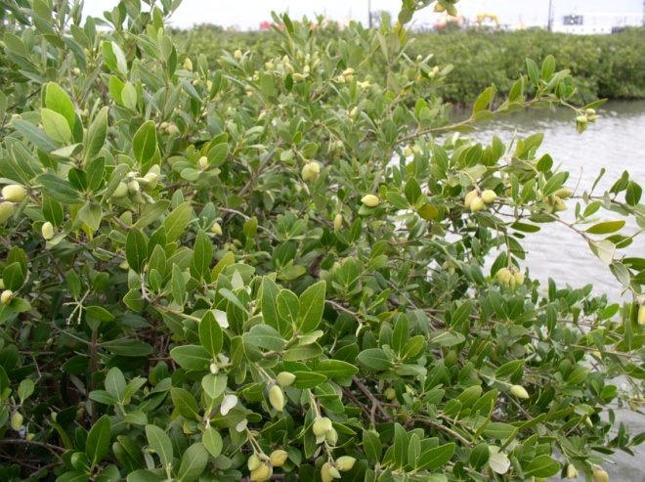

Garret Thomassie, USDA NRCS Golden Meadow PMC

**Alternate Names**

None in common usage

**Uses**

Black mangrove is valuable in soil conservation in brackish and salt water marshes. It serves as nursery habitat for crustaceans and fish, and filters sediment for building new marsh.Black mangrove also mixes well with other native plants to reduce wave energy

**Status**

This species is native to the Gulf of Mexico and has not been identified as invasive or detrimental to the environment. Black mangrove is a native and valuable component of the marsh ecosystem.

Please consult the PLANTS website and your State Department of Natural Resources for this plant’s current status (e.g. threatened or endangered species, state noxious status, and wetland indicator values)

**Description**

*General*: Black mangrove is a subtropical native woody shrub that grows in salt marshes. Mangroves are very hardy, having become adapted to harsh environments where water and salinity levels fluctuate. Pneumatophores, or breather roots, form a network, collecting silt and debris and controlling erosion.

The pneumatophores are also excellent nursery areas for crustaceans in the marsh plant community. Height will vary from 4 to 9 feet. Leaves are 1 to 5 inches long, elliptical, opposite, thick, leathery, dark green, glabrous (smooth) above, and grayish with a tight felt-like pubescence beneath. Glands on the underside secrete salt. Clusters of small sessile flowers with white petals, approximately ½ inch in diameter, are borne in the leaf axils or growing tips on the twigs. The fruit are flat, approximately 1 inch long, dark green and glabrous beneath a velvety pericarp. The bark on the black mangrove is thick, dark brown or blackish, with rough irregular flattened scales. Twigs are grayish in color and smooth, with enlargements at the joints. Mangrove detritus (dead leaves and twigs) in water feeds microorganisms that provide food for young marine life.

*Distribution*: For current distribution, please consult the Plant Profile page for this species on the PLANTS Web site.

*Habitat*: Black mangrove grows in the intertidal zone throughout the Gulf of Mexico. Black mangrove is a truly unique plant species that, when established properly, and under applicable conditions, has provided land stabilization due to the easy transport of seedlings, quick aerial root production, Best practice has been to plant two to three year old seedlings because underground root systems increase sediment holding capabilities. This plant also provides for wildlife and marine habitats. (USDA/NRCS Plant Guide: Small, J.K 1933.)

**Adaptation**

Black Mangrove adaptation is in the sub-tropical to tropical Gulf of Mexico in intertidal zones.

This plant is susceptible to freezing and the native range can be changed drastically by hard winters. The contributions of genetic diversity and habitat are presently under study to determine cold hardiness.

**Establishment**

Black mangrove establishes in nature from seed that floats and can travel some distance on the tides. Seed will germinate quickly to anchor young seedlings in good habitat.

In the nursery, seed collected in the wild will not survive more than three to four weeks. Seed should be soaked in water, the pericarp removed and the seed planted in any commercial potting soil Germination normally occurs within a couple of weeks and seedlings take root.

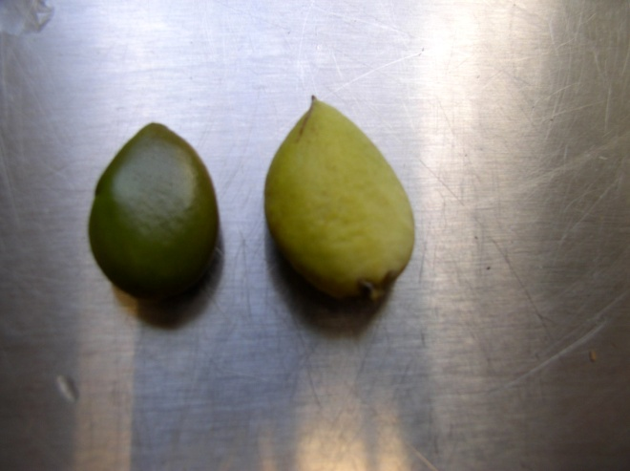

Recalcitrant seed on left, pericarp removed on right

Garret Thomassie, USDA NRCS Golden Meadow PMC

Our experience indicates that a normal variety of commercially available pots will suffice for germination and early growth. Plants can be maintained in fresh water tanks that hold moisture at the bottom of the pots.

**Management**

There are no data on managing native black mangrove stands. In the Gulf of Mexico the range of black mangrove is “managed” by the winter weather.

**Pests and Potential Problems**

There are no known pests that could threaten black mangrove stands in the wild.

**Environmental Concerns**

Black mangrove has persisted in the intertidal marsh and is a valuable component of the ecosystem. Loss of black mangrove is a concern as it is a woody species that persists and assists in habitat development and in breaking wave energy and adds nesting habitat for birds including the pelican.

Care must be taken to planting as black mangrove is very susceptible to freezing. More work needs to be done in collecting ecotypes that might be more frost resistant, or attention to habitat differences.

**Seeds and Plant Production**

Experience at the NRCS-Golden Meadow Plant Materials Center has shown that seed collected in the Fall (October to early December in South Louisiana) can be maintained for about a month, but should be planted as soon as possible after soaking removing the pericarp. There is work presently being conducted on maintaining seed for delayed germination, but at present, seed should have the pericarp removed and planted as soon as possible. Seed may be held longer with aeration (Personal communication Mat Benoit).

Two year old seedlings or older (18 inches tall) seem to be best for successful out planting. Various sizes of tubes and pots have been used with success. The greater the root mass (not pot bound) the greater the chance of successful out planting.

Planting where the tidal flow will cover and uncover the root collar is best. Soil types can vary from muck soils to areas that have some sand.

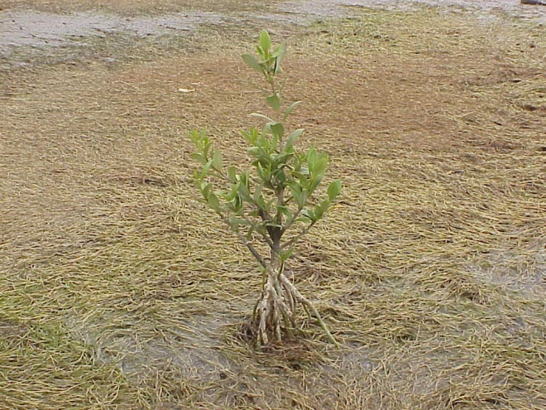

Interior marsh planting

Garret Thomassie, USDA NRCS Golden Meadow PMC

New plantings in areas of high wave energy may have to be protected by baffles or anchoring the seedlings in place until the root system is capable of supporting the plant.

**Cultivars, Improved, and Selected Materials (and area of origin)**

The USDA NRCS Plant Materials Centers have released one variety: Pelican Germplasm black mangrove is a pre-varietal release from the Golden Meadow Plant Materials Center, Galliano, Louisiana, selected to provide a plant for soil conservation in brackish and salt water marshes.

Contact your local Natural Resources Conservation Service office for more information. Look in the phone book under “United States Government”. The Natural Resources Conservation Service will be listed under the subheading “Department of Agriculture.”

**References**

Benoit, M. (Feb) 2007. *Personal communication*. Nicholls State University, Lake Charles, Louisiana

Small, J.K. 1933. *Manual of the Southeastern Flora*, University of North Carolina Press, Chapel Hill.

USDA/NRCS Plant Guide *Avicennia germinans* Golden Meadow Plant Materials Center, Golden Meadow, Louisiana.

**Prepared By**: *Richard H. Neill*, USDA NRCS Golden Meadow Plant Materials Center, Galliano, Louisiana

**Species Coordinator**: *Richard H. Neill*, USDA NRCS Golden Meadow Plant Materials Center, Galliano, Louisiana

Edited: Joel Douglas and Morris Houck; 080827 jsp

For more information about this and other plants, please contact your local NRCS field office or Conservation District, and visit the PLANTS Web site<<http://plants.usda.gov>> or the Plant Materials Program Web site <<http://Plant-Materials.nrcs.usda.gov>>

*The U.S. Department of Agriculture (USDA) prohibits discrimination in all its programs and activities on the basis of race, color, national origin, age, disability, and where applicable, sex, marital status, familial status, parental status, religion, sexual orientation, genetic information, political beliefs, reprisal, or because all or a part of an individual's income is derived from any public assistance program. (Not all prohibited bases apply to all programs.) Persons with disabilities who require alternative means for communication of program information (Braille, large print, audiotape, etc.) should contact USDA's TARGET Center at (202) 720-2600 (voice and TDD).*

*To file a complaint of discrimination write to USDA, Director, Office of Civil Rights, 1400 Independence Avenue, S.W., Washington, D.C. 20250-9410 or call (800) 795-3272 (voice) or (202) 720-6382 (TDD). USDA is an equal opportunity provider and employer."*

*Read about* [*Civil Rights at the Natural Resources Conservation Service*](http://www.nrcs.usda.gov/about/civilrights/)*.*