|  |  |
| --- | --- |
| **Natural Resources Conservation Service** | Plant Guide |

# CANE BLUeSTEM

## Bothriochloa barbinodis (Lag.) Herter

Plant Symbol = BOBA3

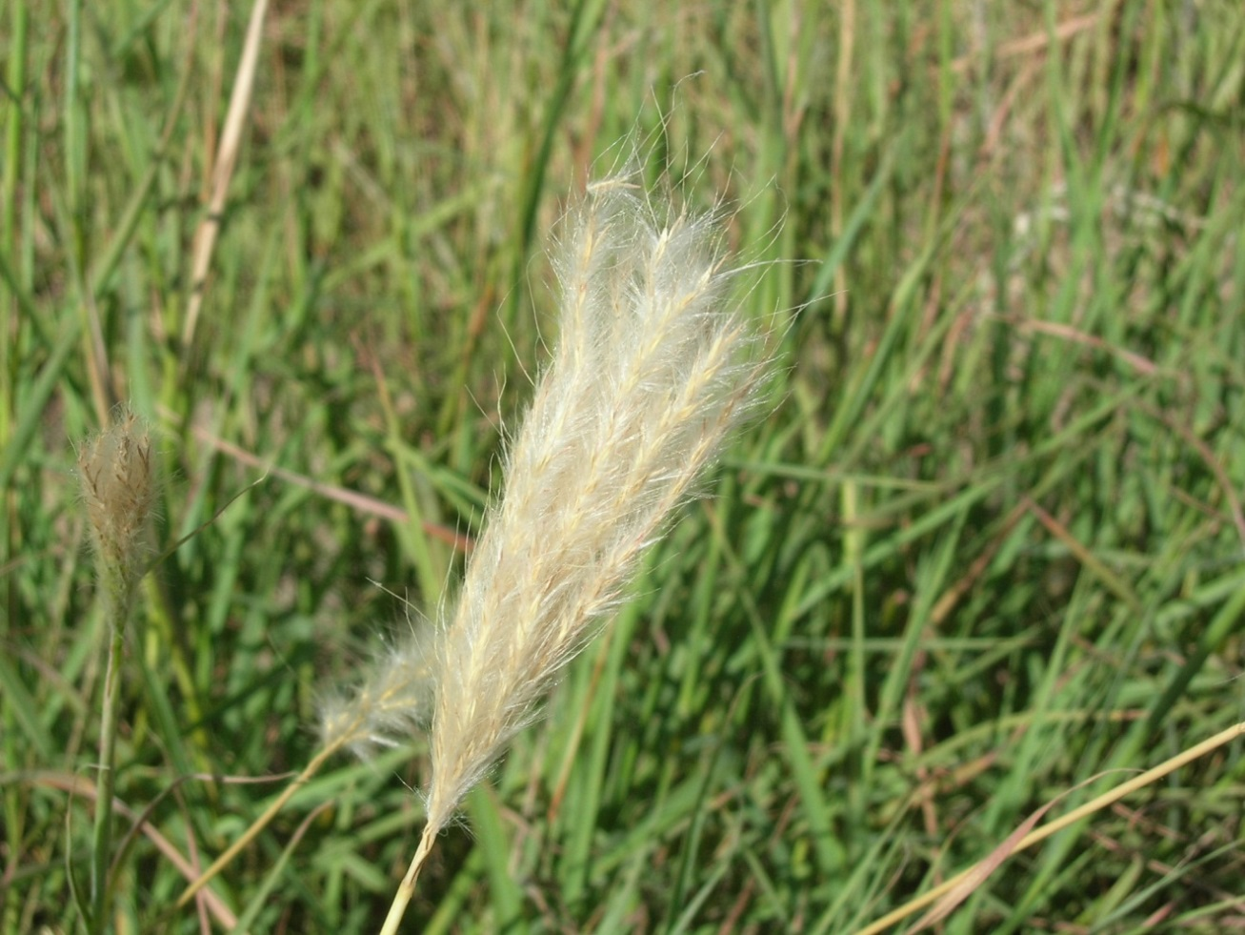

Figure 1. Cane bluestem panicle (Photo by Mary Hershdorfer, USDA-NRCS. Tucson Plant Materials Center)

### Alternate Names

*Common Names:* Cane beardgrass, feather bluestem, plains beardgrass, and pinhole bluestem.

*Scientific Names: Andropogon barbinodis (*Lag.)

### Description

*General*: Cane bluestem is a native, coarse perennial, warm season bunchgrass. It typically grows 2-4 feet tall. The leaves are wide, fairly long, occurring basally and on the flower stalks, bluish green, and cure to a dull red or yellow. Seeds are borne in tufts of silvery hair on the end of the long seed stalks. The fan shaped panicles appear silvery white due to the long tufts of hair and awns on the paired spikelets. The seeds stalks are usually 2 to 4 inches long and about twice as long as wide ( Ruyle and Young 2013). Cane bluestem is very similar to silver bluestem (*Bothriochloa saccharoides*) in habit and appearance, however, the nodes are not as noticeably bearded as cane bluestem (Shreve and Wiggins, 1964).

*Distribution*: Cane bluestem is commonly found in Arizona, New Mexico, western Texas, and north-central Mexico (Gucker, 2011).

For current distribution, please consult the Plant Profile page for this species on the PLANTS Web site.

*Habitat*: Cane bluestem can be found growing on open, sandy or gravelly ground, and rocky slopes. It is particularly abundant along graded roadsides, banks of washes, railroad rights of way, or other places where the soil has been exposed (USDA-NRCS, 2013; Ruyle and Young, 2003).

Cane bluestem is most common in the semi-desert grassland, oak woodland, chaparral, and short grass plains types. It is usually found as scattered plants or in small groups, but seldom in pure stands (Judd, 1962). In Oak woodlands of Arizona, it is often an understory co-dominant with side oats grama (*Bouteloua curtipendula*), Hairy grama (*Bouteloua hirsuta*), threeawn (*Aristida* spp.), and plains love grass (*Eragrostis intermedia*) (Carmichael et. al., 1978). Cane bluestem is common at elevations ranging from 1,600 to 3,900 feet, however, elevations beyond this range have been reported (Gucker, 2011).

***Adaptation***

Cane bluestem can be found growing on a variety of soil types and textures, but growth may be best on calcareous, deep loams, or sandy loams. Cane bluestem is also common on microsites that support pooling water after high precipitation events (Gucker, 2011). This species is important in the southwest since it grows in relatively dry habitat. It can grow where annual precipitation ranges from 5-7 inches, if supplemented by occasional flooding from heavy summer showers (Judd, 1962). This species produces best in areas receiving 12-16 inches of rainfall (Pater and Munda 2002).

### Uses

*Forage:* Cane bluestem, when actively growing, provides fair to good forage for cattle and sheep. However, dry plants are low in nutrients as they leach readily (Gay and Dwyer, 1984). It is a good indicator of proper grazing, since it is one of the first species to disappear when a range is excessively utilized (Judd, 1962).

*Conservation:* Cane bluestem may be used as an erosion control plant on rangelands and critical areas such as abandoned cropland and road cuts. It also has beneficial qualities for food and/or cover for wildlife species including gamble’s quail, dove, rabbits, and other small rodents (Pater and Munda, 2002).

### Status

*Threatened or Endangered*: No

*Wetland Indicator:* Obligate Upland-UPL (USDA-NRCS, 2014)

Please consult with your local NRCS Field Office, Cooperative Extension Service office, state natural resource, or state agriculture department regarding its status and use.

Please consult the PLANTS Web site (<http://plants.usda.gov/>) and your State Department of Natural Resources for this plant’s current status (e.g., threatened or endangered species, state noxious status, and wetland indicator values).

### Planting Guidelines

The recommended seeding rate for a solid stand (100%) cane bluestem is 1.4 pure live seed (PLS) pounds per acre with a drill and approximately 2.8 PLS pounds per acre, if seed is broadcast. If planting as a component of seeding mixture, adjust rate based on 25 seeds per square feet (Garner et. al., 2002; Pater and Munda, 2002). Cane bluestem has approximately 754,000 seeds per pound.

Successful seed establishment is reported to increase when seeds were planted during the summer rainy season (Gucker, 2011). In southern Arizona, the recommended planting period is from late June to late August. Seed should be planted into a firm, weed-free seedbed at a depth of ¼- ½ inch. Broadcast seeding should be followed with a cultipacker or harrow to provide seed with a shallow covering of soil.

**Management**

Cane bluestem is considered a decreaser species and will decline if overgrazed. The presence of cane bluestem is considered an indicator of good range condition (Judd, 1962). Cane bluestem tends to be coarse and fibrous, however, it has been rated as fair to good forage when green (Gould, 1978).

Experimental grazing studies with cane bluestem stress the importance of avoiding continuous and heavy grazing of cane bluestem to maintain a vigorous and productive stand (Gucker, 2011).

### Pests and Potential Problems

No specific pests or potential problems were noted in the literature reviewed.

### Environmental Concerns

No negative environmental impacts were found in the literature reviewed.

### Seeds and Plant Production

For commercial seed increases, cane bluestem should be planted in the early spring into a firm, weed free seedbed at a ¼ depth with 24-38 inches within row spacing. Row spacing can vary from 24-38 inches. The planting should be irrigated to maintain a moist soil surface and to avoid soil crusting. Pre-emergent herbicide may be used to control weeds after the plants have reached the 3-5 leaf stage (Garner, 2004; USDA-NRCS, 2004).

Commercial seed production of cane bluestem may require from 40 to 60 pounds per acre of available nitrogen per year and should be irrigated approximately every four weeks during the growing season. Application of phosphorus and potassium fertilizer should be done according to soil test results (Garner, 2004).

Seed production fields of cane bluestem may be harvested with a seed stripper. The harvested seed can be cleaned by using a brush huller scarifier with a #12 screen to remove the hairs and awns from the seed heads. Seeds may then be separated from the chaff using a clipper air screen seed cleaner with a #9 top screen and a 45x45 bottom screen. (Garner et. al., 2002).

### Cultivars, Improved, and Selected Materials (and area of origin)

*Saltillo origin*

Cane bluestem, was released in 2002 by the USDA-NRCS Tucson Plant Materials Center in cooperation with the Agricultural Research Service and the University of Arizona Agricultural Experiment Station. This release was selected for its superior vigor, forage production, and tolerance to drought and cold (Pater and Munda, 2002).

*Grant Germplasm*

This germplasm was released in 2001 by the USDA-NRCS New Mexico Plant Materials Center and New Mexico State University Agricultural Science Center at Los Lunas, New Mexico. It was selected for superior forage and seed yield (Garner, et al., 2001)

**Literature Cited**

Buechner, Helmut K. 1950. Life History, ecology, and Range Use of the Pronghorn Antelope in Trans-Pecos Texas. American Midland Naturalist. 43(2):257-354.

Carmichael, R.S., O.D. Knipe, C.P. Pase, W. W. Brady. 1978. Arizona Chaparral: Plant associations and ecology. RES. Pap. RM-202. USDA Forest Service, Rocky Mountain Forest and Range Experiment Station, Fort Collins, CO 80523

Gucker, Corey L. 2011. Bothriochloa barbinodis. In: Fire Effects Information System, [Online]. U.S. Department of Agriculture, Forest Service, Rocky Mountain Research Station, Fire Sciences Laboratory (Producer). Available at http://www.fs.fed.us/database/feis/ (accessed 15 July 2014; verified 18 July2014).

Gay, C. W., and D. D. Dwyer. 1984. New Mexico Range Plants. Circular374. New Mexico State University, Cooperative Extension Service. Las Cruces, NM. 88003.

Garner, E. R., M. Jespersen, and D. Goodson. 2001. Notice of Release of a Selection of Cane Bluestem Selected Class of Germplasm. USDA-NRCS, New Mexico Plant Materials Center. Los Lunas, NM 87031

Garner, E.R. 2004. Native Plant production. USDA-NRCS Tucson Plant Materials Center. Tucson, Arizona 85705

Garner, E.R., B. Munda, and M. Pater. 2002. USDA-NRCS, Tucson Plant Materials Center. Cane Bluestem, Plant Fact Sheet. Tucson, AZ 85705

Gould, Frank W. 1978. Common Texas Grasses. Texas A&M University Press, College Station, TX. 267p.

Humphrey, Robert R. 1970. Arizona Range Grasses: Their description, forage value and management. University of Arizona Press, Tucson, AZ. 159p.

Judd, B. I. 1962. Principal Forage Plants of Southwest Ranges. Rocky Mountain Forest and Range Experiment Station. Colorado State University. Fort Collins, CO 80523.

Pater, M. and B. Munda. 2002. Notice of Release of Selection of Cane Bluestem Saltillo Origin. USDA-NRCS Tucson Plant Materials Center. Tucson, AZ 85705

Ruyle, G.B. and. J. Young (eds.) 2003. Arizona range grasses: their description, forage value, and grazing management. University of Arizona Cooperative Extension. College of Agriculture. Tucson, Arizona 85716.

USDA, NRCS. 2013. Conservation Plant Release Brochure for Saltillo Origin Germplasm cane bluestem (*Bothriochloa barbinodis* (Lag.)Herter). Tucson Plant Materials Center, Tucson, AZ 85705.

USDA-NRCS. 2004. Field Office Technical Guide, Section IV: Range Planting - Code550. Conservation Practices Standards and Specifications for Arizona.

USDA, NRCS. 2014. The PLANTS Database. Available at <http://plants.usda.gov> (verified 9 July 2014). National Plant Data Team, Greensboro, NC 27401-4901 USA.

### Citation

E.R. Garner, B.D., Munda, and M. Pater. 2014. Plant Guide for cane bluestem (*Bothriochloa barbinoides*). ed. rev. M. Rosales, 2014. USDA-Natural Resources Conservation Service, Tucson Plant Materials Center, Tucson, AZ 85705

Published: September 2002

Edited: 23jul2014 mr

For more information about this and other plants, please contact your local NRCS field office or Conservation District at <http://www.nrcs.usda.gov/> and visit the PLANTS Web site at <http://plants.usda.gov/> or the   
Plant Materials Program Web site:

<http://plant-materials.nrcs.usda.gov>.

PLANTS is not responsible for the content or availability of other Web sites.

***Helping People Help the Land***

**USDA IS AN EQUAL OPPORTUNITY PROVIDER AND EMPLOYER**