

Plant Guide

# SIDEOATS GRAMA

***Bouteloua curtipendula* (Michx.) Torr. var. *caespitosa* Gould & Kapadia**

Plant Symbol = BOCUC

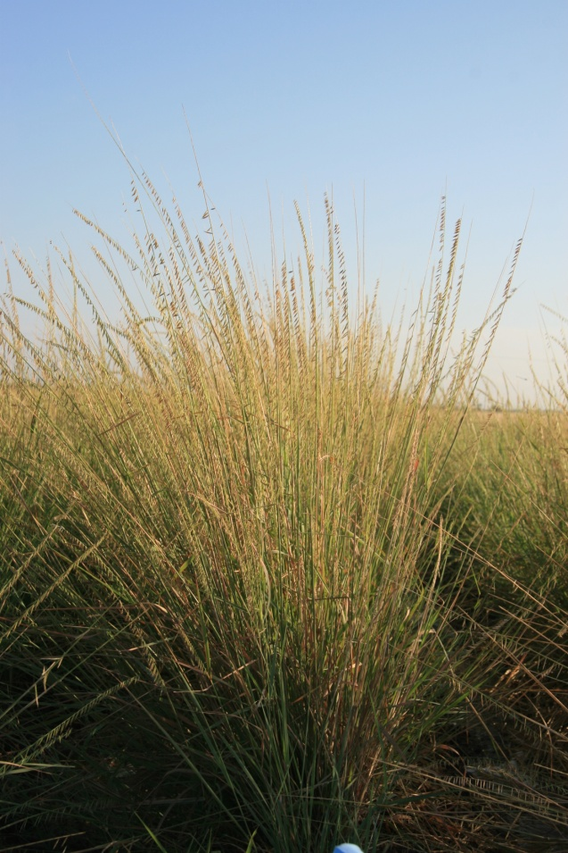

Sideoats grama plant. Photo by Forrest Smith, South Texas Natives, Kingsville, TX.

*Contributed by*: USDA NRCS E. “Kika” de la Garza Plant Materials Center and *South Texas Natives*

### Uses

*Livestock:* Sideoats grama (*Bouteloua curtipendula* [Michx.] Torr. var. *caespitosa* Gould & Kapadia) produces abundant forage on many range sites. It provides moderate to high quality forage for all types of grazing livestock.

*Wildlife*: Sideoats grama provides fair forage for wildlife. It also provides good nesting cover for upland game birds and escape cover for all wildlife.

### Status

Please consult the PLANTS Web site and your State Department of Natural Resources for this plant’s current status (e.g., threatened or endangered species, state noxious status, and wetland indicator values).

### Description

*General*: Sideoats grama is a native, warm-season perennial bunchgrass. It grows 3-4 feet tall. The leaf blade is long, and is distinguished by papilla based hairs along the margin. Variety *caespitosa* does not have rhizomes, and has an upright, caespitose growth form. The seedheads are numerous spikes with 10-30 spikelets generally oriented to one side of the rachis (Barkworth et al. 2007).

*Distribution*: The natural range of sideoats grama is throughout North America and continuing down into Central America. Variety *caespitosa* is generally found in the western portions of the species’ range. For current distribution, please consult the Plant Profile page for this species on the PLANTS Web site.

**Adaptation**

Sideoats grama grows best on fine to medium textured soils.

### Establishment

Seedbed preparation should begin well in advance of planting. Planting can be scheduled for early spring or later summer-autumn. Establish a clean, weed-free seedbed by either tillage or herbicides. Prior to planting, the site should be firm and have accumulated soil moisture.

Sideoats grama is best seeded using a native-grass drill with picker wheels or medium to large seed box to ensure a good planting of the seed. Broadcast seeding may be used in areas not easily planted with a drill, but some type of additional coverage such as culti-packing or light dragging will be beneficial to ensure good seed to soil contact. Seed should be planted 1/8 to 1/4 inch deep. It is better to plant too shallow than too deep.

If one plant per square foot has become established in field plantings, then the seeding can be considered successful.

### Management

Sideoats grama should not be grazed the first year after planting. After a stand is established, either continuous or rotational grazing can be used. It is recommended that a minimum 6 inch stubble height be maintained under continuous grazing. Contact your local USDA-NRCS field office for assistance in planning and applying prescribed grazing. Plants should be allowed to produce seed annually to insure stand health. Sideoats grama is a long-lived perennial that is extremely drought and fire tolerant once established.

### Pests and Potential Problems

### Thrips and rice stink bugs can limit seed production on seed production fields.

### Environmental Concerns

### There are no known environmental concerns associated with sideoats grama.

### Seeds and Plant Production

Seed increase plots have been managed on 36” bedded rows, however flat plantings may be possible with adequate weed control. Sideoats grama can also be established with vegetative transplants. Rapid spread and growth has been observed in transplant established stands providing seed harvests within the first year. Furthermore transplants facilitate better weed control in the seed production fields. Deep soil tillage or frequent close cultivation is recommended to promote seed production.

Seed can be harvested with a Flail-Vac or combine. To clean stems and chaff from harvests, a Clipper seed cleaner has been used. Sideoats grama can produce multiple seed crops per year when grown in cultivation. The quantity and quality of seed harvests vary greatly depending on location and field conditions.

### Cultivars, Improved, and Selected Materials (and area of origin)

South Texas Germplasm sideoats grama was released by *South Texas Natives,* the E. “Kika” de la Garza Plant Materials Center, and Texas AgriLife Research Beeville in 2012. It was selected for its survivability, plant vigor, forage production and seed production characteristics. This germplasm is known to be adapted to the Rio Grande Plain, Gulf Coast Prairies and Marshes, and Coastal Sand Plains Ecoregions of south Texas.

For calibration purposes, South Texas Germplasm contains approximately 165,000 seeds per bulk pound. A seeding rate of 5-10 pounds of pure live seed (PLS) per acre is recommended. In planting mixtures reduce the rate according to the percent of sideoats grama desired on the planting site. Breeder seed is maintained by South Texas Natives.

Well managed seed fields of South Texas Germplasm have produced 80-350 bulk pounds of clean seed per year. Purity of the seed is usually around 50% and germination rates range from 5-20%. South Texas Germplasm has a large amount of dormant seed. It produces four seed crops per year when grown under irrigation in South Texas.

‘Butte’ was selected at Nebraska AES, Lincoln, USDA-ARS and SCS cooperatively by E.C. Conard and L.C. Newell. It represents native collections from Holt and Platte Counties in Nebraska that were combined and tested as Nebraska 37. Repeated field plantings revealed superior germination and establishment characteristics when compared with other sources.

‘El Reno’ was released cooperatively in 1944 by the SCS, Manhattan, Kansas Plant Materials Center and Kansas AES. The original seed was collected in a field location near El Reno, Oklahoma in 1934. The material was outstanding for leafiness, forage production and vigor. It also ranked well for disease resistance, seed production, and winter hardiness. It is widely used in range seedings and is adapted to Kansas, Oklahoma and northern Texas.

‘Haskell’ was released in 1983 by the James E. “Bud” Smith Plant Materials Center, Texas AES and USDA-ARS. The seed for this release was originally collected in 1960 by J.C. Yeary, Jr. in Haskell, Texas.

It was selected based on rhizome production and adaptation as far south as the Rio Grande Valley in Texas. It is also known for its high forage palatability and prolific seed production.

Killdeer was informally released in the late 1960’s by the Bismarck Plant Materials Center in Bismarck, ND. It is composed of seed collected from native stands in 1956 near Bowman, Bowman County and Killdeer, Dunn County, North Dakota. Killdeer possesses outstanding vigor, leafiness, fair seed production, freedom from disease and persistence in a cold, semi-arid environment.

‘Niner’ was released in 1984 by SCS and the New Mexico and Colorado AES. The original seed for the release was collected by G.C. Niner and J.A. Anderson in 1957 west of Socorro, New Mexico. Niner was a bulk increase of the collection made by Niner and Anderson.

Pierre was informally released in 1961 by the Bismarck Plant Materials Center and the South Dakota AES. The original seed for the release was collected in 1954 in Stanley County west of Pierre, South Dakota. The release is described as outstanding in vigor, leafiness, freedom from disease, seedling vigor and persistence in a semi-arid environment.

‘Premier’ was released in 1960 cooperatively by Texas AES and USDA-ARS and NRCS. The original seed was collected in 1953 from a single plant growing between Cuauhtemoc and Chichuahua, Mexico. The release is described as having good seedling vigor, good seed yield, drought tolerance, upright growth form and leafiness.

‘Trailway’ was cooperatively released in 1958 by Nebraska AES and USDA-ARS. The original seed was collected in 1953 in northern Holt County by L.C. Newell. The release is described as winter hardy, long lived, late maturing with a somewhat indeterminate heading and flowering response. Requires most of the growing season to mature a crop in eastern Nebraska and may fail to produce seed in areas with a shorter growing season.

‘Vaughn’ was released in 1940 by the New Mexico AES and SCS Plant Science Division. The original seed was collected from native stands in 1935 near Vaughn, New Mexico. The release is described as slightly variable, but all have erect leaves, good seedling vigor and easy to establish.

Northern, Central and Southern Iowa Germplasms were released in 1995 as source identified releases, by the Elsberry Plant Materials Center, University of Northern Iowa, Iowa Department of Transportation, Iowa Crop Improvement Association and NRVC. They are all composite lines from collections made in Northern, Central and Southern Iowa.

### References

### Barkworth, M.E., L.K. Anderton, K.M. Capels, S. Long, and M.B. Piep. 2007. Manual of

Grasses for North America. Intermountain Herbarium and Utah State University Press. Logan, UT.

SCS 1983. Notice of Release of ‘Haskell’ sideoats grama. United States Department of Agriculture. Washington, D.C.

SCS 1984. Notice of Release of ‘Niner’ sideoats grama. United States Department of Agriculture. Washington, D.C.

Smith, F.S., A.D. Falk, and W.R. Ocumpaugh 2012. Notice of Release of South Texas Germplasm Sideoats grama. Caesar Kleberg Wildlife Research Institute. Kingsville, TX.

USDA NRCS 2010. Plant Guide: Side-oats grama. <http://plants.usda.gov/plantguide/pdf/pg_bocu.pdf>

USDA NRCS 2011. ‘El Reno’ sideoats grama. <http://www.plant-materials.nrcs.usda.gov/pubs/kspmcrb10371.pdf>

**Prepared By**:

John Lloyd-Reilley, Manager

USDA-NRCS, E. “Kika” de la Garza Plant Materials Center, Kingsville, Texas

Forrest S. Smith, Director

South Texas Natives, Caesar Kleberg Wildlife Research Institute, Texas A&M University-Kingsville, Kingsville, Texas

### Citation

Lloyd-Reilley, J. and F. Smith. 2012. Plant guide for South Texas Germplasm sideoats grama. USDA-Natural Resources Conservation Service, E. “Kika” de la Garza Plant Materials Center and *South Texas Natives*, Caesar Kleberg Wildlife Research Institute, Texas A&M University-Kingsville, Kingsville, Texas 78363.

Published July 2012

For more information about this and other plants, please contact your local NRCS field office or Conservation District at <http://www.nrcs.usda.gov/> and visit the PLANTS Web site at <http://plants.usda.gov/> or the Plant Materials Program Web site <http://plant-materials.nrcs.usda.gov>.

PLANTS is not responsible for the content or availability of other Web sites.

**USDA IS AN EQUAL OPPORTUNITY PROVIDER AND EMPLOYER**