|  |  |
| --- | --- |
| **Natural Resources Conservation Service** | Plant Guide |

|  |
| --- |
| Giant Sandreed |
| *Calamovilfa gigantea* (Nutt.) Scribn. & Merr. |
| Plant Symbol = CAGI3  Contributed by: USDA NRCS Manhattan Plant Materials Center |

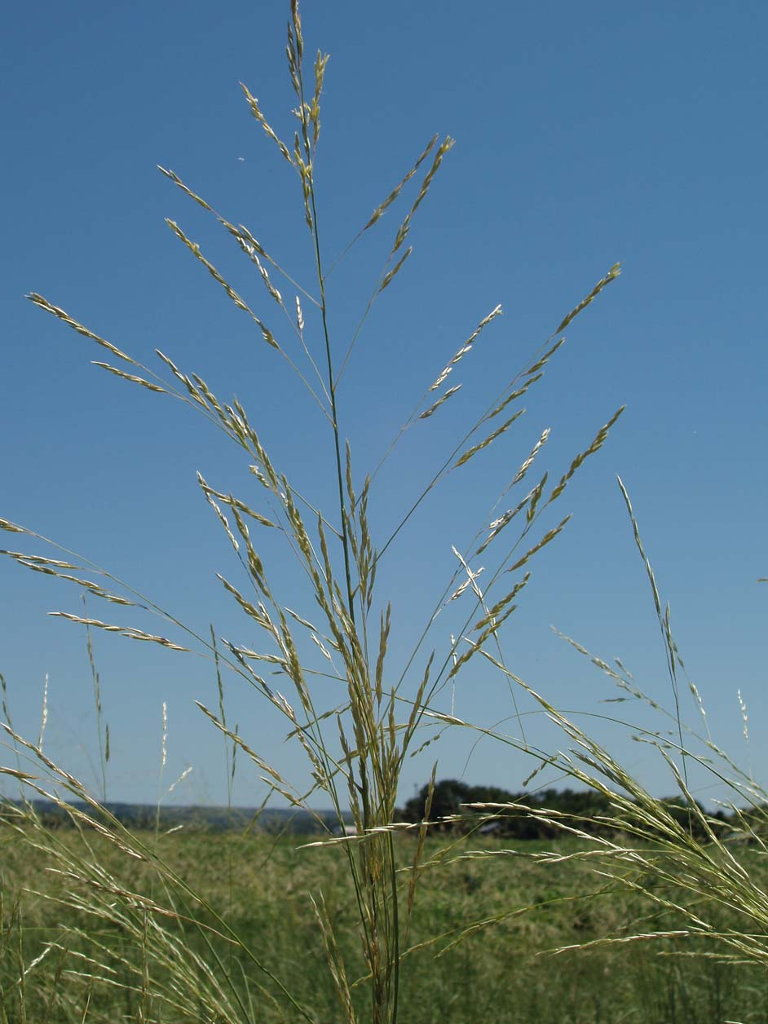

Figure 1 Inflorescence of giant sandreed

Photo by Alan Shadow, USDA NRCS

### Alternate Names

Big sandreed, big sandreed grass

Synonyms

Calamagrostis gigantea Nutt.

### Description

*General*: Giant sandreed is a robust perennial, native, warm-season grass with strong creeping rhizomes. The culms are erect, thick and solid or hollow near the base. Culm height ranges between 1 and 2 meters tall. The leaf blade is 7 to 11 mm wide at the base and rolls inward tapering to a long tip. The leaf sheath is usually glabrous or sometimes pubescent in the vicinity of the ligule. The inflorescence is an open panicle 30 to 65 cm long with lemmas that are villous on their backs, Fig.1.

*Distribution*: For current distribution, please consult the Plant Profile page for this species on the PLANTS Web site. Giant sandreed can be found from southern Utah (north of Kanab, Kane County) to Arizona, east to southwestern Nebraska, Kansas, Oklahoma, and to central Texas.

For current distribution, please consult the Plant Profile page for this species on the PLANTS Web site.

*Habitat*: A valuable sand binder that is closely related to prairie sandreed (*Calamovilfa longifolia*) of the mid-western states. A valuable species to control erosion on deep sandy soils subjected to severe wind erosion. Will grow in large colonies and dominate a site if properly managed, Fig. 2.

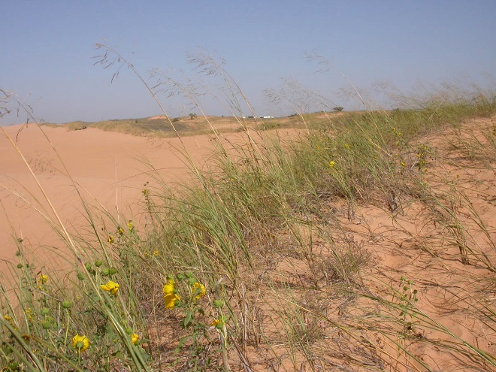

Figure 2 Giant sandreed growing on a sand dune in its natural habitat at Little Sahara State Park, Woods Co., Oklahoma

Photo Courtesy P. B. Pelser @ www.phytoimages.siu.edu

*Adaptation*

This species exhibits optimal performance on sandy textured soils.

### Uses

Giant sandreed is valuable for controlling erosion on deep sands subject to severe wind erosion. It cures well on the stem, thus providing good winter forage for livestock. When grown on sites large enough to be managed as a separate unit it can be hayed or used as reserve for winter forage.

### Ethnobotany

Giant sandreed was used by the Hopi to make prayer sticks and a carrying case for wedding garments. The grass plumes are used to decorate kachina masks and for decorating masks worn by the Jemez.

### Status

Please consult the PLANTS Web site (<http://plants.usda.gov/>) and your State Department of Natural Resources for this plant’s current status (e.g., threatened or endangered species, state noxious status, and wetland indicator values).

### Planting Guidelines

Normally this species exhibits weak seedling vigor and slow growth once it has germinated. This species is typically slow to establish from the seedling stage to a mature plant. It tends to put the majority of its resources into root and rhizome development during the seedling stage. Drill seed 2.54 cm deep in sandy soil and shallower in medium textured soils. Drilling into crop stubble improves stand establishment on erosive sites. Seedling loss can result from over watering on irrigated sites during establishment. Rhizomes may be sprigged in sand dunes or erosive “blowout” sites.

### Management

Spring growth of this species begins several days before other warm-season grasses in the same locality. This provides an advantage when early forage is desired for livestock species. When grown on large sites that require separate management this species can be hayed or grazed. It provides good winter forage for livestock. Summer grazing should be limited to no more than 50 percent removal of the current year’s growth. This will maintain a vigorous stand of grass, while leaving adequate amounts of mulch for control of wind erosion.

### Pests and Potential Problems

There are rust fungi that infect or cause disease on both *Calamovilfa* and *Sporobolus.*

### Environmental Concerns

There are no environmental concerns with this species. Generally, it has reduced seedling vigor and is only adapted to conditions in a sandy soil type environment. It has a very low probability of becoming a weed problem.

### Seeds and Plant Production

### Giant sandreed seed matures later than that of prairie sandreed. The species is difficult to harvest due to long stems wrapping around cylinders and augers of a conventional combine. Harvest seed in the dough stage, dry the bulk material, process with hammer mill and fanning mill for best results. Most of the clean seed is free of the pericarp, thus an achene, Fig.3. Seed quality, based on the seed production experience at Manhattan, Kansas: seed purity ranged from 97% to 99% and germination ranged from 17% to 55% with an average germination of 25%. There are approximately 97,500 seeds per pound (USDA, NRCS. 2014).

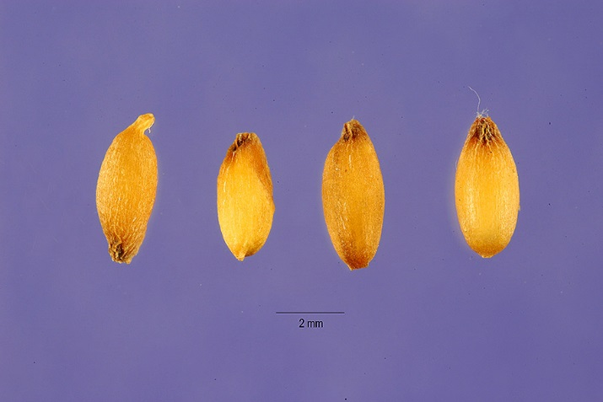

Figure 3 Giant sandreed achenes

Jose Hernandez, hosted by the USDA-NRCS PLANTS Database

### Cultivars, Improved, and Selected Materials (and area of origin)

Cultivars should be selected based on the local climate, resistance to local pests, and intended use. Consult with your local land grant university, local extension or local USDA NRCS office for recommendations on adapted cultivars for use in your area. There are currently no cultivars or improved varieties of giant sandreed available on the commercial market.

**Literature Cited**

Cummins, G.B. and H.C. Greene. 1961. The rust fungi of *Muhlenbergia*, *Sporobolus*, and related genera. Brittonia. Volume 13: 277-285.

Cornelius, D.R. and M.D. Atkins. 1946. Grass establishment and development studies in Morton County, Kansas. Ecology. Volume 27: 342-353.

Leithead, H.L., L.L. Yarlett, and T.N. Shiflet. 1971. 100 native forage grasses in 11 southern states. USDA, SCS Agriculture Handbook No. 389, Washington, DC.

Moerman, D. E. 1998. Native American ethnobotany. Timber Press. Portland · London.

Phyto Images. 2014. *Calamovilfa gigantea* [Online]. http://www.phytoimages.siu.edu/ (accessed 24 Sept 2014). Southern Illinois University, Carbondale, USA.

Rogers, K.E. 1970. A new species of *Calamovilfa* (Gramineae) from North America. Rhodora. Volume 72: 72-79.

Reeder, J.R. and M.A. Ellington. 1960. *Calamovilfa*, a misplaced genus of Gramineae. Brittonia. Volume 12: 71-77.

Reeder, J.R. and D.N. Singh. 1967. Chromosome number in *Calamovilfa*. Bulletin of the Torrey Botanical Club. Volume 94: 199-200.

Thieret, J.W. 1966. Synopsis of the genus *Calamovilfa* (Gramineae). Castanea. 31:145-152.

USDA, NRCS. 2014. Manhattan Plant Materials Center Annual Technical Report. Unpublished.

USDA, NRCS. 2014. The PLANTS Database (http://plants.usda.gov, 18 Nov 2014). National Plant Data Team, Greensboro, NC 27401-4901 USA.

### Citation

Wynia, Richard L. 2007. Plant Guide for giant sandreed (*Calamovilfa gigantea*). USDA-Natural Resources Conservation Service, Manhattan Plant Materials Center. Manhattan, KS 66502.

Published 2007; Revised 2014

Edited: 14Apr2007 jsp; 26Nov2014 jmr; 3Dec2014 jld

For more information about this and other plants, please contact your local NRCS field office or Conservation District at <http://www.nrcs.usda.gov/> and visit the PLANTS Web site at <http://plants.usda.gov/> or the   
Plant Materials Program Web site:

<http://plant-materials.nrcs.usda.gov>.

PLANTS is not responsible for the content or availability of other Web sites.

***Helping People Help the Land***

**USDA IS AN EQUAL OPPORTUNITY PROVIDER AND EMPLOYER**