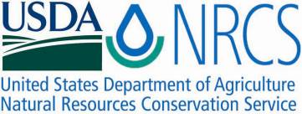

Plant Guide

# camelina

## Camelina sativa (L.) Crantz

Plant Symbol = CASA2

*Contributed by*: USDA NRCS WA Plant Materials Program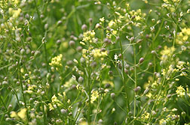

1, Camelina sativa, Photo by Robert Evans, ARS

### Alternate Names

*False flax,Gold-of-pleasure,Linseed dodder*

*Largeseed Falseflax,Leindotter, Siberian oilseed*

### Uses

For a long time camelina was known primarily in North America as a weed. More recently, camelina is being recognized for its value as an oilseed crop. Oil content of the seed, on a dry weight basis, is typically between 30 and 40 percent. The oil contains about 64 percent polyunsaturated, 30 percent monounsaturated, and 6 percent saturated fatty acids (McVay and Lamb 2008). Camelina oil can be used in both edible and industrial products. Historically, the seeds of camelina were crushed and boiled to release oil for food, medicinal use, and lamp oil. More recently camelina is being grown as a source of vegetable oil high in omega-3 fatty acids. Camelina is being marketed in Europe in salad dressing and as cooking oil (it is not suitable as deep-fat fry oil). It is also used in cosmetics, skin care products, soaps, and soft detergents (Ehrensing and Guy 2008). The oil has been used successfully as an adjuvant in agricultural spraying applications, as a biodiesel, and it has been approved for use in cattle, chicken, and pig feed (Ehrensing and Guy 2008, Hulbert et al 2011).

Camelina meal, the product remaining after the oil has been extracted from the seed, is similar to soybean and canola meal and contains more than 40% protein and has a moderately-low glucosinolate content.

Camelina seems to perform well as a companion crop (instead of oats) in establishing legumes for green manure cover and/or forage (Hunter 2010).

### Status

Please consult the PLANTS Web site and your State Department of Natural Resources for this plant’s current status (e.g., threatened or endangered species, state noxious status, and wetland indicator values).

### Weediness

It is considered a weed in many areas, but other areas embrace it for the use of its oils as a food, fuel or for its possible medicinal value. Camelina is primarily a minor weed in flax and not often a problem in other crops (Putnam et al., 1993). Its ability to survive in a diverse range of habitats enables it to be introduced fairly easily into new environments (Global Invasive Species Database).

Please consult with your local NRCS Field Office, Cooperative Extension Service office, state natural resource, or state agriculture department regarding its status and use. Weed information is also available from the PLANTS Web site at <http://plants.usda.gov/>. Please consult the Related Web Sites on the Plant Profile for this species for further information.

### Description

*Camelina sativa* is an annual in the mustard family and attains heights of 1 to 3 feet. It has branched stems that become woody at maturity. Stems are generally smooth or only sparsely hairy near their base (Hitchcock and Cronquist 1973). Leaves are arrow-shaped, sharp-pointed, 2 to 3.5 inches long with smooth edges. It produces prolific small, pale yellow or greenish-yellow flowers with 4 petals. Fruits are pear shaped pods known as silicles and have a squared off tip (Klinkenberg 2008). Seed pods are ¼ to slightly more than ½ inch long. Seeds are small (< 1/16 inch long and about half as wide) pale yellow-brown, oblong, rough, with a ridged surface. There are approximately 400,000 seeds of camelina per pound.

Camelina is widely distributed throughout the northern tier of states within the United States.

For current distribution, please consult the Plant Profile page for this species on the PLANTS Web site.

**Adaptation**

Camelina is native to parts of Asia and Europe, but it is widely naturalized elsewhere (USDA-ARS, 2008). Camelina has been introduced into the lower 48 states of continental United States (USA) as well as Alaska and Canada (USDA-NRCS, 2008).  
  
Camelina is a short-season crop (85 to 100 days) that is well adapted to production in the temperate climate zone. It is generally grown as an early summer annual oilseed crop but can be grown as a winter annual in milder climates (Hunter 2010). It is likely best adapted to cooler climates where excessive heat during flowering is not important. Camelina germinates at low temperature, and seedlings are very frost tolerant. In Montana, no seedling damage has been seen at temperatures as low as 12oF (Ehrensing and Guy 2008). Camelina is often grown on marginal land. It responds well under drought stress conditions and may be better suited to low rainfall regions than most other oilseed crops. In initial trials in Pennsylvania it has not performed well on wet and poorly drained soils (Hunter 2010).

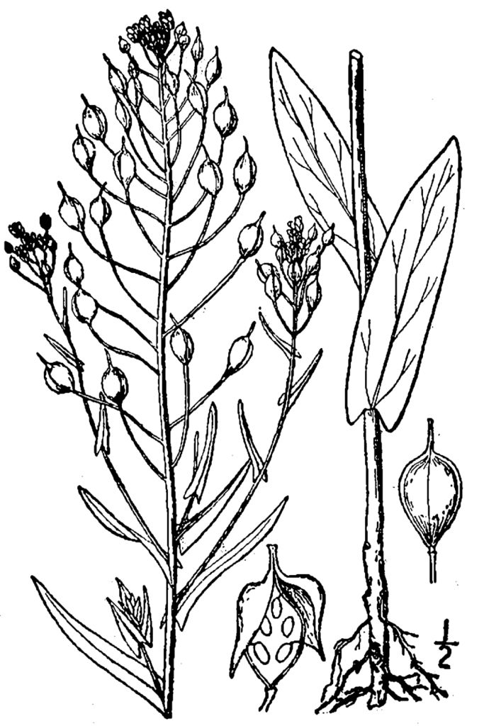

2, Camelina sativa, USDA Plants Database

### Establishment

### A crucial first step in camelina production is field selection. Few herbicides have been approved for use in camelina so it is critical to select fields where prior management has limited weed pressure and weed seed production was kept to a minimum. Perennial weeds such as field bindweed, Canada thistle, and skeletonweed are especially problematic for camelina. Being rhizomatous, or tap rooted, long lived and broadleaves, few if any management practices exist to control these perennials in camelina fields. It is also important to know the field’s chemical history. Camelina is highly sensitive to the soil herbicide imidazolinones (e.g. Beyond® and Pursuit®) (Hulbert et al, 2011). The active ingredient sulfentrazone (Authority®/Spartan®) is also extremely active on camelina (Hunter 2010). Research on camelina’s susceptibility to herbicide carryover has not been completed so other soil applied chemicals may result in damage to the camelina crop. Until further research is done, to determine specific plant back restriction for camelina, following plant back restrictions for canola or rapeseed on herbicide labels will minimize risk to the camelina crop. Depending on specific herbicides, these restrictions may be as long as 4 years. A field bioassay is recommended if questions remain about residual herbicides. Always read label and safety instructions for each pest control method. Trade names and control measures appear in this document only to provide specific information. USDA NRCS does not guarantee or warranty the products and control methods named, and other products may be equally effective.

### Camelina should be seeded in late winter or very early spring at a rate of 3-5 lbs pure live seed/acre. Camelina has no seed dormancy. Planting dates in Oregon, for example, can be as early as late February (Wysocki and Sirovatka 2008). Germination occurs after soil temperatures reach 38oF. Late spring plantings have shown decreased yields (McVay and Lamb 2008, Ehrensing and Guy 2008).

### Seed should be planted 1/4 inch deep, or less, into firm soil. Shallow placement is vital when seeding camelina. No-till and fully prepared seedbeds will allow better control of seed placement than will reduced tillage fields. Current recommendations are to drill camelina seed utilizing packer wheels to ensure good seed to soil contact. Because camelina seed is small and the seeding rate low grain drills may not be capable of metering the seed at the proper rate. Mix rice hulls, or other filler, in with the seed to achieve proper seeding rate. If broadcast seeding is used, the operation should be followed with a roller harrow or other implement to mix the seed and soil together and press the seed into the soil (McVay and Lamb 2008). Broadcast seeding rates should be 1.5 to 2 times the drilled rate.

Soil testing, to determine fertilizer needs, is recommended. Like other crops in the mustard family, camelina responds to nitrogen, sulfur, and phosphorus fertilizer application. Camelina is a short-season crop that requires a modest amount of nitrogen. Approximately 5 lbs N/acre for each 100 lb of expected seed yield is the recommended rate. For sulfur Wysocki and Sirovatka 2008 suggest applying sulfur at 5-10 lb/acre if the field tests low for sulfur or if response to sulfur has been observed with spring cereals. Phosphorus application of up to 60 lb/acre has been shown to increase the yield of camelina (Ehrensing and Gay 2008).

### Management

Currently, camelina production is recommended in conjunction with a small grain rotation. It grows well following wheat, barley, peas, or lentils. Avoid fields following canola, mustard, or other Brassica crops (Grady and Nleya 2010). Planting camelina after similar crops, such as canola, mustard, etc., increases the risk insect and disease problems common to these species. Also, because all seeds are not collected during harvest volunteer plants can become a problem (Steven Guy 2011, personal com.). Choosing fields with low weed pressure, good chemical or mechanical fallow techniques in association with uniform, dense camelina stand establishment are the best defenses against weed growth. Camelina requires few agriculture inputs when compared with other crops.

### Pests and Potential Problems

Downy mildew has been observed on camelina in fields in the Pacific Northwest and Montana. Downy mildew is a seed-borne fungal disease. Seed from down mildew infested fields should not be saved for planting in subsequent years. Camelina is susceptible to sclerotinia stem rot but reports of major outbreaks are uncommon. Infection weakens the plant stem, causing losses from lodging and early ripening. This disease infects many other crops, including sunflower, potatoes, safflower, beans, peas, and alfalfa, and is usually managed by crop rotation. Camelina may also be susceptible to the Rhizoctonia fungus. Camelina is highly resistant to blackleg a major disease of canola and other Brassica crops (Ehrensing and Guy 2008). To avoid potential disease problems, camelina should be rotated with cereal crops and should not be grown following crops like canola or mustard. Grow camelina no more than once every four years on any one field.

### Environmental Concerns

*Erosion* - Camelina does not produce high amounts of residue. Low residue levels could lead to an increase in soil erosion. Contact your local Natural Resources Conservation Service (NRCS) or Extension office for information on sustainable crop production in your area.

*Allelopathic -* Camelina may have an allelopathic suppression effect on flax. Flax yields were more than proportionately lower in fields containing camelina than in fields without, i.e. flax biomass was reduced more than could be accounted for by the increase in camelina biomass within the field. (Grummer and Beyer 1960).

*Weeds -* Preliminary evidence suggests that escaped *C. sativa* populations are likely to be relegated to severely disturbed habitats. The current probability that this species will invade rangelands to cause ecological damage is low (Davis, et al 2011).

### Control

Volunteer camelina is easily controlled with typical fall chemical fallow operations. Seedlings that survive the winter can be readily controlled by chemical fallow operations in subsequent years or by broadleaf herbicides utilized in cereal production practice (McVay and Lamb 2008).

Please contact your local agricultural extension specialist or county weed specialist to learn what works best in your area and how to use it safely. Always read label and safety instructions for each control method.

### Seeds and Plant Production

Camelina grows rapidly and, in Montana field trials, completed its lifecycle a few weeks sooner than spring wheat. Good yields have been achieved following cereal crops on fields which would otherwise have been fallow.

In Montana harvest dates vary from late June to late July depending on seeding date, precipitation, temperature and harvest method. Harvest should proceed only when seeds are 10 percent moisture or less using a canola standard in a moisture meter (Hunter 2010). Camelina is usually direct-combined but can be swathed. Start swathing when about two-thirds of the pods turn from green to yellow. When swathing camelina, the crop should be cut just below the pod canopy to retain as much standing stem as possible. Combine settings similar to those used for canola or alfalfa seed work well for camelina, but combine fan speed must be reduced to minimized seed losses (Hulbert et.al 2011). Since camelina seeds are quite small, leaks in equipment need to be sealed to prevent seed loss during harvest. There is no known seed dormancy in camelina and seed lost during harvest generally germinates soon thereafter.

Camelina seed is susceptible to spoiling under high-moisture conditions. Seed moisture should be no more than 8% for best storage (Grady and Nleya 2010).

Climate has a big impact on camelina yields. In southwestern South Dakota the hot dry conditions that occur during flowering and seed shatter reduce yields significantly. In plot trials the average yield over a 4 year period was approximately 350 lbs/acre. In contrast, in cooler conditions, yields of over 2,000 lbs/acre have been obtained in plot trials at Minot, N.D., and Havre, Montana (Grady and Nleya 2010). In Montana, under dryland conditions, camelina is expected to yield 1,800 to 2,000 lb/acre in areas receiving 16-18 inches of annual precipitation (ppt.), and 900 to 1,700 lb/acre in areas receiving 13-15 inches of ppt. (Ehrensing and Guy 2008).

In the Pacific Northwest camelina yields are greatly influenced by precipitation in the dryland region. Higher precipitation sites such as Pullman, Washington and Moscow, Idaho (18-25 inches ppt.) produce consistently high yields (2,000+ lb/acre), while camelina yields at Lind (9¼ annual ppt.) have ranged from 100 lbs/acre during an extreme drought year to as high as 1000 lbs/acre during a year with 11 ½ inches of precipitation (Hulbert et al, 2011).

### Cultivars

‘*Blaine Creek’*, developed at Montana State University, 2007, is a short-season, high-yield line particularly adapted to high-yield environments. ‘*Blaine Creek’* is also high in omega-3 fatty acids.

‘*Suneson’* , also developed at Montana State University, 2007, is a mid-season, average-yield line. ‘*Suneson’* is typically 2 to 3 percent higher in oil content than *‘Blaine Creek’*. ‘*Suneson*’ is high in α-linolenic acid.   
  
‘*Platte*’, from Blue Sun Biodiesel, which replaced ‘Cheyenne’ in 2009 is a spring variety selected for yield stability in a dryland environment (< 20” annual precipitation).

‘*SO-40’, ‘SO-50’, SO-60’*, developed in 2010 by the Sustainable Oils Company are spring-type camelina varieties with high yield potential across a broad range of environmental conditions. They mature in about 100 days and have an oil content of about 37.5%. In field trials, oil yields ranged from 651 lbs/acre (‘*SO-60’*) to 684 (‘*SO-50’*) lbs/acre.

Varieties from Europe include ‘*Celine*’, ‘*Calena*’, and ‘*Epona*’. Great Plains – The Camelina Company has developed several new varieties as well. Other varieties are available and as work continues on camelina more varieties will, undoubtedly, become available in the near future. Please contact companies for more information on available varieties.

**References**

Britton, N.L., and A. Brown. 1913. An illustrated flora of the northern United States, Canada and the British Possessions. 3 vols. Charles Scribner’s Sons, New York. Vol 2: 157.

Davis, Philip B., Fabian D. Menalled, Robert K. D. Peterson, and Bruce D. Maxwell 2011. Refinement of weed risk assessments for Biofuels using camelina sative as a model species. Journal of Applied Ecology, 48, 989-997.

Dennis, La Rea J., 1980. Gilkey’s Weeds of the Pacific Northwest. Oregon State University Press.

Ehrensing, Daryl T. and Stephen O. Guy. 2008. Camelina. Oregon State University Extension Service, EM 8953-E, January 2008.

Global Invasive Species Database (http://www.issg.org/database)

Grady, Kathleen, and Thandiwe Nleya. 2010. Camelina Production. South Dakota State University, Extension Extra, ExEx8167, May 2010.

Grummer, G and H Beyer. 1960. The influence exerted by species of Camelina on Flax by means of toxic substances. The Biology of Weeds, 153-157, Oxford.

Hitchcock C. Leo and Arthur Cronquist 1973. Flora of the Pacific Northwest, An Illustrated Manual. University of Washington Press. Seattle and London

Hulbert, Scot, Stephen Guy, Bill Pan, Timothy Paulitz, Bill Schillinger, Don Wysocki, and Karen Sowers. 2011. Camelina Production in the Dryland Pacific Northwest. Washington State University, Fact Sheet (in review).

Hunter, Joel and Greg Roth 2010. Camelina Production and Potential in Pennsylvania, Agronomy Facts 72. College of Agricultural Sciences, Crop and Soil Sciences, Pennsylvania State University.

Jackson, G., and J. Miller 2005. Effect of nitrogen, phosphorus and sulfur on yield, oil content, and oil quality of camelina. http;//ag.montana.edu/wtarc/Web2005/Soils/Camelina/2005CamelinaNPS.pdf

King, S.R., 2008. Weed Science Society of America (WSSA). WSSA Meeting Abstract: Montana State University, Huntley MT camelina sativa Tolerance to Preemergence and Postemergence Herbicide Applications.

Klindenberg, Brian. 2008. E-Flora BC: Electronic Atlas of the Plants of British Columbia. Lab for Advanced Spatial Analysis, Department of Georgraphy, University of British Columbia, Vancouver.

McVay, K.A. and P.F. Lamb. 2008. Camelina Production in Montana. Montana State

University Extension, MontGuide, MT200701AG Revised 3/08.

Putnam, D.H., J. T. Budin, L.A. Field, and W.M. Breene. 1993 Camelina: A promising low-input oilseed. In J. Janick and J.E. Simon (Eds.), New crops (pp. 314-322). New York: Wiley.

Sustainable Oils web site. 2009. (http://www.susoils.com/opportunities/protocol_spring.php)

Wysocki, Don and Nick Sirovatka. 2008. Camelina, a Potential Oilseed Crop for Semiarid Oregon.

**Prepared By**:

*Richard Fleenor*, USDA NRCS Plant Materials Program, Spokane WA

### Citation

Fleenor, Richard A. 2011. Plant Guide for Camelina (*Camelina sativa)*. USDA-Natural Resources Conservation Service, Spokane, WA 99201  
  
Published September, 2011

Edited: 20Sep2011 rf,30Sep2011 jab

For more information about this and other plants, please contact your local NRCS field office or Conservation District at <http://www.nrcs.usda.gov/> and visit the PLANTS Web site at <http://plants.usda.gov/> or the Plant Materials Program Web site <http://plant-materials.nrcs.usda.gov>.

PLANTS is not responsible for the content or availability of other Web sites.

**USDA IS AN EQUAL OPPORTUNITY PROVIDER AND EMPLOYER**