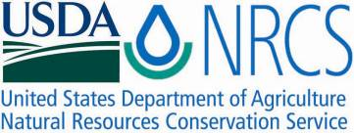

Plant Guide

# navajo sedge

***Carex specuicola* J.T. Howell**

Plant Symbol = CASP9

*Contributed by*: USDA NRCS Idaho and Utah Plant Materials Program

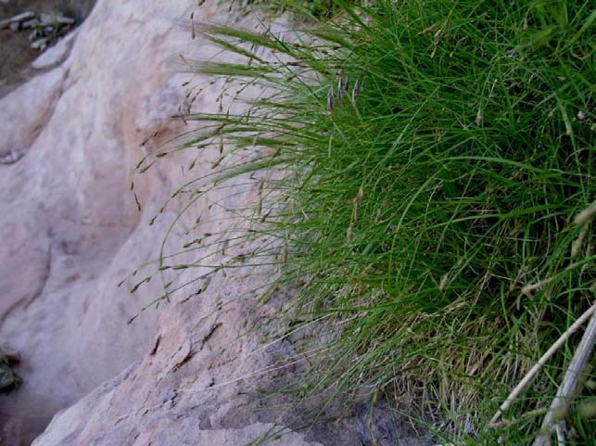**Navajo sedge (Carex specuicola). Photo by Daniela Roth, Navajo National Heritage Project**

### Alternate Names

None

### Uses

There are no known human uses of Navajo sedge. The leaves are grazed by domestic livestock.

### Status

Navajo sedge was listed by the USDI Fish and Wildlife Service as a threatened species in 1985, and was assigned critical habitat (USDI-FWS, 1985).

Consult the PLANTS Web site and your State Department of Natural Resources for this plant’s current status (e.g., threatened or endangered species, state noxious status, and wetland indicator values).

### Description

*General*: Sedge family (Cyperaceae). Navajo sedge is a perennial, grass-like sedge. The plants form bunches from 25 to 45 cm (10 to 18 in) tall with long, slender, pale green leaves, 1 to 2 mm (0.04 to 0.08 in) wide and 12 to 20 cm (5 to 8 in) long. The stems are triangular in cross section, and end in 2 to 4 floral spikes. The terminal spike contains both male and female flowers, with the female flowers situated above the male. The fruit is an achene borne within a perigynium (a sack-like appendage). This species is

unusual in that it has two types of female flowers, those with two-branched styles and lenticular (lens shaped) achenes, and those with three-branched styles and triangular achenes (USDI-FWS, 1987).

*Distribution*:

Navajo sedge exists on lands managed by the Navajo Nation in Coconino, Apache and Navajo Counties, Arizona, and in adjacent San Juan County Utah. The range of Navajo sedge includes the Navajo Creek drainage to the Tsegi Canyon Watershed (CPC, 2011).

For current distribution, consult the Plant Profile page for this species on the PLANTS Web site.

*Habitat*:

Navajo sedge occurs in shaded seeps, springs, and hanging gardens in the pink-red Navajo Sandstone Formation from 1,400 to 2,200 m (4,600to 7,200 ft) in elevation (Roth, 2008). Mean annual precipitation for the area is 19 cm (7.5 in).Navajo sedge occurs with other hanging garden and wetland/riparian species such as monkey flower (*Mimulus eastwoodiae*), helleborine (*Epipactus* *gigantea*), water bentgrass (*Agrostis* *semiverticillata*), and common reed (*Phragmites* *communis*) (USDI-FWS, 1987).

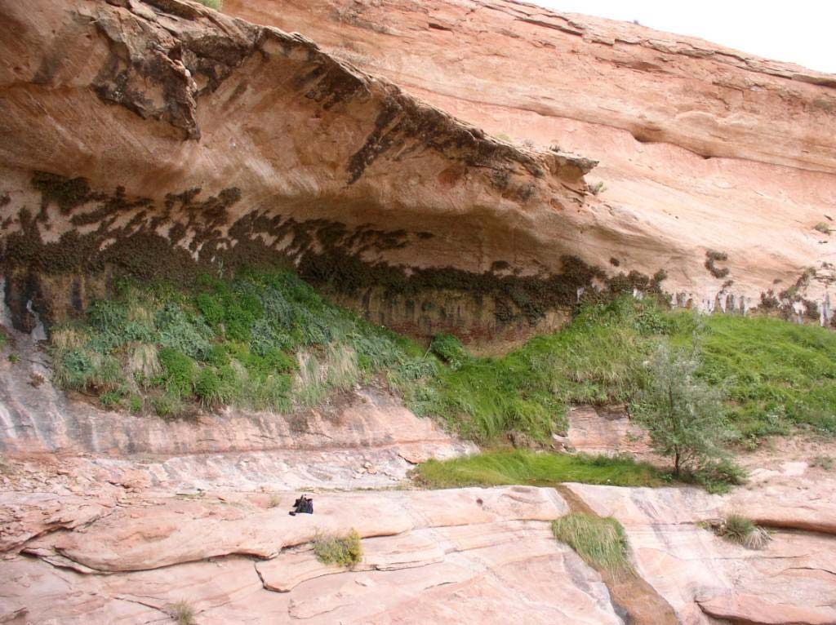

**Navajo sedge habitat. Photo by Daniela Roth, NNHP**

### Management

Populations occupying low-lying accessible habitat are vulnerable to domestic livestock grazing. Horses, sheep, goats and cattle are believed to graze the plants. Off-road vehicles could also negatively impact Navajo sedge habitat. Water development for wells, troughs and capture basins for livestock have resulted in increased grazing in populated areas (USDI-FWS, 1987).

The recovery plan for Navajo sedge covers the protection of known habitats and populations, inventories of potential habitat, and the reintroduction of plants into additional sites (USDI-FWS, 1987).

### Pests and Potential Problems

### There are no known pests associated with Navajo sedge.

### Environmental Concerns

### There are no known environmental concerns associated with Navajo sedge.

### Seed and Plant Production

### Though this species is known to produce seed, the majority of reproduction appears to be vegetative (USDI-FWS, 1987). No propagation information is available.

### References

Center for Plant Conservation. 2011. Plant profile for *Carex specuicola*. Online at: http://www.centerforplantconservation.org. Accessed January 7, 2011.

Roth, D. 2008. Species account for Carex specuicola. Navajo Natural Heritage Program. Windwon Rock, AZ. 2p.

USDI-Fish and Wildlife Service. 1985. Endangered and threatened wildlife and plants; determination of *Carex specuicola* to be a threatened species with critical habitat. In: Federal Register 50 (89): 19370-19374.

USDI-Fish and Wildlife Service. 1987. Navajo sedge recovery plan. U.S. Fish and Wildlife Service. Albuquerque, New Mexico. 39p.

**Prepared By**:

*Derek Tilley*; USDA NRCS Plant Materials Center, Aberdeen, Idaho.

*Loren St. John*, USDA NRCS Plant Materials Center, Aberdeen, Idaho.

*Dan Ogle*, USDA NRCS, Boise, Idaho.

### Citation

Tilley, D., L. St. John and D. Ogle. 2010. Plant guide for Navajo sedge (*Carex specuicola*). USDA-Natural Resources Conservation Service, Idaho Plant Materials Center. Aberdeen, ID.

Published Jan 2011

Edited: 07Jan2011 djt, 07jan ls; 07Jan2011dgo

For more information about this and other plants, please contact your local NRCS field office or Conservation District at http://www.nrcs.usda.gov/ and visit the PLANTS Web site at http://plants.usda.gov/ or the Plant Materials Program Web site http://plant-materials.nrcs.usda.gov.

PLANTS is not responsible for the content or availability of other Web sites.

**USDA IS AN EQUAL OPPORTUNITY PROVIDER AND EMPLOYER**