|  |  |
| --- | --- |
| **Natural Resources Conservation Service** | Plant Guide |

# desert willow

***Chilopsis linearis* (Cav.)Sweet**

Plant Symbol = CHLI2

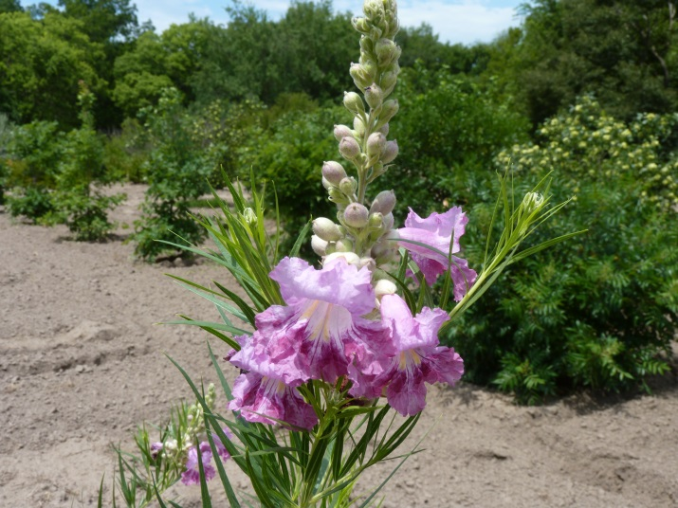

Figure 1 Close up of inflorescence with buds and blooms

*Photo by John M. Row, USDA NRCS, Plant Materials Specialist*

### Alternate Names

*Common Names:* Flowering-willow, willowleaf catalpa, desert catalpa, Flor de Mimbre, mimbre, bow willow (TAMU.edu 2013), false-willow, jano, catalpa-willow (Magill 1974)

Description

*General*: A member of the Bignoniaceae (trumpet vine) family, desert willow is a spreading deciduous shrub or small tree that can surpass 16 feet in height on the Great Plains (Weedon 1986) to 40 feet in the desert southwest (TWC Staff 2010), and 15 to 25 feet wide (NMSUASC and NRCS 2001). Though not a willow, its linear leaves bring willow to mind, thus the name. A native of the Southwest, the species can be found growing in southwest Kansas and western Oklahoma. Its flowers occur in showy clusters at the tips of the branches on new growth from late spring to fall. The trumpet-shaped, sweetly fragrant flowers, ranging from light pink to light violet are reminiscent of catalpa blossoms. In fact this small tree is related to catalpa trees and trumpet vine. The many, large, long lasting, attractive flowers develop into slender fruits (capsules) 6 to 10 inches long that persist on the plant into the following spring and produce seeds with winged hairs.

*Distribution*: Native from the eastern half of the Mohave Desert in California, south into upper Baja California, east to southern Nevada, Arizona, south to north central Mexico to Nuevo Leon and Zacatecas, southern New Mexico, and west Texas. Sometimes escaped or naturalized from introduced populations in southwest Kansas and the western half of Oklahoma, subspecies *linearis.*  (BONAP 2009; USDA, NRCS 2014; Weedon 1993; TWC Staff 2010). For current distribution, please consult the Plant Profile page for this species on the PLANTS Web site.

*Habitat*: Common in dry washes and along riverbanks below 5,000 feet elevation (Shaw 2011), in flood plains and ravines (Weedon 1993) in the desert southwestern US and northern Mexico (Shaw 2011). “These sites generally have underground water available year-round. Plants can withstand seasonal flooding quite well, and often occupy the middle of drainage channels, sometimes covering broad expanses of wash areas (Uchytil 1990).”

***Adaptation***

Desert willow likes arid climates; extremely drought and heat tolerant, performs best on well-drained sites in areas with less than 30″ of precipitation, and thrives best in full sun. Grows on most soils; including dry clay, loam, and sand; tolerant of acidic and alkaline soil conditions (Gilman and Watson 1993). With “rapid growth, drought tolerance, and ease of maintenance, desert willow is a sought-after plant within its range (TWC Staff 2010).” USDA Hardiness Zones 7B through 11 (Gilman and Watson 1993), but has been grown to Zone 6 at the Manhattan Plant Materials Center in Kansas, where winter kill on young growth was overcome by new annual growth (USDA, NRCS 2012). Desert willow has been found to be a lot cold hardier than originally rated, once established it can withstand subzero winter temperatures to Zones 5 and 6 (Salman 2014).

*Fire Effects*: Desert willow occurs primarily in washes which rarely burn. It is able to produce numerous sprouts from the crown following top-kill due to fire (Uchytil 1990).

### Uses

*Conservation*: Desert willow may be planted in arid regions for erosion control purposes such as buffer strips, windbreaks, reclamation projects, and for wildlife cover.

*Ornamental*: Planted as an ornamental, there are numerous cultivars to choose from for courtyards, patios and west facing exposures.

*Wildlife*: Desert willow is utilized by ladder-backed woodpecker for nesting (Jongsomjit and Arata 2008) and a documented occasional ash-throated flycatcher nester in the split trunk of a desert willow (San Diego County 2014). Mourning doves use the shrubs for nesting where better nest choices are unavailable in southwest Kansas (T. Flowers, pers. comm.). Hummingbirds and native bees, especially bumblebees, visit the flowers for their nectar and a variety of birds eats the seeds of desert willow flowers. Desert willow is considered to be unpalatable to livestock and low in palatability to wildlife. Mule deer eat small quantities of the leaves and fruit. Livestock generally do not browse the plant unless other forage is scarce. Tender sprouts following fire may be highly palatable to deer, bighorn sheep, and cottontail rabbits (Uchytil 1990).

### Ethnobotany

*Medicine*: The flowers, leaves, and bark of desert willow were used in hot poultices and to make a soothing tea for coughs. A tea concocted from the flowers “produces a natural anti-oxidant which promotes cardiovascular health and regulates glucose metabolism.” It was also used in preparations to guard against yeast infections, athlete’s foot and as a first aid for scrapes and scratches (Rymer 2004).

*Food*: the flower blossoms and seed pods were used for food (Moerman 1998).

*Fiber*: The bark was used to make fabrics for shirts and breechclouts, and fashioned into cordage to make nets. Branches were stripped of their bark and used as rod foundations for coil basketry. The wood was used in building house frames and granaries (Moerman 1998), fence posts (Gilman and Watson 1993), and hunting bows. Long limbs were used as a tool to “reach fruits and nuts too high to grasp by hand.”

*Other*: Desert dwellers camped under desert willow which provided some shade and shelter (Moerman 1998).

### Status

*Wetland Indicator*:Arid West, Atlantic and Gulf Coastal Plain, and Great Plains –FACU; Western Mountains, Valleys, and Coast –FAC

*Weedy or Invasive*:This plant may become weedy or invasive in some regions or habitats and may displace desirable vegetation if not properly managed. Please consult with your local NRCS Field Office, Cooperative Extension Service office, state natural resource, or state agriculture department regarding its status and use.

Please consult the PLANTS Web site (http://plants.usda.gov/) and your State Department of Natural Resources for this plant’s current status (e.g., threatened or endangered species, state noxious status, and wetland indicator values).

### Planting Guidelines

Plant desert willow in sunny locations on well-drained soils, water the plants until established. Applying fertilizer is beneficial during the establishment period. Apply sparingly as too much fertilizer promotes unruly growth (Daily 2007) weakening new growth that cannot withstand strong winds (Telsch-Williams 2010). Once established, supplemental water is not required.

### Management

An occasional watering during the summer months will contribute to a flush of growth and profuse flowering. Avoid over watering. It is best to not add supplemental water to the plants in the fall or winter when the plants are leafless. Tip dieback is a typical phenomenon; the dead twigs can be easily pruned out in ornamental plantings once the plants have leafed out in the spring. Irregular growth requires attention early on to promote desired trunk development. Desert willow may be pruned to form a tree or shrub as desired. Since blooms occur on new wood, the more it is pruned, the more it flowers (NMSUASC and NRCS 2001; TAMU.edu 2013; USDA, NRCS 1982b).

### Pests and Potential Problems

Virtually disease and insect free. Desert willow “seeds itself into the landscape (Gilman and Watson 1993)” and therefore not recommended for planting in lawns.

### Environmental Concerns

None known

### Control

Please contact your local agricultural extension specialist or county weed specialist to learn what works best in your area and how to use it safely. Always read label and safety instructions for each control method. Trade names and control measures appear in this document only to provide specific information. USDA NRCS does not guarantee or warranty the products and control methods named, and other products may be equally effective.

### Seeds and Plant Production

Collect mature pods in early fall to early spring by hand-picking to obtain fully mature seed units. Spread out the pods for drying, beat them lightly, and shake seeds free of the pods. One hundred pounds of pods yield 30 to 50 pounds of clean seed. The number of seeds per pound ranges from 40,000 to 128,000 with an average of 86,000 seed per pound. Store seed in a cool, dry place until planting, plant seed ¼ inches deep after the soil warms up in the spring (Magill 1974). Desert willow may be propagated from seed, hardwood cuttings (dormant) or softwood cuttings (mid-summer). Seed produced plants may be variable in flower color and other traits. Cuttings should be made if plants identical to the parent plant are desired.

No seed treatment is required, seeds planted ¼ inch deep in a well aerated soilless media sprout in 1 to 3 weeks under warm, moist conditions. Allow the soil to dry out slightly between watering to prevent damping off.

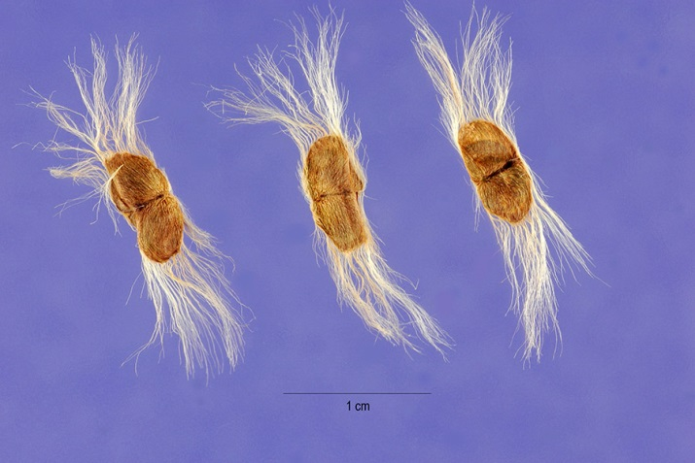

Figure . The unique seeds of desert willow winged with a fringe of hair, borne in slender pods.

Photo by Steve Hurst, hosted by the USDA-NRCS PLANTS Database

Asexually propagated plants ensure duplication of desired plant traits. This may be carried out by taking hardwood cuttings, softwood cuttings, or by air layering. Hardwood cuttings may be taken when the plants are dormant, late winter – early spring. Take ¼ inch stem cuttings 6 to 12 inches long, “brown, hardened bark will root best”, with leaf buds visible the entire length. No rooting hormone is required, “will root quickly.” Stick the cuttings upright in the soil or well-aerated growing medium with only the top inch or two exposed; keep slightly moist until new leafy growth emerges. Softwood or semi-hardwood cuttings are taken in the spring or early summer from the current year’s growth. Select flexible leafy stems with no buds or flowers; treat the bottom of the cuttings with indole-3-butyric acid (concentration <5,000 ppm). Place in a sterile medium, under mist with light shade. Air layering has a “higher potential for failure”, this method may be used in summer to propagate desert willow. Select ¼ inch stems with leafy tips but without flowers or flower buds. “Strip off a 1-inch-wide layer of bark from around the stem roughly 6 to 8 inches from the tip (Leon 2014).” Consult a plant propagation manual if unfamiliar with air layering techniques.

### Cultivars, Improved, and Selected Materials (and area of origin)

In 1978, the New Mexico State University Los Lunas Agricultural Science Center (NMSUASC), New Mexico Department of Transportation, and the USDA NRCS’s Los Lunas Plant Materials Center (PMC) released ‘Barranco’ for conservation use. Barranco is useful for windbreaks, screening, ornamental plantings, and for beautification plantings in highway rest areas, along roadsides, and in road medians (USDA, NRCS 1982a). ‘Hope’ produces white flowers with a yellow throat. It was released in 1980, by the NMSUASC and the Los Lunas PMC for its low water requirement over commercially available trees and shrubs (USDA, NRCS 1982b). ‘Regal’ was released in 1988 by the NMPMC, NMSUASC, and the New Mexico Agricultural Experiment Station for its dark purple flower characteristic and dark green leaves. In all, there are at least twenty known cultivars of desert willow (Creech 2014) offering a range of flower colors, leaf sizes, and number of seed pods (TWC Staff 2010) have been released by the public and private sector. Two seedless cultivars, ‘Timeless Beauty’® P.P. and ‘Art’s Seedless’™ are summer long bloomers (Salman 2014). Cultivars should be selected based on the local climate, resistance to local pests, and intended use. Consult with your local land grant university, local extension or local USDA NRCS office for recommendations on adapted cultivars for use in your area**.**

**Literature Cited**

BONAP. 2009.Chilopsis linearis. Desert willow distribution map. In Floristic Synthesis of North America [Online]. Available at https://www.google.com/search?q=desert+willow+distribution+map&tbm=isch&imgil= etc. (accessed 25 July 2014). Biota of North America Program, Chapel Hill, NC.

Creech, D. 2014. *Chilopsis linearis* – desert willow [Online]. Available at http://sfagardens.sfasu.edu/UserFiles/FIle/PLANTS/Chilopsis%20linearis(2).pdf (accessed 9 July 2014). Stephen F. Austin State Univ., Nacogdoches, TX.

Daily, R. 2007. Growing Desert Willow [Online]. Available at https://suite.io/robert-dailey/h7x255 (accessed 19 August 2014).

Gilman, E. F. and D. G. Watson. 1993. *Chilopsis linearis*, Desert-Willow [Online]. Available at http://hort.ifas.ufl.edu/database/documents/pdf/tree_fact_sheets/chilina.pdf (accessed 9 July 2014). USDA FS Fact Sheet ST-159. 3p. Florida Coop. Ext. Svc, Gainsville.

Jongsomjit, D. and L. Arata. 2008. Ladder-backed Woodpecker (Picoides scalaris). In The Draft Desert Bird Conservation Plan: a strategy for reversing the decline of desert-associated birds in California [Online]. Available at http://www.prbo.org/calpif/htmldocs/desert.html (accessed 25 July 2014). California Partners in Flight.

Leon, A. 2014. How to Propagate Chilopsis Linearis [Online]. Available at http://homeguides.sfgate.com/propagate-chilopsis-linearis-96472.html (accessed 9July 2014). Home Guides. Demand Media. Hearst Communications, Inc.

Magill, A. W. 1974. *CHILOPSIS LINEARIS* (Cav.) Sweet, Desertwillow. In Schopmeyer, C. S. Seeds of Woody Plants of the United States. US Forest Service, Ag. Handbook No. 450. USDA. Washington, D. C.

Moerman, D. E. 1998. Native American ethnobotany. Timber Press. Portland · London.

NMSUASC and NRCS. 2001. Desert Willow. New Mexico State University Agricultural Center and Los Lunas Plant Materials Center, Natural Resources Conservation Service, Los Lunas.

Rymer, C. 2004. Desert Willow Indigenous Imposter [Online]. Available at http://ag.arizona.edu/maricopa/garden/html/pubs/0104/willow.html (accessed 9 July 2014). Master Gardner Journal. The University of Arizona, College of Agriculture and Life Sciences, Cooperative Extension in Maricopa County.

Salman, D. 2014. The beauty of waterwise plants. Am. Nurseryman. August 2014. p. 5.

San Diego County 2014. Ash-throated Flycatcher *Myiarchus cinerascens* [Online]. Available at http://sdplantatlas.org/ge_files/pdf/Ash-throated%20Flycatcher.pdf (accessed 25 July 2014). San Diego County Plant Atlas.

Shaw, E. A. 2011. Desert Willow can be easily tamed [Online]. Available at http://www.ocregister.com/articles/willow-324076-desert-tree.html (accessed 9 July 2014). Orange County Register, Santa Ana, CA.

TAMU.edu 2013. Desert Willow, Flowering Willow, Willowleaf Catalpa, Desert Catalpa, Flor de Mimbre, Mimbre, Bow Willow, *Chilopsis linearis* [Online]*.* Available at http://aggie-horticulture.tamu.edu/ornamentals/natives/chilopsislinearis.htm (accessed 25 March 2013; verified 19 August 2014). Texas A&M Univ., College Sta.

Telsch-Williams, M. 2010. How to Care for a Desert Willow Tree [Online]. Available at http://www.gardenguides.com/77481-care-desert-willow-tree.html (accessed 19 August 2014). Garden Guides, Demand Media, Santa Monica, CA.

Uchytil, R. J. 1990. Chilopsis linearis. In: Fire Effects Information System [Online]. Available at http://www.fs.fed.us/database/feis/plants/shrub/chilin/all.html (accessed 7 August 2014). USDA, FS Rocky Mountain Research Station, Fire Sciences Laboratory.

USDA, NRCS. 1982a. ‘Barranco’ desert willow. Conservation Release Brochure. USDA, NRCS. Los Lunas Plant Materials Center. Los Lunas, NM. 2p.

USDA, NRCS. 1982b. ‘Hope’ desert willow. Conservation Release Brochure. USDA, NRCS. Los Lunas Plant Materials Center. Los Lunas, NM. 2p.

USDA, NRCS. 2012. Evaluation of miscellaneous trees and shrubs. p. 54. In 2012 Annual Technical Report. Manhattan Plant Materials Center. Manhattan, Kansas.

USDA, NRCS. 2014. The PLANTS Database (http://plants.usda.gov, 21 July 2014). National Plant Data Team, Greensboro, NC 27401-4901 USA.

Weedon, R. R. 1986. Bignoniaceae. p. 803-805. In T. M. Barkley (ed.) Flora of the Great Plains. Great Plains Flora Association, Univ. Press of Kansas. Lawrence.

TWC Staff. 2010. *Chilopsis linearis* [Online]*.* Available at <http://www.wildflower.org/plants/result.php?id_plant=CHLI2> (accessed 9 July 2014). Lady Bird Johnson Wildflower Center, Univ. of Texas, Austin

### 

### Citation

Row, J. M. 2014. Plant Guide for desert willow (*Chilopsis linearis*). USDA-Natural Resources Conservation Service, Manhattan, Kansas 66502

Published: August 2014

Edited: DRD; RLW; JLD

For more information about this and other plants, please contact your local NRCS field office or Conservation District at http://www.nrcs.usda.gov/ and visit the PLANTS Web site at http://plants.usda.gov/ or the   
Plant Materials Program Web site:

http://plant-materials.nrcs.usda.gov.

PLANTS is not responsible for the content or availability of other Web sites.

***Helping People Help the Land***

**USDA IS AN EQUAL OPPORTUNITY PROVIDER AND EMPLOYER**